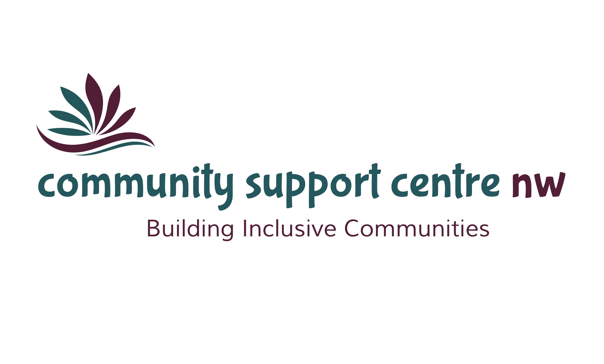

30th

annual report

Celebrating 30 Years of Incorporation

Dryden Observer Newspaper – June 26, 1990

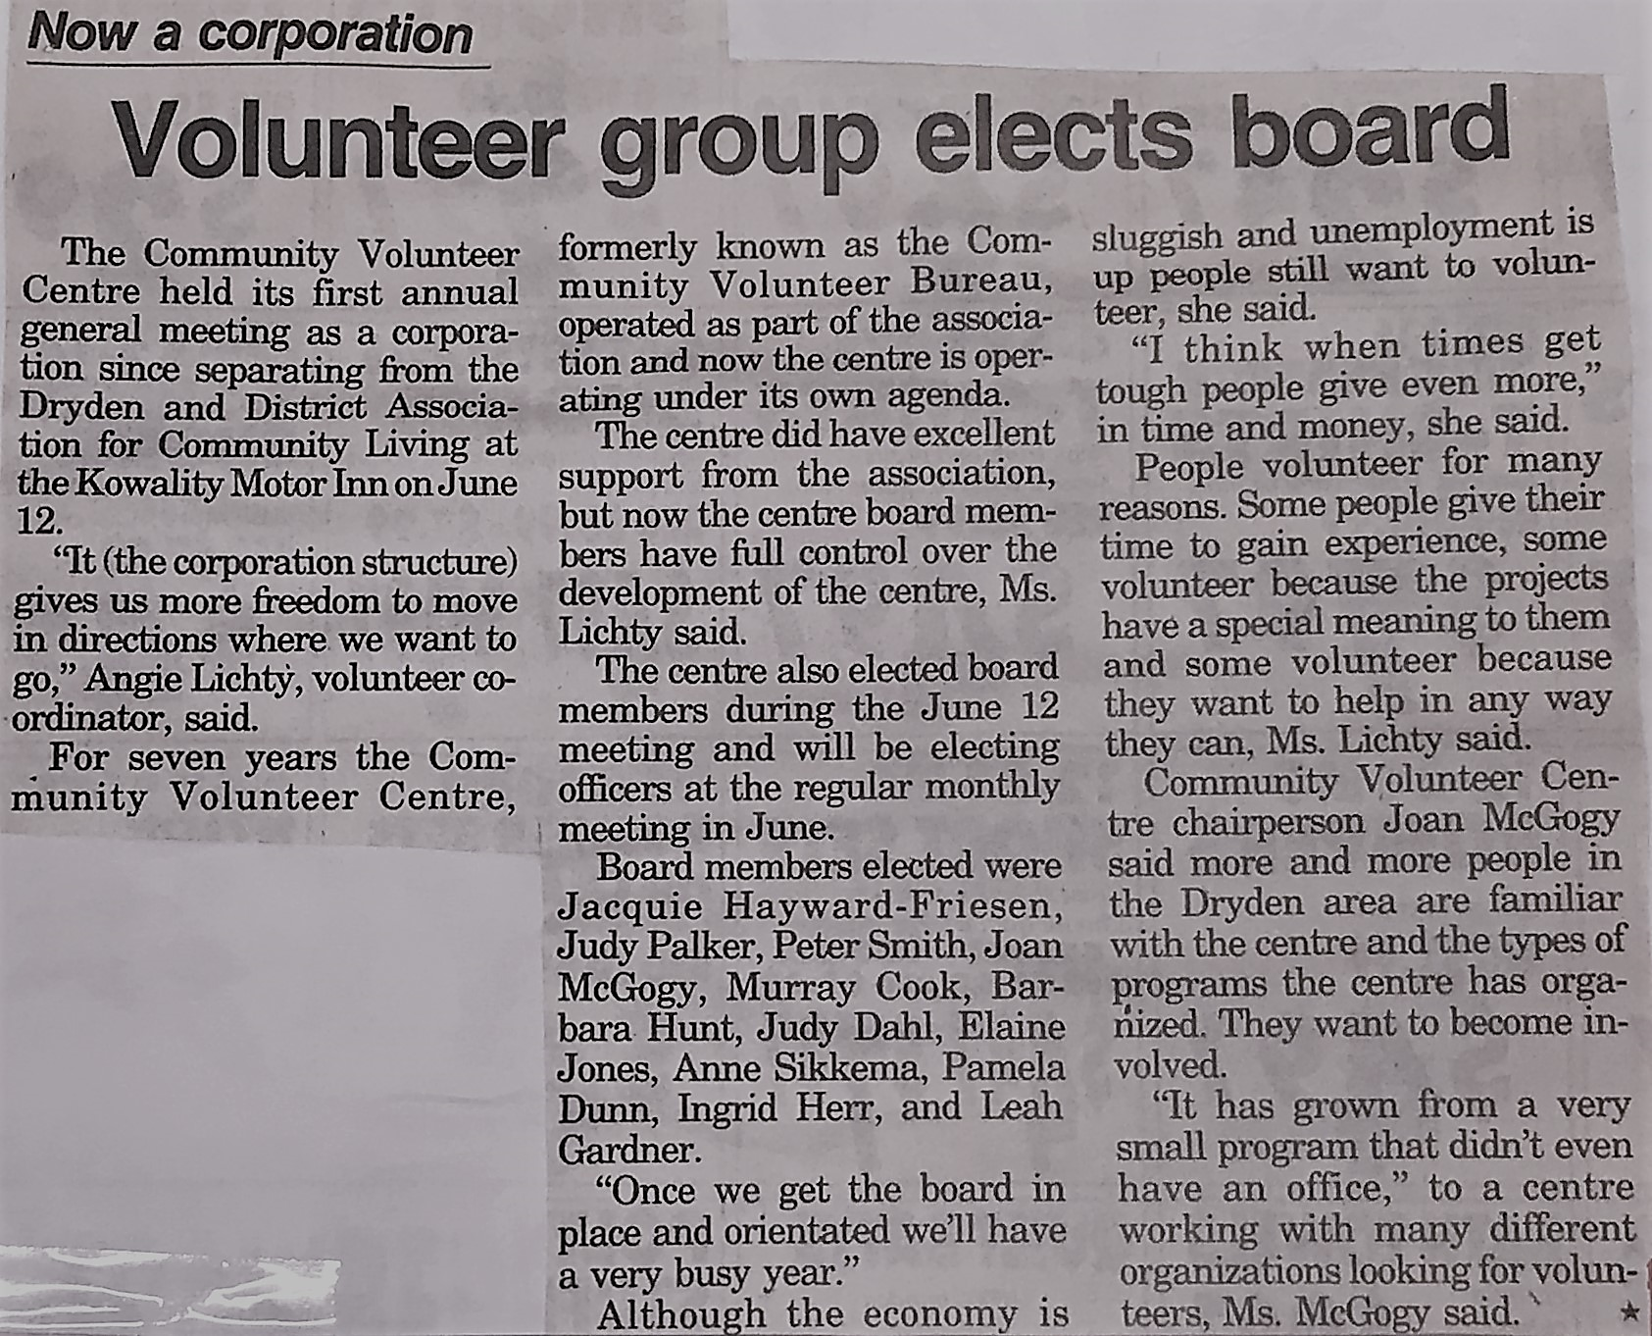
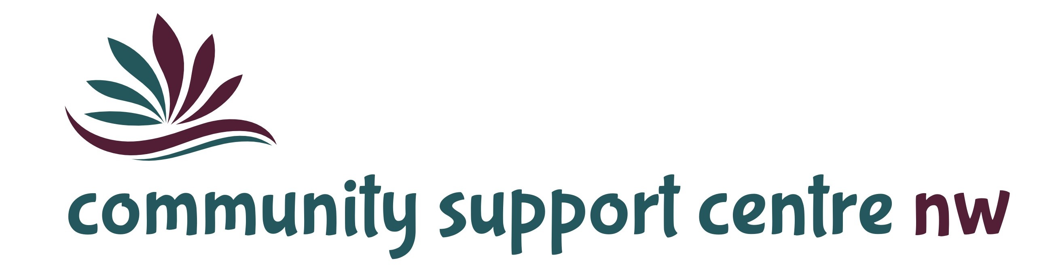

Mission Statement
Providing quality, innovative, client-centred programs and services to enrich the lives of the individuals and families we support.

Our Vision
Where everyone feels valued, connected, included and empowered.

Service Principles

Respect
We believe that every individual has the right to their own values, beliefs and individual choices.

Inclusion
We believe that every individual should be accepted and treated equally as a valued member of the community and are entitled to participate fully and enjoy the same quality of life as all community members.

Collaboration
We believe in the importance of working collaboratively with our service partners to achieve the best outcomes for the people we support.

Accountability
We believe in being fiscally responsible and demonstrating transparency and ethical decision-making.

Innovation
We believe in developing an organizational culture that supports opportunities for learning, growth and development and values the contributions of the individuals we support, their families, the staff and the broader community.

Message from the Board Chair and Executive Director
Executive Director / Board Chair Report

This is not only an opportunity to reflect on this past year’s achievements and challenges, but also a chance to celebrate 30 years of exceptional service. Starting with humble beginnings to the tremendous journey of growth and expansion as a result of the significant contributions of the many inspirational leaders over the years.

Our CIS, Fee for Service and Passport clients continue to be out and about in our community. Our main hall is often empty – and this is a good thing. It means that our supported individuals have access to greater opportunities for community participation. Bowling, hockey games, concerts, fishing, cooking class, coffee groups, chair yoga and library/lunch just to name a few. On the flip-side, our main hall is full during the highly successful monthly “Drop-In” evenings. The individuals we support educate all of us every day on the power of inclusion. As always, our staff continue to seek new and different experiences where individuals can expand their learning, advance social skills and develop meaningful new relationships.

Our first year of Supervised Access as a regional program has been highly successful. Having a single point of access to service in the Kenora and Rainy River Districts has eliminated barriers and created efficiencies for client service. The Ministry of the Attorney General provided excellent support throughout the transition year.

Christmas Cheer was once again an over-whelming success. We were able to bring joy to many families in Dryden and the surrounding area who grapple with hardships and struggle to make ends meet during the holidays. This is only accomplished through the wonderful work of volunteers, many who return year after year with endless energy to make this happen. We extend a huge thank you to our volunteers, our donors, local businesses and the community for their incredible hearts and generous financial support. We couldn’t do this without them. And to our own, Peggy Howard, who coordinates Christmas Cheer from start to finish with proficiency, thank you!

We are grateful to have been provided the opportunity to have a dedicated HR Generalist and a receptionist with us for a one-year period. This was achieved through a partnership agreement with the Dryden Native Friendship Centre, whereby salaries and related costs were covered at 100%. The Community Support Centre provided an opportunity for the employees to gain valuable work experience that will enhance their skills and abilities going forward in their respective career paths.

Of course, this year was like no other with the closure of services in March 2020 due to the COVID-19 pandemic. Our immediate concern was for the health and safety of our staff and our clients. We are extremely thankful that to date, our region has had a low incidence rate and we were able to resume services toward the end of June 2020. This took diligent preparation which included phased service starts, disinfection practices, physical distancing, etc. We are proud of the resiliency of the individuals and their families who weathered the experience when no support services were available. It is however, the employees who deserve the praise during these unprecedented times. They are the ones meeting the challenges necessary to keep themselves and the clients safe while making day-to-day differences in the lives of the children, youth, adults and families we serve. We are privileged to have such devoted staff. Thank you!

And lastly, thank you to the Board of Directors who have been supportive of the work we do and have demonstrated their passion for the Community Support Centre-NW. We could not successfully carry out our mission without the expertise and leadership of our Board of Directors. We look forward to the coming year of on-going success and accomplishments.

Respectfully,

Kim Douglas Debbie Dokuchie
Board Chairperson Executive Director

PROGRAMS and SERVICES

Community Integration Services
(Community Participation and Supports)
Connecting individuals who have a developmental disability to our community through recreation and leisure activities.

Passport
Individualized programs tailored to meet unique needs. Activities may include life skills training, health and fitness and developing social skills through community connections.

Specialized Respite Services
A fee-for-service program for children and youth. Provides respite services to families and foster caregivers involved with the Child and Family Services sector and/or Children’s Mental Health – Complex Special Needs.

Supervised Access Program
Providing a safe and neutral environment for non-custodial parents to visit their children in a supervised setting. Services are provided throughout the Kenora and Rainy River districts.

Healthy Food Box Program
In partnership with the Northwestern Health Unit, the Healthy Food Box program provides affordable access to healthy food options.

Christmas Cheer
Assisting families in need of assistance due to limited finances. Christmas Cheer is a holiday toy and food distribution program accomplished through a coordinated effort of charities, businesses, community members and volunteers to accomplish this annual miracle.

LIVES TOUCHED

Community Integration Services Passport
(Community Participation and Supports)

46 Individuals Served 10 Individuals Served
2,590 Episodes of Service 1,074 Episodes of Service
7,286 Hours of Service 3,108 Hours of Service

Fee for Service Programs

16 Individuals Served
1,499 Episodes of Service
5,958 Hours of Service
5,163
Episodes of Service

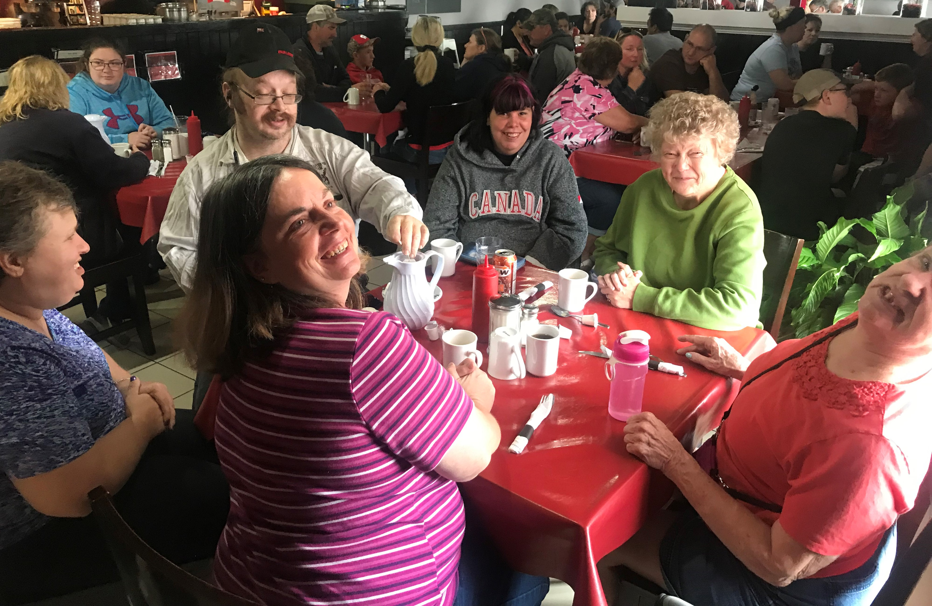
16,352
Service Hours

Coffee Group

18
Front-Line Staff

CHRISTMAS CHEER

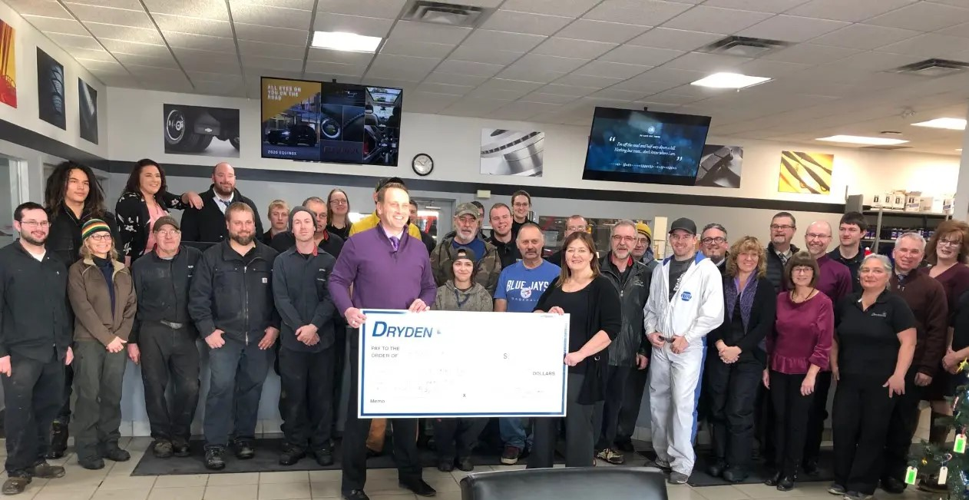

Once again, Dryden GM matched donations from individuals and not-for-profit organizations. An astounding $14,300 was collected during the Dryden “Double Down” campaign resulting in a $28,600 donation for Christmas Cheer.

Thank you, Nick Beyak and the staff at Dryden GM!

Dryden GM Staff make donation to Christmas Cheer

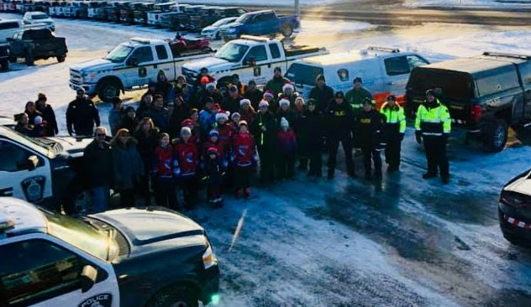

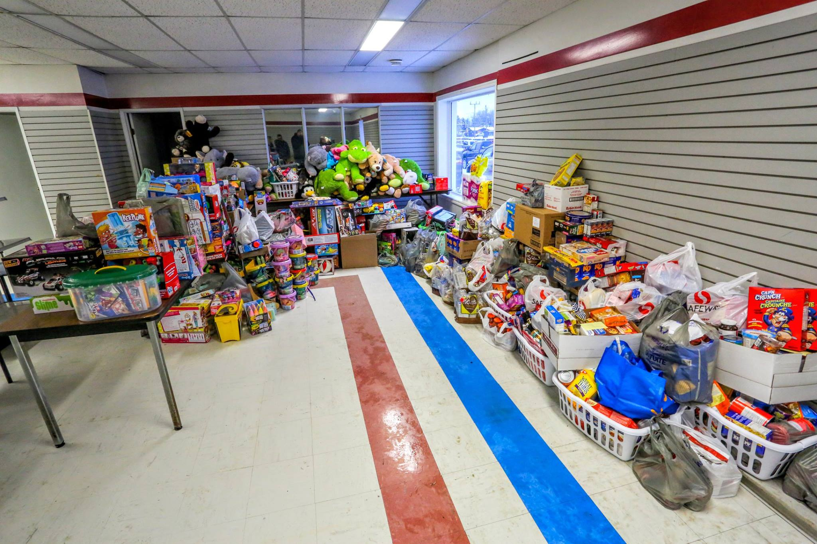
Another successful “Stuff the EMS”

360 Food Hampers Distributed
300 Babies, Children & Youth
Received Toys and Gifts

TOTAL FUNDRAISED FOR CHRISTMAS CHEER 2019: $45,965.00
HEALTHY FOOD BOX PROGRAM
Providing affordable access to healthy food choices.

- Approximately 650 Health Food Boxes Distributed

SUPERVISED ACCESS

The Supervised Access Program now provides services throughout the Kenora and Rainy River districts. The Community Support Centre assumed full responsibility for the Rainy River district beginning in April 2019.

264
Visits

227
Exchanges

SITE | VISITS | EXCHANGES
Dryden | 132 | 60
Fort Frances | 104 | 123
Kenora | 28 | 44

FINANCIALS
REVENUE
Fiscal 2019-2020
Ministry of Children, Community & Social Services 177,526
Ministry of Attorney General 307,608
Passport One 76,313
Fee for Service 262,432
DNFC, NEW 51,915
Christmas Cheer 45,965
Fundraising 10,600
Miscellaneous 925
Transfer from Deferred Revenue 30,000
Transfer to Deferred Revenue (5,526)
957,758
EXENSES
(in dollars / rounded)

BOARD OF DIRECTORS

Kim Douglas Chairperson
Carlynne Bell Vice-Chair
Shannon Wogenstahl Treasurer
Heather Corner Secretary

DRYDEN: 807-223-5995
FORT FRANCES: 807-274-0110
TOLL FREE: 1-844-523-8825

Community Support Centre - Northwest

