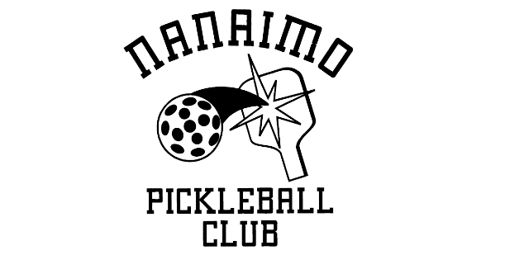

MEXICAN MADNESS FUN TOURNAMENT - AUGUST 27TH 2022

Hi Senors & Senoritas!

Mexican Madness registration is opening on July 1 at 10:00 am. Registration will be via Cognito Forms and you can access the registration form by clicking REGISTRATION. If the registration is full you can put your name on the waitlist by clicking WAITLIST.

Event Details:
WHEN: - Saturday, August 27th
WHERE: - Oliver Woods Community Center, 6000 Oliver Road, Nanaimo
COST: - $40 per person plus processing fee ($1.94). (Cost includes registration fee, lunch, snacks and prizes).

On August 27th:
9.00 - 9:30 AM - REGISTRATION
9:30 AM - INTRODUCTION AND PARTNER DRAW
10:00 AM - PLAY BEGINS

For those of you who have never played in this event here is how it works:

Players are put into sections whereby you will be teamed up with players of your skill level, (as far as possible!). Men & ladies names are randomly drawn from a sombrero, and this is how your partner will be decided. The game begins with you and your partner playing rally points to 25, after which you switch partners and play with your opponent another rally point game to 25. For the next game and any others after that, you play the first game to 25 rally points with your partner and then switch to play with your opponent in the second game. You carry your individual scores through till the end of the event when the top scorers will be identified.

The rooms and gyms are booked until 5:00 pm but play is expected to be finished by 4:00 pm.

N.B. If you would like to withdraw your entry, please let Dee/Ronnie know (deepitcher1@gmail.com) as soon as you can so we have the opportunity to offer your place to someone on the waitlist.

Gratias!

Senor Ron & Senorita Dee

