CAREEPILEPSY
ETHIOPIA
Registration number: 3380
ANNUAL REPORT

2015

Contents
1 An overview of CareEpilepsy 3
2 FROM THE DESK OF THE EXECUTIVE DIRECTOR 4
3 EPILEPSY 5
Epilepsy 6
4 Review of planned activities 2015 7
- General Objectives of our organisation 7
5 Highlights of the Year (Achievements and performance) 8
6 Media, Communications, and IT 9
7 Strategic Partnerships 10
13. Organisational Development 10
14. Programme Management 11
15. Financial Review 11
16. Significant Issues /Challenges 11
17. Outlook for Next Year (January 2016 – December 2016) 12
18 Our Finances 12
19. HOW YOU CAN HELP 12

An overview of CareEpilepsy

ABOUT US

CareEpilepsy Ethiopia is the first non-governmental, non-religious epilepsy focused charitable organisation in Ethiopia. We aim to improve the welfare of patients who have epilepsy, increased access to medical treatments, create a more positive awareness in society, dispel negative thoughts and perceptions of epilepsy, and finally enhance preventative measures against epilepsy at the national level.

OUR PEOPLE

We work for people with epilepsy, their families and anyone who is affected by epilepsy.

VISION

Our vision is to see people affected by epilepsy and associated disabilities receive the quality medical care they need, the public respect, fairness and understanding they deserve so that they can live a healthy productive life, free from discrimination and stigma, and have opportunity to realise their full potential.

MISSION

Our mission is to save the lives of people with epilepsy by facilitating epilepsy care through proper diagnostic tests and treatment options, strengthening the role of primary health care providers to enable the delivery of quality epilepsy services, proving wellbeing assistance and change the perceptions of epilepsy through education, leadership and advocacy.

VALUES

Our core ethics which we abide by are compassionate care, dignity, integrity, partnership, accountability, innovation and inclusiveness

BELIEFS

Our beliefs are derived from the principles outlined by the World Health Organisation "…the highest attainable standard of health as a fundamental right of every human being." We therefore believe:

- People with epilepsy have the human right to receive timely and equitable access to medical care and treatment.
- Local leaders and local institutions are the best agents of change.
- Shared knowledge, skills, and experience are our most valuable tools.
- Culture-tailored communication is the most effective way to relay our message.
- Partnership is the only way to lasting change.

FROM THE DESK OF THE EXECUTIVE DIRECTOR

At CareEpilepsy Ethiopia we consider 2015 to be a successful year for our organisation as a beginning stage as an NGO. We completed our registration of Careepilepsy Ethiopia in Ethiopia and become the only non-profit organisation working for people with epilepsy.

CareEpilepsy takes the position that it is high time to focus on epilepsy and to care for this vulnerable community in Ethiopia. We work to empower people affected by epilepsy to make their own choices in shaping their lives and change public perceptions of epilepsy to end epilepsy stigma through education and advocacy. Our service includes people with epilepsy, family and friends, and anyone whose life is affected by epilepsy. Our work in Ethiopia encompasses the full spectrum of issues: diagnosis and treatment, awareness and education, wellbeing and advocacy. We provided information on aspects of epilepsy, for people living with epilepsy or involved in the care of a person who is living with epilepsy or for anyone who is interested in epilepsy. improving human capacity and leadership, continuing to raise awareness about epilepsy.

During our first year as a registered charity we have made good progress on our overall vision for CareEpilepsy. We worked tirelessly so that people with epilepsy feel accepted, valued, listened to, respected, cared for through proper diagnosis and treatment.

We look forward to working with our new partners, introduced to encourage joint working to improve the health and wellbeing of people living with epilepsy both in England and Ethiopia.

Focus on Epilepsy

Enat Yewnetu
CEO/Founder

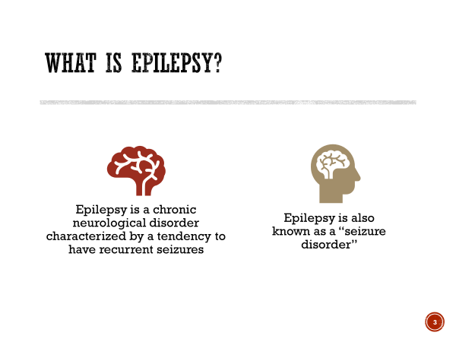
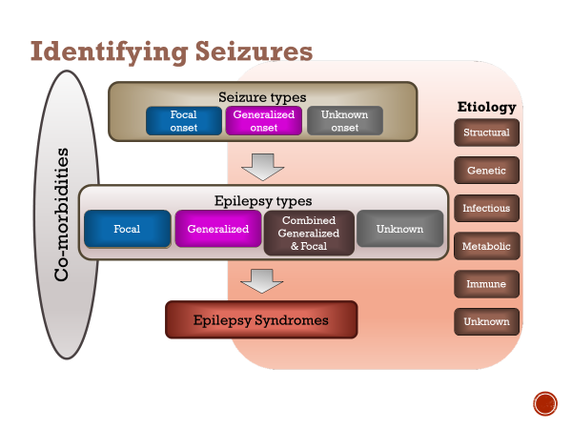
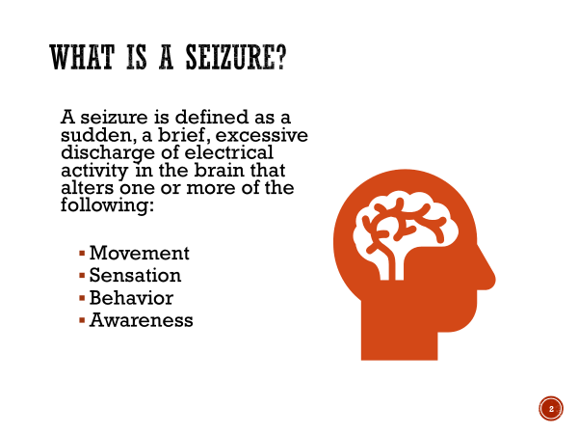
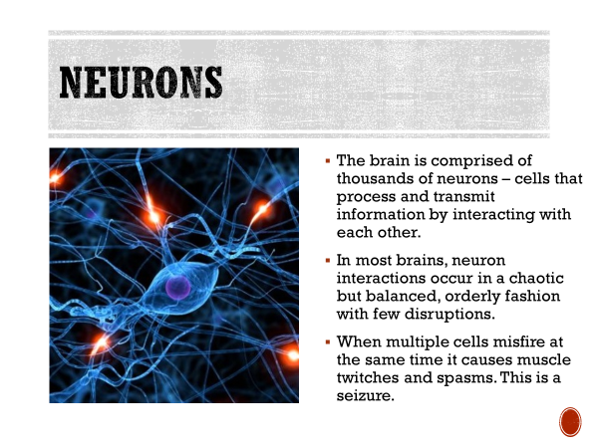
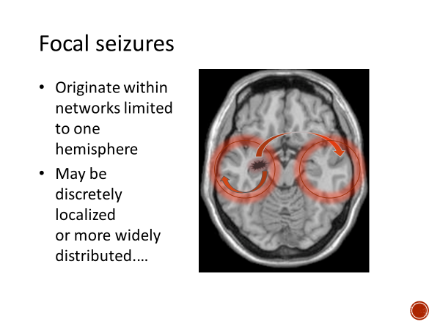
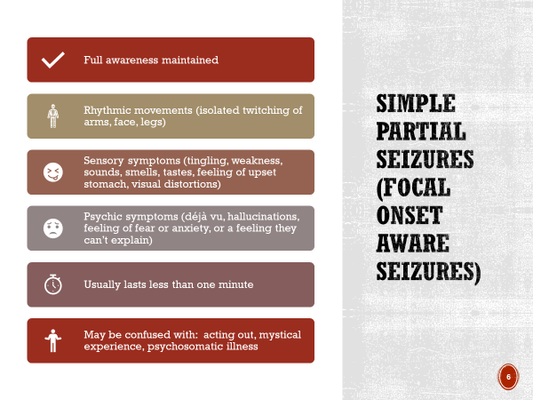
EPILEPSY

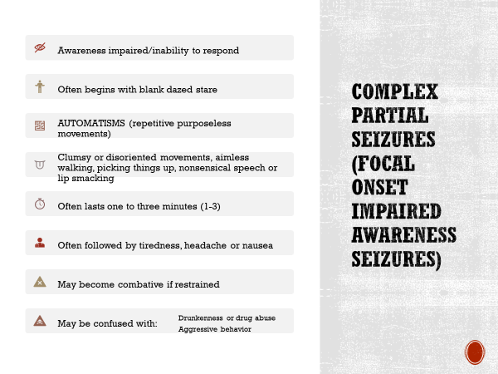
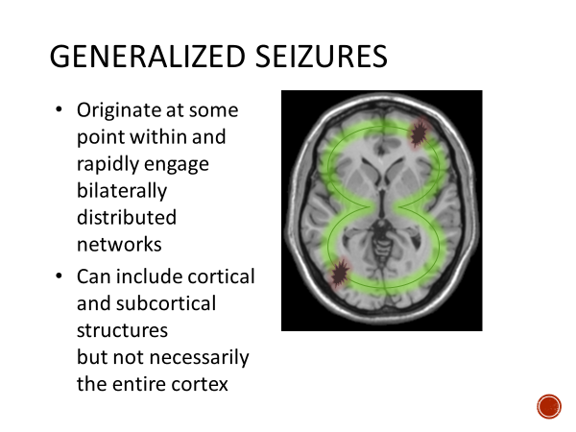
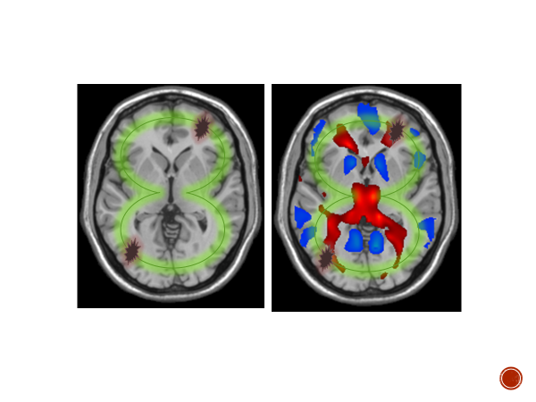
Epilepsy

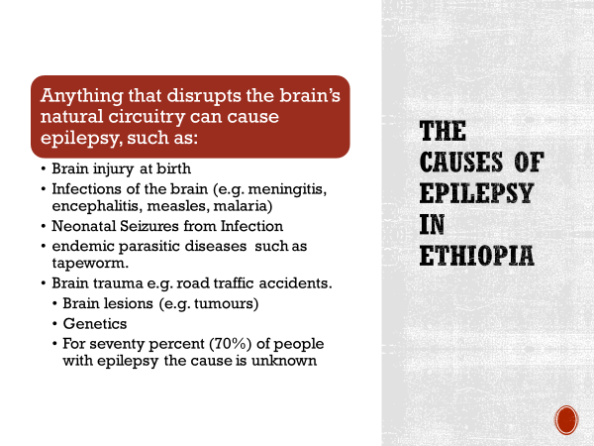
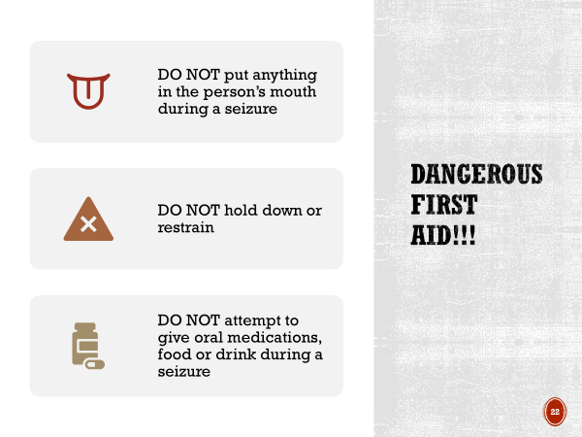
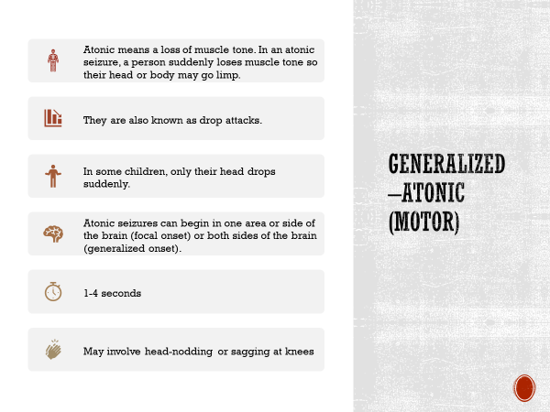

Review of planned activities 2015

General Objectives of our organisation

The overall objectives of the project is to close the gap between knowledge and action in medical care and treatment, strengthen the role of health providers to enable delivery of effective, efficient and quality epilepsy services, build clinical care providers’ capacity to treat epilepsy, enhance the public awareness on epilepsy and associated disabilitie to increase social acceptability, and engage in partnership and advocacy work to address the medical, social and environmental factors contributing to epilepsy.

Our Strategic Objectives for 2015 were to

Our plan for 2015 were to take the first steps we needed to take were

No. | Activities Planned for 2015 | Update on  initiatives and progress
 | Finanlise the registration of CareEpilepsy Ethiopia. | Completed
 | Launch CareEpilepsy Ethiopia. | Completed
 | The move of the country director/chief executive director from the UK to Ethiopia | In-progress
 | Recruit and establish good relationship with our beneficiary group which has good will and respect on both sides. | On-going
 | To identify a group of people who share our passion, and the vision to match in Ethiopia. | In-progress
 | Reconfirm our goals and strategies and be clear about our advocacy and implementation plan. | Completed
 | Build up our professional capacity. | In-progress
 | Identify and communicate with potential partners. | On-going
 | Establish contact with the media to raise awareness of epilepsy. | On-going
 | Promote epilepsy and the needs of people with epilepsy through advocacy and partnership with key partners and stakeholders. | On-going
 | Increase financial capability through donors, sponsors and other fundraising activities. | On-going
 | Establishing CareEpilepsy office and organisational governance in Ethiopia. (delayed because of not receiving a charity status in Ethiopia). | In-process

Highlights of the Year (Achievements and performance)

CareEpilepsy registration with the Ethiopian authority

We have finally achieved a charity status in Ethiopia on 3rd February 2015.

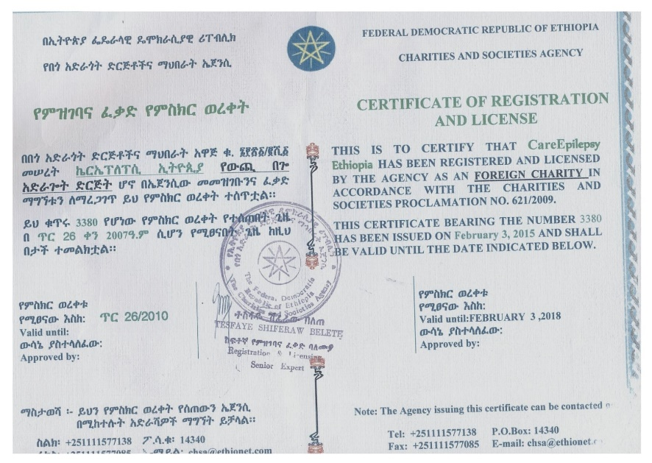

The move of the founder and country director of careepilepsy ethiopia

We faced a delay in the permanent move of Founder and CEO to Ethiopia [proposed date was September 2015] due to funding and delayed in receiving a charity status in Ethiopia. The proposed date is now moved to April 2016.

CareEpilepsy Ethiopia Launch

CareEpilepsy Ethiopia was officially launched in Addis Ababa on 12th October 2015 at Jupiter International Hotel. The launch of CEE brought together health professionals, governmental and non-governmental interests, the diaspora and members of civil society, all committed to tackling this often-neglected illness in Africa. The launch of this ground-breaking initiative introduced a high-profile campaign through which CareEpilepsy Ethiopia, in partnership with other stakeholders, plans to raise the profile of this condition, facilitate improvement of epilepsy care and treatment, and the wellbeing of people living with epilepsy.
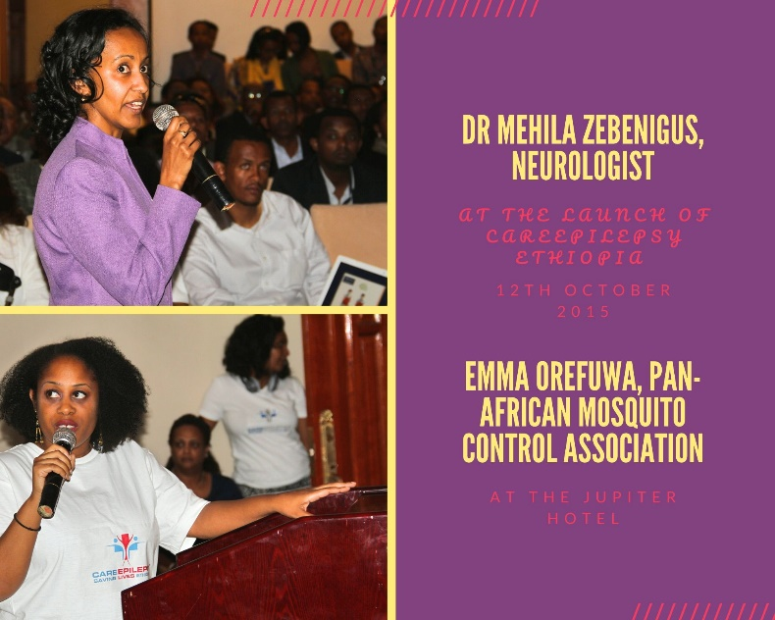
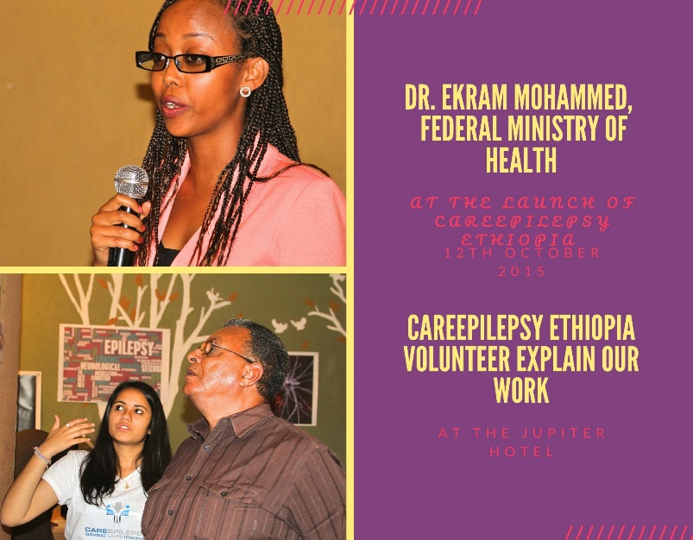

- The CEO with the Board of Directors is putting together a detailed work plan albeit and an epilepsy specialist consultants from the UK and Ethiopia are engaged in this programme planning.

- Developing and creating a web-portal for communicating the activities of the institute, and promoting it in the international community.

- Developing the capacity of CareEpilepsy through partnership support (nationally and internationally, but Bethel, Zewditu and Black lion hospitals especially) and establishing a contact office (allocating office, office supplies, internet and printing facilities).

- We have been advocating and communicating the CareEpilepsy Ethiopia' activity to reach a larger audience for partnership, creating community awareness, liaising with similar institutes, hospitals, government offices to have an intra-institute relationship for developing an excellent foundation, based on the need of the community.

- We set up an office at Addis Ababa.

Media, Communications, and IT

We had the chance to utulise the media during the launch of CareEpilepsy Ethopia. We raised awareness and understanding of epilepsy to eradicate stigma and discrimination, and promoted the inclusion of people with epilepsy in education, the workplace, and the community.

Strategic Partnerships
- In process of networking with local and international NGOs

- Continued discussion with AFFORD African Foundation for Development for partnership and funding, further information at http://www.afford-uk.org/

- We have not been able to secure collaboration with the Southampton Hospital Epilepsy service team, who is working in collaboration with colleagues at Jimma and Gondar University Hospitals for experience sharing in conjunction with the Tropical Health and Education Trust (UK). This will be revised next year.

- No programme has been planned in collaboration with the UK-Uganda Health Alliance Butabika link - East London NHS Foundation Trust. Continued discussion underway for future collaboration to develop these common interests into a project to promote awareness and reduce the stigma attached to Epilepsy common to Uganda and Ethiopia.

- Discussion underway with Zewditu General Hospital (Addis Ababa) neurology team treatment of epilepsy. Raising awareness and improving education. To provide high-quality care, the health professionals who care for people with epilepsy need to know more about epilepsy, its diagnosis, and its treatment and management, as well as its comorbidities and psychological issues.

- Black Lion (Tikur Anbessa) Hospital, general hospital also leading epilepsy service provider. Given the current gaps in epilepsy knowledge, care, and education, CareEpilepsy believes there is an urgent need to take action to increase the power of data, improve care and services for people with epilepsy and their families. With this goal in mind, CareEpilepsy wants to examine the available evidence on surveillance, epidemiology, prevention, and education programs and then develop recommendations and priorities for further research to improve these fields and the programs relevant to epilepsy.

- Seeking collaboration for training with Bethel Teaching General Hospital, Saint Yared General Hospital, and GAMBY Teaching General Hospital – Bahirdar is a private hospital which provides general and specialized medical services. Discussion underway.

8. Organisational Development

- CareEpilepsy regularly consults with people with lived experience, both nationally and internationally, to help develop long-term strategy, as well as in the development of services, projects and campaigns on a day-to-day basis.

- CareEpilepsy Ethiopia functions with Board of Directors and Advisory Board in the UK (Advisory Board in Ethiopia as well). The Board plays an active role in forming all elements of CareEpilepsy’s strategy, and helped develop work programmes that are now in place.

- We have put in place interventions that aim to help CareEpilepsy Ethiopia to grow and change in performance improvement. For CareEpilepsy, organisational development mean:
  - More: extending existing service, growing staff/volunteer base
  - Better: developing people, learning from mistakes, updating equipment
  - The same: if funding or resources are scarce
  - Different: diversifying or specializing

9. Programme Management
- The chief executive director provided the overall direction in which CareEpilepsy Ethiopia moves, managing the day-to-day activities, managing the financial management of projects and accounts; implementing and controlling the accounting management; keeping track of spending against CareEpilepsy Ethiopia’s annual budget and organise the various activities.

- We have a part-time accountant in post.

10. Financial Review

- Still in the process of identifying international donors to build financial capacity and publicity.

- Still in the process of identifying financial sustainability projects which will follow receiving charity status in Ethiopia.

- No fundraising activity was held.

- External auditor report was not required as the income for the Charity is less than 10,000 Birr.

- We work on the principal of 30/70, where only 30% of our project income can be used to fund core organisational costs or capacity building.

11. Significant Issues /Challenges
The followings are an overview of significant current issues facing CareEpilepsy.
- Lack of funds.
- Lack of a named person with real experience or skill in donors/grant pursuits/searches causing loss of opportunity.
- Difficulty in finding financial resources to cover essential administration cost. Donors often desire to see results only in the defined project activities and as such they forbid or limit the use of funds for organisational overheads, administration or development.
- Funders prefer a more developed NGOs, which is not currently applicable to CareEpilepsy Ethiopia.
- Lack of epilepsy specific grants for epilepsy for Africa.

12. Outlook for Next Year (January 2016 – December 2016)
Proposed Projects for the year 2016 are as follows.

Activity | update on  initiatives and progress
Establish CareEpilepsy office and organisational governance in Ethiopia. (delayed because of not receiving a charity status in Ethiopia). | In process
Continue to work on programme activities and develop strategies for implementation. | Ongoing
Continue to search for donors and partners . Consider ways to increase financial capability through membership fees, alternative self-financing means and business ventures, and cooperate sponsorship. | Ongoing
Build human resources capacity for CareEpilepsy Ethiopia. | Ongoing
Develop both national and international volunteering schemes and internship projects. | Ongoing
Develop clinical training manual for epilepsy. (delayed because of lack of time from the contributors). | In process
Fundraising event (minimum of 5) | Completed
Focus on building CareEpilepsy’s network with government office, local and international NGOs | Ongoing

13. Our Finances
- We opened a bank account at Commercial Bank of Ethiopia and Awash International Bank.

- As CareEpilepsy’s income was below the threshold of 10,000 Birr we were not required to present and external audit report.

14. HOW YOU CAN HELP

- Become a member
Membership of CareEpilepsy is open to any individual with epilepsy, or organisation and individuals working or that has an interest in the field of epilepsy.

- Volunteer your time
CareEpilepsy provides both long-term and short-term volunteering opportunity. We take volunteers from all walks of life, doctors, nurses, teachers, musicians, artists, counsellors, craftsmen etc. For international volunteers, there are clear benefits that overseas volunteering brings to Africa countries, however, the benefit to the volunteer is equally priceless.

- Become a corporate partner
CareEpilepsy’s corporate partnership is a mutually beneficial arrangement where we gain funding, support and increased visibility; and the corporate gain good PR and the chance to “make a difference.”

- Donate
Our programmes and effort to save lives and change perception of epilepsy cannot take effect unless we have financial support. Any amount you donate will be greatly appreciated. Our account details are as follows:

