**MATTER AND RADIATION**

**Radiation**

When an object is heated up to considerable temperature, certain waves are emitted, This is normally called as “**Thermal Radiation”.**

Radiation is the emission of waves. When we consider, a filament of a bulb, when it is lit, thermal radiation is there.

All waves are having a **frequency** and a **wave length**. When these waves are arranged in increasing/ decreasing order of frequency then, it is called ***Electro Magnetic Spectrum***.

In thermal radiation, wave length changes from 1 $μm$ to 1mm Normally the frequency is arranged in ascending order. In other words, wave length is arranged in descending order.

***Electro Magnetic Waves*** 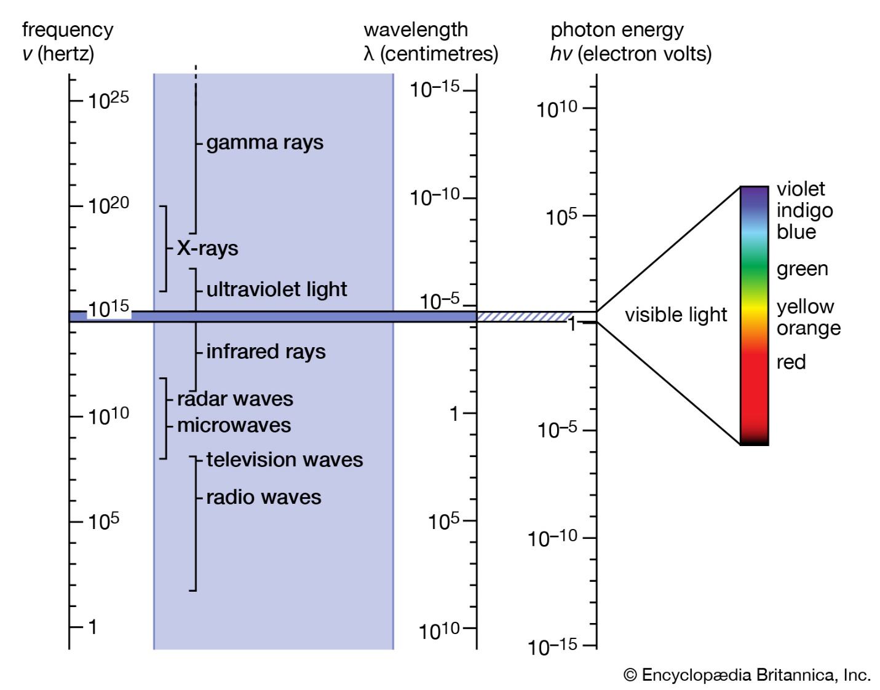

Speed of ***Electro Magnetic***  wave is given by the equation

C = $\frac{1}{\sqrt{{μ_{0}ε}_{0}}} C=\frac{1}{{μ_{0}ε}_{0}}$

V = $\frac{1}{\sqrt{εμ}}$

Find the velocity of EM waves using the equation

V = $\frac{1}{\sqrt{εμ}}$

= $\frac{1}{8.85 x{10}^{-12} x }$

When an object is heated, there is a rate of emission of thermal radiation. It depends on the surface area of the object, temperature of the object and nature of the surface of the object.

To demonstrate the above conditions, a Lesley’s cube is used. It is a hollow cubical container which we can introduce Hot H2O into that, all four vertical surface are having different colors.

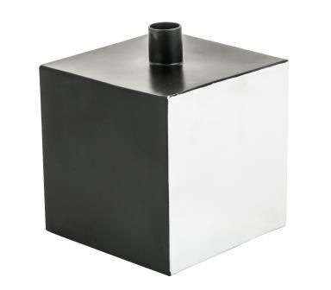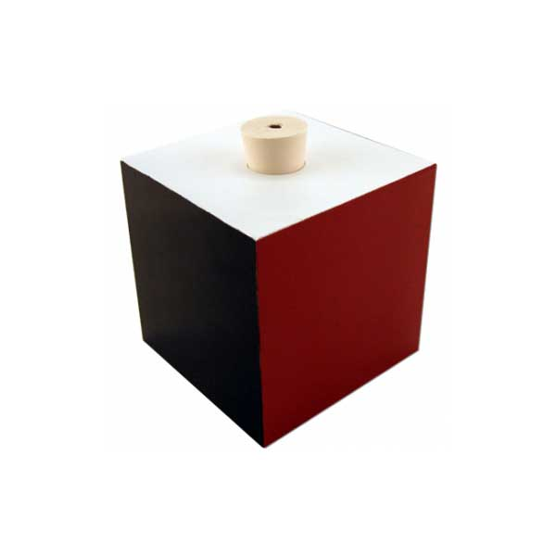



One surface must be a well polished surface. To find the amount of radiation, bolometer or any other device which can generate certain emf can be placed. Keep the meter at the same distance from each surface and check the amount of radiation. Then, according to this experiment, the lees rate of radiation is absorbed for the polished surface the max was observed for the black surface.

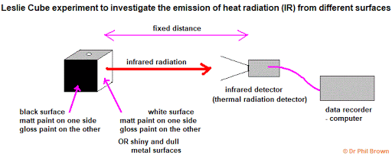

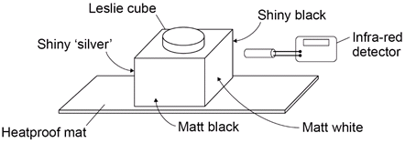

The Lesley’s Cube is now filled with H2O having different temperature. and we only one surface and place the were at a particular distance. But, the device must be **kept at a same consultant distance** from the surface. Temperature increases $↑$, radiation increases . According to the above, the radiation depends on the temperature.

Take three Lesley’s Cubes introduce H2O at the same temperature. Select one particular surface and place the Bolometer at the same distance from the three cubes. Get the reading and reduce the number of Lesley’s Cubes and obtain the reading. It reduces, that were when area $↓$ radiation $↓$. And when Area $↑$, radiation $↑$.

**Black body radiation**

All black surfaces can absorb more radiation.

When all visible range waves are absorbed by the object, it is seen as black. If an object is seen as a particular colour, all other colours are absorbed except that color,

**If any object can absorb all the radiation, then it is called a Black body.**

To make a simple black body, take a normal tin and make a small hole on the lid. Through the hole, the waves travel into the tin and they reflect several times without coming out of the hole. Therefore maximum absorption is available. Then hole is **considered as a black body.**

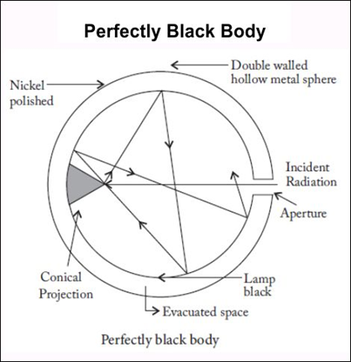We can make a better device.

Take a hollow spherical object and make a small hole on the surface. On the other end of the diameter corresponding to the hole tiny projecting device which is conical is built. On that most of the waves are reflected. The whole waves are absorbed by the hole and the hole acts as a perfect black body. The inside of the hollow spherical cavity is normally painted in black using soot.

When an object is heated more than 2000K, the rate of emission of radiation does not depend on the area or the nature of the surface, it depends only on the temperature.

* When a black body is heated, it emits radiation. Actually energy is emitted.

About this, several experiments were done by the scientist **Stephan**

***The total energy emitted in unit time through unit area of a black body is directly proportional to the 4th power of the absolute (thermodynamic) temperature.***

E T4

is the proportionality constant and it is called **Stephan constant** and the above low is called **Stephan’s law of Black body radiation.**

Units of

E = σT4

**= = =**

OR

**=**

The value of $σ$

$σ$**= 5.7 x ${10}^{-8}{Wm}^{-2}K^{-4}$**

Q. Temperature of an object is 1527oC . If = 5.7 x ${10}^{-8}{Wm}^{-2}K^{-4}$ find the total energy emitted in unit area of surface of object in one second find the total energy emitted in unit area for 5 min

T = 15270C + 273 = 1800K

E = OT4

E = 5.7 x 10-8 x 18004

E = 5.98 x 105 Js-1m-2

for 5 min = 1.8 x 108 Jm-2

==================

When we consider the energy through an area of A, then the energy radiated through unit time

E = T 4A

Energy per unit time = power

Q. A cube side of 10cm is healed up to 15270C find the power radiation of from the cube. Find the energy radiation in 2min. consider all 6 sides

P = T4

= (10 x 10) x 10-4 x 5.7 x 10-8 x 18064 x 6

= 5.98 x 10-3 W x 6 = 35880W

E = 5.98 x 103 x 60 x 2 x 6

717600 J x 6

= 4305600J

=========

**Emissivity and Absorptivity of a surface**

The ratio between the total energy emitted by an object in unit time through unit area at a certain temperature. and the total energy emitted by a black body in unit time through unit area which is at the same temperature is called total emissivity.

Denoted by e.

**No units nor dimensions**

When it is a black body, emissivity is 1.

**Absorptivity**

The ratio between the total energy absorbed by unit area of an object in unit time and the total energy fallen onto the same area in unit time is called as absorptivity

Denoted by α

(Here we consider the word total for all electro magnetic waves)

We can prove that total Emissivity is equal to total absorptivity

If the total energy emanated by a non black body in unit time through unit area € is given by the equation.

When an object having a temperature of QK is kept in an enclose where temperature is to K. Then the rate at which the unit area of surface of black body is receiving from encloses is $ϑ{To}^{4}$

In a case of a non black body radiation in an encloser, then the net energy is given by

Enet = eσ ( $T^{4}$- ${To}^{4}$)

Total emissivity

$0≤$ e $≤$ 1

Q. A black body is heated up to 3270C and placed in a encloses, whose temperature is 1270C. find the net energy emitted / radiated in unit time and unit area.

Enet = ( T4 - To4)

= 5.7 x 10-8 (6004 – 4004)

= 5.7 x 10-8 (1.296 x 1011 – 2.56 x 1010)

= 5.7 x 10-8 x 10.4 x 1010

= 5928 Js-1m-2

=================

If object is non black body, and e is 0.4, then find the power through unit area.

Enet  = e( T4 - To4)

= 5928 x 0.4

= 2371.2 Js-1m-2

Emissivity depends on the **nature of the surface of the object** Normally energy is radiated from the sun. We normally get energy from the sun. Therefor, energy fallen on the surface of the earth is important. We can consider about the energy fallen on unit area of earth in unit time.

When you are staying near by a fire, mainly you get the heat energy through radiation. Convection is concerned that energy is transferred mainly upwards.

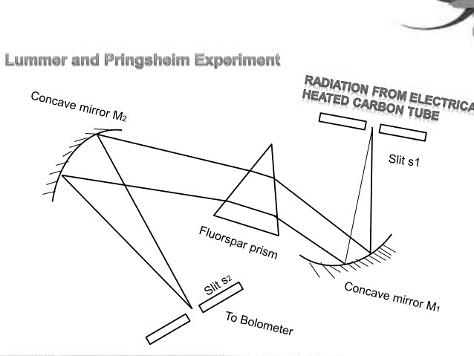**Lummer and Pringsheim** have shown that the radiation of bodies other than black bodies obeys the displacement law, with the sole difference that the constant which forms part of the formula has a different value.

**Energy distributed is a spectrum of a black body.**

Under this, we mainly consider the intensity distribution of black body radiation.

The intensity is energy radiates per unit time and per unit area. When we consider the intensity distribution in a spectrum of a black body the graph **intensity verses wave length** is given below.

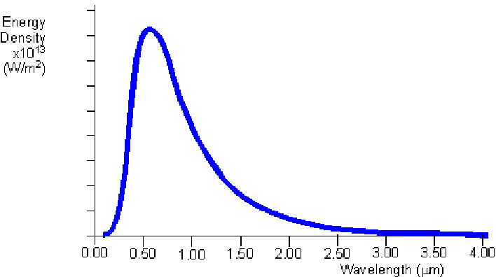

The intensity increases with $λ$ upto certain value and then decreases. The wave length which has the max intensity is denoted by m.

That intensity can be considered as λm . Sometimes If the axes is marked as energy per unit area and per unit time, then it can be denoted as E(m).

When we observe the gradient of the curve, the rate of change of the intensity with the wave length is greater for the waves which are having $wave length$ less than m. smaller for the waves which are having $wave length$ greater than m .

The area under the curve is the total (net) energy emitted within the considered $λ$.

Now we’ll consider objects of different temperature. The Intensity distribution with the wave length graph is given below.

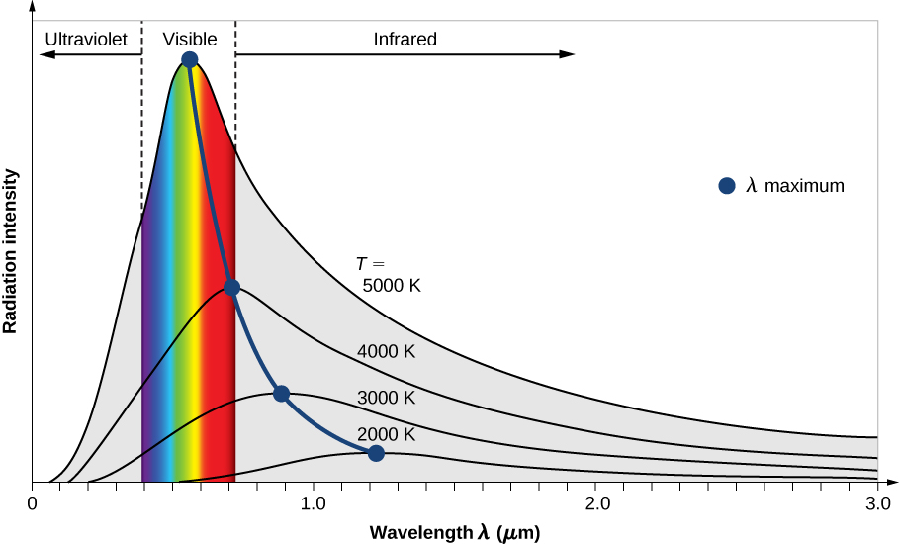

Temperature increases maximum Intensity(m) increases.

Temperature decreases maximum Intensity(m) decreases.

When we consider the $λ$ of corresponding to max intensity with increasing temperature of object, the $λ$ max decreases when we connect the peck value of each curve, the particular curve is called locus of max wavelength corresponding to the max intensity.

When we want to find the black body radiation in an accurate manual, Normally a prism and 3 concave mirror is used with a bolometer.

Always energy radiation at the maximum wave length is considered, for that curve the maximum wave length is inversely proportional to the thermodynamic temperature.

max

max =

max T = construct

max T = C

The value of C is 2.898 x 10-3 mK

Q. Black body radiation with max intensity at 1527oC, find the max wavelength corresponding to max intensity.

$λ$ max P = 2.898 x 10-3

max =

= 1.61 x 10-6

==============

The above experiment with max intensity was performed by wine. According to the graph, the $λ$ m value displaced, related to that $λ$ m value and temperature, he proved.

mT = constant

**This is called weans displacement law**

The product of the absolute temperature(T)and the $wave length$ which produces the maximum intensity (m ) for a black body at the same absolute temperature (T) is a constant.

**mT = constant**

When an object is heated, temperature increases then radiation occurs. At the lowest temperature the object emits infra red (IR) rays. They cannot be seen with naked eye. Then the temperature increases, it becomes red and then yellow and finally white.

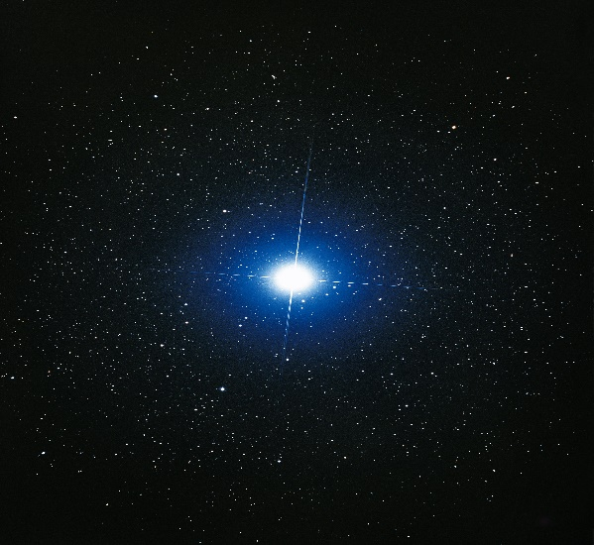To observe, a lit tungsten filament bulb can be used. Connect it to a lowest voltage and increase the voltage gradually. Then we see the illustrated colors when temperature $increases$.

In common the thermal radiation falls in the regions of IR, visible, and finally UV region.

For the radiation of the sun, max $λ$ is observed as 500nm. It falls in the region of visible light (in green). We assume the temperature of sun as 6000K. When we consider the stars, Sirius & Vega those have higher temperatures than the sun. $λ$ max falls in the region of blue.

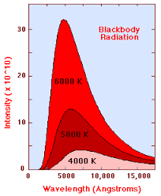*As the temperature of the blackbody increases, the peak wavelength decreases (Wien's Law). The intensity (or flux) at all wavelengths increases as the temperature of the blackbody increases.*

***The total energy being radiated (the area under the curve) increases rapidly as the temperature increases (Stefan–Boltzmann Law).***

**Rayleigh – Jeans theory and Weins theory**

**Classical Physics and Modern Physics**

When we consider physics according to Newtons laws, (they are sometimes called Newtonian Physics) & electromagnetic theory. This kind of theory can’t explain certain theory & laws in radiation. So

there is a failure in explaining certain radiation theory using classical physics.

Rayleigh and Jeans explained a New theory.

But initially they used classical physics for certain end. Acc. To classical Physics

We can prove

C = 2 $π$ ck ; Where C = Speed of light & K = Baltzmann constant T = temperature of the black body

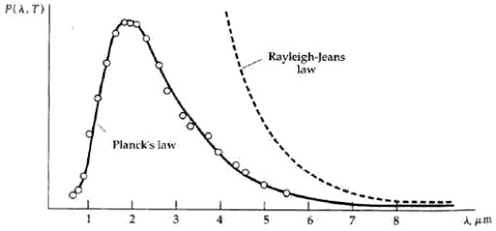

Lord Rayleigh used the classical theories of electromagnetism and thermodynamics to show that the blackbody spectral distribution should be different at longer wavelengths, but it deviates badly at short wavelengths. This problem for small wavelengths became known as the ultraviolet catastrophe and was one of the outstanding exceptions that classical physics could not explain.

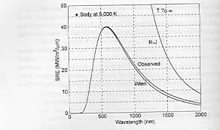When we consider Intensity as $P(λ T)$.

Later weins did experiments and formulated another formula according to be another graph.

A scientist called ***Plank*** did experiments about the energy radiated from black bodies. According to him, the energy is due to the particles which oscillate in a particular matter Those particles are called oscillators They contain energy and that amount of energy can change continuously. According to them, the oscillators cannot have any fixed values. He used a certain equation.

E $α$ f

E = hf

Proportionality constant h is called Plank’s constant

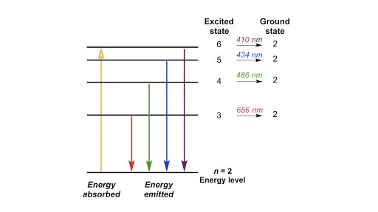Value of h = 6.634 x 10-34 Js

Since energy is Quantanized

The **quantization** of **energy** refers to the fact that at subatomic levels, **energy** is best thought of as occuring in discreet "packets" called photons. Each photon contains a unique amount of discreet **energy**.

E = nhf

Where

n = 0,1,2,3……….

n is called Quantum number

Always energy is a multiple of the quantum number.

When these is no energy, it is n=0 situation.

***When energy is concerned, it is quantized.***

Normally the energy values are hf,2hf, 3hf and so on.

There are discrete values. These energy can be considered in a diagram and it has quantized energy levels.

When any particle gets energy, it reaches to any higher energy levels. when certain particle is at higher energy level, it is unstable. Then particle comes back to lowest energy level by emitting waves that is called radiation.

Actually the above levels are called **quantized energy levels.**

When we consider any element like Na, when heated, last orbital electron jumps to higher energy level. Since electron is unstable at higher energy levels it comes back to lower energy level and energy is emitted as Radiation, that radiation is normally called Emission spectrum in chemistry and the wave length is equal to wave length of yellow light. $∴$ it can be observed as yellow.

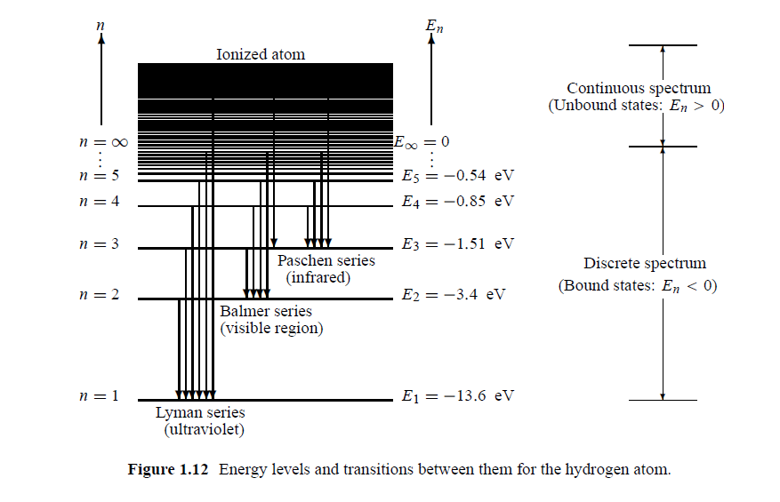

**Different objects have different photons.**

*Eg. The sun has sun’s photons. X- Ray has X- Ray’s photons.*

Q. spring constant of a helical spring is 25Nm-1. It is connected to a ceiling vertically and at the other end a mass of 2Kg is connected, the object oscillates when it is pulled down by 40cm from it’s equalibrium position and released.

i) find the total energy of oscillator and it’s frequency according to classical physics.

ii) find the quantum number corresponding to its energy, assuming that energy is quantized

ii)find the energy corresponding to change of 1 quantum

1. E = $\frac{1}{2}$ K $x^{2}$

= $\frac{1}{2}$ x 25 x $\frac{{40}^{2}}{{100}^{2}}$ = 2J

T = 2 $π$ $\sqrt{\frac{m}{k}}$ f = $\frac{1}{2π}\sqrt{\frac{k}{,m}}$

f = $\frac{1}{2π}\sqrt{\frac{25}{,2}}$ = 0.56Hz

1. E = nhf

n = $\frac{2}{6.634 x {10}^{-34 }x 0.56}$

= 5.4 x

= 6 x

1. E1 = nhf

E2 = (n-1)hf

E2-E1 = hf

=6.634 x ${10}^{-34}$ x 0.56

= 3.72 x ${10}^{-34}$ J

============

Q. find the energy of a quantum corresponding of yellow light

Frequency = 6 x ${10}^{14}$ Hz

E = nhf

= 1 x 6.634 x ${10}^{-34}$ x 6 x ${10}^{19}$

= 3.98 x ${10}^{-19}$ J

============

Q. Assume body temp of human is 35oC and the body is a black body. Then find the wavelength corresponding to the max Intensity of radiation.

mT = c

m x 308 = 2.898 x

m = 9.4 x ${10}^{-6}$ m

============

Q. A certain experiment was performed using a spectrometer with sunlight. The ware length of max

intensity radiation is 481.7m. find the temp of surface of the sun

mT = c

T = $\frac{2.898 x {10}^{-3}}{481.7 x {10}^{-4}}$

= 6016.2K

=========

Q. the rate of energy radiation by the radiation of sun is 3.74 x ${10}^{26}$ w. Mean $λ$ of the sun radiation is 500nm. Find the rate of emission of photon

Normally acc to Planck theory, energy is considered as packets.

One packet is considered as a photon.

E = hf for 1 photon

E = Nhf

N = Number of Photons emitted in one second through unit area

Then E becomes energy emitted in one second through unit area which is intensity (I)

. I = Nhf

I = $\frac{Nhc}{λ}$ c = f $λ$

N = $\frac{λI}{hc}$ f = $\frac{c}{λ}$

======

N = $\frac{500x{10}^{-9}x 3.47 x {10}^{26}}{6.634 x {10}^{-34}x 3 x {10}^{8}}$

= 8.7 x ${10}^{44}$

=========

Q. FM Radio wave transmitter has a power of 100kW and the frequency transmitted is 94 MHz find the rate of emission of photons.

N = $\frac{I}{hf}$

= $\frac{100 x {10}^{3}}{6.63 x {10}^{-34 }x 94 x {10}^{6}}$

= 1.6 x ${10}^{24}$

========

Q. according to an experiment done on a spectrometer, $λ$ for a max intensity of a star emits red light is 700nm. And that for a star emits blue light is 500nm find the temperature of each star.

max T = C

T = $\frac{2.989 x {10}^{-3}}{500 x{19}^{-9}}$

= 5978K

=======

max Tred = C

Tred =

= 4140K

=======

With the publication of "A Dynamical Theory of the **Electromagnetic** Field" in 1865, **Maxwell** demonstrated that electric and magnetic fields travel through space as **waves** moving at the speed of light. He proposed that light is an undulation in the same medium that is the cause of electric and magnetic phenomena.

**Photoelectric effect**

Consider a negatively changed metal plate kept on the disc of an electroscope. Normally **Zinc plate** can be used. Due to negative changes on the disc and the gold leaf, there is a deflection on the gold leaf.

(Figure a )

Now, certain light (UV light) is focused to the zinc plate. (zinc plate is illuminated/ shone with UV light )

Then we can see the deflection of the gold leaf decreases. Since the deflection is small since now less number of negative changes are on the gold leaf and the Zn plate. Certain electrons are emitted (negative changes are emitted. ) (Figure b )

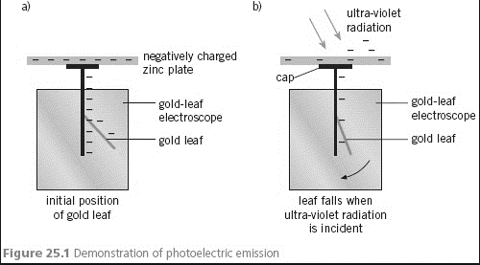

This phenomenon is called **Photoelectric Effect**. The electrons which emitted are called **photoelectrons.** Actually, photo photoelectrons are ejected from a metal surface when Electro Magnetic Radiation of sufficiently high frequency falls on the metal surface. The **minimum frequency** of light which causes electrons to be emitted from a metal surface is defined as **Threshold Frequency for that metal and the light.**

**If no electrons are ejected**, this means that the **frequency** of the light is less than the **threshold frequency**.

when monochromatic light having a frequency which is greater than the **Threshold Frequency** fallen on a metal plate, photoelectrons are emitted.

**Threshold Frequency is denoted by f0 .**

Threshold wave length is the maximum wavelength of incident radiation necessary to eject photoelectrons from a given surface in the photo electric effect.

**Threshold wave length** **is denoted by λ0 .**

**Photocell**

A photocell is just like a **Cathode Ray Tube** (CRT). It consists of two electrodes which are connected to negative polarity is **the cathode** , which is connected to positive polarity is **the anode**. To measure the current micro ammeter ($μ$ A ) or ammeter (A) is connected i**n series** and To measure the potential difference voltmeter ( V ) is connected in parallel. To vary the PD **rheostat** is connected as shown.

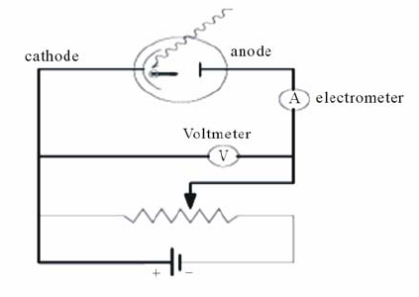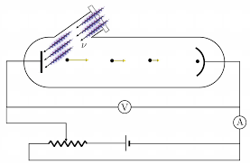

* Let monochromatic light fall on the cathode.
* Then photo electrons are emitted and they are attracted to the anode. Then there is a flow of current observed in the $μ$ A/ A
* If we place this circuit in a dark room, then there is no deflection in $μ$ A. Actually it is zero. If monochromatic light is introduced on to the cathode, Then we can see a deflection in the $μ$ A .

It happens since photo electrons reach to anode from the cathode as a flow therefore the

electrical circuit is completed. Actually from this experiment we can come to a conclusion that

**photoelectrons** are emitted when lights falls on to a metal surface.

(early experiment was done aides high voltage) photo e s connect the circuit.

Now emf (battery) is removed and connect the two ends with a metal conductor (wire) and repeat the practical. Even now we can observe the deflection in $μ$ A. It gives the idea that the circuit is connected due to the photo electrons emitted by the cathode.

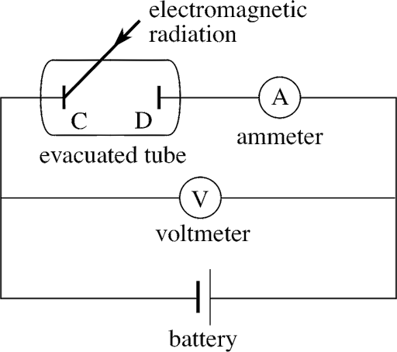**This experiment concludes that if any metal surface is illuminated with light, photo electrons are emitted.**

Now we reverse the emf. It means the electrode which was shone with **UV** light is connected to positive terminal of the battery and the other electrode is connected to negative terminal of the battery.

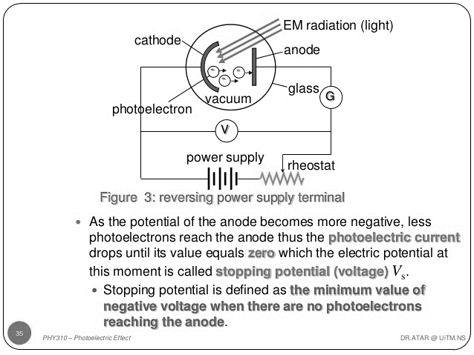

X

When **x** is illuminated, photo electrons are emitted from **X**. These photo electrons are **having different speeds.** Therefore they are having different kinetic energy. Since Y is negative photo electrons having less kinetic energy are repelled by Y. But photo electrons having greater kinetic energy reach Y . therefore $μ$ A has a deflection. In other words a current flows through the circuit.

Now we increase potential difference using rheostat. Then the photo electrons having more kinetic energies are also repelled by Y. Therefore only photo electrons having very large kinetic energies reach y. If potential difference is increased further there is a particular situation that the photo electrons which have the largest kinetic energy are totally repelled & stopped all photo electrons reach Y. Therefore no flow of photo electrons. The **minimum potential** at which stops photo electrons reaching Y is called stop potential of the particular metal (cathode) (V0).At this situation no current flows through the circuit.

If the velocity of an electron which is waving at the stop potential is vm, then their Kinetic energy is $\frac{1}{2}$ M ${V^{2}}_{m}$. M is the total mass of all photo electrons at the stopping potential. This KE is equal to the total Electrical energy at the electrodes. It is the work done by n number of electrons at the stopping potential situation.

Work done W = QV : Q = ne & M = nm : m is the mass of an electron.

$\frac{1}{2}$ M ${V^{2}}_{m}$ = neVo M = nm

$\frac{1}{2}$ m~~n~~ = ~~n~~eVo

**m ${V^{2}}_{m}$ = eVo**

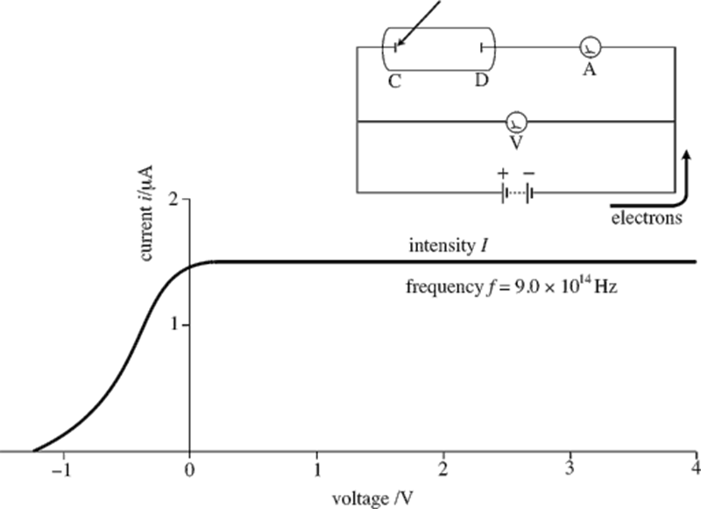**The graph current Vs Potential**

**Graph 1**

**Pd/V**

**we can do different experiments in order to understand the photoelectric effect.**

1. 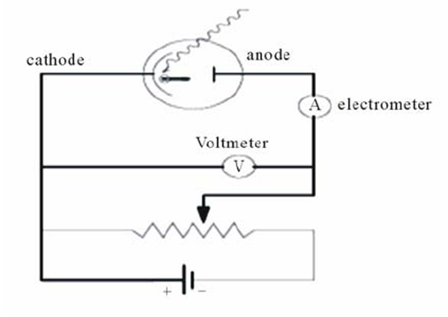**Use the 1st circuit with the batteries**

By keeping the **intensity of light at constant value** and change the potential difference between the cathode and anode. Then Find the current through A and the pd across the cathode and anode and plot a graph current vs pd

Current; I (μA)

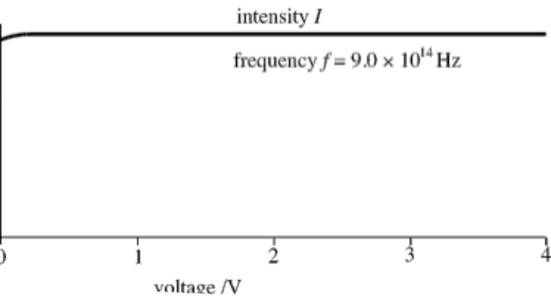

**Graph 2**

**Pd/V**

**The graph current Vs Potential (Graph 1 & Graph 2 together )**

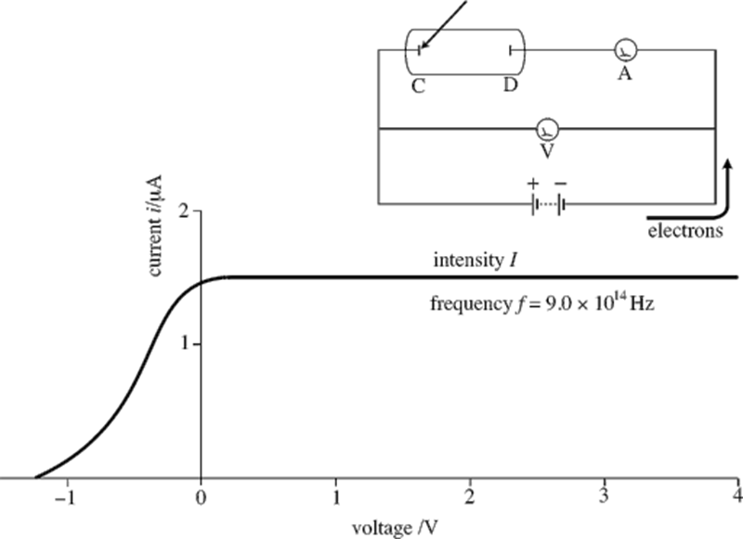

**Conclusion**

When the intensity of incident light is constant, whatever the pd across the cathode and anode, the flowing current is a constant **after certain positive potential difference**. In other words, the rate of electrons flowing (the current ) does not depend on the applied voltage when the intensity is content.

When f is 9 x ${10}^{14 }$ Hz the constant $μ$ A value is usually between 1 $μ$ A and 2 $μ$ A

1. **When the direction of p.d is received**

**\**

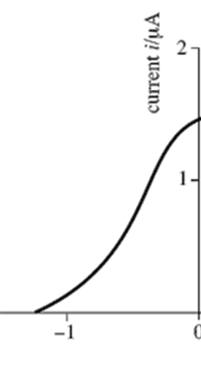While the intensity remains the same value.

The pd is negative. The electrons which are emitted from x are repelled by Y, therefore less number of photo electrons are reaching the anode(Y). When pd is negatively increased, the is a current decreases and comes to zero.

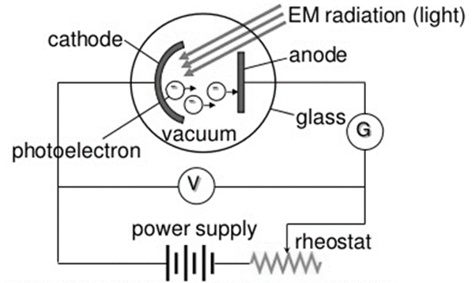

pd /(V)

1. **The intensity of falling light is changed and the pd is also changed.**

When intensity increases, while the pd is positive, the current also increases but having different constant values. The intensity of light increases the constant current values also increase.

When pd is negative, current decreases but stopping potential is the same(V0).

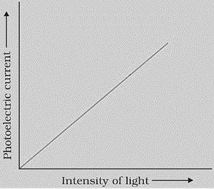

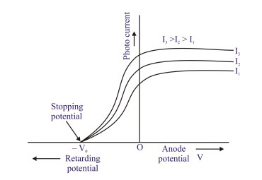

**In the region of positive pd when the intensity is doubled, current also doubles.**

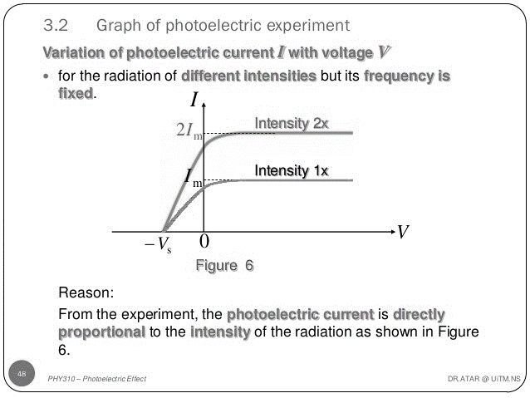

1. **Now intensity of light is kept at a constant value and change the frequency of light. In other words different colour light is used for this.**

In the positive pd range, current is constant from certain value negative pd is concerned frequency increases, stopping potential decreases (negative value increases.) [ν1 <ν2 <ν3 ] ;[ λ3 <λ2 <λ1]

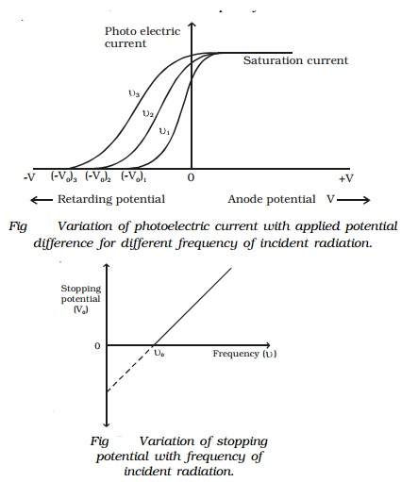

**The graph stopping potential Vs frequency**

**While changing the making of the cathode, we can do the experiment under the same intensity of light under same f/ $λ$**  I

**K**

Na

Zn

Vo3 vo2 vo1 Pd

1. **We consider different vertical cathode and use different frequency**

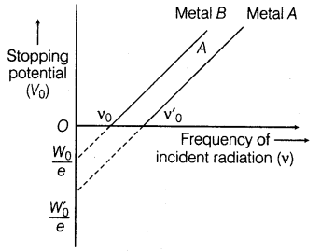 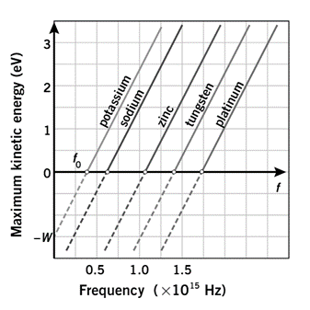

**Facts related to photocathode effect**

* When cathode is illuminated, we can call it photocathode
* When light falls on to a certain cathode, there is a particular minimum frequency in order to emit photo electrons and the frequency ,which is called thresh hold frequency & it is denoted by fo. Whatever the intensity of light if the frequency of light is greater than thresh hold frequency then only photo electrons are emitted. According to plank theory, there is a certain minimum energy & it is called threshold energy.(E0)

E = hf

E0 = hfo

* When any light whose frequency is greatest than fo of, the metal fallen on to a considered metal, number of photo electrons emitted and the current pass through the circuit are directly proportional to the intensity of light. The metal differs, fo differs.
* The max kinetic energy corresponding to the stopping potential does not depend on the intensity of light It depends on frequency of light. Actually the maximum kinetic energy directly proportional to frequency of light.
* As soon as the light rays fall on to the metal surface, photo electrons are emitted if requirement’s are met. There is no time delay normally. If there is, It is ***less than ${10}^{-9}$ s***.

photons

A photon is the smallest discrete amount or quantum of electromagnetic radiation. It is the basic unit of all light.

Photons are always in motion and, in a vacuum, travel at a constant speed to all observers of 2.998 x 108 m/s. This is commonly referred to as the speed of light, denoted by the letter *c.*

As per Einstein’s light quantum theory, photons have energy equal to their oscillation frequency times Planck’s constant. Einstein proved that light is a flow of photons, the energy of these photons is the height of their oscillation frequency, and the intensity of the light corresponds to the number of photons. Essentially, he explained how a stream of photons can act both as a wave and particle.

**Photon properties**

The basic properties of photons are:

* They have zero mass and rest energy. They only exist as moving particles.
* They are elementary particles despite lacking rest mass.
* They have no electric charge.
* They are stable.
* They are spin-1 particles which makes them bosons.
* They carry energy and momentum which are dependent on the frequency.
* They can have interactions with other particles such as electrons, such as the Compton effect.
* They can be destroyed or created by many natural processes, for instance when radiation is absorbed or emitted.
* When in empty space, they travel at the speed of light.

**Facts about photons**

* Not only is light made up of photons, but all electromagnetic energy (i.e. microwaves, radio waves, X-rays) is made up of photons.
* The original concept of the photon was developed by Albert Einstein. However, it was scientist Gilbert N. Lewis who first used the word “photon” to describe it.
* The theory that states that light behaves both like a wave and a particle is called the wave-particle duality theory.
* Photons are always electrically neutral. They have no electrical charge.
* Photons do not decay on their own.

According to classical physics, the energy produced by the light waves fallen on to the surface should be absorbed by the electrons in the metal then only the photo electrons are emitted.

For these two purposes, there may be a time delay of $more than {10}^{-9}$ s

This energy which is absorbed does not depend on the frequency but directly proportional to intensity of light.

Photo electric effect was initially observed by Phillip learned but the explanation was done by Albert Einstein in 1905.

**Explanation of Photoelectric effect**

According to Max Planck, all waves are having certain amount of energy (including light). In other words, all $E$ M waves have energy. According to planck, energy is always provided as small packets/cluster of energy.the energy stored in a certain wave is given by,

E = hf

Actually, this cluster can be considered as a quantum or photon. Frequently used word is **photon**.

***Energy always comes in photons.***

According To Einstein, energy is absorbed as photons & energy is emitted and transmitted as photons.

**Photon theory of light**

According to quantum theory, all EM waves consist of energy quantum which is called photons.

Energy (E ) E = hf

Since all EM travel with speed of light,

V = C

C = f $λ$

f = $\frac{c}{λ}$

E = hf

E = $\frac{hc}{λ}$

======

h is Planck constant,

E $α$ $\frac{1}{λ}$

***The speed of photon in free space is almost equal to the speed of light in vacuum but it has no mass.***

Whole energy of a photon is there as kinetic energy. Always photons move with the speed of light.

Photon has a momentum.

If the momentum of photon is P then,

P = $\frac{E}{C}$ E = hf

P = $\frac{hf}{c}$

In other words

f = $\frac{c}{λ}$

P = $\frac{h}{c}$ x $\frac{c}{λ}$

P = $\frac{h}{λ}$

**Intensity of light fallen onto a certain metal surface**

Suppose beam of light falls onto a certain surface on an area A perpendicularly

Number of photons fallen on this for a second = N

Number of photons fallen onto **unit area (1m2) for a second** = $\frac{N}{A}$

If the energy of I photon = E,

Net energy for the considered number of photons

**(unit area (1m2) for a second** ) = $\frac{EN}{A}$

Intensity (I) = $\frac{EN}{A}$

E = hf or E = $\frac{hc}{λ}$

$∴$ I = $\frac{hfN}{A}$

OR

I = $\frac{Nhc}{λA}$

**Photoelectric Equation**

When a certain ,metal surface is illuminated / shone by light photo electron are emitted when one photon is fallen on the surface. This light should have f > fo. Normally one of the electron very close to the metal surface is emitted as a photo electron. the photon has an energy equivalent to hf (E = hf)

This energy is used to take the electron to the surface of the metal in order to be emitted from the surface. In other words, there should be a certain work done.

This amount of work done is called work function of the metal & denoted by $ϕ$ or W.

Actually this is the minimum energy needed to emit a photo electron from a metal surface.

E = K max + $ϕ$

The minimum energy required to emit a photo electron from a metal surface is called work function.

This value is very small.   
eg : Work function for Zn is 3.0eV (1eV = 1.6 x ${10}^{-19}$ J )

for Na is 2.46 eV

when an electron is emitted it gets a Kinetic energy . When it is just leaving from a metal surface, it has Max Kinetic energy (K max ) . According to these two, the total energy required to emit photo electron from a surface of metal is equal to the sum the maximum Kinetic energy(K max ) of photo electrons and the work function of the metal. This energy is supplied by the photon.

Therefore the energy of the photon is equal to sum of the maximum Kinetic energy (K max )and the work function

Energy of photon = Max Kq of Photon + Work function

E = KE max  + W

OR

E = KEmax  +

KEmax = E – $ϕ$

If maximum velocity of photo electron is Vm

**KE max = MVm2**

**MVm 2 = E -**

**Some explanations of observations in photoelectric effect**

1. The light fallen onto a surface is concerned, according to Einstein theory, one photon can emit only one photo electron.
2. E = hf
3. f = frequency of light

There is a threshold frequency (fo) for the given metal. That is the minimum frequency should be there for the light. Then minimum energy required from a photon is hfo.

If the photo electron is just taken to the surface of metal, then the required energy is work function. Therefore the min energy required to just emit a photo e is hfo and it is equal to $ϕ$.

$∴$ $ϕ$ = hfo

When photo electrons are emitted, the energy of photons $≥$ threshold energy = hf0

IF hf = hfo , Kinetic energy of photo electron is zero.

IF hf > hfo , the maximum Kinetic energy of photo electron is hf – hfo

K max = hf - hfo

When the intensity of the light is increased, number of photons fallen on the metal surface increases.

Even when intensity changes, the maximum Kinetic energy does not change.

$∴$ maximum Kinetic energy depends only on frequency and $ϕ$ of metal.

W = QV

W = eVo

Kmax > Work Done by the pd (eVo)

W.D = eVo where Vo = stopping potential

Kmax > e Vo

When Kmax = eVo , no current flows through the circuit. $∴$ at stopping potential, Einstein equating can be altered as follows.

hf = Kmax +

eVo = hf - $ϕ$

Now plot the graph Kmax VS frequency of light fallen on metal surface.

Kmax = hf - $ϕ$

Y = mx + c

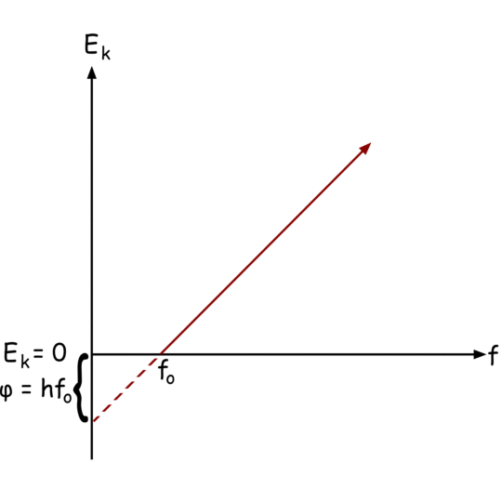

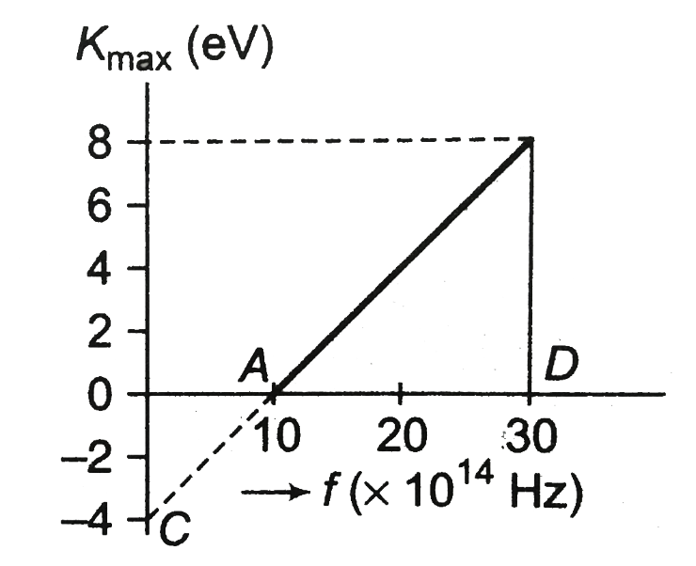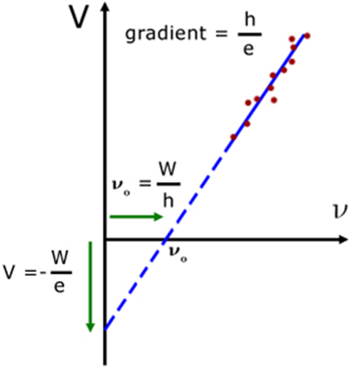

-

From gradient, h can be found

Since $ϕ$ = hfo

fo =

=

C = f $λ$

C = fo

fo = ①

hfo  =

fo =

From ① and ②

$\frac{ϕ}{h}$ = $\frac{c}{λ_{0}}$

$ϕ$ = $\frac{hc}{λ_{0}}$ h = ($\frac{ϕ}{C}$) $λ_{0}$

The wave length corresponding to fo is their should wave length. To emit photo electron, the $λ$ of following light should be less than the $λ_{0}$.

Kmax = hf – $ϕ$

Kmax = hf - hfo

Kmax = -

Kmax = m $v^{2}$ = eVo

1eV = 1.6 x ${10}^{-19}$ J

When we bring one e of change of 1.6 x ${10}^{-19}$ C from one point to another in a potential of 1V (ev) it is the work done.

***Summary***

* *Electromagnetic radiation can push electrons free from the surface of a solid.* 
  + *This process is called the photoelectric effect.*
  + *A material that can exhibit the photoelectric effect is said to be photoemissive.*
  + *Electrons ejected by the photoelectric effect are called photoelectrons.*
* *The photoelectric effect will not occur when the frequency of the incident light is less than the threshold frequency.* 
  + *Different materials have different threshold frequencies.*
  + *Most elements have threshold frequencies in the ultraviolet region of the electromagnetic spectrum.*
* *The maximum kinetic energy of a stream of photoelectrons…* 
  + *is determined by measuring the stopping potential (the applied voltage needed keep the photoelectrons trapped in the photoemissive surface).*
  + *increases linearly with the frequency of the incident light above the threshold frequency.*
  + *is independent of the intensity of the incident light.*
* *The rate at which photoelectrons are emitted from a photoemissive surface…* 
  + *is determined by measuring the electric current.*
  + *is directly proportional to the intensity of the incident light when frequency is constant.*
* *On a graph of maximum kinetic energy vs. frequency…* 
  + *all curves are linear with slope equal to the Planck constant.*
  + *the intercept on the energy axis is the threshold frequency of the material.*
* *Classical physics cannot explain why…* 
  + *no photoelectrons are emitted when the incident light has a frequency below the threshold,*
  + *the maximum kinetic energy of the photoelectrons increases with the frequency of the incident light,*
  + *the maximum kinetic energy of the photoelectrons is independent of the intensity of the incident light, and*
  + *there is essentially no delay between absorption of the radiant energy and the emission of photoelectrons.*
* *Modern physics states that…* 
  + *electromagnetic radiation is composed of discrete entities called photons*
  + *the energy of a photon is proportional to its frequency*
  + *the work function of a material is the energy needed per photon to extract an electron from its surface*
* *Equations* 
  + *photoelectric effect*

*Kmax = E − ϕ = h(f − f0)*

* + *photon energy*

|  |  |
| --- | --- |
| *E = hf =* | *hc* |
| *λ* |

* + *work function*

|  |  |
| --- | --- |
| *ϕ = hf0 =* | *hc* |
| *λ0* |

* + *stopping potential*

*Kmax = eV0*

Q. Monochromatic light beam having 0.15W $m^{-2}$ Intensity and $λ$ of 3000A fallen on to an area of 4 $m^{2}$

$⊥$ find the rate of fall of photons on the surface.

I= $\frac{Nhc}{Aλ}$ 
N = $\frac{0.15 x 4 x {10}^{-4} x 3000 x {10}^{-10}}{6.63 x {10}^{-24} x 3 x {10}^{8}}$

= 9.1 x ${10}^{-2}$ x ${10}^{15}$

= 9.1 x ${10}^{13}$ photons -1

====================

Q. power of a radio transmitter is 400KW. And its frequency of the channel is 89.8 MHz, find the rate of emission of wave quantum

Energy of 1 photon (quantum) = hf

= 6.636 x ${10}^{-34}$ x 89.8 x ${10}^{6}$

= 5.96 x ${10}^{2}$ x ${10}^{-28}$

Energy for n quantum = 5.96 x ${10}^{-26}$ N

FOR 1s

$∴$ Power = $\frac{E}{t}$

400x ${10}^{3}$ = $\frac{5.96 x {10}^{-26}}{1}$ N t = 1

N = 6.7 x ${10}^{4}$ x ${10}^{26}$

N = 6.7 x ${10}^{30 }$ Photons s-1

====================================

Q. Monochromatic light , $λ$ of 300nm fallen onto a photo cathode when the Ke of photo electrons are measured using an electronic devices. The value ranges from 1.2 x ${10}^{-20 }$ J to 4.0 x ${10}^{-19}$ J. find the stopping potential for the light.

eVD = () Kmax

vo  =

vo = (x (4 x )2

vo = (

vo = 2.5V

=======

Q. The threshold $λ$ of an photo/optical cathode is 600nm. The stopping potential for mono chromatic light is 2.5V. Then find the wavelength of this monochromatic light.

= eVo  +

1.6 x ${10}^{-19 }x 2.5+ \frac{1.60x {10}^{-19 }x1.24 x {10}^{3}x{10}^{-4}}{λo}$

$\frac{1.24x{10}^{-6}}{λ}$ = $\frac{2.5λo+1.24 x {10}^{-6}}{λo}$

1.24 x ${10}^{-6}λo$ = 2.5 $λoλ$ + 1.24 x ${10}^{-6}λ$

1.24 x ${10}^{-6}x 600 x {10}^{-4}$ = 2.5 x 600 x ${10}^{-9}$ $λ$ + 1.24 x ${10}^{-6}λ$

7.44 x ${10}^{-14}$ = 15 x ${10}^{-7}λ$ + 1.24 x ${10}^{-6}λ$

2.74 x ${10}^{-6}λ$ = 7.44 x $14$

$λ$ = 2.72 x 10

$λ$ = 272nm

============

Q. On a Ba Photocathode, monochromatic light of $λ$ 400nm is fallen and $ϕ$ of the photocathode is 2.5ev. find the max speed of photo electrons. me = 9.10 x Kg.

= + me2

400 x = 2.5 x 1.6 x ${10}^{-19}$ + $\frac{1}{2}$ x 9.1 x ${10}^{-31 }$ x $v^{2}$

$\frac{1.24 x {10}^{3} x 1.6 x {10}^{19} x {10}^{-9}}{400 x {10}^{-9}}$ = 2.5 x 1.6 x ${10}^{-19}$ + $\frac{1}{2}$ x 9.1 x ${10}^{-31 }$ x $v^{2}$

0.496 x ${10}^{-19}$– 8.4 x ${10}^{-18}$ = $\frac{1}{2}$ x 9.1 x ${10}^{-31}$ x 2

$$\frac{0.096 x {10}^{-18} x 2 }{9.1 x {10}^{-31}}= V^{2}$$

V = 4.6 x ${10}^{5}{ms}^{-1}$

=================

Q. Na photocathode is illuminated with light $wave length of$ 300nm. Work function of Na = 2.46ev find

(i) max. KE of photo e s

(ii) Stopping potential for monochromatic light

(iii)Threshold $λ$ for Na

1. $\frac{hc}{λ}$ = $ϕ$ + Kq

Kq = $\frac{1.24 x {10}^{3}x 1.6 x {10}^{-19}x {10}^{9}}{300 x {10}^{9}}$- 2.46 x 1.6 x ${10}^{-19}$

Kq = 6.62 x ${10}^{-19}$- 2.46 x ${10}^{-19}$ x 1.6

Kq = 2.684 x ${10}^{-19}$ J

=================

(ii) $\frac{1}{2}{mv}^{2}= eVo$

Vo = $\frac{2.684 x {10}^{-19}}{1.60x {10}^{-19}}$

= 1.6775V

========

1. $ϕ$ = $\frac{hc}{λ}$

$λ$ o = $\frac{1.24 x{10}^{3} x 1.6 x {10}^{-19}x {10}^{-9} }{2.46 x 1.6 x {10}^{-19}}$

= 504.1 x ${10}^{-9}m$

= 504.1m

=======================

Q. Monochromatic light having 2 different $λ$’s are fallen onto a photo electrode. Their corresponding stopping potentials are given.

$λ$ Vo

253.6nm 1.95V

407.7nm 0.14V

Find the pluck constant

$\frac{hc}{λ}$ = Kmax + $\frac{hc}{λo}$ $→$ ①

$\frac{hc}{λ1}$ = eVo1 + $\frac{hc}{λo}$ $→$ ①

$\frac{hc}{λ2}$ = eVo2 + $\frac{hc}{λo}$ $→$ ②

① - ②

- = eVo1 - eVo2

hc ($\frac{404.7-253.6 x {10}^{-9}}{404.7 x {10}^{-19}x 253.6 x {10}^{-19}})=$ 1.6 x ${10}^{-19 }$ (1.95-0.14)

hc x $\frac{151.1 x {10}^{9}}{102631.92}$ = 2.896 x ${10}^{-19}$

h = 6.556 x ${10}^{-34}$ Js

=====================

**Wave nature of matter and particle nature of matter**

When we consider waves we can explain certain phenomenon using the wave theory of tight. Here we consider light propagates as a waves. Using this property, we can explain the certain properties of light.

1. Reflection
2. Refraction
3. Interference
4. Diffraction
5. Polarization

**But photoelectric effect cannot be explained with theory of light.**

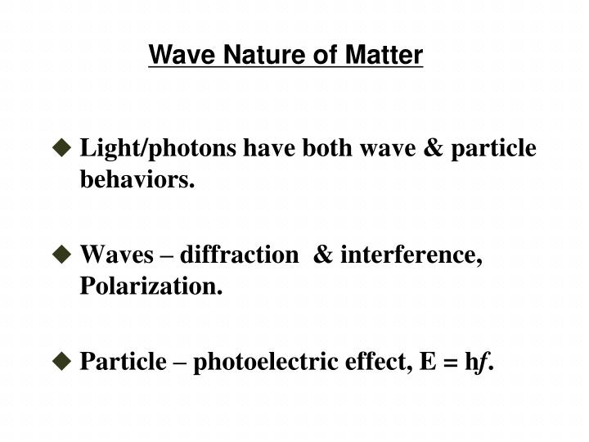Absorption, emission of radiation by substances also cannot be explained. To explain these we have to use quantum theory. All those were considered for light. According to this, light behaves as a wave as well as a particle. Therefore we said light has duality characteristics this is called **duality of light.**

**De Broglie’s hypothesis**

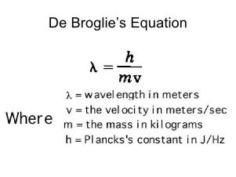Duality of light was explained early but de Broglie through that matters are also having duality. Matters consist of particles and can be considered as particles and waves. According to him, matter has a wave also, He suggest that when an object is moving, it emits a certain wave and it’s wave length is given by the equation

$λ$ = $\frac{h}{p}$ h - planck constant

P - Momentum

P = mv

$λ$ = $\frac{h}{mv}$

The equation is called **De Broglie Equation.** The wave length λ is called **De Broglie wave length**

Always any substance which are having particles can behave as a wave in nature.

Q. Speed of an electron is 1 x ${10}^{8}{ms}^{-1}$ mass of e 9.1 x ${10}^{-31}kg.$ Find the de Broglie wave length .

$λ$ = $\frac{6.63 x {10}^{-34}}{9.1 x {10}^{-31}x 1 x {10}^{8}}$

= 0.728 x ${10}^{-3}$ x ${10}^{-8}$

= 728nm

===========

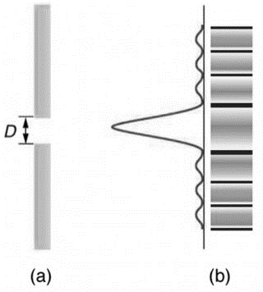Q. Mass of a stone is 100g and it is moving with a speed of 40 ${ms}^{-1}$. Find de Broglie $wave length$

$λ$ = $\frac{6.63 x {10}^{-34}}{100 x {10}^{-3}x40 }$

= 1.65 x ${10}^{-31}m$

===========

Q. A child mass of 25Kg is running with a speed of 20 ${ms}^{-1}$. Find de Broglie $wave length$

$λ$ = $\frac{6.63 x {10}^{-34}}{25 x 20 }$

= 1.326 x ${10}^{-32}m$

===========

**Single Slit Diffraction**

Light passing through a single slit forms a diffraction pattern somewhat different from those formed by double slits or diffraction gratings. Figure 1 shows a single slit diffraction pattern. Note that the central maximum is larger than those on either side, and that the intensity decreases rapidly on either side. In contrast, a diffraction grating produces evenly spaced lines that dim slowly on either side of center.

**Double Slit Diffraction**

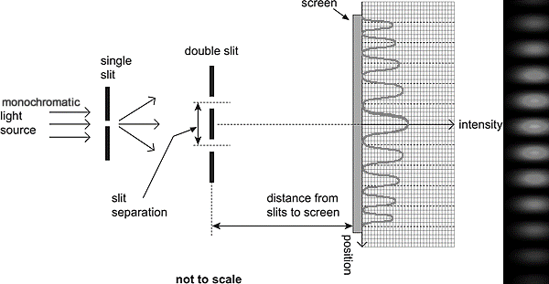

**Electron Microscope**

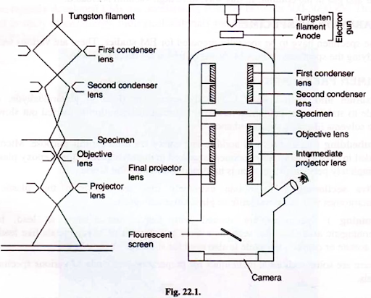

1. Electron gun

2. Electromagnetic lenses—three sets.

3. Image viewing and recording system.

Electron gun is a heated tungsten filament, which generates electrons. Condenser lens focuses the electron beam on the specimen. A second condenser lens forms the electrons into a thin tight beam.

Introduction to Electron Microscope:

In electron microscope, high-speed electron beam is used instead of light waves, which are used in optical microscope. Like light, the stream of electrons has a corpuscular and vibratory character. Electron microscope gives very high magnification and incredibly high resolution.

The first transmission electron microscope was developed by Ernst Ruska and Max Knoll of Germany in 1931. EM is a remarkable research tool of twentieth century. It opened up sub­cellular structures, which were unknown to biologists. It can magnify an object upto 1000000X (one million times). The photomicrographs can be further enlarged and studied by using modern photographic techniques and computer aided techniques.

The electrons can be focused by electro-magnetic lenses much like the light rays. Electron beam can vibrate like light rays but has very short wave length as compared to light rays. Wave length of electron beam λ = 0.005 nm as compared to 550 nm of visible light. Resolution increases with the decrease of wave length.

Resolution is dependent upon the wavelength of radiations. Smaller the radiation, greater will be the resolution. It is inversely proportional relation. The resolution determines the level of details that can be viewed from the specimen. It provides remarkable pictures with fine details.

Light microscope can achieve a maximum resolution of about 0.2 µm or 200 nm. Whereas EM can achieve a resolution of 0.10 nm which is 2000 times better than the best resolution by light microscope. Resolution is the ability of a lens to separate or distinguish between closely positioned small objects.

**Principle of Electron Microscope:**

Electrons are subatomic particles, which orbit around the atomic nucleus. When atoms of a metal are excited by heat energy, electrons fly off from the atom. In electron microscope, tungston is heated by applying a high voltage current, electrons form a continuous stream, which is used like a light beam.

In a normal optical instrument lenses are used/ mirror are used. But in e microscope, the e s are devoted using MF’s which we call, magnetic lenses. E s are passing through the object/ seamen. After that they enter through objective lens and make un intermodal image and again through another lens called projector earn. Then larger final image of intermediate image can be observed.

There are 2 types of transmission of e. therefore there are 2 types of EM Instead of a MF, we can use a MF and GF.

Two kind,

1. Transmission q microscope (QEM)

In this type, the thickness of specimen must be within 50-100nm finally larger image is formed. This is taken on to a monitor.

1. Scanning e microscope (SEM)

In this one e s are reflected by the specimens and those e s are deviated. magnification is very large. Therefore power is very large.

The lenses used in EM are magnetic coils capable of focusing the electron beam on the specimen and illuminating it. The strength of the magnetic lens depends upon the current that flows through it. Greater the flow of the current, greater will be strength of the magnetic field. The electron beam cannot pass through the glass lens.

**Transmission Electron Microscope (Tem):**

It consist of a system of electromagnetic lenses mounted in a column.

**Components of Electron Microscope:**

EM is in the form of a tall column which is vertically mounted.

**It consists of the following main components:**

1. Electron gun

2. Electromagnetic lenses—three sets.

3. Image viewing and recording system.

Electron gun is a heated tungsten filament, which generates electrons. Condenser lens focuses the electron beam on the specimen. A second condenser lens forms the electrons into a thin tight beam.

To move electrons down the column, an accelerating voltage is applied between tungsten filament and anode. Now most EMs use accelerating voltages between 100 kV-1000 kV. Electrons also function as a source of illumination for the specimen. High velocity electrons pass into the system of condenser lenses, which focus them on the specimen.

The specimen to be examined must be extremely thin, at least 200 times thinner than those used in optical microscope. Ultra thin sections of 20-100 nm are cut. The specimen holder is an extremely thin film of carbon or collodion held by a metal grid.

The electronic beam passes through the specimen and electrons are scattered depending upon the thickness or refractive index of different parts of the specimen. The denser regions in the specimen scatter more electrons and therefore appear darker in the image since fewer electrons strike that area of the screen. In contrast, transparent regions are brighter.

The electron beam coming out of the specimen passes down the second of magnetic coils called objective lens, which has high power and forms the intermediate magnified image. Finally, a third set of magnetic lenses called projector (ocular) lenses produce the final further magnified image.

Each of these lenses acts as image magnifier all the while maintaining an incredible level of details and resolution. He whole image remains in focus. This image is projected on a fluorescent screen. Below the fluorescent screen is a camera for recording the image. These lenses provide immense magnification and resolution.

As the EM works in vacuum, the specimen should be completely dry. Air molecules present in the column of EM scatter the electrons causing flicker in the electron beam. Vacuum is created in two steps. Firstly, a mechanical vacuum pump is used to create vacuum. Secondly, a diffusion pump uses a fast downward moving liquid, either oil or mercury which traps air and gas in the column. In this way, ultra high vacuum is created.

**Preparation of Specimen:**

The specimen have to be specially prepared for EM studies. There are various techniques for studying the specimen under EM. Some of which are discussed here.

**Fixation and Dehydration:**

The specimens are fixed in glutaraldehyde, osmium tetroxide to stabilize the cell structure. After fixation, dehydration is carried out slowly with organic solvents like acetone and ethanol.

**Embedding:**

Resins such as araldite and epoxy are used for this purpose. Microbes are embedded in plastic resin. The specimen is soaked in un-polymerized, liquid epoxy plastic until it is completely permeated and then is hardened to form a solid block.

**Ultra sectioning:**

To obtain extremely thin sections from this plastic block, Ultra-microtomes with diamond knife or glass knives are used.

**Staining:**

Specimens are stained with heavy metals such as lead, uranium, phosphotungstic acid. The thin sections soaked in solutions of heavy metals like lead citrate, uranyl acetate or osmium tetroxide is also used for staining.

There are some additional techniques for preparation and study of various specimens and materials.

**Image Viewing, Development and Recording Techniques:**

The image formed in EM is real as compared to the virtual image in optical microscope. The highly magnified image is formed below the projector lens on a fluorescent screen. Below this screen, a camera or a film or light sensitive sensor such as charge-coupled device (CCD) camera are placed. The image can be displayed on computer or monitor. For direct viewing monocular or binocular viewing, lenses are used.

The final image formed will always be in focus and needs no adjustments. The image recording and studying have undergone revolutionary changes. Digital cameras and computers have come to play a major role.

Instead of one picture of one section, series of sections are studied and analysed. By computer aided averaging techniques of numerous images three- dimensional reconstructions of cell organelles of highest clarity are developed. Tilting of specimen also provides three-dimensional picture.

**Use of Electron Microscope:**

Invention of EM has come as a boon for biological sciences and industry. There is hardly any area of science that has not gained from the use of electron microscope. Immense magnification, high resolution has opened new vistas in research in cellular and molecular biology.

Study of microorganisms like bacteria, virus and other pathogens have made the treatment of diseases very effective. Fields of medicine, pathology, human anatomy have gained immensely from electron microscope studies. Health field has benefited tremendously. Nanotechnology studies are the result of electron microscope studies.

Science of microbiology owes its development to electron microscope. It also helps in tumour identification, biopsy, study of cells, variety of molecules. In industry high resolution. 2D and 3D imaging. In foresenic, mining, chemical and petrochemical industries.

**High Voltage Modern Electron Microscope:**

The recently developed EMs use accelerating voltages between 500-3000 kV. These EMs are used in study of metallurgy, biological materials and living cells. Thick sections upto 5µ m can also be studied.

**Scanning Electron Microscope:**

Transmission electron microscope (TEM) and scanning electron microscope (SEM) work on the same basic principle. TEM forms image when radiations pass and are transmitted through the specimen. Whereas SEM produces images by detecting secondary electrons which are emitted from the surface of the specimen due to excitation by the primary electron beam. Therefore SEM is used to examine the surfaces of the microorganisms in great detail.

Secondary electrons hit a scintillator which emits light which is converted into electrical current and amplified. The signal is sent to a cathode ray tube and forms image like the TV picture.

SEM was first introduced in 1965. It produces three-dimensional image, which has high resolution and great depth of field.

Electron beam passes through a pair of scanning coils or deflector plates in the electron column of the SEM in the final lens which deflects the beam on the surface of the specimen. The electrons interact with atoms on the surface of the specimen producing signals that contain information about the properties of the specimen.

The signals produced in an SEM include secondary electrons, back scattered electrons (BSE). X-rays, transmitted electrons and light. The signals scan the surface of the specimen from side to side, in lines from top to bottom. This is known as roster scanning. They produce high resolution images of the specimen surface and provide information about the composition of the specimen.

**Phase Contrast Microscope:**

Normally cells are studied after fixation and staining of the tissues. Only dead cells can be studied in optical microscopes. But phase contrast microscope provide a technique for studying transparent cells without staining. Different organelles appear in various shades of grey depending upon the thickness and difference between refractive index of the object and the medium. This microscope is most suitable for studying cells cultured in vitro, during mitosis, protozoans, living cells etc.

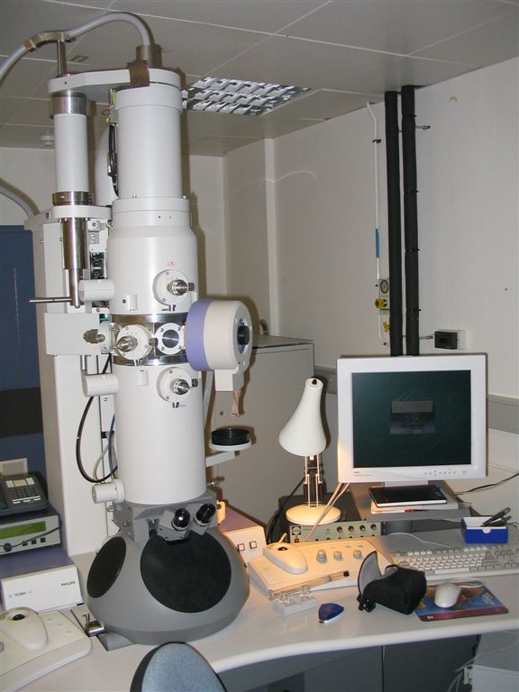

Electrons are accelerated by applying PD of V .Mass of electron is m ,speed of the electron is v charge of an electron is e.

KE = Work Done

mv2 = e V

V = ; p = mv ; p = m $\sqrt{\frac{2eV}{m}}$

P = $\sqrt{2emV}$

λ = $\frac{h}{p}$ λ = $\frac{h}{\sqrt{2emV}}$

***Q . Find the wave length when applied PD 3600V***

**X-Rays**

About cathode says, several scientists performed experiments. In 1897 J.J. Thomson also did more experiment on cathode rays. Later Wilhelm Rontgen also did some experiments and he found that some unexposed film kept in that tube had some kind of blurred patches. Then he again introduce another unexplored film to the and did the practical again. The same results were found, then he came to the conclusion, that there must be some kind of rays emit from the cathode ray tube. He could not explain and no explanation was given. Therefore he named them X-rays. X is there to represent unknown rays Now we know of X-rays but we still use the term. Now X-rays are produced using a different kind of cathode.

The following CRP which is modified produce X-rays.

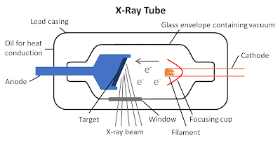

To produce X rays, CR are directed to a certain metal plate kept in an inclined. That metal is called target metal. To produce cathode rays, a tungsten filament is need and heated using a p.d of about 10v. the target metal is embossed in a cu rod for the target metal, we are using no mainly.pt can also be used.

Between cathode and anode, high potential about 105v is used. This particular different is called operating potential. Sometime this is called accreting p.d. the filament is producing e s. those are accelerated by the accelerated potential therefore the e are having large velocity leading to get large Kq. After hiting the target metal e s, decelerate instantaneously Due to that X-rays are produced.

Mainly the Kq converts in to heat. Amount is about 99% of Kq only 1% of energy is used to produced rays. The produced energy is absorbedly the cu rod and it should be coded using flowing oil or H2O.

Always large energy is lost when producing X-rays. Until the CR (es) come to rest, X-rays are produced. But if are to explain in Modern physics.

Energy in X-rays can be considered as X-rays photon. X-rays photons having max Energy emit when the total Kq of an e directly converts to an X-rays photon.

Max Kq of an e is equal to the energy of 1 x-rays photons.

Suppose the frequency of photon is f or Fmax

E = hf max $→$ ②

KE max = $\frac{1}{2}$ ${mv}^{2}$ max

W = eV

KE max = eV = $\frac{1 }{2}$ ${mv}^{2}$ max $→$ ②

From $①$ and ②

Hf max = eV for x-ray photons

The max frequency is f. Then it gets win wavelength

C = f max $λ$ min

F max = $\frac{C }{λ min}$

eV = $\frac{hc}{λ min}$

=========

When explaining X-rays, sometimes we use the word boiled off e are boiled off from the heated cathode by thermionic emission and they are accelerated towards the target metal by a large p.d. The bulb is evacu vated to get a pressure of ${10}^{-7}$ atm.

E s travel from cathode to anode without colliding with air molecules when the p.d. is high/greeted than or equal to 105V radiation called X-rays is emitted from the target face.

X-rays are EM waves

Speed is almost equal to speed of light

$λ$ change from 0.0005 nm to 0.01nm.

1. X-rays tube given a high tension of 1 x ${10}^{5}$ V. find the $λ$ of the X-rays which produce with max. Energy.

eV = $\frac{hc}{λ min}$ when max energy, we assure no heat is generated

1.6x ${10}^{-19}$ x 1 x ${10}^{5}$ = $\frac{6.63 x {10}^{-34}x 3 x {10}^{8}}{λmin}$

$λ$ min = 1.25 x ${10}^{-41}$ min

=====================

Q. X-ray tube is operated on a pd. of 40kVdc voltage. The target metal produces heat in the rate of 720W. Only the 0.5% of the KE of electrons convert in to X-ray,s find.

(1) number of es fallen on the metal on 1s.

(2) find the velocity of es fallen on target metal ($\frac{e}{m}$ = 1.8 x ${10}^{-11}{kq}^{-1}$)

1. % of energy converts to X –Rays = 0.5%

$∴$% of energy used to produce heat in the target metal = 99.5%

$∴$ Let the current and high tension in tube be I and V

$Power generated in the tube =$ VI

$energy for 1s$ = I x 40 x ${10}^{4}$

$$this connect in to Kq of e for 1s$$

Energy for heating for 1s = 4 x ${10}^{4}$ I x $\frac{99.5}{100}$

720 = 4 x ${10}^{4}$ I x $\frac{99.5}{100}$

I = 0.018A

I = $\frac{Q}{t}$

For 1S

I = Qn

n = $\frac{0.018}{1.6 x {10}^{-19}}$ = 1.125 x ${10}^{17}$

1. eV = $\frac{1 }{2}$ ${mv}^{2}$

2 x $\frac{e}{m }$ x v = $v^{2}$

$v^{2}$ = 2 x 1.8 x ${10}^{11}$ x 40 x ${10}^{3}$

V = 12 x ${10}^{7}$ ms 1

Q. the accelerating p.d of a TV tube is 20Kv. Find the max energy of X-rays produced in a TV.

W = eV $→$ ①

W = Energy of X-rays

E = 1.6 x ${10}^{-19}$ x 20 x ${10}^{3}$

= 3.2 x ${10}^{-15}$ J

===========

Q. The max wavelength for an X-rays is 2.1 x ${10}^{-11}$ m. find the operating p.d.

E = $\frac{hc}{λ}$ $→$ ①

E = eV $→$ ②

From ① and ②

$\frac{1.24 x {10}^{3}x 1.6 x {10}^{-19}}{2.1 x {10}^{-11}}$ = 1.6 x ${10}^{-19 }$ x V

V = 6 x ${10}^{4}$ V

============

Q. X-rays are produced and the operating voltage is 50KV. It work in a 1% of efficncey and producing X- rays energy with a rate of 20W. find the current in the tube.

E = e x v

Total energy = 1.6 x ${10}^{-19}$ x 50 x ${10}^{3}$ x n

Energy used to produce / emit e s = P = $\frac{E}{t}$ x 100

1. = $\frac{E}{1s}$ x 100

E = $\frac{1}{100}$ J

Kq is % of total energy

KE = 8 x ${10}^{-15}$ x $\frac{1}{100}$ x n = 8 x ${10}^{-17 }$ x n.

Kq = Energy of X-rays

20 = 8 x ${10}^{-19 }$ x n

N = 2.5 x ${10}^{17}$

$∴$ I = $\frac{Q}{t}$

I = $\frac{ne}{1}$

I = 2.5 x ${10}^{-19 }$ x 1.6 x ${10}^{-19 }$

I = 0.04A

==========

Q. In a X-ray tube, operating p.d. is v.

1) find the energy of e s in ev.

2) find the de Broglie’s wavelength of the e

3) find the max Kq of X-rays and the min $λ$

1. Energy = eV

= 1.6 x ${10}^{-19 }$ J x ${10}^{4 }$ V

= ${10}^{4}$ eV

========

1. E = $\frac{hc}{λ}$

$λ$ max = $\frac{hc}{E}$

= $\frac{1.24 x {10}^{3}x 1.6 x {10}^{-19}}{{10}^{4}x 1.6 x {10}^{-15}}$

= 0.124 x ${10}^{-9}$

= 0.124nm

==========

1. E = $\frac{1 }{2}$ ${mv}^{2}$

1.6x ${10}^{-19}$ x ${10}^{4}$ = $\frac{1 }{2}$ x ${m x v}^{2}$

$V^{2}$ = 2 x $\frac{e}{m }$ x ${10}^{4}$

$V^{2}$ = 2 x 1.8 x ${10}^{11}$ x ${10}^{4}$

$v$ = 6 x ${10}^{7}$ ${ms}^{-1}$

$$=================$$

Q. Operating voltage of a X-ray tube is 50Kv, 0.4% of cathode rays convents in to X-rays. Heat is generated at target metal with a power of 600W. Find the current flows through the tube. Find the num of e s falling on the target metal.

Total Energy = 1.6 x ${10}^{-19}$ x 50 x ${10}^{3}$ x n

$∴$ Energy of e s = 1.6 x ${10}^{-19}$ x 50 x ${10}^{3}$ x $\frac{0.4}{100}$ x n

$∴$ Energy generated = 1.6 x ${10}^{-19}$ x 50 x ${10}^{3}$ x $\frac{99.6}{100}$ x n

600 = 1.6 x ${10}^{-19}$ x 50 x ${10}^{3}$ x $\frac{99.6}{100}$ x n

n = 7.53 x ${10}^{16}$

I = 0.012

==========

**The X-Rays properties are given below:**

* They have a shorter wavelength of the electromagnetic spectrum.
* Requires high voltage to produce X-Rays.
* They are used to capture the human skeleton defects.
* They travel in a straight line and do not carry an electric charge with them.
* They are capable of travelling in a vacuum.

**Different between X-ray and Ordinary light:**

|  |  |
| --- | --- |
| Ordinary light | x-ray |
| These are visible | These are invisible |
| They have heating effect | They have no heating effect |
| The wavelength of ordinary light range from 4 x 10-7m to 7.6 x 10-7m. | The wavelength of x-ray range from 10-9m to 10-12m. |
| It does not have high penetrating power. Ordinary light penetrates only transparent substance not opaque. | They have high penetrating power and power of transparency for opaque substance |

The important properties of X – rays are:

(i) The X – rays are the electromagnetic wave of wavelength 10A° to 0.5°

(ii) The X – ray travels in vacuum with the speed of light ie. 3 * 108m/s.

(iii) They affect high penetrating power.

(iv) They have photographic effect.

(v) They are not deflected by electric and magnetic field.

**1:Radio Therapy**

X-rays kill the diseased tissues of the body.Hence they are used to λ cure intractable skin diseases,malignant tumours etc.If the affected part is superficial soft rays are applied and for deep seated organs hard rays are used.

**2:Engineering**

Because of their high penetrating power they are used ti investigate the structure of metals, test of castings for flaws and gas pockets causes of weakness in structure and to detect cracks and below holes in metal plates.The method has  the advantages that unlike some mechanical tests it does not destroy to piece.

**3:Surgery**

X-rays can pass through flesh and through bones.They are extensive use in surgery to detect fractures,foreign bodies,diseased organs etc.The patient is made to stand between an X-ray source and a fluorescent screen.Thus a deep shadow of the bones and a light shadow of the flesh will be obtained.A photograph may also obtained,it is called a radiography.

**4:Industry**

X-rays are employed in industry to detect defects in motor tyres,golf and tennis ball,wood and wireless valves and testing the presence of pearls in oysters.

**5:Scientific research**

 X-rays have been used to investigate the structure of crystals,structure and properties of atoms and arrangement of atoms and molecules in matter.

**6:Detective departments**

X-rays are used at customs post for detection of contraband goods like explosive opium,etc.Concealed in leather or wooden cases in examining contents of parcels with out opening them and in the direction of precious metals like gold and silver in the body of smugglers.They are used in distinguishing real diamonds and parts from artificial ones,pure ghee from vegetable oils.

X-rays are a type of radiation called electromagnetic waves. X-ray imaging creates pictures of the inside of your body. The images show the parts of your body in different shades of black and white. This is because different tissues absorb different amounts of radiation. Calcium in bones absorbs x-rays the most, so bones look white. Fat and other soft tissues absorb less and look gray. Air absorbs the least, so lungs look black.

The most familiar use of x-rays is checking for [fractures](https://medlineplus.gov/fractures.html) (broken bones), but x-rays are also used in other ways. For example, chest x-rays can spot pneumonia. Mammograms use x-rays to look for breast cancer.

When you have an x-ray, you may wear a lead apron to protect certain parts of your body. The amount of radiation you get from an x-ray is small. For example, a chest x-ray gives out a radiation dose similar to the amount of radiation you're naturally exposed to from the environment over 10 days.

**The most common form of X-ray used is X-ray radiography, which can be used to help detect or diagnose:**

* [Bone fractures](https://www.medicinenet.com/broken_bone_types_of_bone_fractures/article.htm)
* Infections (such as [pneumonia](https://www.medicinenet.com/pneumonia_quiz/quiz.htm))
* Calcifications (like [kidney stones](https://www.medicinenet.com/kidney_stones/article.htm) or vascular calcifications)
* Some tumors
* [Arthritis in joints](https://www.medicinenet.com/arthritis/article.htm)
* Bone loss (such as [osteoporosis](https://www.medicinenet.com/osteoporosis/article.htm))
* Dental issues
* Heart problems (such as [congestive heart failure](https://www.medicinenet.com/heart_failure/article.htm))
* Blood vessel blockages
* Digestive problems
* Foreign objects (such as items swallowed by children)

### What Is a Chest X-Ray

# Imaging using X-rays

When imaging with X-rays, an X-ray beam produced by a so-called X-ray tube passes through the body. On it’s way through the body, parts of the energy of the X-ray beam are absorbed. This process is described as attenuation of the X-ray beam. On the opposite side of the body, detectors or a film capture the attenuated X-rays, resulting in a clinical image. In conventional radiography, one 2D image is produced. In Computed Tomography, the tube and the detector are both rotating around the body during the examination so that multiple images can be acquired, resulting in a 3D visualization.

The most common methods of X-ray in medical imaging are X-ray radiography, [computed tomography (CT)](https://www.medicalradiation.com/types-of-medical-imaging/imaging-using-x-rays/computed-tomography-ct/), [mammography](https://www.medicalradiation.com/types-of-medical-imaging/imaging-using-x-rays/mammography/), [angiography](https://www.medicalradiation.com/types-of-medical-imaging/imaging-using-x-rays/angiography/) and [fluoroscopy](https://www.medicalradiation.com/types-of-medical-imaging/imaging-using-x-rays/fluoroscopy/).

[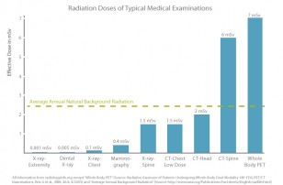](http://www.medicalradiation.com/wp-content/uploads/Radiation-Doses.jpg)

Fig. 1: Chart comparing typical effective doses of medical examinations with the average natural background radiation.

Different organs and tissues have a different sensitivity to radiation. This is why the actual risk to the body from X-ray procedures varies depending on the part of the body being X-rayed. “Effective dose” is a parameter of the dose absorbed by the entire body that takes account of these differing sensitivities.

Doctors and manufacturers are well aware of the risks and do everything possible to [minimize radiation dose](https://www.medicalradiation.com/reducing-radiation-dose/). Guided by technical standards that are set and continually updated by national and international radiology protection councils, they take special care during X-ray examinations to use the lowest radiation dose possible while producing the images for. Advanced X-ray systems contain special features that help reduce the radiation dose. For example there are technologies developed to ensure that those parts of a patient’s body not being imaged receive no or only minimal radiation exposure.

* [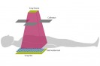](https://www.medicalradiation.com/types-of-medical-imaging/imaging-using-x-rays/radiography-plain-x-rays/)

### [Radiography (Plain X-rays)](https://www.medicalradiation.com/types-of-medical-imaging/imaging-using-x-rays/radiography-plain-x-rays/)

Conventional X-rays have advanced considerably since the earliest radiological imaging and, today, digital X-ray techniques are replacing film.

* [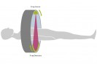](https://www.medicalradiation.com/types-of-medical-imaging/imaging-using-x-rays/computed-tomography-ct/)

### [Computed Tomography (CT)](https://www.medicalradiation.com/types-of-medical-imaging/imaging-using-x-rays/computed-tomography-ct/)

Computed tomography (CT) scanners produce detailed images of the body. Due to their high resolution, these images can provide additional information compared to conventional radiography.

* [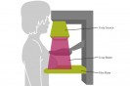](https://www.medicalradiation.com/types-of-medical-imaging/imaging-using-x-rays/mammography/)

### [Mammography](https://www.medicalradiation.com/types-of-medical-imaging/imaging-using-x-rays/mammography/)

Mammography is a special type of X-ray imaging used to create detailed images of the breast and is commonly used in screening for breast cancer.

* [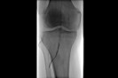](https://www.medicalradiation.com/types-of-medical-imaging/imaging-using-x-rays/angiography/)

### [Angiography](https://www.medicalradiation.com/types-of-medical-imaging/imaging-using-x-rays/angiography/)

Angiography is a specific type of X-ray technique for viewing blood vessels and organs, especially the heart, by injecting a contrast agent into the blood that enhances its visibility on the X-ray image.

* [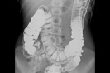](https://www.medicalradiation.com/types-of-medical-imaging/imaging-using-x-rays/fluoroscopy/)

### [Fluoroscopy](https://www.medicalradiation.com/types-of-medical-imaging/imaging-using-x-rays/fluoroscopy/)

Fluoroscopy is a type of medical imaging that produces a continuous ‘live’ X-ray image of the patient’s internal structures on a monitor.

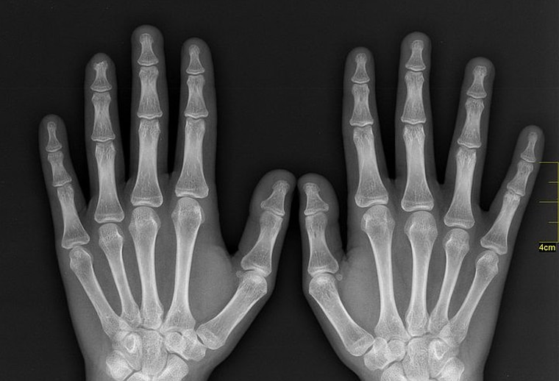

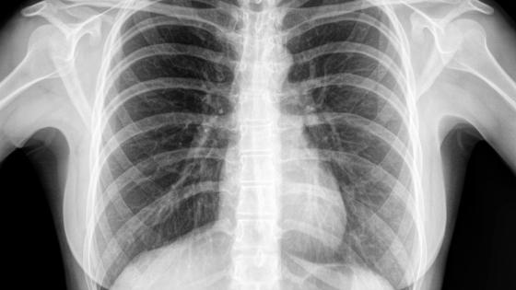

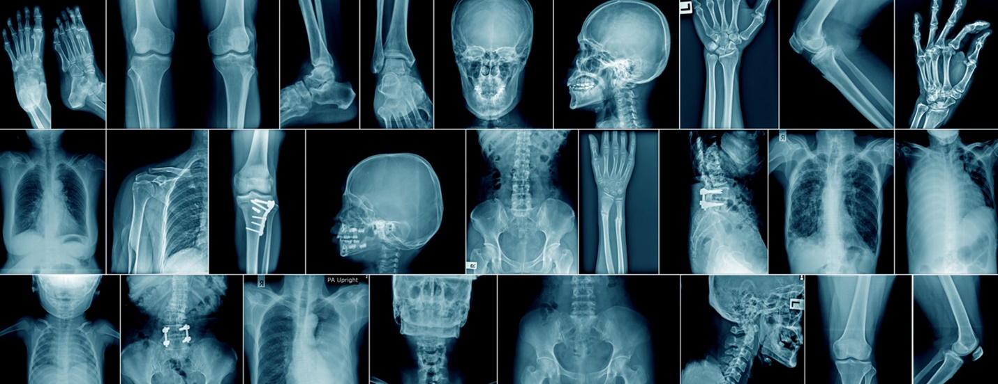

**Radio activity**

Henry Becquerel did some experiments using uranium salts. He kept some uranium salts inside a drawer and in another drawer below that, there were some unexposed films, and a key was inside the 1st drawer. He found that the image of key on the film. To get an Image there should be some rays fall on the film & react From that he understood that some radiation was emitted by uranium salts since no other substance was not there in drawers.

Emission of radiation spontaneously from certain substance is called Radioactivity. Radioactivity was discovered by Henry Becquerel. These experiments were done by Marie curie and she was helped by her husband Pierre curie.

**Production of Radioactivity**

In certain substances can emit particle like $α , β and γ$ rays. Those substances are called Radioactive substances.

$α$**Particles**

$α$ is He Nucleus It has a charge of +2, and it’s a particle.

**Notation for an element**

Mass number

x charge

Eg

+  = (ray only)

From the emission of radiation or any particles spontaneously from elements ends producing new element is called Radioactivity.

Macula they emit $α , β and γ$ rays.

$α$ particle is He nucleus ${}_{2+}^{4}α$

$β$ = ${}_{-1}^{0}e$ ${}_{0}^{0}γ$

Other than these particles, some other parcels are involved in radioactivity

Eg. positrons ( ${}_{+1}^{0}e$)

Neutron ( ${}_{0}^{1}n$) protium ${}_{1}^{1}H$ deuterium ${}_{1}^{2}H$ tritium ${}_{1}^{3}H$

**Properties of $α$ particles**

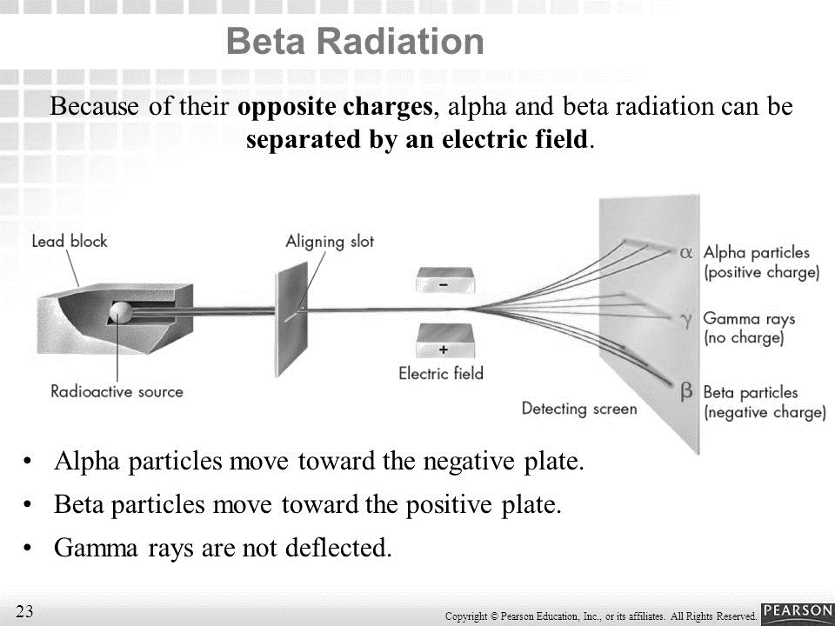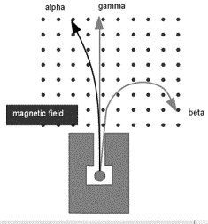Radioactive substances are kept in a Lead chamber. Therefore emitted particles / rays can’t come out for all directions.

$γ$**travels in a straight line.**

$α$**and $β$ are deviated against in a Magnetic Field). To find the direction of deflect)**

A **magnetic field** (only one pole is shown) affects radioactive rays differently depending **on** the type of ray. **Alpha** rays (heavy, positively charged particles) are deflected slightly in one direction. **Beta** rays (light, negatively charged electrons) are deflected strongly in the opposite direction. ( Apply Fleming’s left hand rule for directions) -

Use Flemming’s left hand rule.

When negative charges are moving , direction of the conventional current is to the Opposite direction.

When positive charges are moving , direction of the conventional current is to the same direction.

**Properties of $α,β$ and $γ$ rays**

**Alpha Rays**

Alpha rays are the positively charged particles. Alpha-particle is highly active and energetic helium atom that contains two neutrons and protons.  These particles have the minimum penetration power and highest ionization power. They can cause serious damage if get into the body due to their high ionization power. They are capable of ionizing numerous atoms by a short distance. It is due to the fact that the radioactive substances that release alpha particles are required to be handled after wearing rubber gloves.

**Beta Rays**

Beta particles are extremely energetic electrons that are liberated from the inner nucleus. They bear negligible mass and carry the negative charge. A neutron in the nucleus splits into a proton and an electron on the emission of a beta particle. Hence, it is the electron that is emitted by the nucleus at a rapid pace. Beta particles have a higher penetration power when compared to alpha particles and can travel through the skin with ease. Beta particles can be dangerous and any contact with the body must be avoided, though their ionization power is low.

**Gamma Rays**

The waves arising from the high-frequency end of the electromagnetic spectrum that has no mass are known as gamma rays. They hold the highest power of penetration. They are the most penetrating but least ionizing and very difficult to resist them from entering the body. The Gamma rays carry a large amount of energy and can also travel via thick concrete and thin lead.

The below table describes the characteristics of beta, alpha and gamma radiations and compares the masses and charges of the three rays.

|  |  |  |  |
| --- | --- | --- | --- |
| Property | α\alpha α ray | β\beta β ray | γ\gamma γ ray |
| Nature | Positive charged particles, 2He 4 nucleus | Negatively charged particles (electrons). | Uncharged ?~0.01a, electromagnetic radiation |
| Charge | +2e | –e | 0 |
| Mass | 6.6466 × 10–27 kg | 9.109 × 10–31 kg | 0 |
| Range | 10 cm in air, can be stopped by by 1mm of Aluminium | Upto a few m in air, can be stopped by a thin layer of Aluminium | Several m in air, can be stopped by a thick layer of Lead |
| Natural Sources | By natural radioisotopes e.g.92U236 | By radioisotopes e.g.29Co68 | Excited nuclei formed as a result of Gamma decay |

In alpha decay, an energetic helium [ion](https://www.britannica.com/science/ion-physics) (alpha particle) is ejected, leaving a ***daughter nucleus*** of [atomic number](https://www.britannica.com/science/atomic-number) two less than the ***paren***t and of [atomic mass number](https://www.britannica.com/science/mass-number) four less than the parent. An example is the decay (symbolized by an arrow) of the abundant isotope of [uranium](https://www.britannica.com/science/uranium), 238U, to a thorium daughter plus an alpha particle:

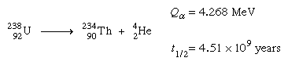

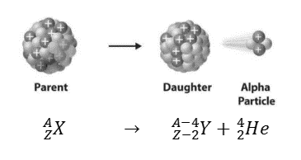Given for this and subsequent reactions are the energy released (*Q*) in millions of electron volts (MeV) and the half-life (*t*1⁄2).

**Daughter nucleus & Parent nucleus**

The original **nucleus** is called the parent **nucleus**, and the **nucleus** remaining after the decay is called the **daughter nucleus**. ... If a **nucleus** emits an alpha particle, it loses two protons and two neutrons; therefore, the **daughter nucleus** has an atomic mass of 4 less and an atomic number of 2 less than the parent **nucleus**.

**Radioactive decay**

In the periodic table, most of the elements are stable. But heaviest nudes are not completely stable (mainly f block). This unstable nuclei can emit off radiation spontaneously by emitting $α, β$ particles or sometimes followed by $γ$ rays (photons)

The emission of radiation spontaneously from unstable nuclei is called disintegration. Using that, we can state as follows. The unstable nuclei disintegrate by emitting $α, β$ praticles and $γ$ rays. This is called Radioactive decay. When any radioactive decay of substance, or any radioactive reaction , is connected the mass and charge is conserved the mass and charge is conserved separately. After decay, another element is produced. There can be more than one.

The one which decay is called parent element. The one we obtain is called daughter element.

${}_{a}^{b}X$ $→$ ${}_{2}^{4}d$ + ${}_{c}^{d}Z$

Since charge is conserved a = 2 + c

Since mass is conserved b = 4 + d

Eg. ${}_{88}^{226}{Ra}$ emits He nucleus. Find the produced element

${}_{88}^{226}{Ra}$ $→$ ${}_{2}^{4}α$ + ${}_{b}^{a}X$

a + 4 = 226 ; b + 2 = 88 ; a = 222 ; b = 86 Now check in the periodic table the actual element

corresponding to ${}_{86}^{222}X$ ie ${}_{86}^{222}{Rn}$

${}_{88}^{226}{Ra}$ $→$ ${}_{2}^{4}α$ + ${}_{86}^{222}{Rn}$

In some radioactive element decay, until it produce a stable element (light element)

If $α$ is involved in decaying, it is called $α$ decay.

If $β$ is involved, it is called $β$ decay.

**eg. For $α$ decay**

${}_{92}^{238}{Ur}$ $→$ ${}_{2}^{4}α$ + ${}_{90}^{234}{Th}$

${}_{88}^{226}{Ra}$ $→$ ${}_{2}^{4}α$ + ${}_{86}^{222}{Rn}$

**eg - For $β$ decay**

${}_{6}^{14}C$ $→$ ${}_{-1}^{0}β$ + ${}_{7}^{14}N$

When $γ$ rays are emitted, those can be considered as photons Most of the Occasion, excited state elements emit $γ$ rays.

${}_{a}^{b}X$ $→$ ${}_{0}^{0}γ$ + ${}_{c}^{d}Y$

a = 0 + C

b = 0 + d

${}_{a}^{b}X$ $→$ ${}_{0}^{0}γ$ + ${}_{a}^{b}X$

Energy is lost

There are some natural radioactive series, from certain elements disintegration occurs spontaneously. Normally there are 2 series

1. Uranium series
2. Thorium Series

${}_{92}^{238}U$ $→{}_{90}^{234}{Th}$ $→{}_{91}^{234}{Pd}→{}_{92}^{237}{Pd}$ $→$…………………… ${}_{82}^{206}{Pb}$ $⇐$ Uranium series end up with stable ${}_{82}^{206}{Pb}$

${}_{2}^{4}α$ ${}_{-1}^{0}β$ $β$

${}_{90}^{232}{Th}$ $→{}_{88}^{228}{Ra}$ $→{}_{89}^{228}{Ac}→{}_{90}^{228}{Th}$ $→$…………………… ${}_{82}^{208}{Pb}$ $⇐$ Thorium series ends with stable ${}_{82}^{208}{Pb}$

$α$ $β$

**Actinium also has a natural series**

${}_{89}^{227}{Ac}$ ends up with ${}_{82}^{207}{Pb}$

**Finally they end with Pb Isotopes.**

**Artificial Radioactivity**

In laboratories, some elements are reacted together with parantals. New elements are produced there may be some other particles involved. This is called Artificial Radioactivity.

+ +

eg –

${}_{11}^{22}{Na}$ can not be found in nature. It is very unstable & radioactive. It emits a positron and comes to a stable state

${}_{11}^{22}{Na}$ $→$ ${}_{+1}^{0}β$ + ${}_{10}^{22}{Na}$

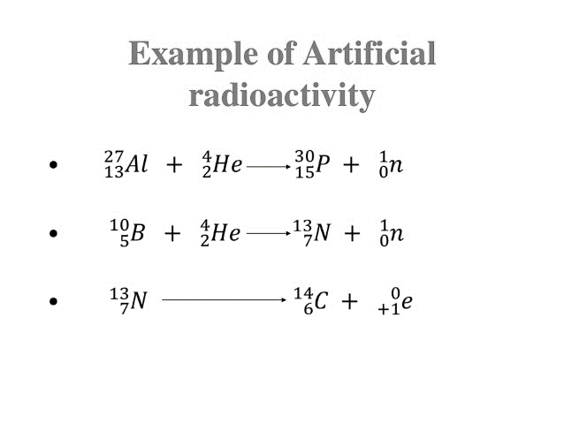

**Geiger Muller counter**

To measure the radioactivity, Geiger Muller counter is used

|  |
| --- |
| *[http://atomic.lindahall.org/siteart/questions/geiger-counter_sm.jpg](http://atomic.lindahall.org/siteart/questions/geiger-counter_lg.jpg)Geiger counters are used to detect radioactive emissions, most commonly beta particles and gamma rays. The counter consists of a tube filled with an inert gas that becomes conductive of electricity when it is impacted by a high-energy particle. When a Geiger counter is exposed to ionizing radiation, the particles penetrate the tube and collide with the gas, releasing more electrons. Positive ions exit the tube and the negatively charged electrons become attracted to a high-voltage middle wire. When the number of electrons that build up around the wire reaches a threshold, it creates an electric current. This causes the temporary closing of a switch and generates an electric pulse that is registered on a meter, either acoustically as a click that increases in intensity as the ionizing radiation increases, or visually as the motion of a needle pointer.   Radioactivity can be measured in order to discover the amount of radiation a material emits or the amount of radiation absorbed by a human or mammal. The unit for measuring radioactive emissions is the becquerel (Bq). The Bq indicates the number of decays per second. The roentgen equivalent in man (rem) is an older standardized unit for measuring absorbed dose. The mrem, 1000th of that unit, is the unit used today in medicine.*  *https://upload.wikimedia.org/wikipedia/commons/d/da/Geiger-Muller-counter-en.png****The sound of a Geiger counter*** *is often associated with nuclear weapons and fallout. While it is useful in these situations, it is also used every day for the detection and control of nuclear waste, by-products and exposure in nuclear power plants, hospitals and even mines.*  *These ingenious devices allow anyone to detect potentially harmful radiation around them, using the power of electrons and the degradation of unstable radioactive atoms.*  *The detector is the main part of the Geiger counter. It is responsible for capturing, detecting and then signalling that a radioactive particle, known as a radioactive isotope, has passed through the detector.*  *In order to understand what is going on, we first must know what radioactive ionising radiation is, why it is worth detecting and what makes the distinctive clicking sound.*  *Atoms are one of the fundamental building blocks of matter in the Universe.*  *Every element is made up of atoms with their own number of subatomic particles. Hydrogen is the simplest atom, having just one positively charged proton and one negatively charged electron. Having no neutral neutrons it is extremely stable, being used today in a wide variety of applications.*  *Uranium, on the other hand, has 92 protons, 92 electrons and 146 neutrons. This makes it much heavier and far more unstable, very slowly breaking apart into smaller, and more stable elements.*  *When it breaks down, it releases energy and small particles. These by-products of the atom breaking down have the ability to knock electrons off other nearby atoms, and so are known as ionising radiation. Remember this point as it is vital to understanding how the Geiger counter works.*  *Radiation comes in three main types: alpha, beta and gamma.*  *Alpha particles are slow and can’t travel more than a few centimetres.*  *Beta particles are able to travel further. Gamma radiation (not a particle, but an energy wave) can travel long distances and penetrate many metres of solid concrete. It is the most dangerous type of ionising radiation as it can penetrate the body, causing massive damage to the atoms inside our cells.*  *That’s why a Geiger counter is usually tuned to best detect beta particles and gamma radiation as they have the greatest potential to cause harm to our bodies.* |

**Radioactive decay and Half life time $t_{\frac{1}{2}}$**

When these is a radioactive decay, within the some duration, its mass or activity becomes half, with the same constant period. This constant period is called **half life time.**

$\frac{t1}{2}$ $\frac{t1}{2}$ $\frac{t1}{2}$

M $→ \frac{M}{2^{1}}$ $→$ $\frac{M}{2^{2}}$ $→$ $\frac{M}{2^{3}}$ $→$…………………… $\frac{M}{2^{n}}$

after one after 2 after 3 after n

½ life ½ lives ½ lives ½ lives

If you consider disintegration

$\frac{t1}{2}$ $\frac{t1}{2}$ $\frac{t1}{2}$ $\frac{nt1}{2}$

N $→$ $\frac{N}{2^{1}}$ $→$ $\frac{N}{2^{2}}$ $→$ $\frac{N}{2^{3}}$………………………… $\frac{N}{2^{n}}$

½ Life time varies for different elements.

eg ; ${}_{92}^{238}{Ur}$- 4.51 x ${10}^{4}$ years

- 24.1 days

- 2.47 x ${10}^{5}$ years

- 1620 years

- 3.82 days

- 3.05 min

- 5730 years

**Activity of a given Radioactive Substance**

***Number of disintegrations per second is defined as activity.***

**Law of Radioactivity decay**

In a radioactive sample the rate of emission of particles per unit time (for 1s) is directly proportional to number of particles in the sample **in that instant.**

If N number of particles are emitted in t seconds, then

$\frac{N}{t}$ = Rate of emission of particles.

Using calculate notation, (-) for decaying,

= - $\frac{dN}{dt}$

Using decay law,

- N

- = N

$λ$ = decay constant

- =

Using integration,

${}_{No }^{N}{(luN)}$ = - $λ$ (${t)}_{0}^{+}$

N = $N_{0}e^{-λt}$ (Not in the Syllabus)

==========

$t_{\frac{1}{2}}$

No

=

=

Ln1 = - $λ$ t1/2

2.303lg2 = $-λ$ t1/2

0.693 = $-λ$ t1/2

t1/2 = $\frac{0.693}{λ}$

Not in Syllabus

**The graph, the number of decays vs time**

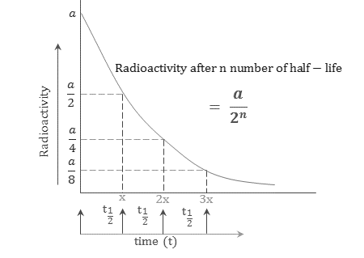

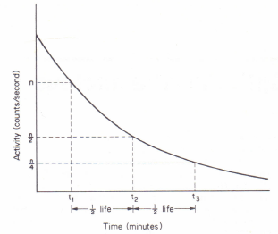

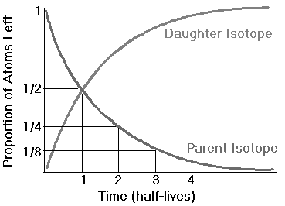

Q. Initial activity of a radioactive material is 100. ½ time is 5min. What is the amount of substance after

1. 625min?

2. for 20min

**Rate of decay - $\frac{-dN}{dt}$ =**

Also called activity of the substance.

No = Initial number of parent nuclei present

N = Number of parent nuclei present after time t.

$λ$ = Decay constant,

The fraction of nuclei decaying in unit time

Dimensions of $λ$ = Tn

Initially mass of radioactive element is 200 $μ$ g. Lates it is found to be 12.5ng. If ½ time is 30 days. Find the time taken to show this activity.

Q. ${}_{36}^{87}{Kr}$ half life time is 78min. Find the activity of 10 $μ$ g of Kr. L = 6 x ${10}^{23}$ ${mol}^{-1}$?

Q. Mass of ${}_{6}^{11}C$ is 3.5 $μ$ g half life time is 20.4 min. find the initial activity. L = 6 x ${10}^{23}$?

Q. the half life time of ${}_{88}^{226}{Rn}$ x 5 1.6 x ${10}^{3}$ years. If it has 3 x ${10}^{16}$ allows. Find the activity at that time.

Activity is measured using Becquerel (Bq)

Activity is measured using. Because (Bq) (SI Unit) If Number of disintegration per second is one, then the activity is called one Bq.

Most of the time, the unit curie is used not as SI units. Denoted by (Ci)

When 3.7 x ${10}^{10}$ disintegration are there for a radioactive element per second, It is defined as 1 Ci. This is equal to amount of radiation from 1g of Ra in one second.

(Ci = 3.7 x ${10}^{10}$ Bq

Other Units mCi , $μ$ Ci

1 $μ$ Ci = ${10}^{-3}$ Ci

1 $μCi = {10}^{-6}$ Ci

1Ci = 3.7 x ${10}^{10}$ Bq

=====================

**Uses of Radioisotopes**

Radioisotopes are used to study various problems in Physics, Chemistry and Biology. Radioisotopes have so many uses, just because of two properties.

1. They are chemically identical.
2. They can be easily detected. The masses of even small amounts of radioisotopes may be

accurately determined.

The applications of isotopes can be classified under two categories,

(i) As tracers and

(ii) as sources of radiation.

**1.Isotopic tracer — tagging**

*The process of adding very small amount of radioisotopes to an element is called tagging or labelling and the isotope used is called isotopic tracer.* This method of studying the dynamics of a particular system, by observing the course of radioisotope added to it, is called **tracer technique***.* For example, phosphorous uptake by plants from the soil can be studied, using a phosphate fertilizer, containing the radiophosphorous isotope. Using Iodine-131, brain tumour can be detected. The transport of fluid by the roots and plants can be studied by the tracer method

**2.Radioisotopes are used in Medicine for diagnosis as well** as **therapy**

(i) The circulatory disorder in blood vessels can be detected by injecting radiosodiumβ

and studying its path by recording the β and ϒ-rays using a Geiger counter.

(ii)For the detection of anemia, radio-iron is injected, After some time, the blood is tested by measuring its activity, thus anemia can be detected.

(iii)Radioactive iodine is absorbed by thyroid gland very quickly. This tact is used in the detection and effective treatment of hyperthyroidism, without surgery or X-rays.

(iv)Radiostrontium is used to remove tumours.

(v) For the treatment of skin disease, radiophosphorous is used. (w) For cancer treatment, cobalt-60 and caesium-137 are used.

(vi) For the treatment of cancerous tissues, hollow thin walled *sealed* metal needles, filled

with radon gas are implanted in the affected region.

**3.In industry**

(i) To find the thickness of walls or plates, which cannot be measured by other devices like callipers etc. For this, a radioisotope is placed on one side and a counter on the other side. From the count rate, thickness can be found out.

(ii) The hydrogen content of the oil in oil well, can be studied. For this neutrons produced during artificial radioactivity is used.

(iii) Using a bearing made of radioactive steel, it is possible to know how much a given bearing will wear out, under certain conditions of running. For this radioactivity in the lubricating oil is measured.

(iv) To detect the leakage in the burned pipes carrying petroleum and other liquids.

**4.In agriculture**

(i) If the seeds are exposed to radionuclides, then they can germinate & grow into unusual plants. Their characteristics will be much improved.

(ii) For producing new plant varieties, cobalt-60 is used.

(iii)The process of photosynthesis can be studied, using radioisotopcs.

(iv)The absorption of fertilizers by wheat can be studied, using radiophosphorus.

**5.Sterilisation**

(i) Bacteria are killed when suitable radiation is allowed to fall on them

(ii) If perishable articles are exposed to radiations, they remain fresh beyond their normal

life-span.

(iii) The sprouting, of onions, potatoes etc. can be delayed, if they are exposed to

radiations,

(iv) Storage time of foodstuffs can be extended, if they are eradicated with suitable

radiations.

**6.In chemistry**

(i) Radioisotopes are used to study the reaction-rate.

(ii) To study the molecular structure.

(iii)Using radioisotopes, several synthesized elements are produced

(iv) By eradicating polythene with radiations, linkage of molecules can be effected which increases the strength of the material.

1. By allowing the radiations to fall on suitable salts, luminescence may be produced.
2. **Production of Electricity**

The radiations emitted from radioisotopes produce heat, when they are absorbed by matter. The heat thus produced is used to generate electricity. Sr*90, Cs*137 etc. are the isotopes used for this.

By surrounding strontium titrate with a mosaic of semiconductor thermocouples electricity can be produced.

9.Thickness of very thin films can be found out by knowing the radiations absorbed by them.

1. Radioactive cobalt Co60 is used for making cobalt-bomb.
2. Radioactive cobalt Co60 is used for testing of welds and castings, to find the flaws in them, by taking photographs with y-rays emitted from Co60 .

**Carbon Dating**

* **Carbon-14 is a weakly radioactive isotope of Carbon; also known as radiocarbon, it is an isotopic chronometer.**
* **C-14 dating is only applicable to organic and some inorganic materials (not applicable to metals).**

${}_{6}^{12}C$ Common isotope in C. (${}_{7}^{14}N$) $N_{2}$ atmosphere react with neutron and produce ${}_{6}^{14}C$ and one proton. ${}_{6}^{14}C$ is unstable. It is radioactive Carbon. It’s half life time is 5730 years. The rate of producing ${}_{6}^{14}C$ in the atmosphere and decaying ${}_{6}^{14}C$ in the atm is having the same values. Therefore amount of ${}_{6}^{14}C$ remains constant. Normally ${}_{6}^{12}C$ is present in the alm and in other substance in the world. Accordingly to (Cycle, ${}_{6}^{12}C$ amount does not change. $∴$ the ratio between ${}_{6}^{4}C$/ ${}_{6}^{12}C$ remains constant in all substance on the earth. It is the same for living objects.

+ +

After the death of any living body ${}_{6}^{14}C$/ ${}_{6}^{12}C$ ratio reduces according to the half life time of ${}_{6}^{12}C$. First find the rate of activity of ${}_{6}^{14}C$ or its ratio of its activity of ${}_{6}^{14}C$/ ${}_{6}^{12}C$ with a fossil or dead body.

Using N = $N_{0}e^{-λt}$ find t the age.

${}_{7}^{14}C$ $→$ ${}_{-1}^{0}e$ + ${}_{7}^{14}N$

**The nucleus was discovered in 1911 by Ernest Rutherford, a physicist from New Zealand. In 1920, Rutherford proposed the name proton for the positively charged particles of the atom. He also theorized that there was a neutral particle within the nucleus, which James Chadwick, a British physicist and student of Rutherford's, was able to confirm in 1932.**

**Virtually all the mass of an atom resides in its nucleus, The protons and neutrons that make up the nucleus are approximately the same mass (the proton is slightly less) and have the same angular momentum, or spin.**

**The nucleus is held together by the** [**strong force**](https://www.livescience.com/48575-strong-force.html)**, one of the four basic forces in nature. This force between the protons and neutrons overcomes the repulsive electrical force that would otherwise push the protons apart, according to the rules of electricity. Some atomic nuclei are unstable because the binding force varies for different atoms based on the size of the nucleus. These atoms will then decay into other elements, such as carbon-14 decaying into nitrogen-14.**

**Non-SI unit of mass (equal to the atomic mass constant), defined as one twelfth of the mass of a carbon-12 atom in its ground state and used to express masses of atomic particles,**

**1u≈1.660 5402×10−27 kg.**

**Nucleolus Energy**

When we consider protons and neutrons, they can be called Nucleolus. The diameter of the nucleus is ${10}^{-15}$ m and the diameter of atom is ${10}^{-10}$ m. 99.9% of mass is concentrated on the nucleus To measure the mass of these particles, we are a different unit called unified atomic mass unit. Denoted by u.

This unit is equal to 1/12 th mass of ${}_{6}^{12}C$ atom.

1u = 1.66 x ${10}^{-27}$ kg

**Einstein equation for energy**

E = ${mc}^{2}$

Using this, we can the energy corresponding to 1U.

E = 1.66 x x (3 x )2

E = 1.494 x x ${10}^{-10}$

E = 991 Mev

**Binding Energy of an atom**

When stable nucleus is formed, protons and neutrons are to be combined, the mass of the nucleon is less than the mass of the neutron and proton combined together Acc. To Einstein equation, E = ${mc}^{2}$ can, find the Energy different m is the mass different. According to this, certain amount of energy is given out while forming the nucleus.

This energy different is called Binding energy of the nucleus. If you consider any stable, huetrons and proctor to be separated. The min energy required is equal to the Bq.

Q. Mass of proton = 1.00783u.

Mass of neutron = 1.00867 u

$M_{2}^{o}$ He = 4.00260u.

Acc. To this find the binding energy of the nucleus.

Q. find the Bq of ${}_{1}^{3}H$

$M_{1}^{3}$ H = 3.00953u.

Sometimes they ask you to find mean Bq.To find the mean value, divide the total BE by the number of nucleons in that.

Avg / Mean BE = $\frac{Total BE }{Nucleon Number }$

Mean binding energy changes rapidly up to Be but after that the value changes

The following graph should the mean BE VS mass Number around 60, peak value is seen. Around these peak value, Nucleolus are more stable. After that stability reduces

**Nuclear Binding Energy**

Nuclei are made up of [protons](http://hyperphysics.phy-astr.gsu.edu/hbase/particles/proton.html#c1) and [neutrons](http://hyperphysics.phy-astr.gsu.edu/hbase/particles/proton.html#c3), but the mass of a nucleus is always less than the sum of the individual masses of the protons and neutrons which constitute it. The difference is a measure of the nuclear binding energy which holds the nucleus together. This binding energy can be calculated from the [Einstein relationship](http://hyperphysics.phy-astr.gsu.edu/hbase/relativ/releng.html#c1):

Nuclear binding energy = Δmc2

For the alpha particle Δm= 0.0304 u which gives a binding energy of 28.3 MeV.

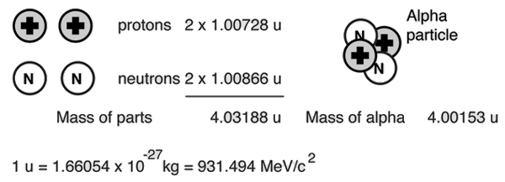

The enormity of the nuclear binding energy can perhaps be better appreciated by comparing it to the binding energy of an electron in an atom. The comparison of the alpha particle binding energy with the binding energy of the electron in a hydrogen atom is shown below. The nuclear binding energies are on the order of a million times greater than the electron binding energies of atoms.

|  |  |  |
| --- | --- | --- |
|  |  |  |

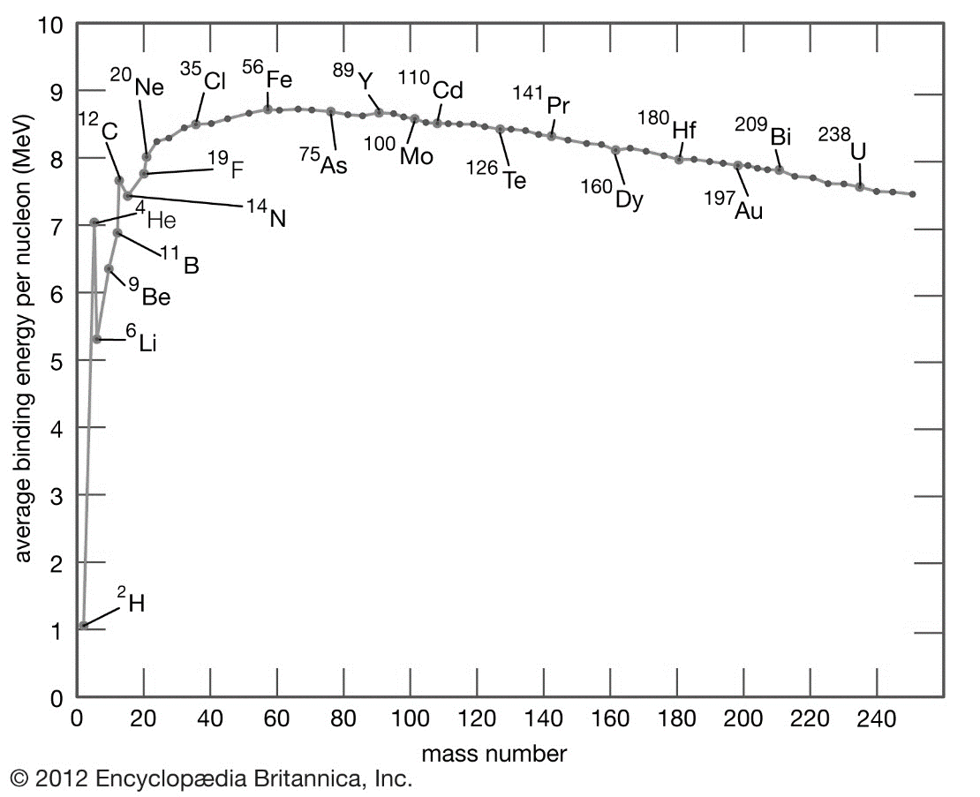

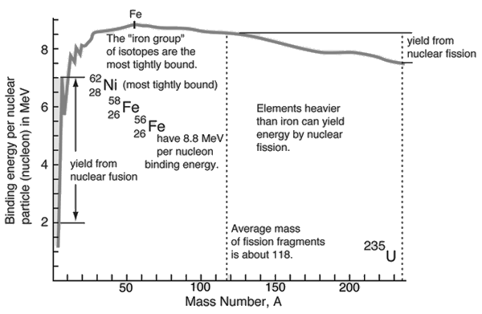

.

**Nucleus Reactions**

Reechoes with nucleolus and any other particles are called Nucleus Reactions.

Some nucleolus can collide with neutrons or protons and produce energy.

There are 2 kinds of nucleus Re’s

1. Nuclear Fission
2. Nuclear fusion

# Nuclear Fission:

When a nucleus fissions, it splits into several smaller fragments. These fragments, or fission products, are about equal to half the original mass. Two or three neutrons are also emitte

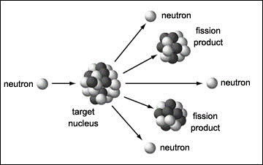The sum of the masses of these fragments is less than the original mass. This 'missing' mass (about 0.1 percent of the original mass) has been converted into energy according to Einstein's equation.

Fission can occur when a nucleus of a heavy atom captures a neutron, or it can happen spontaneously.

**Nuclear Chain Reactions**

A chain reaction refers to a process in which neutrons released in fission produce an additional fission in at least one further nucleus. This nucleus in turn produces neutrons, and the process repeats. The process may be controlled (nuclear power) or uncontrolled (nuclear weapons).

U235 + n → fission + 2 or 3 n + 200 MeV

If each neutron releases two more neutrons, then the number of fissions doubles each generation. In that case, in 10 generations there are 1,024 fissions and in 80 generations about 6 x 10 23 (a mole) fissions.

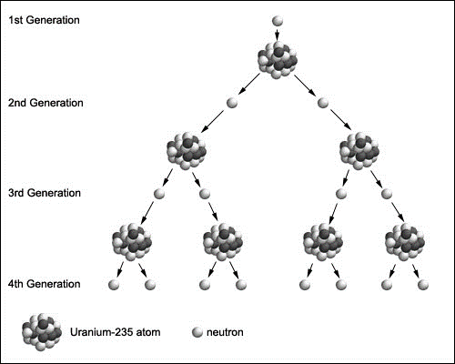**Energy Released From Each Fission**

Nucleus fission is the decay process in which a stable nucleus splits into two fragments or more instead of emitting $α, β or γ$. A large amount of energy is emitted.

Eg; when,

$${}_{92}^{235}U collide with neutrons.$$

|  |  |
| --- | --- |
| 165 MeV 7 MeV 6 MeV 7 MeV 6 MeV 9 MeV  **200 MeV** | ~ kinetic energy of fission products ~ gamma rays ~ kinetic energy of the neutrons ~ energy from fission products ~ gamma rays from fission products ~ anti-neutrinos from fission products |

+ and sprit into fragments

+ + 3 ${}_{0}^{1}n$

1. ${}_{92}^{235}U$ + ${}_{0}^{1}n$ $→$ ${}_{56}^{144}{Ba}$ + ${}_{36}^{89}{Kr}$ + 3 ${}_{0}^{1}n$ + $∈$
2. ${}_{92}^{235}U$ + ${}_{0}^{1}n$ $→$ ${}_{92}^{236}U$
3. ${}_{92}^{235}U$ + ${}_{0}^{1}n$ $→$ ${}_{54}^{140}{Xe}$ + ${}_{38}^{94}{Sr}$ + 2 ${}_{0}^{1}n$ + $∈$

**Fusion;**

This is the combining nucleus, In nucleus fusion, 2 or more light nucleus (fuse together) to form a larger nucleus fusion re release energy. The BE per nucleus after is greater than the fission fusion produces more energy than fission.

eg; around the sun, energy forms according to nucleus fusion

+ + Energy

+

+ + + Energy

Nuclear fusion is a way of producing energy by joining two light nuclei together to get one heavier nucleus.   
**It is nuclear fusion that powers the stars!**  
One simple reaction is to join two nuclei of heavy hydrogen (deuterium) together to make one nucleus of helium.

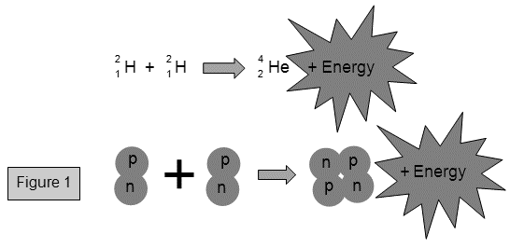

The reason that energy is produced is that the mass of the two deuterium nuclei is slightly greater than the mass of the one helium nucleus. This tiny difference becomes energy. You can work out the amount of energy released by using the famous equation proposed by Albert Einstein:

Energy (E) = mass (m) x (speed of light)2  
E = mc2

You don't get much energy produced when two nuclei fuse as you do when one nucleus of uranium splits but because deuterium is so much lighter than uranium there are many more nuclei per kilogram of material and the energy released per kilogram is actually a little more for deuterium fusion than for uranium fission.   
Deuterium is found in water (since a water molecule is made of two hydrogen atoms and one oxygen atom) and in fact one atom in every 5000 atoms of hydrogen in sea water is deuterium. This means that there is a vast supply of deuterium as heavy water that could be used for fusion.

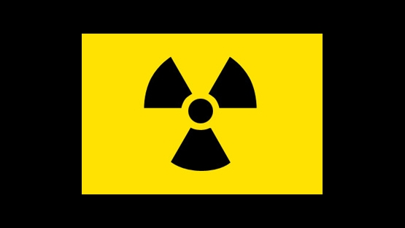Certain H atoms are lost, we assume that the sun’s mass contain 4.2 x ${10}^{23}$ protons If all these protons were fused the total energy released would be 130 ${Kwh}^{-1}$. If sun radiation contriously at its present rate, it would exhaust its supply of protons in about 30 Billions years.

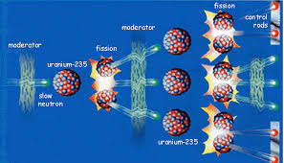

**(01) Give a labelled diagram of a set up that can be used to investigate photoelectric effect. (i) Sketch the variation of photocurrent** (I) with the potential difference (V) between the electrodes for light of fixed intensity and frequency. Draw the expected variations of

I with V for the light of (1) same frequency but twice the intensity and ( 2 ) same intensity but a higher frequency on your above sketch. Label situation (1) as X and situation (2) as Y (ii) A surface of a metal is illuminated with light and photoelectrons are observed.

(1) What is the largest wavelength that will cause photoelectrons to be emitted ? (2) What is the stopping potential when light of wave length 220 nm is used? What is the maximum velocity of the emitted electrons? Work function of the metal = 4.08 eV, Mass of the electron = 9.11x10-31kg , Electronic charge = 1. 60 x 10-19C , Velocity bf light = 3.0x108ms-1  Planck constant = 6.6x10-34Js

**[** **3.05x10-7m , 7.4x105ms-1]**

**(02) Read the following passage carefully and answer the questions given below. Not all atomic nuclei are stable. Unstable nuclei** transform themselves into other nuclei by spontaneous emission of α particles, β particles and γ-rays. Such unstable nuclei are said to be radioactive nuclei. This phenomenon was discovered in 1896 by a French scientist named Henri Becquerel. The rate of decay which is called the activity (A) of a given radioactive sample is directly proportional to the number of unstable nuclei (N) in the sample. This radioactivity law can be expressed as A = λN , where λ ( =0.693/T ) is the decay constant and T is the half-life. One important application of radioactivity is the radiocarbon dating which is a technique used for the determination of the age of fossils. Radioactive carbon 146C is being produced continuously in the Earth's atmosphere as a result of a nuclear reaction between a nitrogen 147N atom in air and a cosmic ray neutron with the emission of a proton. Subsequently 146C atom decays into nitrogen by emitting a β- particle with a half-life of 5730 years (=1.8 x 1011s). Because of these two processes there exist an equilibrium between the rate at which 146C is produced in the atmosphere and the rate at which it decays. As the composi­tion of the Earth's atmosphere and the flux of cosmic rays have not been changed significantly in the last few thousand years, the ratio, ( number of 146C atoms ) / (number of' 126C atoms) which is 10-12 in atmospheric carbon dioxide (CO2) can be considered to be constant throughout this period. Living plants and animals take carbon from the atmosphere and hence the percentage of 146C in plants and animals remains constant as long as they are alive. When a plant or an animal dies, the 146C continues to decay without being replaced. As a result the percentage of 146C decreases with time. In radioactive carbon dating the number of β- particles given off in a certain period of time by a fixed volume of CO2, gas in the atmosphere at a given temperature and pressure is first measured using a particle counter. Hence the activity of 146C in the atmospheric CO2 volume can be calculated. Then a small piece of the fossil is burnt and an equal volume of CO2 under the same conditions is prepared. The activity of 146C in the fossil sample can be calculated by measuring the number of β- particles emitted from this CO2 volume. Using the above data the  
age of the fossil can be determined , (i) What is the SI unit of activity? (ii) Write down the law of radioactivity in words. (iii) Define the half-life of a radioactive sample. (iv) What is the reason for the radioactive decay of certain nuclei? (v) Write down the nuclear reaction corresponding to the production of 146C in the atmos­phere. (vi) Write down the decay reaction of 146C . (vii)What are β- and β+ particles? What is an α particle? (viii)Explain how the percentage of 146C in the atmosphere remains constant. (ix)Find the decay constant λ of'146C.

(x) There are 5.0 x1022 atoms of 126C in 1g of carbon. If all the β- , particles emitted by a sample of 1g or carbon of a living plant are counted, how many counts would be accumulated in one hour. (xi) Radiocarbon dating has been used to find the age of a piece of fossil. Number of β- counts obtained in one hour from 1g of carbon in the fossil is found to be 347. Find the age of the fossil.

**[****3.85x10-12s-1 , 693 acc , 5730yrs]**