**MOBILE 0777 70 71 61 SARATH DEVAPPRIYA**

**Vernier Caliper** /**Calliper**

**The Vernier Caliper is a precision instrument that can be used to measure internal and external distances extremely accurately.**



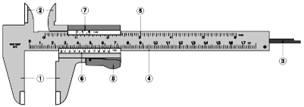

**Parts of a vernier caliper:**

1. **External jaws**: used to measure external lengths 2. **Internal jaws**: used to measure internal lengths

**3. Depth probe/shaft/blade**: used to measure depths 4.**Main scale** (cm) 5.**Main scale** (inch)

**6. Vernier** **scale** (cm) 7.**Vernier**  **scale** (inch)

8. **Retainer**: used to block movable part to allow the easy transferring a measurement

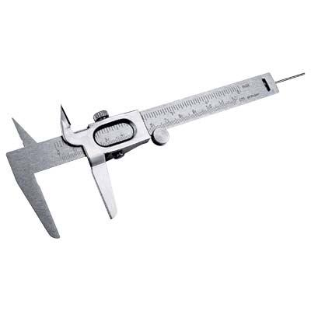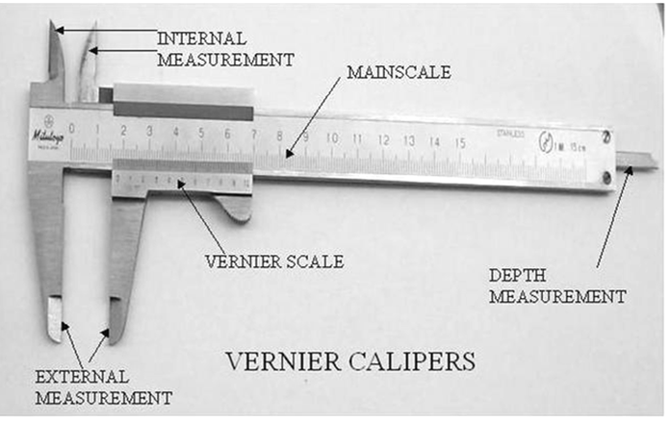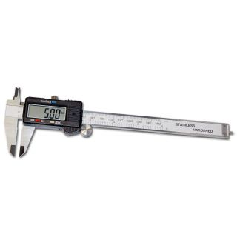 **Digital vernier caliper**

[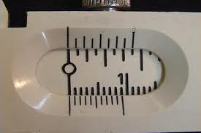](http://images.google.lk/imgres?imgurl=http://phoenix.phys.clemson.edu/tutorials/measure/zero.jpg&imgrefurl=http://phoenix.phys.clemson.edu/tutorials/measure/&h=480&w=720&sz=33&hl=en&start=44&tbnid=Md5tsJGjDn_CsM:&tbnh=93&tbnw=140&prev=/images?q=Students+Vernier++caliper&start=40&gbv=2&ndsp=20&hl=en&sa=N)

**Long Jaws Vernier Caliper**

The least value that can be measured by an instrument is called The least count of the instrument.

**The value of one vernier scale division = $\frac{The value of the n number of divisions on the main scale}{number of divisions on the vernier scale }$**

**The least count = The value of one main scale division - The value of one vernier scale division**

***The least count = (The value of main scale division/divisions - The value of one vernier scale division***

***Just before the 1st division on the vernier scale)***

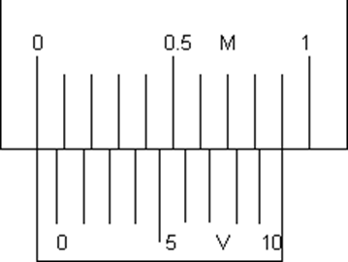**Students Vernier Caliper**

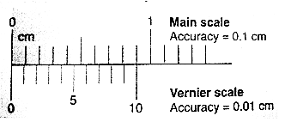

**A Students vernier caliper is used to measure a**

* small object with dimension up to  **12cm**
* There are two pair of jaws, one is designated to measure linear and outer/external diameters while  
  the other is to measure inner /internal diameter
* A vernier caliper consists of two steel bar scales, one sliding over the other.

(i) The main scale is graduated in intervals of **1 mm.**

(ii) The sliding vernier scale has a scale on which ten divisions are equal to

nine small divisions on the main scale **( 9mm )**

(iii) The difference between the sizes of one division on the main scale and

one division on the vernier scale is **1mm- .9mm = 0.1mm = 0.01cm** giving a vernier scale an accuracy **of**

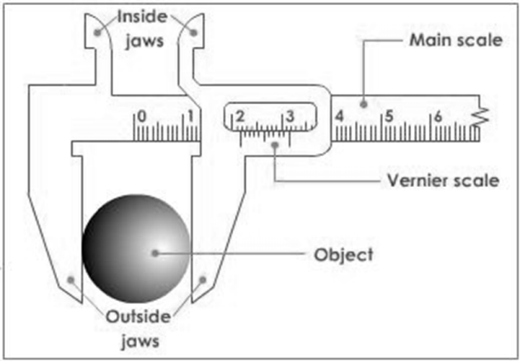 **0.01 cm.**

**How to use Vernier Calliper**

* Close the jaws **lightly** on the object to be measured.
* If you are measuring something with a round cross section, make sure that the axis of the object is perpendicular to the caliper. This is necessary to ensure that you are measuring the full diameter and not merely a chord.
* Ignore the top scale, which is calibrated in inches.
* Use the bottom scale, which is in metric units.
* Notice that there is a fixed scale and a sliding scale.
* The boldface numbers on the fixed scale are centimeters.
* The tick marks on the fixed scale between the boldface numbers are millimeters.
* There are ten tick marks on the sliding scale. The left-most tick mark on the sliding scale will let you read from the fixed scale the number of whole millimeters that the jaws are opened.

**Vernier Scale Reading = least count x Number of the division which coincides with the main scale division**

**Vernier Caliper Reading = main scale reading + (least count x Number of the division which**

**coincides with the main scale division)**

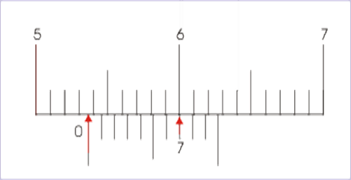**Vernier Caliper Reading** **= main scale reading + Vernier Scale Reading**

**Wow to read Vernier Calliper**

1. **First obtain the main scale reading.**

That is the reading on the main scale **up to the main scale division** just before **the zero division on the vernier scale**

MSR =53mm= 5cm + 3mm = 5cm +0.3cm = 5.3cm

1. **Now obtain vernier scale reading.**

That is the reading on the vernier scale corresponding to the vernier scale division which coincides with a main scale division.

7th division on the vernier scale

**Vernier Scale Reading = least count x Number of the division which coincides with the main scale division**

= 0 .1mm x 7 = 0.7mm = 0.07cm

**Vernier Caliper Reading = main scale reading + Vernier Scale Reading**

= 5.3cm + 0.07cm = 5.37cm

**Vernier caliper reading is** = 5.37 x 10mm = 53.7mm

**Least count of Different Vernier Callipers**

**Eg 1 49 divisions on the main scale are divided in to 50 on the vernier scale**

The least count = The value of one main scale division - The value of one vernier scale division

= 1mm - $\frac{1mmx49}{50}$ = 1mm – 0.98mm = 0.02mm

**Eg 2 39 divisions on the main scale are divided in to 20 on the vernier scale**

The least count = (The value of main scale division/divisions - The value of one vernier scale division

Just before the 1st division on the vernier scale)

= 2mm - $\frac{1mmx39}{20}$ = 2mm – 1.95mm = 0.05mm

**For MCQ’s**

**The least count** = $\frac{The value of one division on the main scale}{number of divisions on the vernier scale }$

**Eg 1**  **The least count** = $\frac{1mm}{50}$ = 0.02mm

Eg 2 **The least count** = $\frac{1mm}{20}$ = 0.05mm

**ZERO ERROR OF VERNIER CALLIPHERS**

**(i) No zero error.**

The '0' mark on the main scale is exactly in line with the '0’ mark On the vernier scale when the vernier

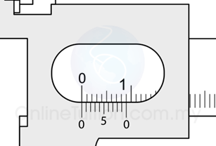 caliper is fully closed.

**( ii) Positive zero error**

The vernier scale is at distance to the right of the '0' mark on the main scale when vernier caliper is fully

closed .

Eg 1 This error is positive zero error = + 0.02 cm Eg 2 This error is positive zero error = + 0.03 cm

(Fig. 1) Correction = - 0.02cm (Fig. 2) Correction = - 0.03cm

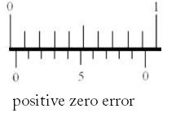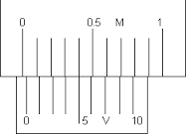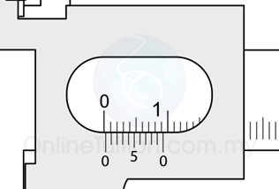

**(Fig. 2)**

**(Fig. 1)**

**(iii) Negative zero erro**r

**Negative zero erro**r = **(Total number of divisions - Number of the coincident ) x least count**

**on the vernier scale division**

The vernier scale is at distance to the left of the '0' mark on the main scale when vernier caliper is fully closed.

This error is negative zero error = - ( 10 - 4 ) x0.1 This error is negative zero error = - (10 - 3 ) x0.1

**(Fig. 3)** = - 6x0.1 **(Fig. 4)** = - 7 x 0.1

= - 0.06cm = - 0.07cm

Correction = + 0.06cm Correction = + 0.07cm

**(Fig. 3)**  **(Fig. 4)**

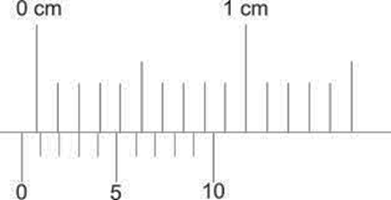

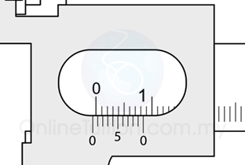

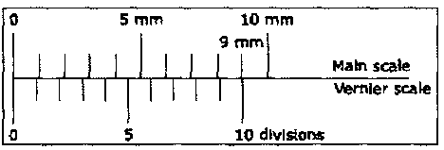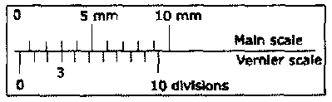**No Zero Error Positive Zero Error ……………………………**

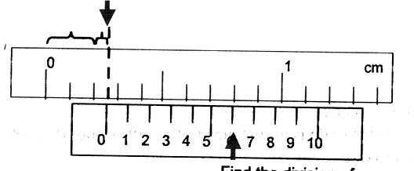

**Negative Zero Error ………………………………**

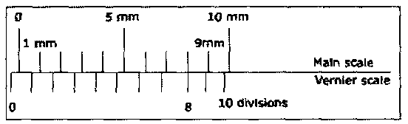

**(01) Reading ………………………**

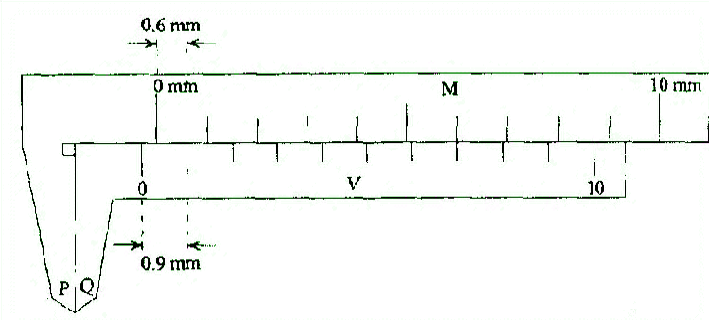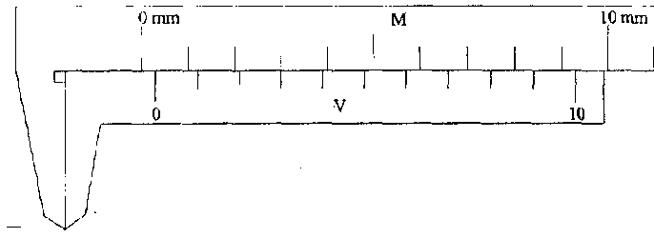

***(02) Zero error …………………….* (03) Zero error …………………….**

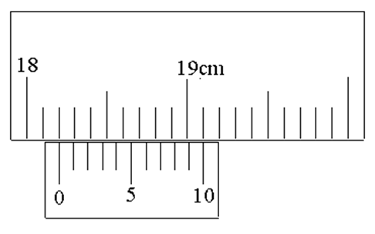

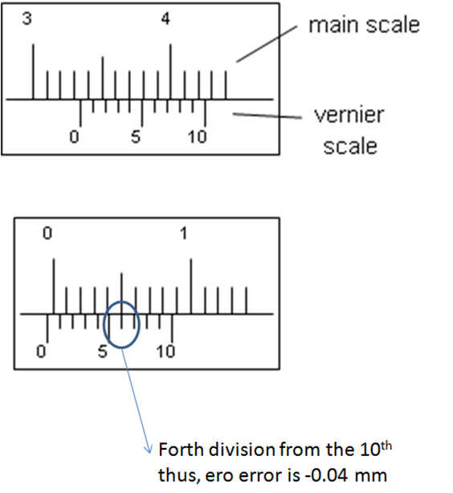**(04)**

**Reading ……………………..**

**(05) Reading ……………………………. (06) Zero error**

**……………………..**

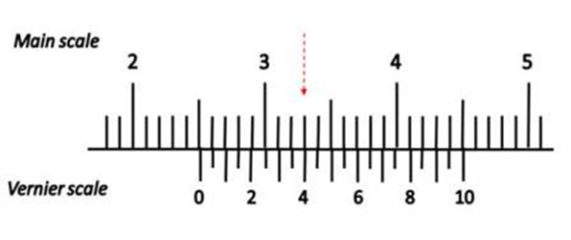

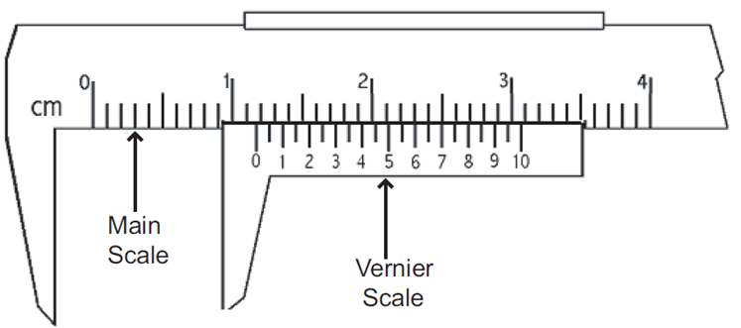

(07) **Reading ………………………**

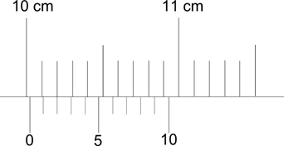

(08) **Reading ……………………… (09) Reading ………………………**

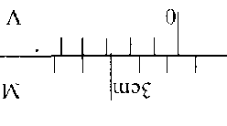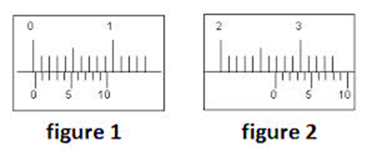

(12) **Reading ……………**

(10) **Zero error …………… (11) Reading ………………**

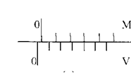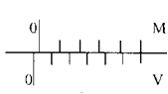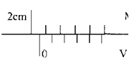

**(13) Reading ……………… (14) Zero error ……………………. (15) Zero error …………………….**

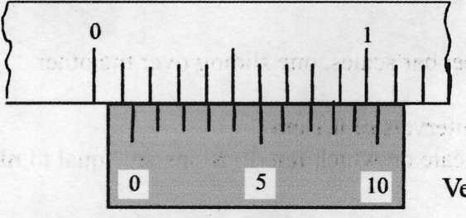 **(20 )**

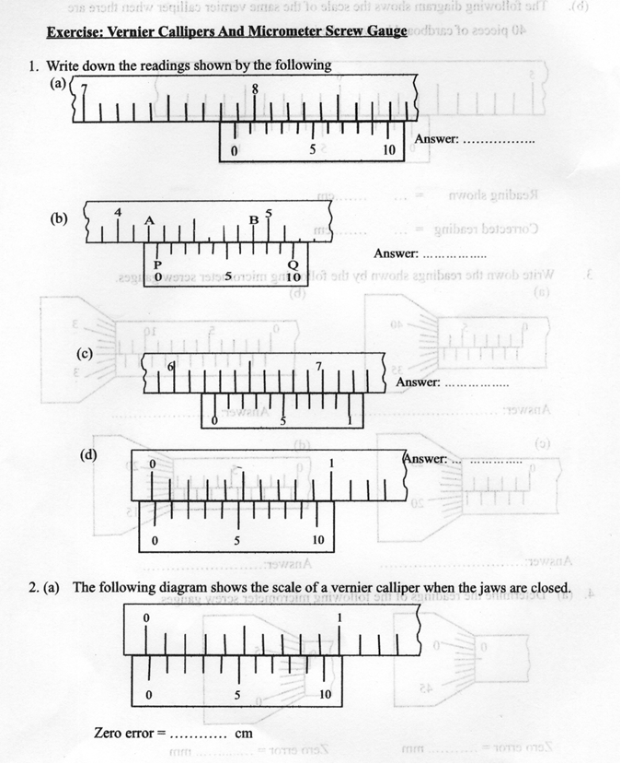

(16)

**(16) Zero error …………………….**

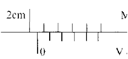

**(17) Reading ………………**

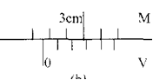

**(18) Reading ………………**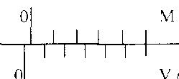

**(19) Zero error …………………….**

NOTES……………………………………………………………………………………………………………………………………………………………………………………………………………………………………………………………………………………………………………………………………………………………………………………………………………………………………………………………………………………………………………………………………………………………………………………………………………………………………………………………………………………………………………………………………………………

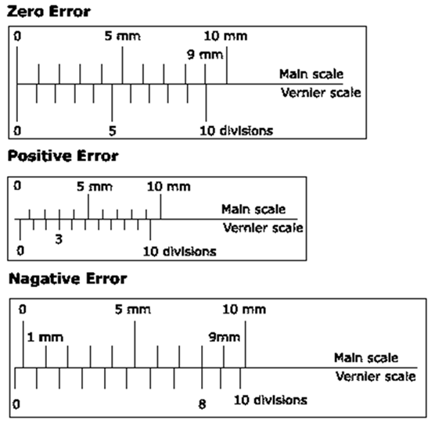

(07) ………………….. (08)…………………………. (09)…………………..

SN ………………………………………………………………………………………………………………………………………………………………..

……………………………………………………………………………………………………………………………………………………………………..

………………………………………………………………………………………………………………………………………………………………………

………………………………………………………………………………………………………………………………………………………………………

…………………………………………………………………………………………………………………………………………………………………………………………………………………………………………………………………………………………………………………………………………………………………………………………………………………………………………………………………………………………………………………………………………………………………………………………………………………………………………………………………………………………………………………………………………………………………………………………………………………………………………………………………………………………………………………………………………………………………………………………………………………………………………………………………………………………………………………………………………………………………………………………………………………………………………………………………………………………………………………………………………..

)

For AL Physics Small Group classes ENGLISH MEDIUM DEV PHYSICS CENTRE No. 52, Lorenz ROAd , BAMBALAPITIYA Sarath Devappriya

Mobile – 0777 792289 TP (011) 720 2600

**ZERO ERROR OF VERNIER CALLIPHERS**

**(i) No zero error.**

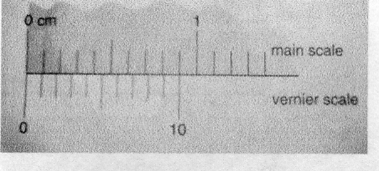the '0' mark on the main scale is exactly in line with the '0’ mark On the vernier scale when the vernier caliper is fully closed.

**( ii) Positive zero error**

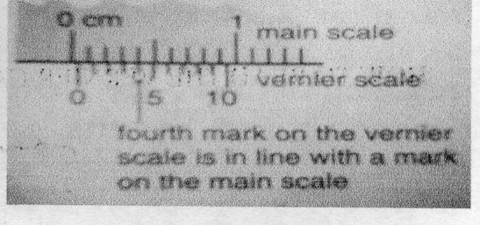the vernier scale is at distance to the right of the '0' mark on the main scale when vernier caliper is fully closed This error is positive zero error = + 0.04 cm

Correction = - 0.04cm

**ii) Negative zero error**

the vernier scale is at distance to the left of the '0' mark on the main scale when vernier caliper is fully closed.

This error is negative zero error = - ( 0. 1 - 0.08 )

= - 0.02cm

Correction = + 0.04cm

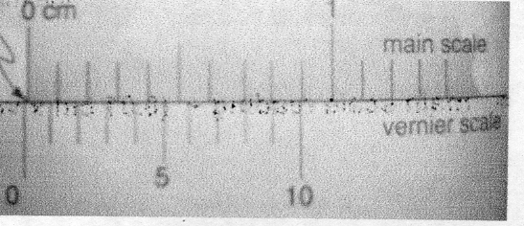

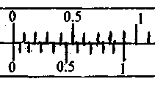

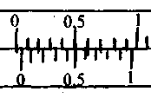

For AL Physics Small Group classes ENGLISH MEDIUM DEV PHYSICS CENTRE No. 52, Lorenz ROAd , BAMBALAPITIYA Sarath Devappriya

Mobile – 0777 707161 TP (011) 720 2600