CAWS
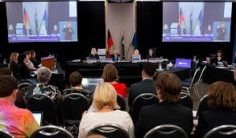
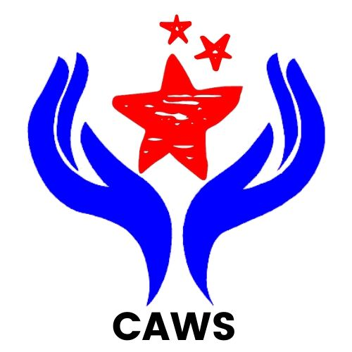
NEWSLETTER
December 2020
Royal Commission into Violence, Abuse, Neglect and Exploitation of People with Disability
What is it?
This is the full title of what we call the Disability Royal Commission or The Commission.
A Royal Commission is an investigation that is independent of Government where they look into something that everyone thinks is very important and not working properly.
The Commission started in April 2019 because the community was worried about people with disability being abused and exploited now and in the past. They are investigating how to:
- Prevent & Protect people with disability from experiencing violence, abuse, neglect & exploitation
- Find the best way to report, investigate and respond when this does happen
- Promote a better society that includes and supports people with disability to be as independent as possible and live free from violence, abuse, neglect & exploitation
The Commission will spend a lot of time researching, holding public hearings and listening to stories from people that have had bad experiences and then they will put together a report for the Australian Government by 29th April 2022.
How can you contribute to The Disability Royal Commission?
Anyone can make a submission and you can do it however you want to including:
- Telephone
- Email
- Video
- In writing through the website
If you think you have a story to tell about something that has happened to you CAWS can help.
If you want our help to make a submission to The Commission please ring Chris on 0416 050 693 or Lindy at the office on 02 9893 8210 and we will organise a time to meet with you.

We can sit down with you and write out your story, or we can help you to make an audio or video recording of your story if you prefer. Then we can help you to put your story to The Commission so that it is heard. CAWS will make sure that you know what could happen once you put in a submission; some of that information is below.
You can ask for a private session with a Commissioner. In these sessions you can tell the Commissioner what your experiences are and you can have a support person with you. CAWS can help you to organise this and if you would like us to provide support for the meeting we can.
Once The Commission receive and review submissions they may ask someone to give evidence at a public hearing. This is where witnesses give evidence, like in a court room, about events and issues that are relevant to The Commission. If you are asked to do this a solicitor will help you prepare for the hearing, and CAWS can support you for as much or as little as you want.
Counselling Services
The Commission has a team of counsellors who can provide support if you are called to a public hearing.
Blue Knot Foundation offers free specialist counselling for people with a disability, their families and supporters, and anyone affected by the Disability Royal Commission.
Call the National Hotline on 1800 421 468. It is open every day.
CAWS vision is to promote, protect & defend the rights of people with a disability. To ensure that people with a disability have access to every opportunity that is available to any members of the community in which they live. We do this by helping people with disability to be heard.
Give CAWS a call if you have a story 9893 8210

3rd December each year we celebrate
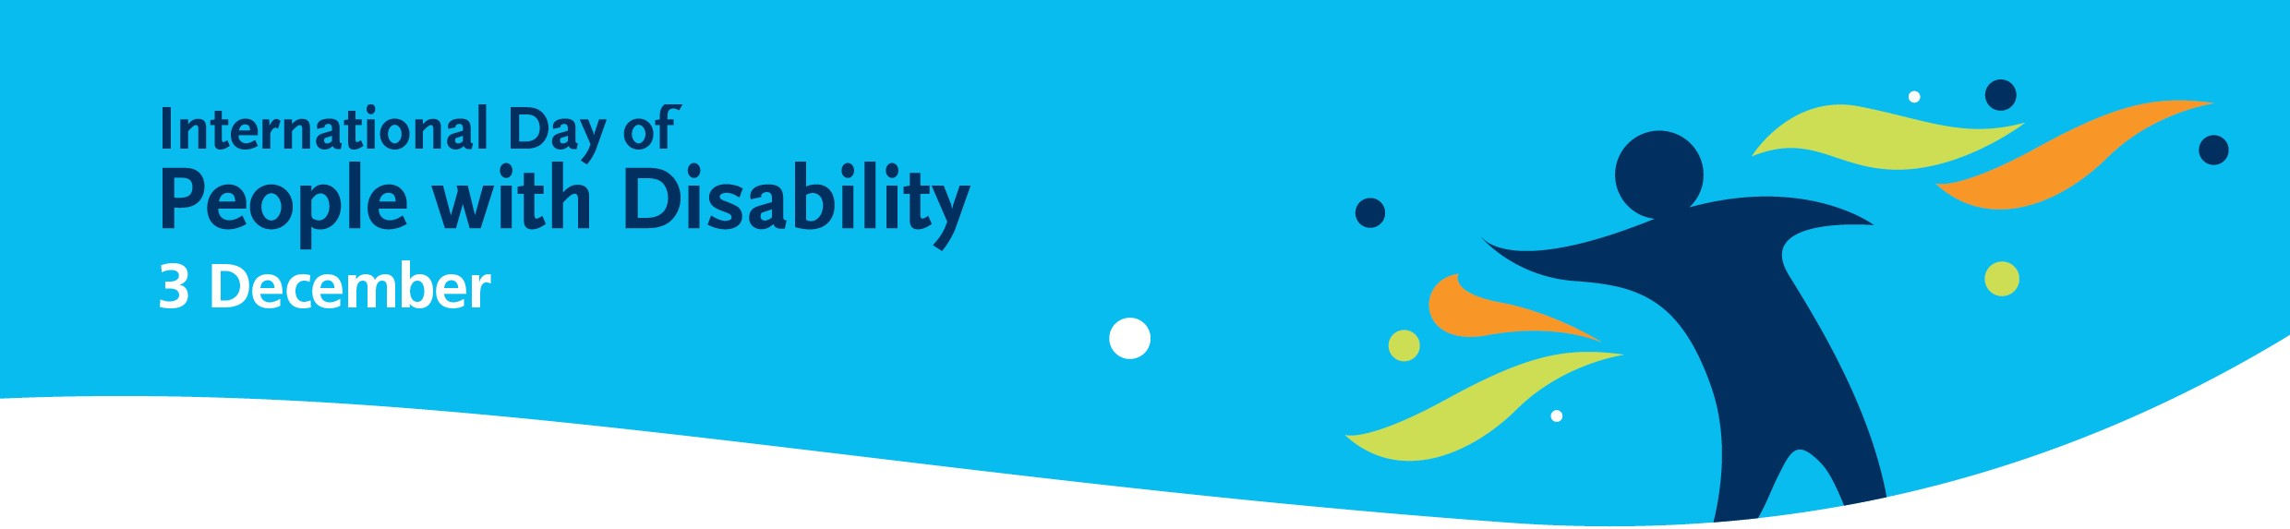

International day of People with Disability.

IDPwD is a United Nations observed day celebrated
internationally. It aims to increase public awareness, understanding and acceptance of people with disability and celebrate their achievements and contributions.
We have witnessed a lot of people achieving amazing things this year and we congratulate you all. We nominated two of our champions at the Blacktown City IDPwD Disability Awards and Talent Showcase and both have made it as finalists. We wish them both luck at the ceremony on Friday 4th December.
Matthew was nominated for the Advocate of the Year category. Matthew has been working hard this year as the CAWS We Matter representative on the Board to bring issues and ideas from the CAWS participants to management’s attention.
Wayne was nominated for the Volunteer of the year category. Wayne is always on duty at the Lalor Park Community Markets looking after the CAWS stall and is our representative on the markets committee. During the COVID shutdown Wayne helped, distributing food to needy people in Lalor Park.
Thank you both for your hard work and commitment to CAWS in 2020.
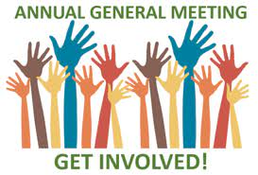
The 2020 Annual General Meeting (AGM) has been held up
this year due to unforeseen circumstances. We usually hold our
AGM in October or November and we were planning to do that
again this year. We had to change auditors at a late stage
of the audit process and this has meant that our financial
statements were not ready in time for us.
We anticipate holding our AGM in early 2021, we will send
out details to our members as soon as we have a date.
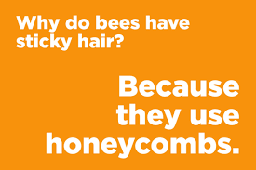
Are you interested in getting more involved at CAWS?
We are seeking interested volunteer Board members with skills and
capacity to contribute to the development of CAWS and its services
as it grows and expands.
We require interested people, skilled professionals with commitment
to good governance who possess skills in marketing & media; business
and finance; strategic planning and other business skills. Our Board
members also have a commitment to quality, equity of access and inclusion for all.
Being a Board Member at CAWS involves a commitment of approximately one meeting per month at Lalor Park with possible additional time for committees if you opt in. Positions on the committees exclusively is also an option for those interested, as a co-opted member.
Further information can be obtained by contacting the Chairperson, Angie Hatchman on 0449 920 010.
Expressions of Interest marked 'Confidential - Board Vacancy' can be sent to angiehatsis@gmail.com
From All of us to All of you, we wish you a Happy Christmas and New Year
May we look forward to a 2021 filled with joy and happiness for everyone around us and all over the world.

