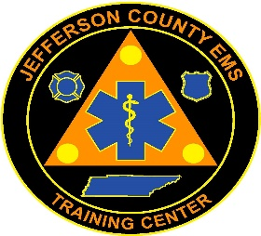

Jefferson County EMS Training Center

581 W. Old AJ Hwy
New Market, TN 37820
Telephone: 865-471-9001
Fax: 865-475-9458

AEMT Course Pricing

AEMT Class Fee $410 (paid at the beginning of class for textbook, clinical shirts)

EMS Enrollment Fee $175 (paid at the beginning of class for state fees)

Platinum Online Registration $200 (on-line testing & clinical scheduling/documentation
platform)

Total Payment for Course Admission $785

TN Application/License Fee $150 (paid at the completion of class to TDH-EMS)

NREMT Application Fee $115 (paid at the completion of class to NREMT)

Total Course Cost: $1050

