Make-Tech kit
Contents of a kit
The first assessment designed by teachers, for teachers.
The kit comes with lesson plans, instructional videos, "Programming with ChatGPT "
1 x Arduino development board
1 x analog/digital light intensity sensor
1 x Smart Car Chassis
2 x yellow direct current motor with gear
2 x quality wheel compatible with the engine
1 x Current Pushing Circuit for L298N Motors
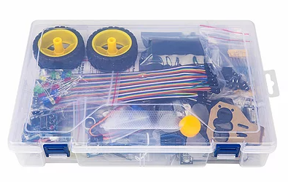
1 x servo motor
1 x 360 bracket for servo motor
6 x switches
2 x set of 40 bridging wire in colors
1 x LCD screen 1602 including I2C
1 x LM36 temperature sensor
1 x Distance Sensor (Ultrasonic) HC-SR04
1 x stand for distance sensor
1 x Infrared receiver circuit
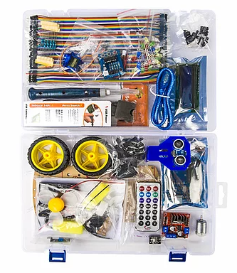
1 x infrared remote control
1 x ISD1820 audio recording/playback circuit
25 x resistors of different values ​​(50, 100, 220, 50K, 470K)
25 x LED bulbs in different colors (red, green, yellow, white, blue)
2 x colored LED bulb
1 x 2N2222 transistor
1 x matrix 400 holes
1 x soldering iron set with USB connection
1 x Plastic Storage Box

