Attachment1
Project Introduction

Ⅰ. Enrollment Groups
Adults who have not learned Chinese or have a Chinese vocabulary of less than 200.
Ⅱ. Course Objectives
1. To focus on developing learners' practical skills in Chinese listening and speaking;
2. To master 409 common Chinese words and 139 basic Chinese sentence patterns , and reach HSK Level 2 ;
3. To be able to carrying on simple and daily communication in Chinese, and lay the foundation for further Chinese learning.
Ⅲ. Curriculum Organization
Class hours | Course content | Cantonese Culture
The 1st week | GREETING & ADDRESS | Guangzhou history
The 2nd week | INTRODUCTION | Guangzhou dialect: Cantonese Language
The 3rd week | GETTING TO KNOW THE OFFICE | Festival customs
The 4th week | TIME EXPRESSION | Lion Dance Culture
The 5th week | HAVING A MEAL | Cantonese cuisine
The 6th week | CONTACT INFORMATION | Guangzhou business district
The 7th week | INVITATION & GIFT-GIVING | Guangzhou craftsmanship: Canton Embroidery, Canton Porcelain, Canton Sculpture
The 8th week | SEEKING HELP & PRAISE | Guangzhou music: Cantonese opera, Cantonese Music
The 9th week | LOCATION & DIRECTION | Places of interest in Guangzhou: Chen Clan Academy, Yuexiu Park, The Museum of the Nanyue King Mausoleum
The 10th week | TRAFFIC & TRAVEL | Guangzhou architecture:  Lingnan Garden, Sai Kwan Mansion
Ⅳ. Text Book
The first volume of the "General Chinese in International Workplaces" series of textbooks independently developed by 5Idea Chinese. The content of this textbook is in line with the real workplace environment, taking into account the professionalism, times and practicality, so the textbook is divided into three different levels: elementary, middle, and advanced. The first textbook used in this course is suitable for elementary Chinese learners who have never learned Chinese or whose Chinese vocabulary is less than 200.
Ⅴ. Learning methods
It is a learning method combining online live teaching with APP reinforcement learning. The teachers teach through the online classroom live broadcast, and the learners use the "CHIease" APP to complete preview, practice, and test in their spare time for reinforcement learning.
Ⅵ. Class Hours
There are 20 class hours of live online classroom teaching, and each class hour is 1 hour. Learners can use "CHIease" APP to strengthen their learning for 60 hours anytime and anywhere.
Ⅶ. Registration Deadline
Please submit the Student List, Student Registration Form (Attachment 2) and Class Schedule (Attachment 3) together to Ping@gztlv.com before March 10, 2023.
Ⅷ. Registration Guide
1. The course will be taught on the Chinese learning software "CHIease" APP. Please download the "CHIease" APP in time. The download method is as follows:
(1) Search for "CHIease" in the app store, then download and install it.
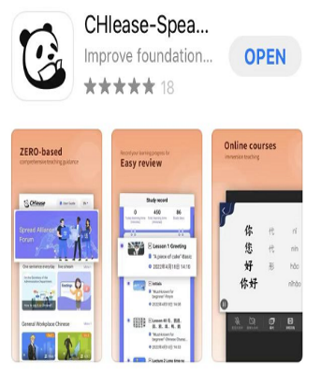
(2) Scan the QR code below, then download and install the app.
2. The provided email account of registration must stay the same as the registered email account of "CHIease" APP.
3. In order to ensure our class open successfully, please fill in the "Student Registration Form" (Attachment 2) and the "Class Schedule" (Attachment 3) with details.

