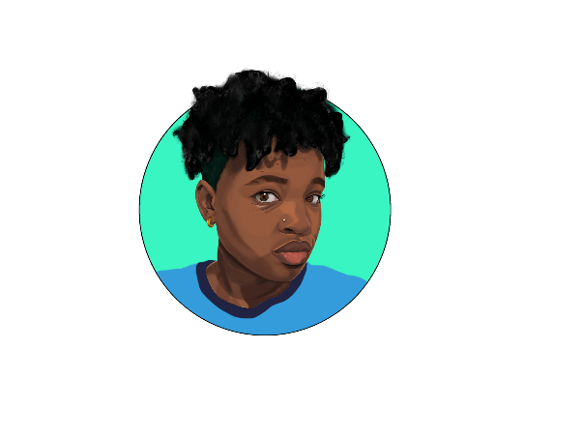
The Art Flows-
Creativity Without Limits
Website: www.theartflows-creativity.com
Email: theartflows.creativity@gmail.com
Social Media (Instagram/Ello): @theartflows
YouTube: The Art Flows with Tash

Project Questionnaire
The purpose of this questionnaire is to help me gain an understanding of what you are looking for. When answering each question please be as accurate/detailed as possible. Some of the questions may seem self-explanatory given the type of project you are looking for. For example, there is a question asking about font. If you are looking to have a business card created, there will be text on the card to let your potential customers know who/what you are and where to go to purchase your product. I would like you to answer that question because if you are looking for a specific font type, I need to know. There is a section at the end of this form that will allow you to add any additional information not specified within the form.
Type of Project (Check one or more of the following):
□Logo Design □Album Cover □Portrait (Human/Animal) □Tattoo Design
□Character Artwork □Fan Art □Landscape □Album Cover
□Promotional Design (one or more of the following: Business Card, T-Shirt Design, Brochure, Poster, Flyer, Social Media art)
□Website (Basic or E-commerce)
□Other________________________________________________________________________

How is the artwork to be created?

□Digital □Traditional □Combination of both

Color Scheme:

□Black/White/Grayscale □Identify Color Scheme Here:________________________________

Size/Dimension of Artwork (i.e, 9in x10in , 18in x24in, 3 ft x 5ft etc): _________________

Will there be font involved? □Yes □No If yes, please provide an example of the style of font you are looking for as an attachment in the email.

Do you have references/examples of what you are looking for? □Yes □No If yes, please provide references as an attachment in the email.

How soon does the artwork need to be created? (i.e, one day, a week, a month)
______________________________________________________________________________

If you are choosing digital artwork, does the artwork need to be in RGB (web) or CMYK (print) colors? □RGB □CMYK (RGB is meant for online platforms. CMYK is used when the artwork is to be printed)

For digital artwork, which file type would you like the artwork to be saved in?

□JPEG □PNG □PDF □TIFF □Other_________________________________

If you are choosing traditional artwork, what medium would you like the art to be created with?

□Graphite Pencils □Charcoal □Colored Pencils □Marker □Oil Paint
□Acrylic Paint □Gouache Paint □Watercolor Paint
□Mixed Media: ___________________________________________

For traditional artwork, what surface would you like the art to be created on?

□Paper (□Plain White or □Colored) □Canvas □Cardboard □Wood □Other___________________

Please provide any additional information not specified above in the section below:

__________________________________________________________________________________________________________________________________________________________________________________________________________________________________________________________________________________________________________________________________________________________________________________________________________________________________________________________________________________________________________________________________________________________________________________________________________________________________________________________________________________________________________________________________________________________________________________________________________________________________________________________________________________________________________________________________________________________________________________________________________________________________________________________________________________________________________________________________________________________________________________________________________________________________________________________________________________________________________________________________________________________________________________________________________________________________________________________________________________________________________________________________________

Note: This questionnaire is just the starting point to help me have a basic understanding of what you are after. There will be more questions asked once this is completed to ensure that both you and I are on the same page. Thank you for taking the time to complete this questionnaire.

