Up with the birds Granny Square
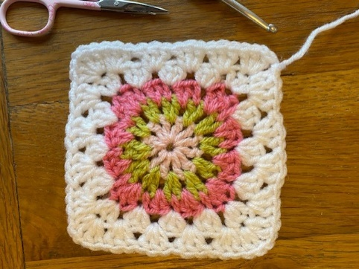
I used DK yarn and a 4.5mm hook. UK term throughout.
Ch4, join with a slip stitch to form a ring.
Round 1 – ch3 (counts as 1 tr), work 11 tr into the ring. Join with a ss to 3rd ch of beg ch 3 (12 tr)
Round 2 – with a new colour join yarn in between any tr from round 1, ch3 (counts as 1 tr), work 1 tr in same space, continue around working 2 tr in between each st. join with a ss to 3rd ch of beg ch 3 (24 tr)
Round 3 – with new colour join yarn between any 2 tr which are in the same stich below, ch1 (does not count as a st) *work 1dc in same st, 2tr between next 2 sts, 1 dc in next sp, 2 tr in next sp, 1 dc in next sp, 3 tr in next sp (this will be your corner), rep from * 3 more times. Join with a ss to 3rd ch of beg ch3. (28 tr, 12 dc)
Round 4 – With edging colour join yarn to any centre tr in corner, ch 3 (counts as 1 tr) work 2 more tr in same sp, skip next tr, 3 tr in dc from round 3, skip next 2 tr, 3 tr in next dc… continue around square working 3 tr in each dc and 3 tr in centre corner st. Join with a ss to 3rd chain of beg ch3, ss to centre stitch of corner for next round. (48 tr)
Round 5 – ch3 (counts a 1 tr) work 1 tr, 1ch, 2tr in same st. work 3 tr in next sp between 3 tr clusters from round below, continue work 3 tr in each sp and 2 tr, ch1, 2 tr in corners. Join with a ss to 3rd ch of beg chain 3. (64 tr)

