Crochet Head Band / Ear warmer
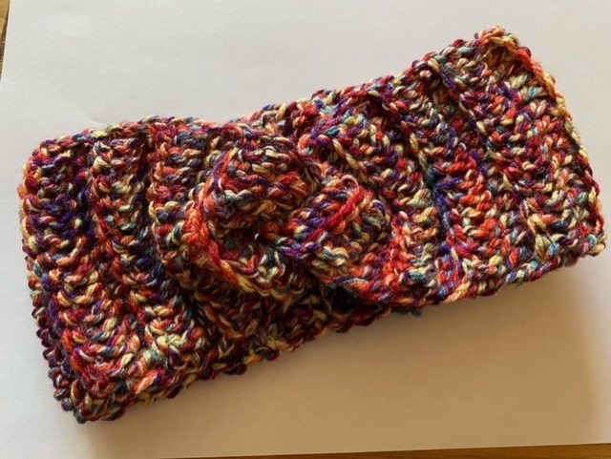
I used chunky weight yarn (James C Brett Masquerade)
6.5mm hook
Abbreviations
Ch – Chain
Tr – treble crochet
BLO – back loop only
St – stitch

**Now the usual rule of thumb is to ch3 at the beginning of a row when working in trebles but as we are using chunky yarn the ch 2 at the start of each row creates neater sides.

Let’s begin -Ch 15
Row 1 - Working in 3rd chain from hook work 1 tr, work 1 tr in each st across. Turn.
(you should end up with 14 tr- this includes counting the skipped 3 chains at the beginning of the row as a treble)
Row 2 – ch2, we will be working in the BLO throughout from this point forward. Work 1 tr in each BLO. Turn (14)
Working into the BLO
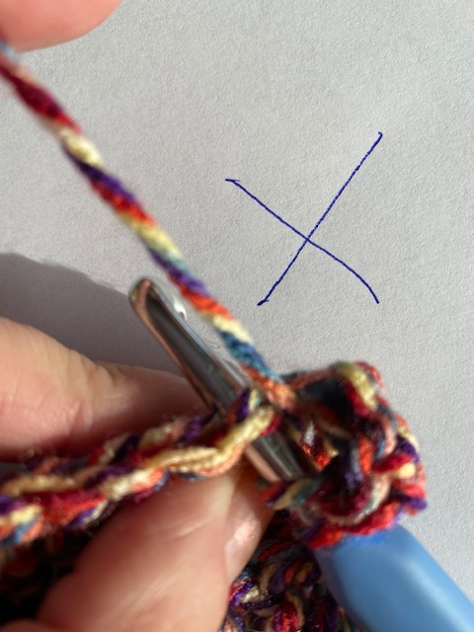 | 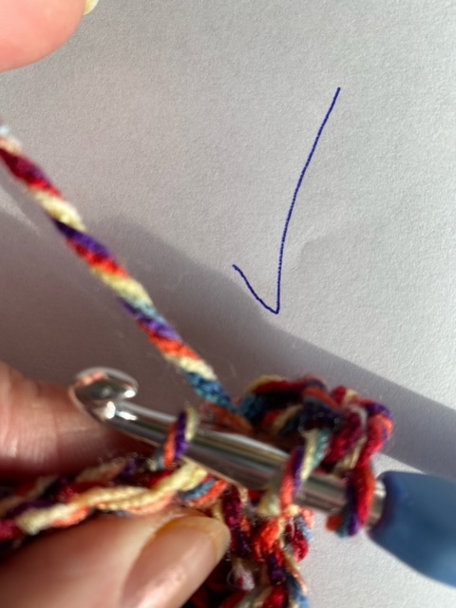

Repeat Row 2 x 32 times, or until it fits nicely around your head with a little stretch.

Now to join – Fold the short edges into a kind of s shape using the following picture as a guide, make sure you stitch securely through all pieces as we don’t want any holes !
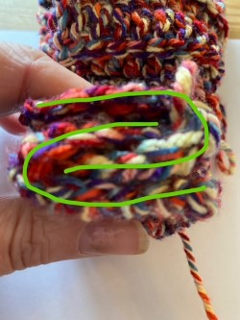
Flip back to the right side and viola you can now keep your ears nice and warm!

