Email : ergeorge1@weyer.co.za / christiaan@weyer.co.za
Tel : 044 878 2730 / 32 Whatsapp : 069 231 6099
Website : www.erfilter.co.za

AGRICULTURAL MARKET

INDUSTRIAL AIR FILTRATION

AUTHORIZED DISTRIBUTOR OF

Overview
Donaldson supplies reliable dust collection and combustible dust mitigation solutions to fit a variety of grain processing applications.
With over 100 years of experience engineering dust collectors and filters, Donaldson Torit is the name you can trust above all others for grain processing.

Full Range of Leading Dust Collectors
From the PowerCore® CP Series to the time-tested RF, Donaldson dust collectors are dependable workhorses in the grain industry.

PowerCore, Pleated Bag and Dura-Life™ Filtration Solutions
Donaldson advanced filtration technologies enhance performance and help reduce operating expenses.

Combustible Dust Mitigation Experience
We work with you to support your fire and explosion prevention and protection strategies.
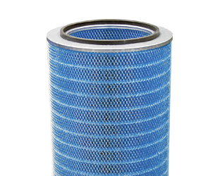

Looking for more? Search and buy filters & parts directly online.
Shop Now
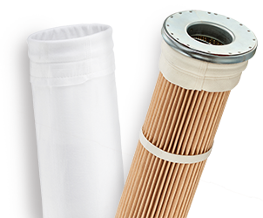

Submarkets

Grain
Donaldson is a trusted supplier of industrial air filtration, providing effective solutions for grain processing applications.
Our filtration expertise, wide breadth of product offerings, and unrivaled product support optimize filtration performance and reduce long-term cost of operation. We offer an extensive range of first-fit and aftermarket products and services to keep your process running efficiently, from incoming materials all the way through to packaged goods.

Nut
Donaldson is a trusted supplier of industrial air filtration, providing effective solutions for nut processing applications.
Our filtration expertise, wide breadth of product offerings, and unrivaled product support optimize filtration performance and reduce long-term cost of operation. We offer an extensive range of first-fit and aftermarket products and services to keep your process running efficiently, from incoming materials all the way through to packaged goods.

Seed
Donaldson is a trusted supplier of industrial air filtration, providing effective solutions for seed processing applications.
Our filtration expertise, wide breadth of product offerings, and unrivaled product support optimize filtration performance and reduce long-term cost of operation. We offer an extensive range of first-fit and aftermarket products and services to keep your process running efficiently, from incoming materials all the way through to packaged goods.

Products
Baghouse

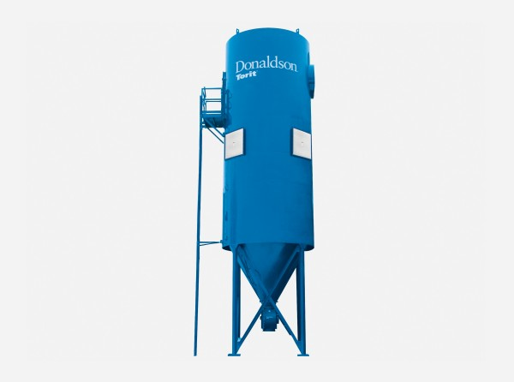

RF Series
The Donaldson Torit® RF baghouse dust collector handles heavy-dust loads and large volumes of air and offers a cleaning system that does not require compressed air.

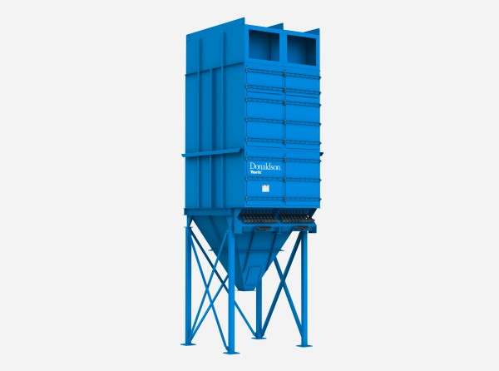

Dalamatic®
The Dalamatic® baghouse dust collector uses Dura-Life™ envelope-shaped bag filters, providing greater movement to dislodge dust cakes during pulsing.

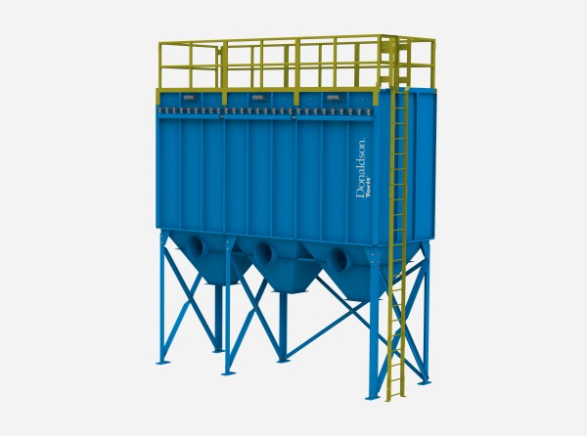

Modular Baghouse
Donaldson Torit® Modular Baghouse dust collectors deliver reliable, efficient, continuous-duty, pulse jet operation in a compact design with easy maintenance.
Cartridge

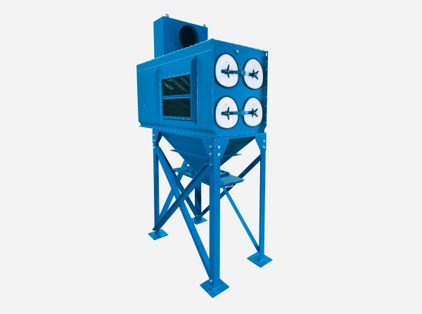

Downflo® Evolution
The Donaldson Torit® Downflo® Evolution (DFE) cartridge dust collector is capable of reducing equipment size and the number of required filters by up to 40%.

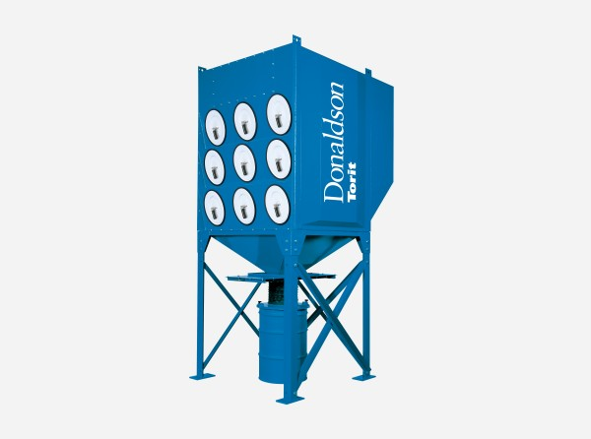

Downflo® Oval
The Donaldson Torit® Downflo® Oval (DFO) cartridge dust collector is a compact, high-efficiency unit that use oval-shaped filters suited for filtering submicron dust.
PowerCore®

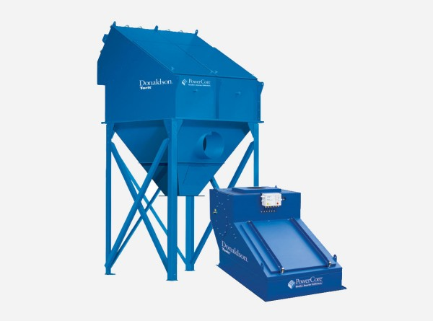

CP Series
Donaldson Torit® PowerCore® CP Series cartridge dust collectors use smaller, more efficient filters compared to baghouse models with a footprint up to 50% smaller.
Filters & Parts

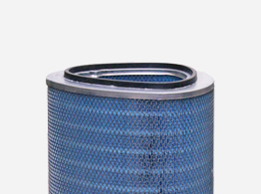

Cartridge Filters
Choose cleaner air with Donaldson Torit® advanced-technology cartridge dust collectors filter media that conquer the challenges of most types of industrial dusts.

PowerCore® Filter Packs
The high filtration efficiency of PowerCore® Filter Packs reduces emissions and saves energy, lowering your total cost of ownership.

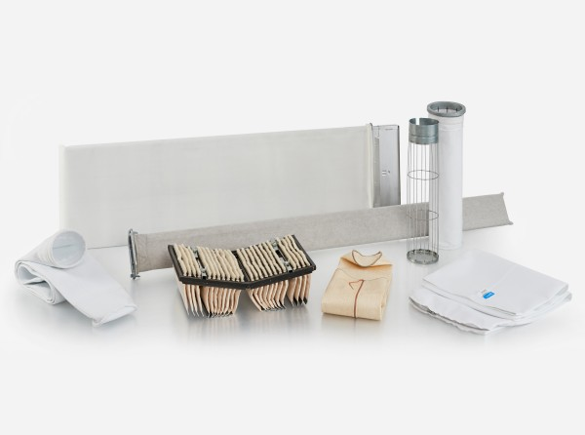

Fabric Bags
We provide the widest range of fabric dust collector filter bags for any baghouse dust collector.

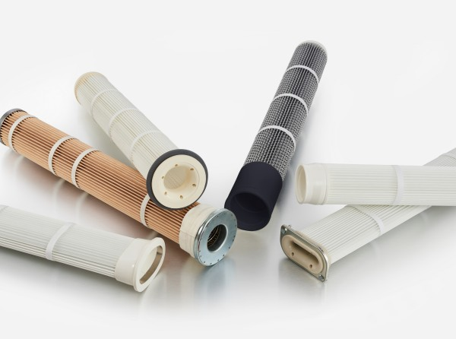

Pleated Bags
Donaldson pleated bag filters deliver longer filter life, higher efficiency, and greater cost savings over standard 16 oz. bag filters for baghouse collectors.

Applications
Donaldson’s advanced dust collection technology is the most widely used in the grain, agriculture and feed industry and is becoming the new standard for dust control in this sector. We provide air filtration expertise in the most challenging dusty situations. Common applications include e.g. intake hoppers, elevators, screw, chain, and belt conveyors, storage bins, silos, screens and sieves, grinders and pellet mills.
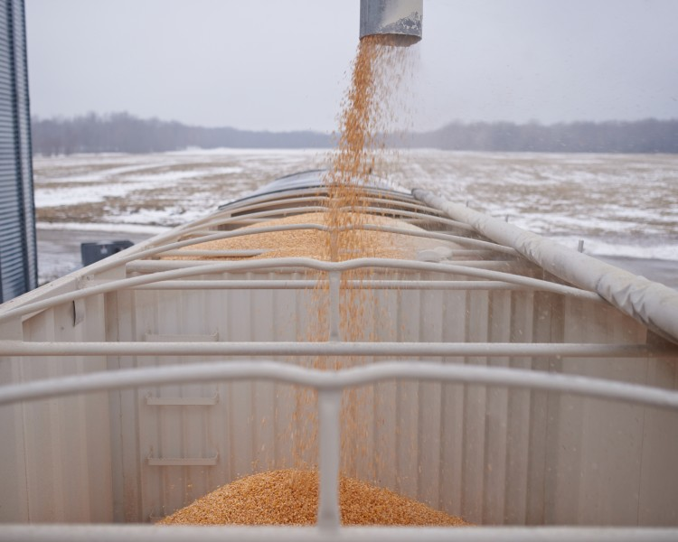

Conveying
Donaldson advocates “source collection” designs for conveyor applications, where the dust collector operates near to the point of dust creation. This way less ductwork and fewer discharge systems, which leads to lower purchase costs and less energy consumption. The PowerCore CPV and DLMV dust collectors are well suited for this configuration. Donaldson also offers several styles of dust collectors easily customizable to mount remotely from the actual dust generation point.
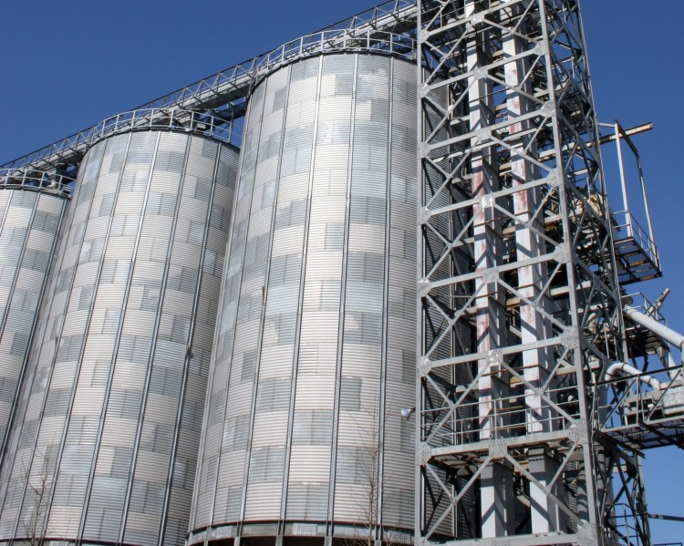

Silo & Bin Venting
The agricultural industry has the requirement to store materials in bulk and Donaldson offers superior dust control technology in the form of small compact bin vent dust collectors through to large venting units for integrating in to large silos. The benefit of integrated dust control is that it delivers efficient product recovery without the need for ducting and separate cdischarge equipment.

Content : www.donaldson.com

Milling
Barley, corn, maize, wheat, rye, and oats are all materials that can be processed, and from these, a coarse, fibrous dust is generated typically in an atmosphere containing oil vapors and high humidity. In addition, dust from these materials can have the potential to create explosive atmospheres.
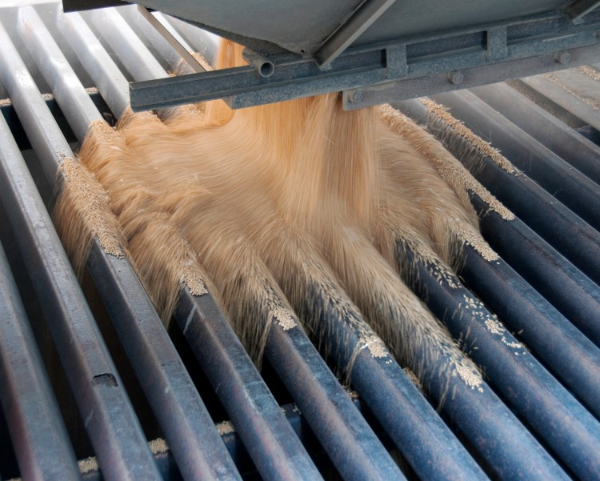

Mixing
Mixing and blending processes create fine dust having a variety of properties, such as hygroscopic characteristics, sticky, and frequently with the potential to be explosive. Donaldson has an equally wide range of products to satisfy this application and solutions include state of the art PowerCore CP range with its compact design and ease of maintenance benefits, and the Dalamatic range of bag dust collectors fitted with Dura-Life media for high air flow capacity, and suitable for handling agglomerating materials.

CONTACT US TODAY

Contact person : Christiaan Weyer
Email : christiaan@weyer.co.za
Cc : erfiltration@gmail.com
Whatsapp : 084 207 5852
Landline : 044 878 2730

