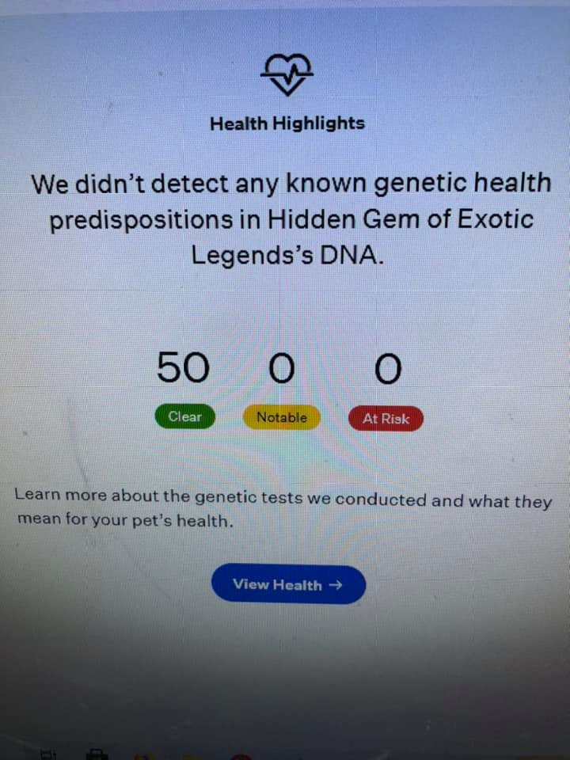

0 At Risk
We did not detect any at risk genetic conditions in Hidden Gem of Exotic Legends’s DNA.
0 Notable
We did not detect any notable genetic variants in Hidden Gem of Exotic Legends’s DNA.
50 Clear

Acute Intermittent Porphyria (Variant 1)
Acute intermittent porphyria (AIP) is a disorder caused by decreased cellular enzymatic activity leading to an accumulation of byproducts, called porphyrins, in the tissues. The disease is characterized by the brownish coloration of the teeth and brownish urine of affected cats.

Acute Intermittent Porphyria (Variant 2)
Acute intermittent porphyria (AIP) is a disorder caused by decreased cellular enzymatic activity leading to an accumulation of byproducts, called porphyrins, in the tissues. The disease is characterized by the brownish coloration of the teeth and brownish urine of affected cats.

Acute Intermittent Porphyria (Variant 3)
Acute intermittent porphyria (AIP) is a disorder caused by decreased cellular enzymatic activity leading to an accumulation of byproducts, called porphyrins, in the tissues. The disease is characterized by the brownish coloration of the teeth and brownish urine of affected cats.

Acute Intermittent Porphyria (Variant 4)
Acute intermittent porphyria (AIP) is a disorder caused by decreased cellular enzymatic activity leading to an accumulation of byproducts, called porphyrins, in the tissues. The disease is characterized by the brownish coloration of the teeth and brownish urine of affected cats.

Acute Intermittent Porphyria (Variant 5)
Acute intermittent porphyria (AIP) is a disorder caused by decreased cellular enzymatic activity leading to an accumulation of byproducts, called porphyrins, in the tissues. The disease is characterized by the brownish coloration of the teeth and brownish urine of affected cats.

Autoimmune Lymphoproliferative Syndrome
Autoimmune Lymphoproliferative Syndrome is an immunologic disorder characterized by severely enlarged lymph nodes.

Burmese Head Defect (Discovered in Burmese)
Burmese Head Defect is a disorder where cats with two copies of the mutation will be born with severe facial defects requiring humane euthanasia shortly after birth.

Chediak-Higashi Syndrome (Discovered in Persian cats)
Chediak-Higashi Syndrome (CHS) is a metabolic disoder that causes partial albinism, sensitivity to light, cataracts at an early age, and prolonged bleeding.

Congenital Adrenal Hyperplasia
Congenital adrenal hyperplasia is an endocrine disorder that causes excessive drinking and urination, abnormalities of the genitallia, and aggression.

Congenital Erythropoietic Porphyria
Congenital Erythropoietic Porphyria (CEP) is a disorder caused by decreased cellular enzymatic activity leading to an accumulation of byproducts, called porphyrins, in the tissues. The disease is characterized by the brownish coloration of the teeth and brownish urine of affected cats.

Congenital Myasthenic Syndrome (Discovered in Devon Rex and Sphynx)
Congenital Myasthenic Syndrome (CMS) is a neuromuscular disorder characterized by muscle weakness and fatigue.

Cystinuria Type 1A
Cystinuria is a metabolic disorder which predisposes the affected cat to form cystine crystals and stones within the urinary tract, which can then cause irritation and blockage.

Cystinuria Type B (Variant 1)
Cystinuria is a metabolic disorder which predisposes the affected cat to form cystine crystals and stones within the urinary tract, which can then cause irritation and blockage.

Cystinuria Type B (Variant 2)
Cystinuria is a metabolic disorder which predisposes the affected cat to form cystine crystals and stones within the urinary tract, which can then cause irritation and blockage.

Cystinuria Type B (Variant 3)
Cystinuria is a metabolic disorder which predisposes the affected cat to form cystine crystals and stones within the urinary tract, which can then cause irritation and blockage.

Dihydropyrimidinase Deficiency
Dihydropyrimidinase deficiency is a metabolic disorder that causes tiredness, weakness, vomiting, and high levels of ammonia in the blood.

Earfold and Osteochondrodysplasia (Discovered in the Scottish Fold)
Earfold and osteochondrodysplasia (discovered in the Scottish Fold) is the condition behind the breed defining folded ears; however, it also associated with skeletal malformations and arthritis.

Factor XII Deficiency (Variant 1)
Factor XII deficiency is a common blood factor deficiency in cats which does not result in an abnormal tendency to bleed but may have an effect on blood clot stability.

Factor XII Deficiency (Variant 2)
Factor XII deficiency is a common blood factor deficiency in cats which does not result in an abnormal tendency to bleed but may have an effect on blood clot stability.

Familial Episodic Hypokalaemic Polymyopathy (Discovered in Burmese)
Familial Episodic Hypokalaemic Polymyopathy is a disorder that causes skeletal muscle weakness and pain that is episodic in nature.

GM1 Gangliosidosis
GM1 Gangliosidosis is a disorder characterized by progressive nervous system degeneration with signs including incoordination of movements and tremors.

GM2 Gangliosidosis
GM2 Gangliosidosis is a disorder characterized by progressive nervous system degeneration with signs including incoordination of movements and tremors.

GM2 Gangliosidosis, type II (Discovered in Burmese cats)
GM2 Gangliosidosis Type II is a disorder characterized by progressive nervous system degeneration with signs including incoordination of movements and tremors.

GM2 Gangliosidosis, type II (Discovered in domestic shorthair cats)
GM2 Gangliosidosis Type II is a disorder characterized by progressive nervous system degeneration with signs including incoordination of movements and tremors.

GM2 Gangliosidosis, type II (Discovered in japanese domestic cats)
GM2 Gangliosidosis Type II is a disorder characterized by progressive nervous system degeneration with signs including incoordination of movements and tremors.

Glutaric Aciduria Type II
Glutaric Aciduria Type II is a rare metabolic disorder that causes organic acids to accumulate in the blood and urine.

Glycogen Storage Disease (Discovered in Norwegian Forest Cat)
Glycogen Storage Disease Type IV is a disorder that affects the metabolism of glycogen resulting in low blood sugar levels and progressive neuromuscular disease.

Hemophilia B (Variant 1)
Hemophilia B, also known as Factor IX Deficiency, is a blood clotting disorder more commonly seen in males, which can result in tiredness, decreased appetite, fever, lameness, and prolonged bleeding times after injury, trauma or surgery.

Hemophilia B (Variant 2)
Hemophilia B, also known as Factor IX Deficiency, is a blood clotting disorder more commonly seen in males, which can result in tiredness, decreased appetite, fever, lameness, and prolonged bleeding times after injury, trauma or surgery.

Hyperoxaluria type II
Hyperoxaluria is a kidney disorder leading to profound weakness and acute kidney disease at a young age.

Hypertrophic Cardiomyopathy (A31P; Discovered in Maine Coon)
Hypertrophic cardiomyopathy is a disorder where the heart muscle wall increases in thickness, eventually leading to heart failure.

Hypertrophic Cardiomyopathy (Discovered in Ragdoll)
Hypertrophic cardiomyopathy is a disorder where the heart muscle wall increases in thickness, eventually leading to heart failure.

Hypotrichosis (Discovered in Birman cats)
Hypotrichosis is a disorder of the immune system causing kittens to be born hairless and to develop serious infections.

Lipoprotein Lipase Deficiency
Lipoprotein Lipase Deficiency is a metabolic disorder that causes reduced body mass and growth rates in kittens, lipemia (excessive fatty substances in the blood), and increased stillbirth rates.

Medication Sensitivity (MDR1)
Medication Sensitivity (or Multidrug Resistance 1) is a disorder resulting from a defective drug pumping protein that plays an important role in limiting drug absorption and distribution (particularly to the brain). Cats with the ABCB1 mutation may have severe adverse reactions to some commonly used medications.

Mucopolysaccharidosis Type I
Mucopolysaccharidosis Type I is a disorder causing failure to thrive, facial and other skeletal abnormalities, tremors, and corneal clouding.

Mucopolysaccharidosis Type VI (mild form)
Mucopolysaccharidosis VI is a lysosomal storage disease resulting in a degenerative joint disease. This mutation (the G1558A variant) may cause for a mild form of the disease, but only if one copy of the severe disease variant (the T1427C variant) is also present.

Mucopolysaccharidosis Type VI (severe)
Mucopolysaccharidosis Type VI is a disorder causing dwarfism, degenerative joint disease, and corneal clouding.

Mucopolysaccharidosis Type VII
Mucopolysaccharidosis Type VII is a disorder causing weakness, growth retardation, facial and other skeletal abnormalities, and corneal clouding.

Mucopolysaccharidosis VII
Mucopolysaccharidosis Type VII is a disorder causing weakness, growth retardation, facial and other skeletal abnormalities, and corneal clouding.

Myotonia Congenita
Myotonia Congenita is a neuromuscular disorder that affects cats from birth, causing stiff movement and delayed relaxation of muscles after exercise.

Polycystic Kidney Disease (PKD)
Polycystic kidney disease is the most common inherited disease in cats. The disease causes the formation of fluid-filled cysts in the kidneys that can lead to kidney failure.

Progressive Retinal Atrophy (Discovered in Bengal cats)
Bengal Progressive Retinal Atrophy (PRA) is an eye disorder that causes the degeneration of the light sensing retina at the back of the eye, resulting in vision loss.

Progressive Retinal Atrophy (Discovered in Persian cats)
Persian Progressive Retinal Atrophy (PRA) is an eye disorder that causes the degeneration of the light sensing retina at the back of the eye, resulting in vision loss.

Progressive Retinal Atrophy (rdAc-PRA)
Progressive Retinal Atrophy (PRA) is a disorder that causes the degeneration of the light sensing retina at the back of the eye, resulting in vision loss.

Pyruvate Kinase Deficiency
Pyruvate Kinase (PK) Deficiency is a disorder that causes anemia due to the breakdown of red blood cells.

Sphingomyelinosis (Variant 1)
Sphingomyelinosis (Mutation 1) is a neurological disorder that causes progressively severe neurologic signs, enlargement of the spleen and liver, and changes in the lungs.

Sphingomyelinosis (Variant 2)
Sphingomyelinosis (Mutation 2) is a neurological disorder that causes progressively severe neurologic signs and reduced menace response.

Spinal Muscular Atrophy (Discovered in Maine Coon)
Spinal muscular atrophy is a muscular disorder that causes muscle wasting and progressive weakness. Please note that this test detects presence or absence of the disease mutation and cannot distinguish cats that have one copy of the disease mutation from cats with two copies of the disease mutation.

Vitamin D-Dependent Rickets
Vitamin D-Dependent Rickets (VDDR) is a metabolic disorder resulting in low blood calcium levels and skeletal abnormalities.

© 2021 Mars, Inc. All Rights Reserved

