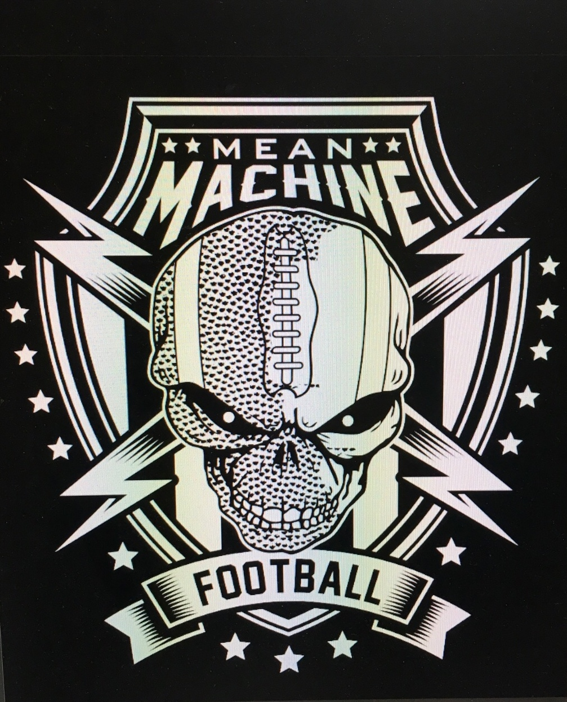

FLAG FOOTBALL GUIDELINES

GAME FORMAT FOR 5 vs 5 , 6 vs 6 , 7 vs 7
- Games are played 5 players vs 5 players – 6 players vs 6 players – 7 vs 7 players, pending the team roster sizes.
- Minimum player rule- Teams may play having 1 player down. Teams may not play having 2 players down and this will be considered a forfeit against the team record. Coaches may agree to share or add players to allow a game to be played however the record will reflect a forfeit. When adding players Care should be taken to select players from the same age group to prevent injury. An injury during a game causing the loss of a player that brings a team to 2 players down will be treated with the same minimum player rule. If the injury was the result of a penalty or un-necessary rough play from an opposing teams player(s) the referee will have discretion of deciding the outcome of the game.
- Field is 25-30 yards wide and +/-50 yards long, including the +/-5 yard end zone. The field will be split into 2 equal haves, with a 5yard no run zone before mid field and a 5 yard no run zone before the goal line.
- The offensive team will have 3 downs to cross mid field for a first down and an additional 3 downs to score after crossing mid field.
- Sidelines- Coaches, Players and Fans shall not be allowed within 1 yard of the side line and within 5 yards of the end zone. Fans should remain 7 yards from all the field boundaries.
- Coaches, Players, Fans who exhibit poor sportsmanship, behavior or foul language may be asked to leave the venue, with possible future events suspension.

Scoring
- Touchdowns = 6 points
- Extra point from 5 yards = 1 point
- Extra points from 10 yards = 2 points

8U Division Rules and Goals
- 45 second play clock
- QB has 6 seconds to release a pass or make a direct hand off
- Unlimited runs with maximum 3 direct handoffs behind the LOS per play
- No runs allowed when ball is spotted within 5 yards of mid-field or within 5yards of end zone.
- Runs allowed on extra points from 10 yards out
- One coach is allowed on the field for both offense and defense.

11U Division Rules and Goals
- 30 second play clock
- QB has 4 seconds to release a pass or make a direct hand off
- One run per offensive possession with maximum 3 direct handoffs behind the LOS per play
- No runs allowed when ball is spotted within 5 yards of mid-field or within 5yards of end zone.
- No runs allowed on extra points
- One coach is allowed on the field for both offense and defense.

14U-17U Division Rules and Goals
- 30 second play clock
- QB has 4 seconds to release a pass or make a direct hand off
- NO runs. Maximum 3 direct hand offs may be made behind the LOS but handoffs may not be advanced. If the ball is advanced past the LOS on a hand off it is an illegal run penalty.
- NO coach is allowed on the field except during time outs.

Rules
- Coin flip -visiting team calls the toss to determine choice of possession, teams may defer to the 2nd half.
- Two 20 minute halves with a minimum 5 minute halftime break.
- There will be a running clock and will only stop for time outs and injuries.
- In the last 1 minute of the game if the score is within 8 points
The clock will stop on the following actions:
-Incomplete passes
-Out of bounds
-Change of Possession
-Penalties- If it is an offensive penalty the clock will start on the official un-less it is a dead ball foul.
-Clock will not run during extra point attempts.
-Games cannot end on a defensive penalty- 1 untimed down will be allowed.
- Each team has ONE- 45 second timeout per half.
- Timeouts called after a touchdown - clock will not start until the start of play after the extra point attempt.
- The play clock starts at referee spotting the ball- Play clock for 8U division is 45 seconds - Play clock for ages above 8U division is 30 seconds.
- Pass timer will start with a direct snap or shotgun/pistol snap between the centers legs. The original quarterback must pass or hand off the ball before pass timer expires. If a pass or hand off isn not made the result of the play is an incomplete pass, with ball returning to the original LOS.
- If a hand off is made in any division the pass timer is no longer applied and the new passer would have unlimited time to throw the ball, or run the ball in divisions where runs are allowed. Maximum 3 behind the LOS hand-offs may be made on any 1 play.
- Motions and Shifts- only 1 player may be in motion at a time. NO motions toward the LOS are allowed, multiple players may shift forward, back or sideways but must be re-set for a minimum of 1 second before a snap is made. (refer to players allowed off the LOS rule below)
- If a player takes a hand off and then makes a pass the play is not counted as a run play.
- If a hand off is made the defense may cross the LOS to pursuit the ball carrier.
- There is no intentional grounding penalty.
- If the ball touches the ground on a snap the play is dead and placed at the LOS with no loss of yardage
- Any fumbles will result in the play being called dead and the ball spotted where the players hips are when the ball was fumbled. Fumbles may not be recovered by the defending team.
- A play is dead when any of the following occur to the ball carrier:
-Flag is pulled (excess belt shall be tucked in- if defense pulls a loose belt the play is dead at the spot)
flags shall be arranged on the players sides.
-Long shirts should be tucked in- if an un-tucked shirt prohibits a flag pull play is dead at the spot
-Ball carrier’s Knee, Hips, or body touch the ground
-Ball carrier’s loses a flag after a snap and a defender touches them.
-Ball carrier starts a play without both flags - ball is dead when and where player receives the ball.
(including the QB and Center)
-Ball carrier dives, jumps, leaps or hurdles- the ball is spotted where the player left the gound- Loss of
Down. Ball carriers may spin to avoid flag pulls.
- Ball carriers must not flag guard using their arms or other body parts- spin moves are permitted
- Offensive players may not use their body to pick, screen, shield, or block defensive players before or after a pass or permitted run is made, with the exception of the center may remain stationary after the ball is snapped.
- Once an offensive player catches the ball or advances the ball past the LOS on a permitted run, all other offensive players must stop and attempt to remain still as to not block, shield, or in any way impede the path of the defenders pursuing the ball carrier. In hurry up situations players may follow at a 5yd distance behind the ball carier to get to the new line of scrimmage but not impede a defensive player.
- Defenders may not attempt knock out or strip the ball once the ball carrier has possession this will result in a defensive holding penalty.
- All players are eligible to score- a hand off to the center must be made after the ball is fully exchanged to the quarterback then back to the center(not under the legs)
- No rushing the quarterback or defensive crossing the LOS unless there is a hand off or fake hand off. With a Hand off the defense may cross the LOS to pull the flag, on a fake hand off the defender may cross the LOS due to deception however must return back across the LOS and not interfere with the pass.
- The original quarterback may not advance the ball, in divisions where runs are allowed a complete hand off exchange must be made and returned to the QB before the original QB can advance the ball.
- Handoffs behind the LOS must be direct and cannot be Pitched, Tossed, or Thrown behind the LOS.
- Passers must make an overhand throw or pass from the chest, NO Underhand passes allowed.
- NO backward passes or Passes behind the LOS- the result is spotting the ball where the pass is caught or an incomplete pass if the pass is not caught.
- Ball is placed where the flag is pulled, not where the ball is when the flag is pulled
- Players hips must cross the mid-field line for a first down, as well as the goal line for a score, not the ball extended over the lines.
- A receiver must have one foot in bounds and have control of the ball to count as a reception.
- Only the quarterback and One additional player may be off the LOS. All other players must be on the LOS.
The exception is in the 8U division many players may be off the LOS,
The 11U Division may have QB and 2 additional players off the LOS.
- Defensive players must not be closer than 2 yards from the LOS unless the ball is within 1 yard of mid field or within 1 yard of the goal line, then they may be ½ yd from the LOS.
- Defenders should avoid excessive body, arm or leg contact with the receivers. (holding, jamming, Etc.)
- Absolutely No Tackling, a defender who wraps one or both arms around any part of the ball carriers body will be a defensive holding penalty. (tackling may result in an un-sportsmanlike penalty)
- No offensive pass or handoffs may occur past the LOS-If an exchange is made past the LOS it will be an illegal forward pass (this includes the QB stepping past the LOS accidentally)
- Defensive interceptions can be advanced, except on an extra point. Interceptions with a flag pull result with the ball being placed on the yard line the same distance from the opposite end line. Interceptions advancing past the end line will result in a touch down with an extra point(s) attempt allowed. If a receiver and defender both have control of a pass- after 2 seconds shall be ruled an offensive catch.

Mercy Rule and Minimum Play
- Coaches are encouraged to avoid running up a score, by adjusting offense and defensive players and formations/plays. If a team is ahead by 30 or more points their offensive possessions will be limited to 2 downs to cross mid-field and 2 downs to score. The team down by 30 or more points will have 4 downs to cross mid-field and 4 downs to score. Regular rules apply when score differential is under 30 points.
- There is No minimum play rule-coaches shall ensure that all players get to play in a part of each game.

Overtime Rules
- Overtime format only applies in playoff games. Each Overtime period is un-timed and will allow each team a possession and attempt to score. The team the with higher score after OT wins.
- A coin flip called by the Home team determines the choice of 1st or 2nd possession.
- Possession begins at the 10 yard line with both teams going in the same direction.
- The 1st offensive team will get 2 plays to score, if a touch down is scored the team chooses to go for a 1 or 2 point extra point.
- If there is an interception on the first possession per OT and a touch down is scored by running past the opposite end line, the intercepting team wins. If the interception does not result in a touchdown. Then the 2nd offensive team will make get their possession from the 10 yard line.
- If the game is still tied, overtime will be repeated until there is a winner, Teams alternate 1st possession each overtime period.

Penalties

Offensive Penalties
- Offensive pass interference- 10 yd penalty and replay the down
- Illegal motion or Shift- 5 yd penalty and replay the down
- Illegal formation- 5 Yd penalty and replay the down
- Illegal Run- 5 yd penalty and loss of down.
- False Start- 5 yd penalty and replay the down
- Illegal forward pass- 5 yd penalty & loss of down (QB crosses LOS or makes forward pass behind LOS)
- Blocking/Screening/Impeding- 5yds from the spot of the ball carrier at time of foul and loss of down
- Leaping- ball is placed at the spot of the foul and loss of down
- Flag Guarding- 5 yd penalty from spot of foul and loss of down
- Un-Sportsmanlike conduct- 15yd penalty (possible ejection)
- Delay of Game- Clock is stopped and 5yd penalty
- No Intentional grounding penalty
- DEFENSE MAY DECLINE PENALTIES

Defensive Penalties
- Defensive pass interference- 10yd penalty and replay down (if result is a catch –offense may decline)
- Illegal Contact (holding, jams, etc.) 5 yd penalty and replay the down
- Defensive holding while pulling flag- 5yd penalty added to end of play
- Illegal flag pull (pulling before player has ball)- 5yd penalty and replay down
- Illegal Rushing (before a hand off occurs) -5 yd penalty and replay the down.(See Fake hand off rule)
- Intentional or inadvertent tackle from behind with clear path to the end zone-Automatic touchdown.
- Un-Sportsmanlike conduct- 15yd penalty (possible ejection)
- Defensive penalties greater than the distance to the goal line result in ½ the distance to the goal line.
- OFFENSE MAY DECLINE PENALTIES – and may result in a first down or touch down.

