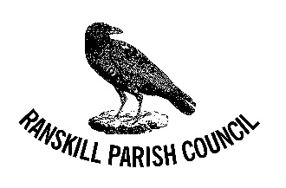

Ranskill Neighbourhood Plan Update

As you are aware the 5th public consultation resulted in the village voting that no further development was needed in Ranskill, with the exception of those that have already been granted planning permission.

This result was ratified by the Parish Council and the Neighbourhood Plan re-drafted to reflect the results of the consultation.

Following the redrafting the updated version of the Plan was unanimously adopted by the Parish Council at our October meeting. After liaising with Bassetlaw District Council it was decided that the Plan is ready to progress to the next stage.

Regulation 14 Consultation.

This is primarily for statutory bodies to comment on the draft Neighbourhood Plan but is also another opportunity for those that live and work in Ranskill to put forward any further comments they may have on the latest version of the draft plan.

The latest version of the Plan can be found on the Neighbourhood Plane website www.ranskillplan.co.uk along with all supporting documents.

If you have any new comments on the Ranskill Neighbourhood Plan please email parishcouncil@ranskill.org.uk

Alternatively you can drop your comments off at:

3 Southfall Close, Ranskill DN22 8NE

As with previous consultations individual comments cannot be replied to.

The consultation period runs as follows: -
1ST DECEMBER 2021 TO 31ST JANUARY 2022

Thank you all once again for your help in shaping the future of Ranskill.

