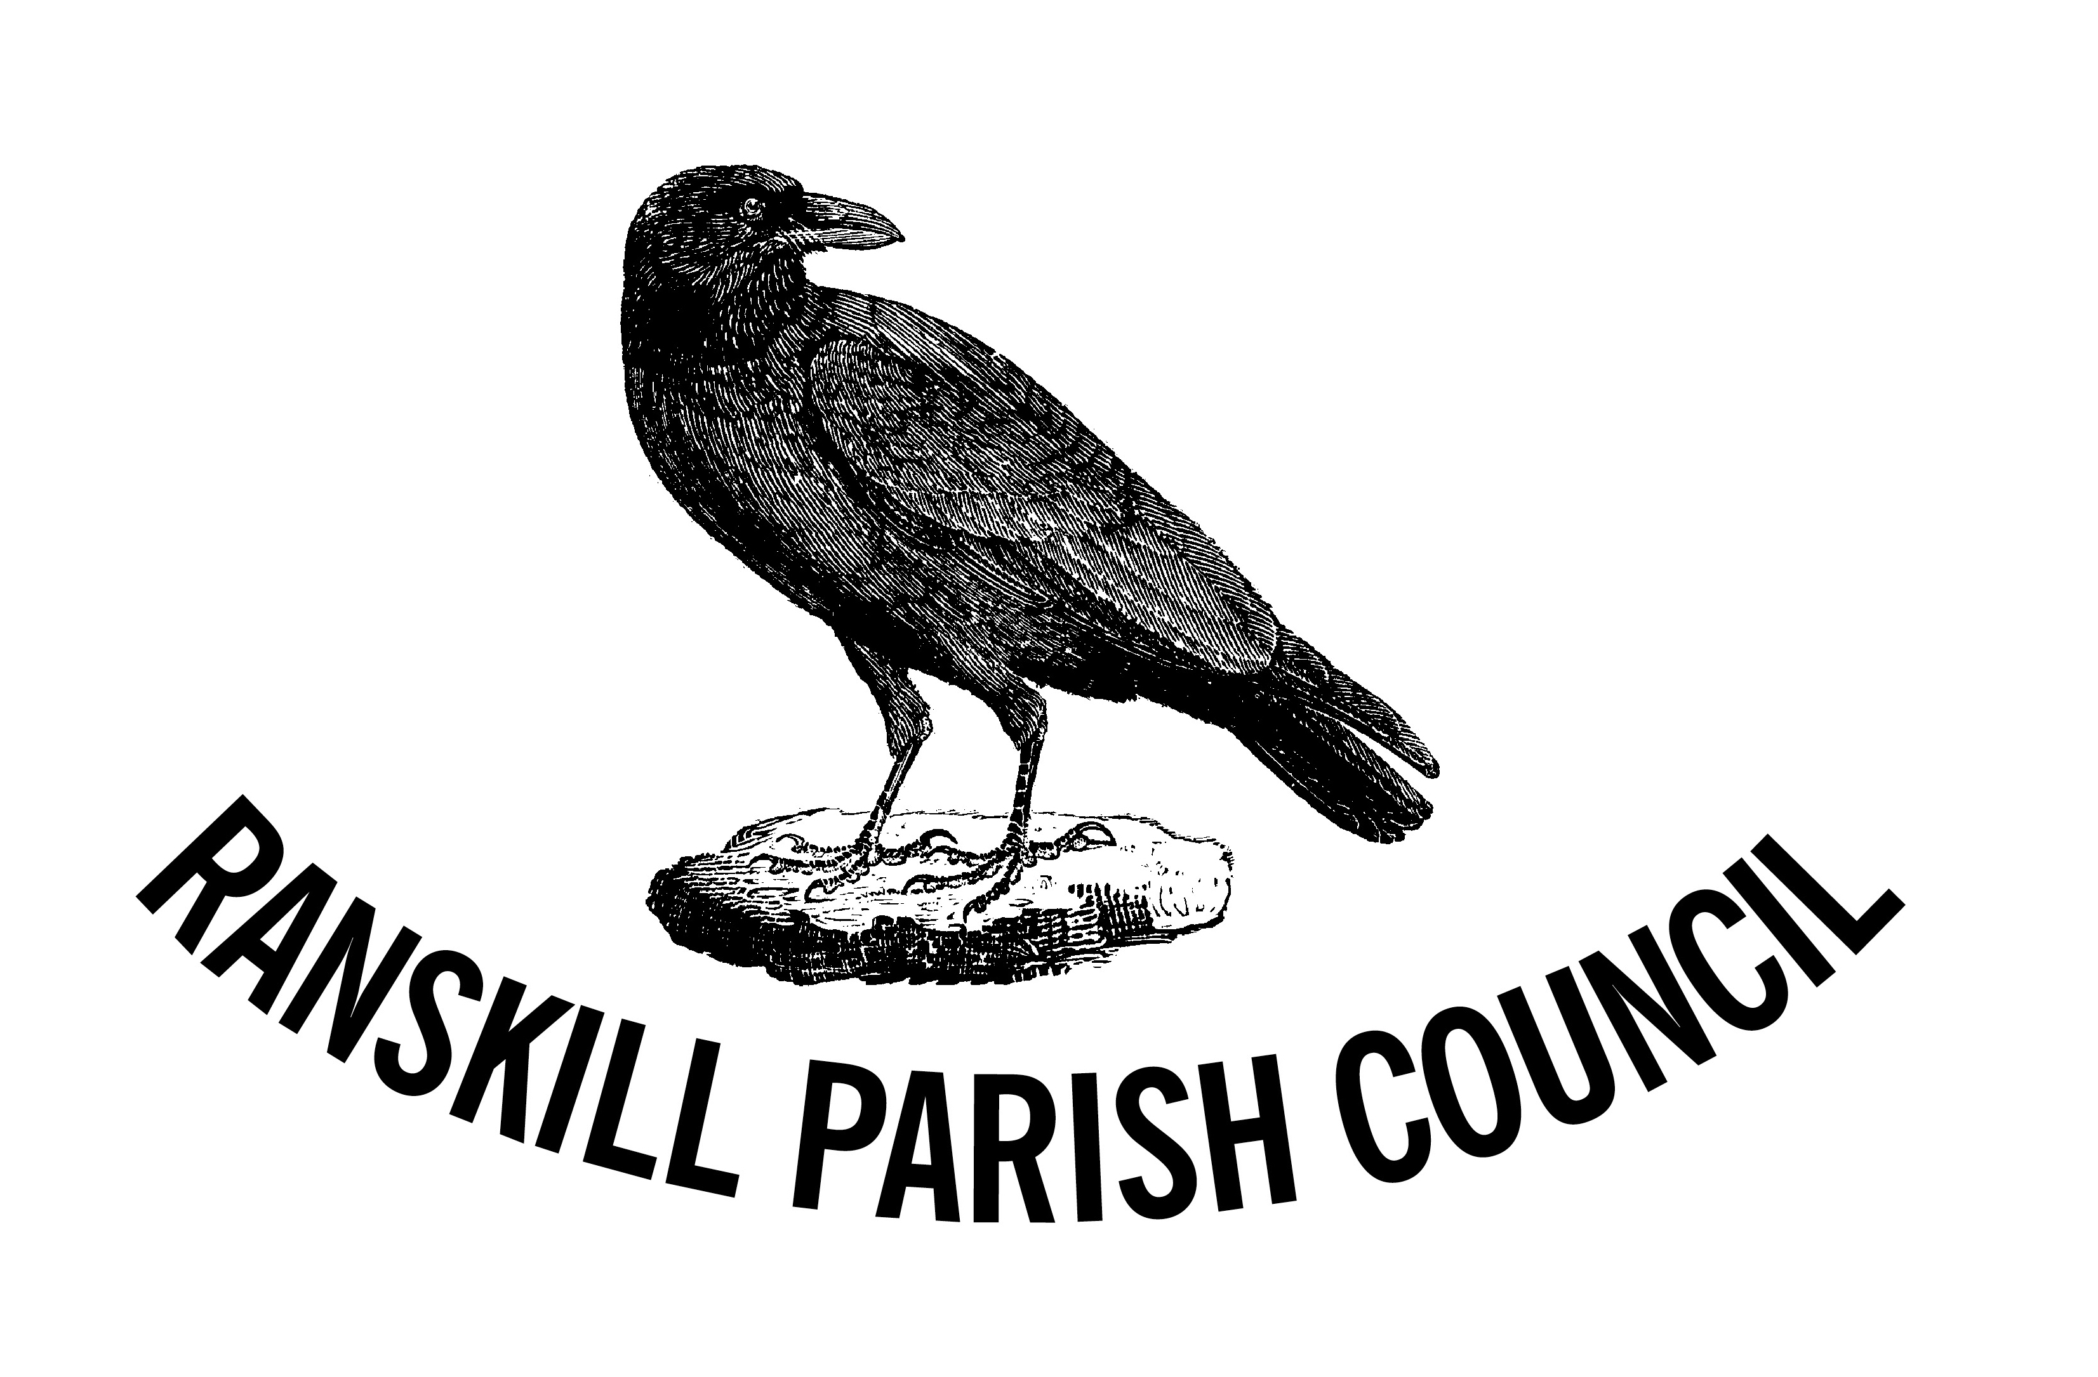
Ranskill Parish Council
Neighbourhood Plan Steering Group
Notice To All Residents
THIRD PUBLIC CONSULTATION
WITHDRAWAL
Bassetlaw District Council has just published a new Bassetlaw Plan for public consultation. The number of houses required to be provided by Small Rural Settlements has reduced from 20% to 5%, with reference to the housing stock as at April 2018.
For our own village this means the requirement being reduced from 121 to 30 houses, for which there are already planning approvals. There is no requirement for the village to be compelled to provide further homes at this time. As a result the running third public consultation is erroneous as we are now asking for your opinion based on the wrong information.
As a result the third public consultation is being withdrawn
We thank those residents who have already taken the time to submit their opinions. It is with regret that we have had to cancel the consultation. We had no notice of the significant change in the approach from Bassetlaw District Council, who knew that we had just launched a new consultation with our residents and we feel could have informed us of their forthcoming plans. We are disappointed with the resultant waste of public money and volunteer resources.
The Parish Council and the Steering Group will now consider the new situation and plan to launch a new simplified consultation in the New Year. Stay Safe.

