Project Rise and Shine: Live Life to the Fullest

(Funded by Hogg Foundation for Mental Health, Communities of Cares Initiative, COC-032)
https://hogg.utexas.edu/initiatives/communities-of-care-houston

Final Community Assessment Report

Prepared by

Furjen Deng, Ph. D
Sam Houston State University
Email: soc_fjd@shsu.edu

Acknowledgements

This report is a result of group efforts. We are very grateful for the different levels of support provided by the following organizations and individuals: 1) All 662 participants of in-person surveys, focus group interviews and online surveys, 2) project coordinators from each partner site (George Chen, Sandra Chen, Wei Guo, Joe Jong, Lily Lam, Pastor Benjamin Lam, Haitrieu Nguyen, Lie Sie Oei, Grace Shay, Father Steven Tran and Ruiting Wu), 3) Hogg Foundation-Communities of Care Initiative (Vicky L. Coffee), 4) Prevention Institute (Alisha Soniji and Will Crary), 5) Light and Salt Association (Sharon Cheng, Dr. Helen Sun, Loretta Tse and Yu Gu), and 6) Sam Houston State University (Dr. Dan Hong Chen).

Table of Contents

- Introduction………………………………………….…….3

- Executive Summary……………………….………...…...4

- Methodology……………………………….......………….6

- Results from In-Person Surveys and Focus Group Interviews………………….…………..………….8

- Results of Online Surveys over the Impacts of the COVID-19 Pandemic…………………….……….….….20

- Results of Secondary Data Analysis….………….…22

- Conclusion and Recommendations….……….........24

- Introduction
The mental well-being of Asian-American (AA) children and youth have been overlooked because of social and language barriers as well as the cultural stigma associated with mental illness and being labeled as a model minority. With generous funding support provided by the Communities of Care Initiative of the Hogg Foundation, the Project Rise and Shine (PRS) collaborative was formed in 2019 to address these barriers. Specifically, PRS focuses on the underlying social and structural determinants of the mental wellbeing among AA children and youth in the Houston Metropolitan Statistical Area. To achieve the goal, PRS employs a multisector collaborative approach that involves 12 partners from 7 different sectors (community-based organizations, churches, Asian language schools, service providers, mass and social media, parents, and a university). The Project Rise and Shine collaborative, led by the Light and Salt Association, consists of the following ten churches, language school, and counseling center in the Chinese and Vietnamese communities:
- American Chinese Fellowship
- Chinese Christian Herald Crusades
- Clear Lake Chinese Church
- Hua Xia Chinese School
- Light and Salt Association
- Pearland Chinese Church
- Prince of Peace Catholic Church
- New Hope Christian Church
- West Houston Chinese Church
- Vietnamese Redemptorist Youth Ministry
The Hogg Foundation, established in 1940 by the children of Texas Gov. James Hogg, and affiliated with the University of Texas, historically focused primarily on individual mental illness but recently evolved to also tackle causes at the community and systems level.
The goal of the Communities of Care initiative is to support collaborative approaches to well-being in the Houston Metropolitan statistical area. The grants strengthen efforts to transform the environments where people live, learn, work, play, and pray, bringing a population health approach to support community resilience, mental health, and well-being with a focus on children and youth of color and their families. A total of $11.5 million in grant funds were awarded to eleven organizations over the five-year grant term. Ten organizations were awarded $800,000 each to build on an existing community collaborative. Each collaborative consists of key stakeholders from across sectors who are working together to plan and implement activities that address a wide range of community needs. The ten community-based organizations are AccessHealth, Asian American Health Coalition of the Greater Houston Area, CHRISTUS Foundation for HealthCare, Family Service Center of Galveston County, First3Years, Houston Parks Board, Light and Salt Association/the Project Rise and Shine, Mental Health America of Greater Houston, My Connect Community, and Neighborhood Recovery Community Development Corporation. An eleventh organization, Prevention Institute, received $3.5 million in grant funding to provide coordination for the initiative.
The Communities of Care initiative begins with all grantee collaboratives conducting a community assessment to identify and prioritize the community determinants of mental health that impact the collaborative’s selected population of focus. The assessment of community determinants provides baseline data for planning and development of the collaborative’s implementation plan. It is important for collaboratives to prioritize deep engagement of the population of focus in this process, particularly for those groups that have been historically excluded. This process should result in an assessment of community conditions seen through the eyes of the children, youth and families that are the beneficiaries of the collective effort. It is important that collaboratives identify and prioritize community-wide assets/strengths and needs, including factors in the community environment that contribute to mental health, resilience, and well-being among children and youth of color and their families.
This report is a summary of a yearlong effort of the community assessment conducted by members of the Project Rise and Shine collaborative. The goal was to identify and prioritize the community needs and assets/strengths in order to improve the mental wellbeing of AA children and youth in the Houston Chinese and Vietnamese communities. The data collected from the community assessment will be used to inform the planning and development of implementation plans for each member of the PRS collaborative.

- Executive Summary

- The community assessment consisted of two components: secondary data collection and primary data collection. The primary data collection included: focus group interviews, in-person surveys and online surveys. A total of 662 participants were recruited from the Chinese and Vietnamese communities and participated in the primary data collection process.

- As to the 12 THRIVE factors, participants felt their community was doing well in the parks and open space and air, water, and soil factors. However, the community was not very effective in social network and trust, participation and willingness to act for the common good, what’s sold and what’s promoted, and living wages and local wealth factors.

- Youth and adult participants viewed the community needs slightly differently. For the youth, the top priorities are norms and culture (49.0%), social network and trust (46.9%), and participation and willingness to act for the common good (46.5%). For adults, the top priorities are social network and trust (42.7%), participation and willingness to act for the common good (48.7%), education (40.6%), and norms and culture (38.5%). More youth selected norm and culture as one of the top three choices while more adults selected education as one of the top three choices.

- The top three urgent mental health issues that need to be addressed are: depression (42.3%), academic/school stress (35.5%), and gaming (31.2%). For youth, depression (49.7%) and academic/school stress (49.7%), while for adults, gaming (44.5%) and depression (38.1%) were selected as urgent mental issues. In comparison to Chinese participants, more Vietnamese participants identified suicidal thoughts and smoking and vaping as urgent mental health issues.

- As to factors contributing to the mental health problems, for youth, the factors are pressures from parents and peers, and stereotypes. For adults, the factors are different cultural and belief system between them and their children, lack of parenting and communication skills, and lack of awareness of mental health issues. For low-income families, due to work schedule, lack of time spent with their kids and supervision were also the contributing factors. For Vietnamese participants, both lack of parental supervision due to work and pressure from social media concerning self-image were also the contributing factors.

- More than half of participants have reported “adequate” or “outstanding” accessibility of the following mental health services: school counselor (76.5%), pastoral counseling (69.5%), peer support services or groups (61.1%), inpatient mental health institutions or services (56.5%), psychiatrist (54.3%), licensed professional counselor (51.2%), marital and family therapist (50.0%). Six services listed were not known to participants (i.e., no accessibility or no knowledge of these services): crisis services (46.8%), psychologist (46.1%), prevention and screening services (45.7%), clinical social worker (42.9%), substance abuse/addiction services (detox and rehab) (30.5%), certified alcohol and drug abuse counselor (29.1%).

- The majority of participants reported some of the following barriers to receiving mental health services: cultural stigma and fear (74.8%), language barriers (74.6%), lack of awareness (68.4%), work schedule (61.4%), don’t know where to find a mental health service provider (58.6%), don’t know where to find information and resources (56.8%), long waiting list for an appointment (55.9%), and childcare issue (50.1%).

- Results from the online surveys confirmed the following three areas were the major concerns as a direct result of the COVID-19 pandemic: 1) being infected with COVID-19 (65%), racial discrimination and harassment related to COVID-19 (47.5%), and management of children’s school work (47.5%).

- The majority of participants held very positive views about mental health treatment (81.3%). However, participants were less certain on the public’s acceptance towards people with mental illness (60.7%), and on encouraging people with mental illness who actively participate in coalitions, task forces, committees, boards, etc. that meet to discuss mental health issues (55.2%). Also, an item that was reported more negatively than positively is “People with mental illness are seen as experts and are respected by mental health providers (38% vs. 37%).” There were also 24.9% of participants who neither agreed nor disagreed with this item.

- In comparison to their Chinese counterparts, more Vietnamese participants considered depression (55.8%), suicidal thoughts (27.3%) and smoking and vaping (23.4%) as urgent mental health problems among children and youth. For Chinese participants, gaming (37.2%) and social isolation and loneliness (24.2%) were considered as urgent mental health problems. As to accessing mental health services, Vietnamese participants were more knowledgeable in some mental health services such as certified alcohol and drug abuse counselor and substance abuse and addiction services while Chinese participants were more aware of inpatient mental health services. As to barrier to access mental health services, Vietnamese participants encountered more tangible barriers such as lack of health insurance, transportation services and internet access while Chinese counterparts expressed greater barrier in cultural stigma and fear. For Vietnamese participants, they also held less certain views on how people with mental illness were positively treated in the community.

- Results from the secondary data analysis indicated that in 2017, suicide was the leading cause of death for Asian Americans (AA) ages 15 to 24, 17.4% of AA students in grades 9 to 12 reported suicidal ideation, and 5.7% of them reported attempting suicide. In general, the use of a mental health specialist (psychiatrist or mental health provider) was relatively low for AAs in comparison to non-Hispanic whites and many of them prefer to use service providers of their own ethnic group. In addition, cultural stigma towards mental illness still exists. Mental illness was viewed as personal weakness and family shame, and medication for treating mental illness is addictive.

- Recommendations to improve the overall mental wellbeing of Asian-American youth and children include 1) Immediate needs: provide opportunities for dialogues and building bonding between children and parents (social network and trust factor), help youth build self-identity and invite youth organizations to join the collaborative (norms and culture factor), develop initiatives to reduce COVID-19 related racial discrimination and harassments against Asian Americans and community members’ fears over public safety (look, feel and safety factor), and help families impacted by the COVID-19 pandemic apply for unemployment and other assistance benefit programs (living wages and local wealth factor); 2) Intermediate goals (participation & willingness to act for the common good factor): continue to build bonding and trust between kids and parents, build youth’s leadership skills, organize training opportunities for parents to improve communication and parenting skills, promote public awareness about mental illness, increase bilingual service providers, and establish bilingual resource and information support system, and enhance churches’ capacity to continue to provide mental health support for its members.

- Methodology

The goals of the community assessment are threefold. First, using the THRIVE worksheet developed by the Prevention Institute, we would like to identify possible social and physical determinants of mental wellbeing among Asian-American (AA) youth and children. These are upstream root causes of the problems. Second, we also would like to identify specific type of mental health needs among AA children and youth. Third, identify the community assets that would help members of the collaborate develop the implementation plan for years 2 to 5.

To provide a systematic assessment of the Chinese- and Vietnamese-Americans’ community assets and needs, the community assessment consisted of two components: secondary data collection and primary data collection. The secondary data collection was conducted to compile any existing information or data regarding the social and structural determinants of the mental wellbeing of Asian American children and youth in the greater Houston area, or at state and national levels. The primary data collection consisted of three components: focus group interviews, in-person surveys and online surveys. The focus group interviews and in-person surveys were conducted before the COVID-19 pandemic while the online surveys were conducted during the COVID-19 pandemic to assess the impacts of the pandemic on the project target communities.

From September 2019 to March 2020, the Project Rise and Shine collaborative recruited 160 youth (i.e., 19 years old and under) and 380 adults from the Chinese and Vietnamese communities in the greater Houston area to participate in the focus group interviews and in-person surveys. To ensure the inclusion of historically excluded communities, we include the voices of the youth and vulnerable populations such as immigrant families with limited English proficiency, single families, and families with a child receiving Medicaid/CHIP in the process. The components of the assessment instruments for the focus group interviews and in-person surveys included the THRIVE worksheet, participants’ demographic information and specific questions about mental health needs among Asian American children and youth. All instruments were first developed in English and then were translated into Chinese and Vietnamese by the project team. The instruments were reviewed and approved by Sam Houston State University Committee for the Protection of Human Subjects on August 13, 2019 (PROTOCOL #: IRB-2019-165).

Participants of the focus group interviews and in-person surveys were recruited by the project site coordinator from each community partner. From November 2019 to March 2020, 24 sessions of focus group interviews (10 sessions for youth and 14 sessions for adults) were conducted and 48 sessions of in-person surveys were administrated. Each focus group interview lasted about 2 to 3 hours and was facilitated by the assessment lead, Dr. Furjen Deng. Forty nine youth and 74 adults completed focus group interviews. In-person surveys were administered by Drs. Furjen Deng and Helen Sun for Chinese community and Dr. Furjen Deng and Ms. Haitrieu Nguyen for the Vietnamese community. 111 youth and 306 adults completed in-person surveys at different locations. Participants were relatively represented from the areas where AA population are geographically distributed (see Figure 1). Data collected from in-person surveys were analyzed using SPSS statistical software while data collected from focus-group interviews were analyzed using NVivo qualitative data analysis software.

Participants of the online surveys were also recruited by the project site coordinator from each community partner. A total of 122 participants were recruited and completed the online surveys through Survey Monkey. The online survey contained 10 questions mainly asking participants’ feedback on how COVID-19 pandemic has impacted his/her life.

Figure 1. Participants’ Residences by Zip Code Area
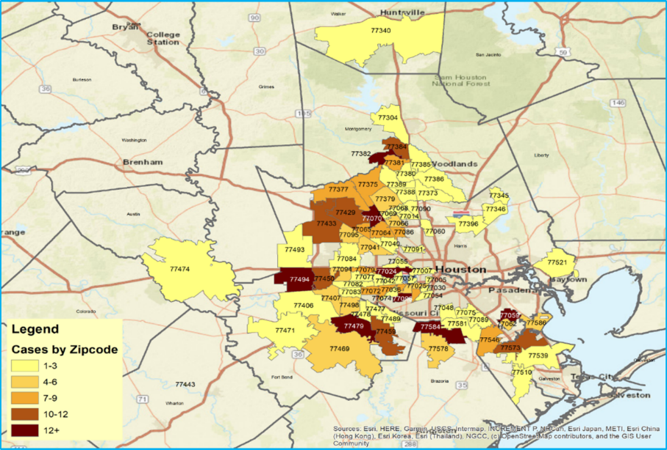
- Results from In-Person Surveys and Focus Group Interviews (n=540)

- Demographic Characteristics of Participants

Table 1 describes the demographic characteristic of the participants. Forty nine youth and 74 adults completed the focus group interviews and an additional 111 youth and 306 adults completed in-person surveys. Among 540 participants, 46.7% of them completed the focus group interview or in-person surveys in English while the rest of them completed them in Chinese (52%) and in Vietnamese (1.3%). As for age distribution, the three largest age groups were: age 36 to 50 (43.9%), under 18 (29.6%) and 51 to 64 (10.4%). Thirty nine percent were male and 61% were female. The majority of participants were Chinese (79.8%), 18.5% were Vietnamese, 1.5% were multiracial groups and 0.2% were Korean. Students (i.e., high school and college students) accounted for 36.1%, while parents accounted for 58% of the sample. An additional 6% were teachers and volunteers for the project. Most participants resided in Harris County (54.6%) and the rest of them resided in Fort Bend County (20.6%), Brazoria (12.8%), Montgomery (8.3%), Galveston (3.1%) and other (0.6%).
Table 1. Participants’ Demographic Characteristics
Characteristics | Frequency or Percent
Type of Assessment  In-Person Survey (n=417)  Focus Group Interviews (n=123) | Youths: 111 Adults: 306  Youths: 49 Adults: 74
Language Use  English  Chinese  Vietnamese | 46.7  52.0  1.3
Age  Under 18  19 - 26  27 - 35  36 - 50  51 - 64  65 and older | 29.6  7.8  6.9  43.9  10.4  1.5
Gender  Male  Female | 39.4  60.6
Racial/Ethnic Background  Chinese  Vietnamese  Other (Korean, multiple groups) | 79.8  18.5  1.7
Current Status  Student  Parent  Teacher  Staff or volunteer of the project | 36.1  58.0  3.9  2.1
County of Residence  Brazoria  Fort Bend  Galveston  Harris  Montgomery  Others | 12.8  20.6  3.1  54.6  8.3  0.6

- Results of the Community Assessment on THRIVE (Tool for Health & Resilience in Vulnerable Environments) Factors
All 540 participants were asked to fill out the THRIVE worksheet. The THRIVE worksheet is a tool designed by the Prevention Institute to engage members of the community to identify and prioritize community determinants of health in the community. It also enables members of the community to take actions to change the community determinants in order to improve health, safety, and health equity. The community determinants consist of 12 factors as listed in Table 2. For this project, the THRIVE worksheet was slightly modified to focus on the assessment of mental health conditions in the target community. Table 2 summarizes results of the community assessments on community determinants of mental health for all participants. Results for youth and adult samples are separate.

Community Effectiveness Scores (0-5): participants were asked to rate how his/her community is addressing the 12 THRIVE factors from a scale of 0 (failing) to 5 (excellent). Overall, participants rated several factors not doing very well, with mean scores below 3:
- Social Network and Trust:
- Members of my community work to foster new and strengthen existing connections for the mental wellbeing of all residents (mean=2.81).

- Participation and Willingness to Act for the Common Good:
- Members of my community have individual capacity, desire, and ability to participate, communicate, and work to improve the mental wellbeing of children and youth (mean=2.99).
- Members of my community have meaningful participation in local leadership positions (mean=2.88).
- Members of my community are actively involved in local community and social organizations and participate in the political process (mean=2.94).

- What’s Sold and What’s Promoted:
- My community has limited promotion, availability, and concentration of potentially harmful products and services (e.g. unhealthy food, tobacco, firearms, alcohol, and other drugs) (mean=2.75).

- Living Wages and Local Wealth:
- Community residents have access to investment opportunities (mean=2.99).
Only the following two THRIVE factors were rated an effectiveness with a mean score of 4 and above:
- Parks and Open Space:
- Community residents have access to safe, clean parks, green space and open areas that appeal to interests and activities across the generations (mean=4.10).

- Air, Water and Soil:
- My community has safe and non-toxic water, soil, indoor and outdoor air (mean=4.11).
Priority Rating for Future Efforts (Low-Medium-High): Given what participants know about the effectiveness of current efforts to address each of the 12 factors, participants were asked to rate the priority of future efforts to increase mental health and decrease inequality for each factor. The following factors received “high” priority ratings for future efforts by more than 30% of participants:
- Education (48.5%)
- Participation and willingness to act for the common good (42.2%)
- Look, feel and safety (36.5%)
- Air, water and soil (34.7%)
- Norms and culture (34.5%)
- Parks and open space (34.3%)
- Social network and trust (32.8%)
Top Three Priorities: Based on effectiveness and priority ratings, participants were asked to select three areas across all twelve factors that he/she feels are most important to address in his/her community with the goal of increasing mental health and safety and reducing health inequalities. The following factors were selected by more than 30% of participants:
- Participation & willingness to act for the common good (47.9%)
- Norms and culture (42.5%)
- Social network & trust (43.9%)
- Education (35.8%)
Differences in Youth and Adult Samples: The last two columns of Table 2 and Figure 2 compare different results generated by youth (age 26 and younger) and adult/parent samples (also shown in Figure 2). For the youth, the following factors were selected by more than 30% of participants as the top three choices that the community needs to address: norms and culture (49.0%), social network and trust (46.9%), and participation and willingness to act for the common good (46.5%). For adults, the following factors were selected by more than 30% of participants as the top choices that the community needs to address: social network and trust (42.7%), participation and willingness to act for the common good (48.7%), education (40.6%), and norms and culture (38.5%). More youth selected norms and culture as one of the top three choices while more adults selected education as one of the top three choices. These differences also reached statistical significance at .05 level. Three other THRIVE factors also reached statistically significant differences: what’s sold & how it’s promoted, living wages and local wealth, and parks & open space. More youth want the first two factors to be addressed while more parents want to address the third factor (parks & open space).
Table 2. Summary of the Results for 12 THRIVE Factors on Overall, Youth and Adult Samples (n=540)
 | THRIVE Factor | Effectiveness Score (0-5): Mean and SD | Priority Rating: % | Top 3 Picks: %
 |  |  |  | Total Sample | Youth Sample | Adult Sample
People | - Social Network & Trust:  - Members of my community trust each  other; | 3.56/1.00 | Low: 18.1  Moderate:  49.1  High: 32.8 | 43.9  (χ2=.56/p=.45) | 46.0 | 42.7
 | - Members of my community share common history, mutual obligations, and opportunities to exchange information; | 3.18/1.22
 | - Members of my community work to foster new and strengthen existing connections for the mental wellbeing of all residents. | 2.81/1.30
 | - Participation & Willingness to Act for the Common Good:  - Members of my community have individual capacity, desire, and ability to participate, communicate, and work to improve the mental wellbeing of children and youth; | 3.13/1.24 | Low: 12.3  Moderate:  45.5  High: 42.2 | 47.9  (χ²=.80/p=.67) | 46.5 | 48.7
 | - Members of my community have meaningful participation in local leadership positions; | 2.88/1.28
 | - Members of my community are actively involved in local community and social organizations and participate in the political process. | 2.94/1.28
 | - Norms & Culture:  - My community has broadly accepted behaviors to which people generally conform that promote mental health, wellness, and safety among all community residents; | 3.35/1.16 | Low: 19.7  Moderate:  45.8  High: 34.5 | 42.5*  (χ²=5.69/p=.017) | 49.0 | 38.5
 | - My community discourages behaviors that inflict emotional or physical distress on others; | 3.81/1.16
 | - My community rewards behaviors that positively affect others; | 3.60/1.25
 | - My community’s norms (e.g., values and practices) stem from the belief systems that are often linked to those core personal characteristics from which identity derives. | 3.46/1.11
Place | - What’s Sold & How It’s Promoted:  - My community promotes safe, healthy, affordable, culturally appropriate products and services (e.g. healthy food, exercise programs, pharmacies, books and school supplies, sports equipment, arts and crafts supplies, and other recreational items); | 3.23/1.34 | Low: 32.6  Moderate:  46.4  High: 20.9 | 21.2  (χ²=9.46/p=.002) | 28.2 | 17.0
 | - My community has limited promotion, availability, and concentration of potentially harmful products and services (e.g. unhealthy food, tobacco, firearms, alcohol, and other drugs). | 2.75/1.53
 | - Look, Feel & Safety: My community’s surroundings are well-maintained, appealing, perceived to be safe and culturally inviting for all residents. | 3.96/ 1.02 | Low: 32.0  Moderate:  31.5  High: 36.5 | 23.1  (χ²=2.61/p=.106) | 19.3 | 25.4
 | - Parks & Open Space: Community residents have access to safe, clean parks, green space and open areas that appeal to interests and activities across the generations. | 4.10/1.09 | Low: 34.5  Moderate:  31.3  High: 34.3 | 10.8 (χ²=3.83/p=.050) | 7.4 | 12.8
 | - Getting Around: My community has safe, reliable, accessible, and affordable ways for people to move around, including public transit, walking, and biking trails, and using devices such as Uber that aid mobility. | 3.44/1.34 | Low: 31.8  Moderate:  41.4  High: 26.9 | 13.4 (χ²=.06/p=.81) | 13.9 | 13.1
 | - Housing: My community has high-quality, safe, and affordable housing that is accessible for residents with different income levels. | 3.60/1.13 | Low: 32.3  Moderate:  41.8  High: 25.9 | 8.8 (χ²=.01/p=.92) | 8.9 | 8.7
 | - Air, Water & Soil: My community has safe and non-toxic water, soil, indoor and outdoor air. | 4.11/.99 | Low: 34.8  Moderate:  30.5  High: 34.7 | 11.8 (χ²=2.19/p=.14) | 9.1 | 13.4
 | - Arts & Cultural Expression:  - There are abundant opportunities existing within my community for cultural and artistic expression and participation, and for positive cultural values to be expressed through the arts; | 3.30/1.23 | Low:28.1  Moderate:  49.3  High: 22.6 | 18.2 (χ²=1.26/p=.26) | 15.8 | 19.7
 | - Arts and culture positively reflect and value the backgrounds of all community residents. | 3.24/1.20
Equitable Opportunity | - Living Wages and Local Wealth:  - The community assets are locally owned; | 3.41/1.14 | Low: 25.6  Moderate:  51.5  High: 22.9 | 15.3 (χ²=6.32/p=.01) | 20.3 | 12.2
 | - Residents can access local employment that pays living wages and salaries; | 3.38/1.16
 | - Community residents have access to investment opportunities. | 2.99/1.31
 | - Education: There are high quality and accessible education and literacy development for all ages that effectively serves all types of learners in my community. | 3.89/1.15 | Low: 24.1  Moderate:  27.5  High: 48.5 | 35.8 (χ²=9.09/p=.00) | 27.7 | 40.6

Figure 2. Top Three Choices that the Community Needs to Address by Type of Participants (n=510)
*

- Urgent Mental Health Issues among Asian American Youth and Children
To identify specific urgent mental health issues among AA children and youth, members of the collaborative compiled a list of twenty six mental health issues that had been reported by members from their respective community. Participants of in-person surveys were asked to rate the priority of future efforts to increase the mental wellbeing among AA children and youth. Based on priority ratings, they were also asked to select three areas across all twenty six mental health issues that he/she feels are most important to address in his/her community with the goal of increasing mental well-being and reducing mental health inequalities. Results of these ratings and the top three selections are summarized in Table 3 below.
As for the priority rating on specific mental health issues, more than 40% of participants rated “high” priority for the following issues: academic/school stress (55.2%), social media addiction (52%), depression (49.2%), gaming (48.1%), anxiety disorders (44%), social isolation/loneliness (42.8%), and bullying including cyber bullying (41.6%).

When asked to select top three urgent mental health issues that need to be addressed, the following three areas were selected by more than 30% of all participants: depression (42.3%), academic/school stress (35.5%), and gaming (31.2%).

Differences in Youth and Adult Samples: When the data were broken down by youth (n=111) and adult (n=306) samples, there were different results reported (See Figure 2 and Table 3). For youth, depression (49.7%) and academic/school stress (49.7%), while for adults, gaming (44.5%) and depression (38.1%) were selected as urgent mental issues.

Different results for depression, suicidal thoughts, intellectual disabilities, gaming, social isolation and loneliness, smoking and vaping, academic/school stress, bullying, and traumatic and stressful circumstances of personal history between youth and adult samples were also statistically significant at .05 level. More youth identified depression, academic/school stress, smoking and vaping, and stressful circumstances of personal history were urgent problems in comparison to their parents. In contrast, more parents identified gaming, social isolation and loneliness, and bullying were urgent problems in comparison to youth.

Table 3. Results of the Priority Rating for Mental Health Issues among Asian American Children and Youth
(n=417)
Category | Priority Rating: % |  |  | Top 3 Pick: % |  |  | χ² values/P values
 | Low | Medium | High | Total Sample | Youth Sample | Adult Sample
Depression | 21.0 | 29.9 | 49.2 | 42.3 | 49.7 | 38.1 | 5.22/.02
Anxiety disorders | 19.5 | 36.5 | 44.0 | 21.0 | 22.1 | 20.4 | .18/.67
Schizophrenia | 62.3 | 25.6 | 12.1 | 2.4 | 1.4 | 3.0 | 1.12/.29
Suicidal thoughts | 41.3 | 23.8 | 34.9 | 14.3 | 20.1 | 10.9 | 6.59/.01
Neurodevelopmental disorder/Intellectual disabilities | 48.2 | 34.1 | 17.8 | 4.3 | 1.3 | 6.0 | 5.06/.03
Gaming | 20.9 | 31.0 | 48.1 | 31.2 | 7.4 | 44.5 | 61.35/.00
Social media addiction | 16.1 | 31.8 | 52.0 | 29.2 | 25.5 | 31.3 | 1.56/.21
Social isolation/loneliness | 17.3 | 39.9 | 42.8 | 22.0 | 15.2 | 25.7 | 6.02/.01
Drug/substance abuse | 41.7 | 29.2 | 29.2 | 8.9 | 12.1 | 7.2 | 2.83/.09
Alcoholism | 51.1 | 29.6 | 19.3 | 2.7 | 2.7 | 2.6 | .00/.98
Smoking and vaping | 44.5 | 29.3 | 26.2 | 10.4 | 18.8 | 5.7 | 17.67/.00
Pornography | 45.2 | 31.6 | 23.2 | 4.8 | 3.4 | 5.7 | 1.10/.29
Eating disorders | 44.3 | 40.7 | 14.9 | 2.7 | 2.7 | 2.6 | .00/.98
Academic/school stress | 13.4 | 31.4 | 55.2 | 35.5 | 49.7 | 27.5 | 20.37/.00
Financial stress | 36.4 | 45.1 | 18.4 | 4.8 | 6.7 | 3.8 | 1.79/.18
Relationships with parents | 21.2 | 41.8 | 37.0 | 17.9 | 21.5 | 15.8 | 2.06/.15
Relationships with siblings | 34.9 | 43.6 | 21.5 | 1.7 | 1.3 | 1.9 | .17/.68
Relationships with grandparents | 50.1 | 37.9 | 12.0 | 0.7 | 0.0 | 1.1 | 1.71/.19
Dating | 35.7 | 45.8 | 18.6 | 3.6 | 4.7 | 3.0 | .77/.38
Bullying including cyber bullying | 27.9 | 30.5 | 41.6 | 19.1 | 12.1 | 23.0 | 7.39/.01
Verbal abuse | 27.6 | 34.5 | 37.9 | 6.5 | 5.4 | 7.2 | .51/.48
Emotional abuse | 39.5 | 29.4 | 31.1 | 0.2 | 0.0 | 0.4 | .60/.74
Sexual abuse | 54.0 | 22.4 | 23.6 | 3.1 | 4.0 | 2.6 | .60/.44
Physical abuse | 50.0 | 26.0 | 24.0 | 1.2 | 2.0 | 0.8 | 1.27/.26
Domestic violence | 48.7 | 26.3 | 25.1 | 3.6 | 4.7 | 3.0 | .77/.38
Traumatic and stressful circumstances of personal history | 46.0 | 32.2 | 21.8 | 2.2 | 4.0 | 1.1 | 3.76/.05

Figure 3. Top three urgent mental health issues that need to be addressed by type of participants
*
*
*: p value is ≤.05 level.

During the focus group interviews, we also asked participants to identify factors that contributed to the urgent mental health issues among AA youth and children in their community. Using the word cloud generator, Figure 4 depicts the results of the different factors reported by youth and adults/parents’ samples. Figure 4 shows two interesting findings. First, both youth and parents agreed that “parents” were the most important factor contributing to mental health issues among AA youth and children. Secondly, the specific reasons contributed by parents were very different. Youth tended to see the “pressures” or “stress” from parents were the main factor. Specifically, the overemphasis on academic and imposing a very narrow definition of career success for their children. Pressures from peers and stereotypes towards Asian kids were also cited by youth as contributing factors. On the other hand, parents acknowledged the different cultural and belief systems between them and their children played an important role. As new immigrants, parents were raised and grew up in the Asian cultural system which is very different from the American cultural system which their kids encounter every day. Additionally, many parents also acknowledged that lack of parenting and communication skills as well as lack of awareness of mental health issues were also the contributing factors.
For low-income families, due to work schedule, lack of time spent with their kids and supervision were also the contributing factors. For Vietnamese participants, in addition lack of time with kids and supervision, pressures from social media on self-image was also a contributing factor.

Figure 4. Factors Contributing to AA Youth Mental Health Problems
Youth (n=49) Adults/Parents (n=74)
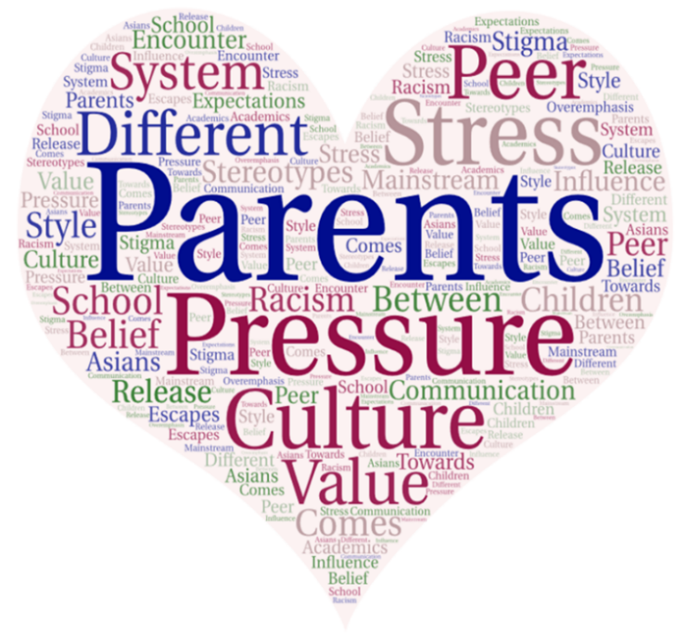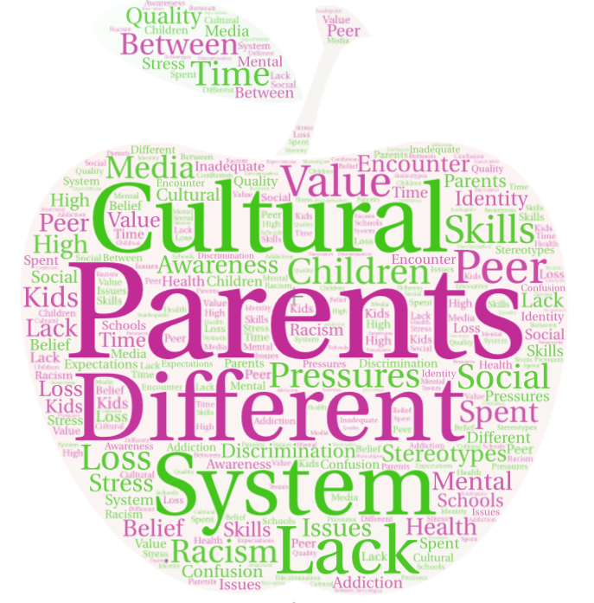

- Gaps and Barriers to Accessing Mental Health Services
Participants of in-person surveys were asked to evaluate the extent of their accessibility to a list of 13 mental health services. The results are shown in Table 4 below. Overall, seven mental health services are rated “adequate” to “outstanding” accessibility: school counselor (76.5%), pastoral counseling (69.5%), peer support services or groups (61.1%), inpatient mental health institutions or services (56.5%), psychiatrist (54.3%), licensed professional counselor (51.2%), and marital and family therapist (50.0%). Six services listed were not known to participants (i.e., no accessibility or no knowledge of these services): crisis services (46.8%), psychologist (46.1%), prevention and screening services (45.7%), clinical social worker (42.9%), substance abuse/addiction services (detox and rehab) (30.5%), and certified alcohol and drug abuse counselor (29.1%).

Table 4. Gaps in Accessing Mental Health Services (%, n=416)
Category | Adequate and Outstanding Accessibility | No Accessibility | I Don’t Know
School Counselor | 76.5 | 10.2 | 13.3
Pastoral Counseling | 69.5 | 7.9 | 22.6
Peer Support Services or Groups (including self-help, drop-in centers, training courses in wellness and recovery etc.) | 61.1 | 13.7 | 25.2
Inpatient mental health institutions or services | 56.5 | 14.4 | 29.1
Psychiatrist | 54.3 | 18.3 | 27.4
Licensed Professional Counselor | 51.2 | 24 | 24.8
Marital and Family Therapist | 50.0 | 18.5 | 31.5
Crisis services | 46.8 | 17.8 | 35.4
Psychologist | 46.1 | 24.3 | 29.6
Prevention and screening services | 45.7 | 18.1 | 36.2
Clinical Social Worker | 42.9 | 24.1 | 33
Substance abuse/addiction services (detox and rehab) | 30.5 | 25.9 | 43.6
Certified Alcohol and Drug Abuse Counselor | 29.1 | 28.4 | 42.5

Participants were also asked to identify the barriers for community members to receive mental health and other supporting services. Table 5 summarizes the results from in-person surveys. According to the data shown in Table 5, the following barriers have the highest percentages reporting “sometimes” or “often a barrier” in receiving mental health services (in rank order):
- Cultural barriers (stigma and fear) (74.8%)
- Language barriers (74.6%)
- Lack of awareness (68.4%)
- Work schedule (61.4%)
- Don’t know where to find a mental health service provider (58.6%)
- Don’t know where to find information and resources (56.8%)
- Long waiting list for an appointment (55.9%)
- Childcare issue (50.1%)
- No health insurance (44%)
- Limited hours of operation (43.1%)
- Transportation services (36.5%)
- Lack of internet access (27.1%)

Only two areas that have the highest percentage that the majority of participants did not see as a barrier are:
- Lack of internet access (62.6%)
- Transportation services (47%)

Table 5. Barriers to Receiving Mental Health and Other Supporting Services (%, n=417)
Item | Sometimes or Often a Barrier | Not a Barrier | I Don’t Know
Cultural barriers (stigma and fear) | 74.8 | 18.2 | 7.2
Language barriers | 74.6 | 15.9 | 9.4
Lack of awareness | 68.4 | 17.5 | 14.1
Work schedule | 61.4 | 21.4 | 17.1
Don’t know where to find a mental health service provider | 58.6 | 20.2 | 21.2
Don’t know where to find information and resources | 56.8 | 22.1 | 21.1
Long waiting list for an appointment | 55.9 | 19.9 | 24.2
Childcare issue | 50.1 | 28.3 | 21.6
No health insurance | 44.0 | 38.2 | 17.8
Limited hours of operation | 43.1 | 25.8 | 31.1
Transportation services | 36.5 | 47.0 | 16.5
Lack of internet access | 27.1 | 62.6 | 10.3

Results from Focus Group Interviews: Participants of focus group interviews were also asked to identify barriers for individuals with mental illness to seek help. Results were summarized in Figure 4. The results were very similar to the results reported in in-person surveys. Both youth and adults identified similar barriers. Cultural stigma toward mental illness and fear of negative impact of disclosure were mentioned by both parents and youth as one of major barriers. In the Asian culture, people feel “shame” and lose “face” towards people with mental illness. In addition, people with mental illness are scared of seeking help because they don’t want to be labeled as “weak” people or are afraid of affecting their kids’ school and future career status.
Lack of awareness of mental illness is the second most commonly mentioned barrier. It includes how to recognize the symptoms of mental illness and find quality service providers and other supporting services. Physical symptoms of mental illness are not as straightforward as physical illness. Thus, many people are not aware that they are having the problem. Nor do they know their conditions like any physical illness that need to seek professional help. Other barriers mentioned include language barrier, long waiting time for an appointment, and financial burden.
Figure 5. Barriers for Asian Americans with Mental Illness to Seek Help
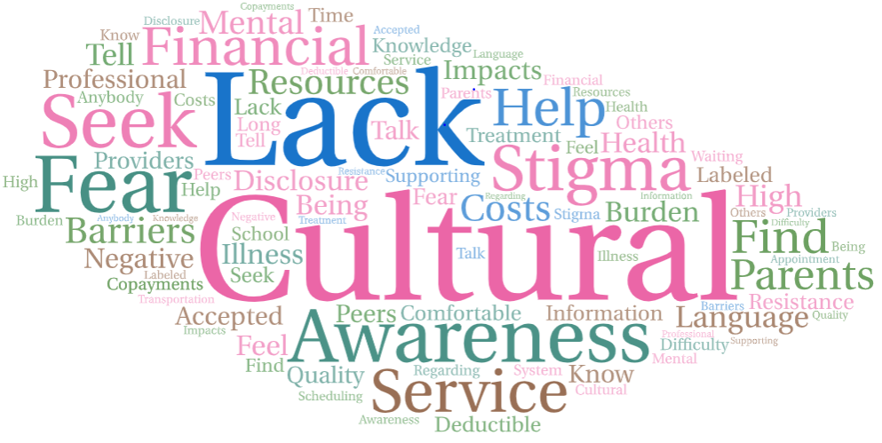
- Perceptions towards People with Mental Illness
Participants of in-person surveys were asked their perceptions towards people with mental illness and results are summarized in Table 6 below. As shown in Table 6, overall, the majority of participants held very positive views about mental health treatment (81.3%). However, participants were less certain on the public’s acceptance towards people with mental illness (60.7%), and on encouraging people with mental illness who actively participate in coalitions, task forces, committees, boards, etc. that meet to discuss mental health issues (55.2%). Also, an item that was reported more negatively than positively is “People with mental illness are seen as experts and are respected by mental health providers (38% vs. 37%).” There were also 24.9% of participants who neither agreed nor disagreed with this item.
Table 6. Perceptions towards People with Mental Illness (%, n=417)
Item | Strongly Disagree | Slightly Disagree | Neither Disagree Nor Agree | Slightly Agree | Strongly Agree
Treatment can help people with mental illness lead normal lives. | 3.1 | 8.6 | 7.0 | 27.1 | 54.2
People are generally caring and sympathetic to people with mental illness. | 4.8 | 19.2 | 15.3 | 33.1 | 27.6
People with mental illness actively participate in coalitions, task forces, committees, boards, etc. that meet to discuss mental health issues. | 8.4 | 14.1 | 22.3 | 18.5 | 36.7
People with mental illness are seen as experts and are respected by mental health providers. | 18.5 | 18.5 | 24.9 | 16.5 | 21.6

- Differences Between Chinese and Vietnamese Participants

In addition to generational differences, we also examined any significant different findings reported between Chinese and Vietnamese participants. Using the chi-square analytical technique, overall, participants from both communities held many similar viewpoints about the 12 THRIVE factors and concerns on the major urgent mental health problems among children and youth. However, the data also indicated significant differences between Chinese and Vietnamese participants in several areas. Table 7 summarizes the areas that different results were reported.

In comparison to their Chinese counterparts, more Vietnamese participants considered depression, suicidal thoughts and smoking and vaping as urgent mental health problems among AA children and youth. For Chinese participants, gaming and social isolation and loneliness were considered as urgent mental health problems. As to accessing mental health services, Vietnamese participants were more knowledgeable in the following two mental health services: certified alcohol and drug abuse counselor and substance abuse and addiction services while Chinese participants were more aware of inpatient mental health services. As to barriers to accessing mental health services, Vietnamese participants encountered more tangible barriers such as lack of health insurance, transportation services and internet access while Chinese counterparts expressed greater barrier in cultural stigma and fear. For Vietnamese participants, they held less certain views on how people with mental illness were positively treated in the community.
Table 7. Results of Different Findings between Chinese and Vietnamese Participants
Urgent Mental Health Issues among Asian American Children and Youth (% Yes, n=417)
 | Total  Sample (%) | Chinese  Sample (%) | Vietnamese  Sample (%) | Χ² Statistic/  P value
Depression | 42.2 | 39.0 | 55.8 | 7.32/.01
Suicidal Thoughts | 14.3 | 11.3 | 27.3 | 13.00/.00
Gaming | 31.4 | 37.2 | 6.5 | 27.31/.00
Social Isolation/Loneliness | 22.2 | 24.2 | 13.5 | 3.96/.05
Smoking and Vaping | 10.6 | 7.6 | 23.4 | 16.31/.00
Gaps in Accessing Mental Health Services (%)
(1=no accessibility, 2=adequate or outstanding accessibility, 3=don’t know)
Certified Alcohol and Drug Abuse Counselor | 1=28.8  2=28.5  3=42.7 | 1=31.0  2=23.3  3=45.7 | 1=19.5  2=50.6  3=29.9 | 22.83/.00
Substance Abuse/ Addiction Services | 1=26.2  2=30.0  3=43.8 | 1=27.9  2=25.4  3=46.8 | 1=19.5  2=49.4  3=31.2 | 17.08/.00
Inpatient Mental Health Institutions or Services | 1=14.7  2=56.0  3=29.2 | 1=13.9  2=59.1  3=27.0 | 1=18.2  2=42.9  3=39.0 | 6.77/.03
Barrier to Access Mental Health Services (%)
(1= not a barrier, 2=sometimes or often a barrier, 3=don’t know)
Cultural Stigma and Fear | 1=16.0  2=74.7  3=9.3 | 1=13.9  2=78.5  3=7.6 | 1= 24.7  2=58.4  3=16.9 | 13.66/.00
No Health Insurance | 1=38.8  2=43.5  3=17.7 | 1=41.7  2=42.3  3=16.0 | 1=26.3  2=48.7  3=25.0 | 7.17/.03
Transportation Services | 1= 47.3  2=36.0  3=16.7 | 1=50.5  2=33.2  3=16.3 | 1=33.8  2=48.1  3=18.2 | 7.62/.02
Lack of Internet Services | 1=63.0  2=26.5  3=10.5 | 1=66.8  2=23.6  3=9.7 | 1=46.8  2=39.0  3=14.3 | 10.83/.00
Perceptions Towards People with Mental Illness
(%, 1=strongly or slightly disagree, 2=Neutral, 3= Strongly or slightly agree)
People are generally caring and sympathetic to people with mental illness. | 1=23.5  2=15.4  3=61.0 | 1=23.9  2=13.3  3=62.8 | 1=22.1  2=24.7  3=53.2 | 6.28/.05
People with mental illness actively participate in coalitions, task forces, committees, boards, etc. that meet to discuss mental health issues. | 1=22.1  2=22.1  3=55.9 | 1=19.9  2=17.8  3=62.2 | 1=31.2  2=40.3  3=28.6 | 30.49/.00

- Results of Online Surveys over the Impacts of COVID-19 Pandemic (n=122)

The COVID-19 pandemic has changed every dimension of our lives tremendously. To assess these impacts within the project’s target communities, the engagement lead, Sharon Cheng, developed and administered a short online survey using the Survey Monkey platform in May 2020. The online survey consisted of 10 questions asking participants’ feedback regarding the impacts of the COVID-19 pandemic on their life. The impacts included things that worried them the most, encountering any challenges, ways to cope with the negative impacts brought by the COVID-19 pandemic, their needs during the pandemic, sources of COVID-19 related information they received and trusted most, and age of participants. A total of 122 members from the collaborative had completed the surveys. The three largest categories of age distribution were ages 35 to 50 (52%), 51 to 64 (27.3%), and 26 and younger (12.4%).

Figure 6 summarizes the results when participants were asked to identify problems that bothered them during the last 2 weeks. “Getting infected by COVID-19” was mentioned by 69% of the participants. “Feeling nervous, anxious or on edge” was mentioned by 35% of participants.

Figure 6. Over the last 2 weeks, have you been bothered by the following problems? (% Yes, n=122)

Figure 7 summarizes the issues that participants worried most during the pandemic. The results show that being infected with COVID-19 was the number one fear reported by 65% of respondents, followed by racial discrimination and harassment related to COVID-19 (47.5%), and children’s education, schoolwork (47.5%), and public safety (43%). The recent surge of fears of racial dissemination and harassment in the AA community was not surprising because COVID-19 originated from China and this was further politicized by some politicians. This is a perfect example of social and political determinants of the mental well-being of vulnerable populations in the society.

Figure 7. What do you worry about most during the COVID-19 pandemic? (n=120)
Racial discrimination & harassment related to COVID-19

When asked what they needed most during the pandemic, the following items were listed: medication and medical supplies such as masks and sanitizers (39%), mental or emotional support (36%), support for childcare or elderly care (31%), food and household supplies (24%), and financial support (21%). The two most challenging tasks were changes in lifestyles (57%) and helping children with schoolwork (47%). Furthermore, there were a variety of ways participants had used to cope with stress, fear and anxiety during the pandemic. These activities included, but were not limited to: cooking (53%), watching a movie (48%), gardening (40%), listening to music (38%), reading and writing (37%), crafting (20%), and playing video games (17%).

Participants received information about COVID-19 from a variety of sources: social media like WeChat, Facebook, and Twitter (69%), mass media such as TV, radio and newspaper (63%), government or related public organizations websites (55%), and family members, friends, or coworkers (45%). However, participants only trusted information published by the government (58%) and TV, newspapers or radio (47%). Social media is listed as trusted source only by 21% of participants.

Participants were also asked to identify actions that they need to do to feel safe and to take care of themselves and their family during the pandemic. Participants’ answers were summarized in Figure 8. As shown in Figure 8, “stay at home’’, “support from family, friends and church”, “avoid public places”, “social distancing”, “adequate protection measures”, and “pray” were mostly frequently mentioned actions.

Figure 8. Actions Need to Do to Feel Safe and to Take Care of Themselves and Their Family

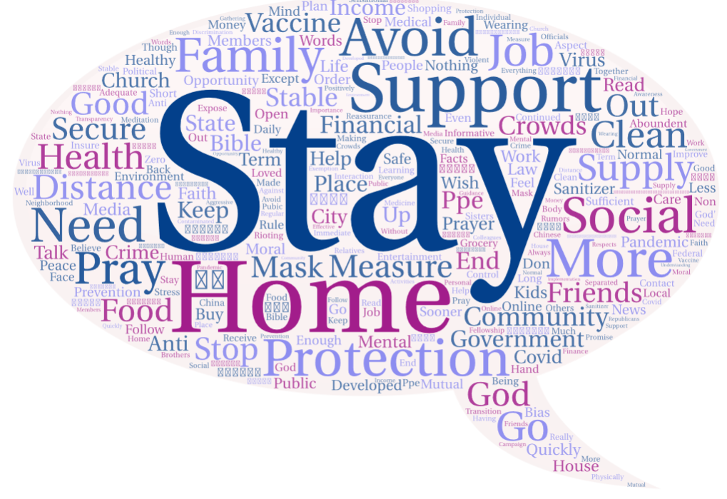

- Results of Secondary Data Search

Secondary data collection was conducted from November 2019 to May 2020 and five sources were identified:
- US Department of Health and Human Services, Office of Minority Health (2020). Mental and Behavioral Health: Asian Americans. https://www.minorityhealth.hhs.gov/omh/browse.aspx?lvl=4&lvlid=54.
- SAMHSA (2019). Results from the 2018 National Survey on Drug Use and Health: Mental Health Detailed Tables. Tables 8.17B and 8.21B. https://www.samhsa.gov/data/report/2018-nsduh-detailed-tables
- Nepal, V., Beiyi, C., Childers, M., Gor, B. J., Bryant, W., Banerjee, D. (2015). State of Asian American and Pacific Islander Health in Houston/Harris County and Surrounding areas. Houston, TX: Houston Health Department.
- Nguyen, P. V., Leung, P. V. and Cheung M. (2011). Bridging Help-Seeking Options to Vietnamese Americans with Parent-Child Conflict and Depressive Symptoms. Children and Youth Services Review 33:1842-1846.
- Yuri Jang, (2016). Asian American in Austin: Final Report of the Asian American Quality of Life (AAQoL) Survey, School of Social Work, the University of Texas at Austin. https://data.austintexas.gov/City-Government/Final-Report-of-the-Asian-American-Quality-of-Life/hc5t-p62z.

Three types of information were specifically collected: prevalence rates of mental illness, uses of mental health services, and stigma relating to mental health and service usage. The findings are summarized below:
Prevalence Rates of Mental Illness:
- National Data (Office of Minority Health, 2020):
- Suicide was the leading cause of death for Asian Americans, ages 15 to 24, in 2017.
- 17.4% of Asian American students in grades 9 to 12 reported suicidal ideation in 2017. Similar statistics for non-Hispanic whites was 17.3%.
- 5.7% of Asian American students in grades 9 to 12 reported attempting suicide in 2017. Similar statistics for non-Hispanic whites was 6.1%.
- Asian American females, in grades 9-12, were 20 percent more likely to attempt suicide as compared to non-Hispanic white female students, in 2017.
- Southeast Asian refugees are at risk for post-traumatic stress disorders (PTSD) associated with trauma experienced before and after immigration to the U.S. One study found that 70% of Southeast Asian refugees receiving mental health care were diagnosed with PTSD.
- The overall suicide rate for Asian Americans is half that of the non-Hispanic white population.
- 2.1% of Asian Americans reported serious psychological distress in the past 30 days among adults 18 years of age and over, 2015-2016. Similar statistic for non-Hispanic whites is 3.7%.

- Texas Data (Jang, 2016):
- 44.2% of the overall sample (n=2,609, Austin, Texas) had mental distress and 6.1% fell in the category of serious mental illness (SMI). The prevalence rates of mental distress and SMI was highest in Vietnamese (54.6% and 9.2%), followed by Korean (43.8% and 7.2%) and other Asians (48.9% and 7.1%).

- Mental Health Data in the greater Houston area:
- 5.8% of AAPI in the greater Houston area had been diagnosed with depressive disorder (Nepal, et al., 2015).
- The 2008 Asian Survey found that 30.2% of Vietnamese Americans reported depressive symptoms and 46.3% experienced parent-child conflicts (Nguyen, et. al., 2011).
Use of Mental Health Services:
- 6.3% of AA adults age 18 and over received mental health services in 2018. In addition, 3.6% received prescription medications for mental health services. Similar statistics for non-Hispanic whites are 18% and 15.4%, respectively.
- In general, the use of a mental health specialist (psychiatrist or mental health provider) was relatively low for Asian Americans in Austin Texas, with 2.2% or 3.4% in the overall sample. 18% used general doctors as the main source of mental health treatment. The highest rate was observed in Filipinos (33.8%), followed by Asian Indians (25%). About 6% of the overall sample reported the use of religious leaders as a source of mental health treatment. The highest rate was found in Koreans (9.6%), followed by Filipinos (8.1%) (Jang, 2016).
- 49.2% of AAs prefer a counselor of their own ethnic group if they use counseling. The rate is notably high in the three groups with a high level of limited English proficiency: Koreans (64.2%), Vietnamese (61.5%), and Chinese (54.3%).
- According to the Health of Houston Survey (2010), higher proportions of Vietnamese living in Houston/Harris County reported that they had mental health needs (19.8%) and had seen a doctor for mental health issues (13.8%) than other AAPI groups. Similar statistics for Chinese were 10.9% and 2.8%, respectively (Nepal, et al., 2015).

Stigma Relating to Mental Health and Service Use:
- More than 37% of the overall sample thought that depression was a sign of personal weakness. About 9% of the overall sample associated mental illness with shame and 19% with family disappointment. More than 44% of the overall sample thought that antidepressant medicines are addictive. (Jang, 2016)
- Depressive symptoms and parent-child conflicts did not predict seeking help from mental health professionals. Many of them believed the problems would be naturally resolved or they seek help from herbalists (Nguyen, et. al., 2011).

- Conclusion and Recommendations

After analyzing both primary and secondary data collected from the community assessment, the challenges and community assets that contributed to the overall mental wellbeing of AA children and youth at different levels were identified and depicted in Figure 9. Words in blue color with a “+“ sign were identified as assets-having positive impacts on the mental wellbeing of AA children and youth while words in red color with a “-“ sign were identified as challenges- having negative impacts on the mental wellbeing of AA children and youth. The farthest circle from the center listed the underlying social determinants (as measured by THRIVE factors) that were identified as challenges or below the average in effectiveness scores and as assets or above the average in effectiveness scores. The next circle to the center lists the specific mental health problems of AA children and youth identified. The circle closest to the center lists the supporting resources, barriers and public perceptions towards individuals with mental illness. Overall, the results show that the AA community in the greater Houston area had more challenges than assets when dealing with issues related to the mental wellbeing of AA children and youth in the greater Houston area.
Figure 9. A Summary of Challenges and Assets that Contributed to the Mental Wellbeing of Asian-American Children and Youth
Living Wages & Local Wealth (-)
Social Networks & Trust (-)
Look, feel & safety (-)
Accept & Engage People w/ Mental Illness (+)
Participation & Willingness to Act for the Common Good (-)
Challenges: Red Color (-)
Assets: Blue Color (+)
Air, Water & Soil (+)
Parks & Open Space (+)
Verbal & Emotional Abuse (-)
Suicidal Thoughts (-)
Anxiety Disorders (-)
Social Isolation/ Loneliness (-)
Depression (-)
Social media Addiction (-)
Academic Stress (-)
Bullying (-)
Gaming (-)
Relationships w/ Parents (-)
Treatment Effectiveness (+)
Language Barriers (-)
Stigma & Fear (-)
Lack of Awareness, Resources & Information (-)
School Counselors (+)
Peer or Group Support (+)
Inpatient Services (+)
What‘s Sold & What’s Promoted (-)

As to stressors for the mental wellbeing of AA children and youth, results from the primary data analyses are generally consistent with the results presented by the secondary data analysis. In summary, the following factors were identified as stressors for AA children and youth:

- Parental pressure to success, especially emphasis on academic success and narrow definition of career success
- Pressure to live up to “Model Minority” stereotype
- Cultural stigma towards mental illness and fears of negative impacts of disclosure
- Different cultural and belief system between kids and parents and obligations to family expectations
- Racism, discrimination, and anti-Asian sentiment, especially during the COVID-19 pandemic
- Difficulties talking with parents

One striking result from the primary data analyses was that youth and parents held different perceptions about community needs and on kids’ mental health issues. For example, as to the top THRIVE factors to be addressed in the community with the goal of increasing mental health and safety and reducing health inequalities, both youth and parents agreed upon the following two factors that need to be improved: “participation and willingness to act for the common good” and “social network and trust”. However, the youth selected “norms and culture” as another top priority that need to be addressed in the community while parents selected “education” as another top priority that need to be addressed. These discrepant results were not surprising. The youth have clearly indicated that parental pressure for success extending from the Asian culture was one the major stressors contributing to their mental wellbeing. For some of them, the two different cultural and belief systems encountered at the school or societal level (i.e., the American culture) and at home (i.e., the Asian culture) had resulted in identify confusion or loss. For parents who were raised in Asian cultures held high expectations for their kids in academic success. They believed the importance of academic success would lead to a successful career path and eventually life success in America.
Another area of discrepant results between youth and parents is the list of urgent mental health issues identified. For youth, depression and academic/school stress were selected as urgent issues, while for adults, gaming and depression were selected as urgent mental issues. Using a chi-square analytical technique, more statistically significantly different results were reported between youth and parent/adult samples. For example, more youth identified depression, academic/school stress, smoking and vaping, and stressful circumstances of personal history were urgent problems in comparison to their parents. In contrast, more parents identified gaming, social isolation and loneliness, and bullying were urgent problems in comparison to youth.
As to factors contributing to the mental health issues among AA children and youth, the results were very clear that both youth and parents acknowledged parents are a major factor that contributed to kid’s mental stress. However, the underlying reasons were different: youth wanted parents to emphasize less on academics and be open-minded to cultural diversity and the acceptance of mental illness, while parents wanted more training opportunities for parenting skills as well as mental health awareness. These results suggest that more opportunities for generational dialogues and cultivating mutual understandings are immediately in need.
In addition to generational differences, we also examined any potential different findings between Chinese and Vietnamese samples. Overall, in comparison to their Chinese counterparts, more Vietnamese participants considered depression, suicidal thoughts and smoking and vaping as urgent mental health problems among AA children and youth. For Chinese participants, gaming and social isolation and loneliness were considered as urgent mental health problems. For some Vietnamese participants, lack of parental supervision due to work schedule and pressure from social media concerning self-image were also listed as factors contributing to the mental health problems among youth. As to accessing mental health services, Vietnamese participants were more knowledgeable in the following two mental health services: certified alcohol and drug abuse counselor and substance abuse and addiction services while Chinese participants were more aware of inpatient mental health services. As to barriers to accessing mental health services, Vietnamese participants encountered more tangible barriers such as lack of health insurance, transportation services and internet access while Chinese counterparts expressed greater barriers in cultural stigma and fear. For Vietnamese participants, they held less certain perceptions on how people with mental illness were positively treated in the community.
Consistent with the results from the prior research, cultural stigma and fear, language barriers, and lack of awareness remain the major barriers for AAs in accessing and receiving mental health services. In addition, work schedule, no knowledge of where to find information about mental health and supporting resources, and long waiting lists when seeking help from professional service providers were also viewed by more than half of participants as barriers. In addition, pastoral counseling was rated the second highest level in accessing mental health services for participants, next to school counselors. Peer support groups were rated as the third highest level of accessibility. These two types of services not only can be provided by trained personnel with the same cultural and linguistic backgrounds recruited from the project’ target communities, but also can be accessed easily and at no charge for members of the target communities.
In summary, according to the results revealed in the community assessment, the mental wellbeing of AA children and youth are determined by different levels of factors and a single one-size-fits-all approach will not be effective. To help each partner understand the assets and needs of their target community, eight individual assessment reports based on data collected from their target populations were prepared and sent to the project coordinator at each partnering site. The information contained in these reports as well as the current final report will be used to help them draft an implementation plan to address the mental well-being of their children and youth during the next 4 years. Certainly, the collaborative as a whole will continue to have conversations about the results of the assessment reports and help them share the results with their members at large. Partners will also contribute to a broader collaborative approach that addresses community conditions that impact all of their community members.
What can the community do to improve the quality of life for individuals with mental illness and to improve the overall mental wellbeing of AA children and youth in their respective community? The following guidelines are recommended based on the results of the community assessment:
Immediate need (Year 2):
- Provide opportunities for dialogues and building bonding between children and parents (social network and trust factor).
- Provide opportunities to help youth build self-identity and thrive (norms and culture factor). As a collaborative, more youth organizations will be invited to join the collaborative.
- Develop initiatives to reduce COVID-19 related racial discrimination and harassments against Asian Americans and community members’ fears over public safety (look, feel and safety factor). There were a variety of ways participants had used to cope with stress, fear, and anxiety during the pandemic. These activities included, but were not limited to cooking, watching a movie, gardening, listening to music, reading and writing, crafting, and playing video games.
- Help families impacted by the COVID-19 pandemic apply for unemployment and other assistance benefit programs (living wages and local wealth factor).
Intermediate goals (participation & willingness to act for the common good factor; Years 2 to 5):
- Continue to build bonding and trust between kids and parents.
- Provide opportunities to build youth’s leadership skills and include youth’s voices in all churches or organizational decision-making processes that will impact their life.
- Organize training opportunities for parents to improve communication and parenting skills.
- Promote public awareness about mental illness.
- Increase bilingual mental health service providers.
- Establish a bilingual resource and information support system.
- Strengthen churches’ capacity to continue to provide mental health support for its members.

