

 

Integrated Planning and Budgeting: Influencing Domestic Finance for Energy Access for

Development in Ethiopia, Kenya, and Tanzania

**Proceedings of Integrated Planning and Budgeting Workshop of Tanzania**

(Nashera Hotel, Dodoma, Tanzania)

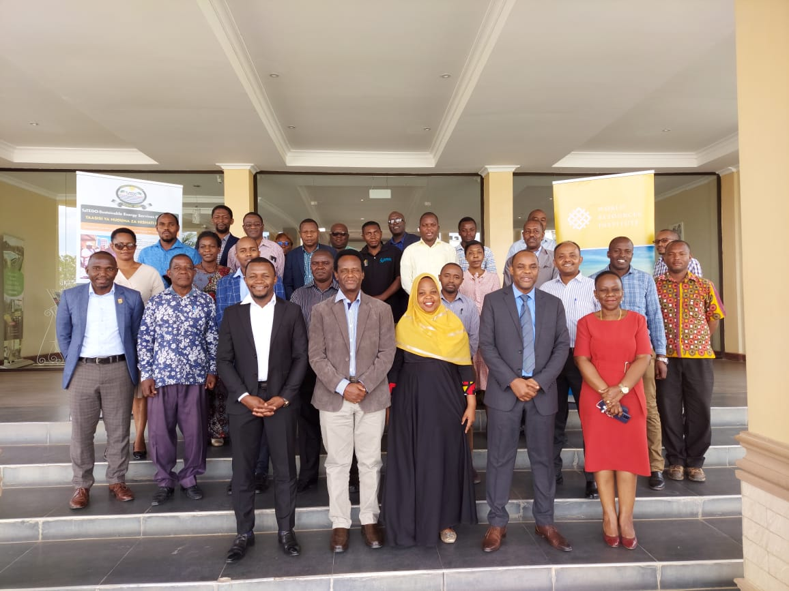

**23 November 2022**

**TABLE OF CONTENTS**

**1.0** **INTRODUCTION** 1

**20** **THE WORKSHOP** 2

2.1 Goal and Objectives 2

2.2 Participation 2

2.3 Venue and Date 2

2.4 Methodology 2

**3.0**  **DELIBERATIONS** 3

3.1 Opening Remarks 3

3.2 Overview of Integrated Planning and Budgeting 5

3.3 Key Steps in MTEF Planning and Budgeting Process 11

3.4 Planning and Reporting System (PLANREP) 14

3.5 Planning Budgeting and Reporting Systems of the MoE 17

**4.0** **PANNEL DISCUSSION** 19

**5.0** **PLENARY DISCUSSION AND FURTHER REFLECTIONS** 22

**6.0** **PROPOSED ACTIONS FOR NEXT STEPS** 22

**7.0** **CLOSING SESSION** 23

7.1 Closing Remarks 23

7.2 Closing Speech 23

**ABBREVIATIONS**

ASDP Agricultural Sector Development Program

CDC Chamwino District Council

CSO Civil Society Organisation

DPP Director of Policy and Planning

FAO Food and Agriculture Organisation

GDP Gross Domestic Product

IDPB Integrated Development Planning and Budgeting

IRENA International Renewable Energy Agency

LGA Local Government Authority

M & E Monitoring and Evaluation

MoFP Ministry of Finance and Planning

MoA Ministry of Agriculture

MoE Ministry of Energy

MTEF Medium Term Expenditure Framework

PLANREP Plan and Reporting System

PO-RALG President Office-Regional Administration and Local Governments

REA Rural Energy Agency

SAGCOT Southern Agricultural Growth Corridor of Tanzania

SDC Sector Development Committee

SDG Sustainable Development Goals

SSA Sub-Saharan Africa

TANESCO Tanzania Electric Supply Company

TaTEDO-SESO TaTEDO-Sustainable Energy Service Organisation

UNDP United Nations Development Programme

WRI World Resources Institute

# **1.0 INTRODUCTION**

It is widely recognized that access to sustainable and affordable energy services is a crucial factor in reducing poverty and enhancing sustainable development. Despite recent gains in global electricity access rates, it is estimated that there will still be some 620 million people without access to electricity by 2030; 85 percent of them will be sub-Saharan Africans (IEA et al. 2020). Lack of access to energy arises from different factors, even though energy poverty is mostly related to economic issues in sub- Saharan Africa. Financial constraints represent a major hurdle to overcome, as many African citizens face difficulties in covering energy-related costs, either upfront and/or consumption costs (Michoud, B & Hafner and M. 2021). Universal electrification of sub-Saharan Africa needs an estimated $27 billion per year (2018–2030), which represents at least double the current levels of financing (Corfee-Morlot et al., 2018). The financing gap is also considerable for clean cooking, being valued at $1.8 billion per year by 2030 (ibid.). Compared to the $28 million dedicated to this sector in 2017, investments will need to increase significantly to allow the provision of clean cooking systems to every African household by 2030 (Michoud, B & Hafner, M. 2021).

Despite the interdependencies, electricity and development sector goals in Africa are largely pursued in isolation from one another (Odarno, L. 2020). Siloed approach to planning and budgeting at national and sub-national government levels has also denied needed finance for energy access from development budgets, as budgetary structures are not fully appropriated. Lack of strong coordination among sectors like agriculture, energy, with facilitation from finance and planning departments deny the opportunities for identification of opportunities for integrated planning and budgeting, thus denying potential financing for energy access interventions(RMI 2021). Thus, investment in sustainable energy requires major shifts in how financing is provided to enterprises supplying decentralized energy services and a systemic change in the national and global financial mechanisms supporting the sector.

Integrated planning and cross-sectoral coordination are crucial to avoid trade-offs and create synergies between different development agendas. Renewable energy solutions and integrated food-energy systems advances energy and food security, while also contributing to job creation, gender equality and climate resilience and adaptation. However, this opportunity is not without its challenges, such as soloed policy making, a lack of forward market linkages, a dire shortage of affordable financing for consumers and enterprises, and concerns about sustainability (IRENA and FAO. 2021), which calls for key stakeholders such as governments, development partners, the private sector and financing institutions in forging a common vision of inclusive and sustainable food systems, energy systems, and societies for better production, better nutrition, a better environment, and a better life for all, leaving no one behind.

Approaches to planning and budgeting that are not well integrated frequently result in plans for investment that are overambitious, delays and cost overruns in project implementation, and weak accountability for results (Richard Allen, et. al 2020). Planning establishes a framework of national, sectoral, and sub-national government goals, policies, and targets. Budgeting puts these policies into a defined fiscal space and resource envelope, thus allowing policymakers to move from aspiration to action. In many countries, however, strategic planning and budgeting systems are neither efficient nor well integrated. Planning systems are often poorly designed and largely aspiration in focus, while decisions on major infrastructure projects such as energy can be dominated by short-term political and electoral considerations. Budgeting is often separate from the planning process, undermined by weak enforcement of fiscal and budgetary rules, and affected by poor control in budget execution, so that the annual budget lacks credibility.

Cognizant of these, WRI aims to influence allocation of domestic resources to the energy access (for development) space, by influencing integration of energy needs into sector budgets at national and sub- national levels in Tanzania. At both levels of government, we will work with the ministries of agriculture, energy, as well as finance and planning to inform, and influence an integrated approach to plans and budgets.

# **20 THE WORKSHOP**

## 2.1 Goal and Objectives

**2.1.1 Goal**

Increased allocation of financing from domestic budget for energy access interventions through an integrated approach to facilitate planning and budgeting at national and sub-national governments.

**2.1.2 Objectives**

* Increased appreciation of the need/value for integrated approach to planning and budgeting by planners at national and sub-national levels
* Improved coordination during planning and budgeting process by key stakeholders (including planners)
* Increased allocation of finance from sectoral budgets to renewable energy related interventions

## 2.2 Participation

The participation of the workshop comprised of 30 staff who came from the government sectoral ministries, district councils of Kongwa and Chamwino and selected CSOs from Dodoma. The list of participants is attached as annex 2.

## 2.3 Venue and Date

The workshop was conducted in 23 November 2022 at Nashera Hotel, Dodoma, Tanzania

## 2.4 Methodology

The workshop brought together sectoral ministries and other stakeholders to discuss integrated approach for planning and budgeting by planners at national and sub-national levels in Tanzania. The workshop focused on exploring the possibility that the government can draw on for planning and budgeting. Ministry of Finance and Planning, WRI and TaTEDO performed this consultation on integrated planning and budgeting from different ministries and stakeholders with consideration of access to energy services.

The workshop was therefore distributed into four main parts. The workshop sessions started from 9:00 to 13:40 hours for all participants. This was distributed into four sections of opening session, overview and existing planning and budgeting systems, panel discussion for staff from different sectoral ministries and closing session. To achieve the set of objectives stipulated for this workshop, timetable was prepared to lead discussions of the participants (see Annex I). The workshop papers were presented and discussed through plenary sessions.

# **3.0 DELIBERATIONS**

## 3.1 Welcome Remarks *(Mr. Benson Ireri, Africa Lead, WRI)*

Habari ya Asubuhi!

Let me take this opportunity to highlight few things about today’s event on the Stakeholder Consultation for Integrated Planning and Budgeting. There are two important areas we have to consider during this consultation which are 1) finance and 2) governance/equitable development. These areas will be discussed in relation to energy access which is ability of all people to access energy services. The energy access has three areas required in the process of ensuring energy services to the people. These are clean energy transition, energy efficiency and availability of energy services. As we know 2030 is not far and this time is when we are supposed to deliver Sustainable Development Goals (SDGs). Therefore, it is very important for all of us to develop ability to work together and ensure no one is left behind.

This call for different stakeholders to work together in order to ensure we achieve SDGs. In order to achieve sectoral growth in the development sectors, there some areas which are key for planning promoted by the WRI. These are actual data and planning (using Energy Access Explorer) and actual implementation of energy in the development sectors (agriculture, water, industries, etc),

We will not be able to achieve growth in those sectors without financial resources. Despite of availability of resources, there is no country in the world which has developed without adequate access to appropriate and sustainable energy services. There is no any sectoral ministry can deliver without reliable energy services. That is why we need integrated planning and budgeting for all sectors of the economy and energy access improvement.

We want to have this consultation workshop as open conversation to discuss how we are going to integrate planning and budgeting activities and find out challenges hindering this process and development budgets in different sectors.

Thank you for coming, it is our hope you will be free to share your experiences for the success of this important theme and workshop.

3.2 **Opening Speech** *(Dr Muhajir Kachwamba, Commissioner- National Planning, MoFP)*

**Good morning,**

On behalf of the Ministry of Finance and Planning, Tanzania, World Resources Institute (WRI) and TaTEDO-Sustainable Energy Services Organization (TaTEDO-SESO) who are the organizers of this consultation workshop on Integrated Planning and Budgeting, I am pleased to warmly welcome all the participants invited from the different ministries, as well as local Governments. More specifically, I would like thank WRI in collaboration with TaTEDO for supporting this initiative.

The focus for today’s conversation is very timely. For the next couple of hours, we are going to be discussing a very critical top icon how Integrated Planning and Budgeting can help us to identify the much-needed resources from our domestic resources for investment in promoting increased access to energy access.

Ladies and gentlemen, as you all know, it is widely recognized that access to sustainable and affordable energy services is a crucial factor in reducing poverty and enhancing sustainable development. In fact, access to energy is interconnected with 125 (74%) out of 169 of the global sustainable development (SDG) targets.

Despite recent gains in global electricity access rates, statistics indicate that about 620 million people will still lack access by 2030, and 85 percent of these will be found in Sub-Saharan Africa, the region with the highest level of energy poverty. In Tanzania, for example, data from World Bank shows that access to electricity in 2020 stood at about 40 percent. In terms of cooking, statistics from the Rural Energy Authority (REA) indicated that less than 10% of the Tanzanian population had access to clean cooking fuels and technologies during the same year.

Distinguished participants, although energy poverty in Sub-Saharan Africa is mostly linked to economic challenges, there are many other factors that contribute to this. Amongst these, lack of access to adequate finance at both households, as well as national level, represents one of the major challenges facing the sector. Additionally, while the average costs of renewable energy technologies has continued to decline over the last decade or so, the overall cost, especially the high upfront costs also remain as a major barrier to access to electricity, as many households can’t afford.

At the same time, research shows that the soloed approach to planning and budgeting – one in which electricity and development sector goals are pursued in isolation of each other despite their interdependencies, is another major challenge that needs to be addressed.

Integrated planning and cross-sectoral coordination are crucial to avoid trade-offs and create synergies between different development agendas, national and sub-national geographies as well as sectoral linkages to influence energy access financing.

As the Ministry of Finance & Planning, and with support from WRI and TaTEDO, we are committed to collaborate with key government agencies such as the President’s Office - Regional Administration and Local Government (PO-RALG) in providing support and coordination to ministries and departments from local government in undertaking an integrated approach to planning and budgeting.

I hope this workshop will give us a chance to identify existing planning and budgeting challenges as well as opportunities for collaboration to influence energy access financing for development.

I Look forward to the discussion today, let us share experiences on how to make contribution to promote integrated planning and budgeting approach for enhancing energy access financing in Tanzania via renewable energy investments.

Once again, a very warm welcome to everyone.

I wish you a fruitful deliberation.

Thank you very much for your attention!

3.2 Overview of Integrated Planning and Budgeting **(***by Dr Adugna Nemera, Senior Finance Associate)*

**3.2.1 Conceptual Overview**

**i) What is the Development Planning?**

* The process of setting goals, developing strategies, outlining the implementation arrangements and allocating resources to achieve those goals (UNDP, 2009)
* Planning is an organized, conscious and continual attempt to select the best available alternatives to achieve specific goals.

**ii) Generic Stages of a National Planning Cycle**

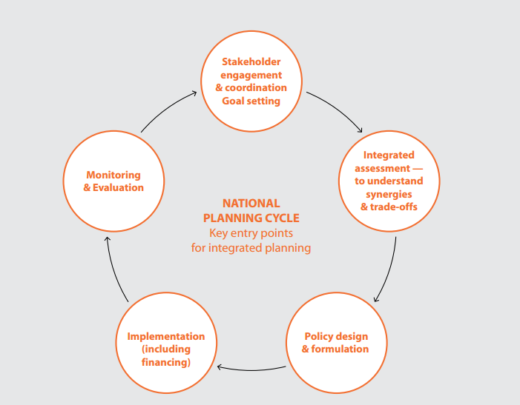

**iii) Integrated Planning and Budgeting**

Integrated planning is an ongoing, systematic process designed to create synergy between various plans and the allocation of resources to ensure that development priorities are achieved.

It is a cross-sectoral and functional process that ensures all stakeholders are involved at the right time to align priorities across organizations and geographies

The integrated development approach emphasis on the need of coordinating different perception of development under a single management system of essential components required to get development moving.

Energy is interconnected with 125 (74%) out of 169 SDG targets*

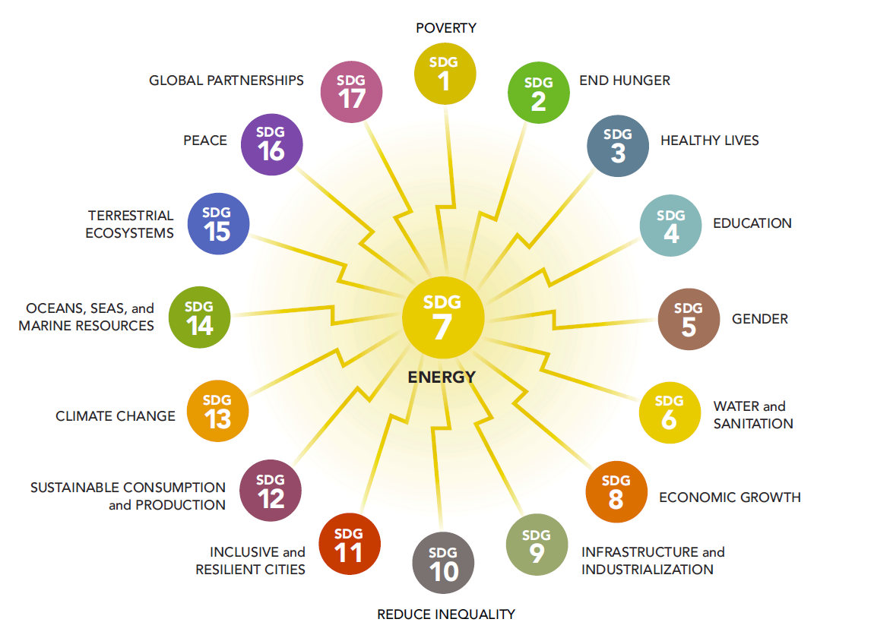

iv) **Why Do Integrated Planning and Budgeting?**

Integrated planning and Cross-Sectorial coordination are crucial to avoid trade-offs and create synergies between different development agendas at national & sub-national levels

* Ensures alignment on key organizational, national and sub-national objectives
* Ensures that all functions within an organization are speaking the same language and that everyone can work together towards a common goal.
* Helps to set strategic priorities and to better coordinate the use of resources
* Helps to identify the best strategies and activities for mitigating risks and choosing the best course for action
* Assist with showing transparency and accountability in activities throughout a public sector organization

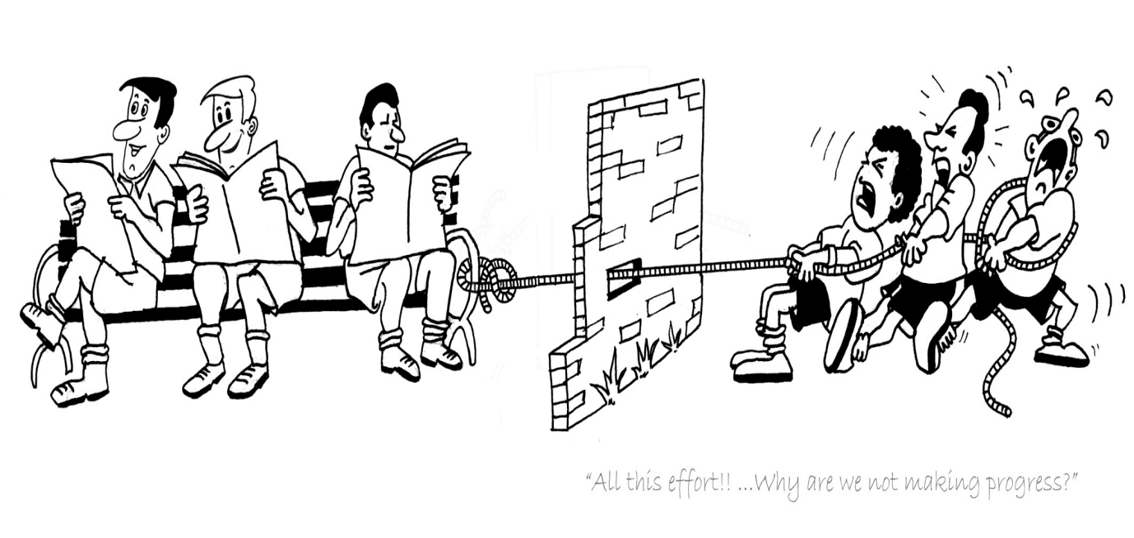

**ENERGY**

**DEVELOPMENT**

Integrated Planning and Budgeting Ecosystem

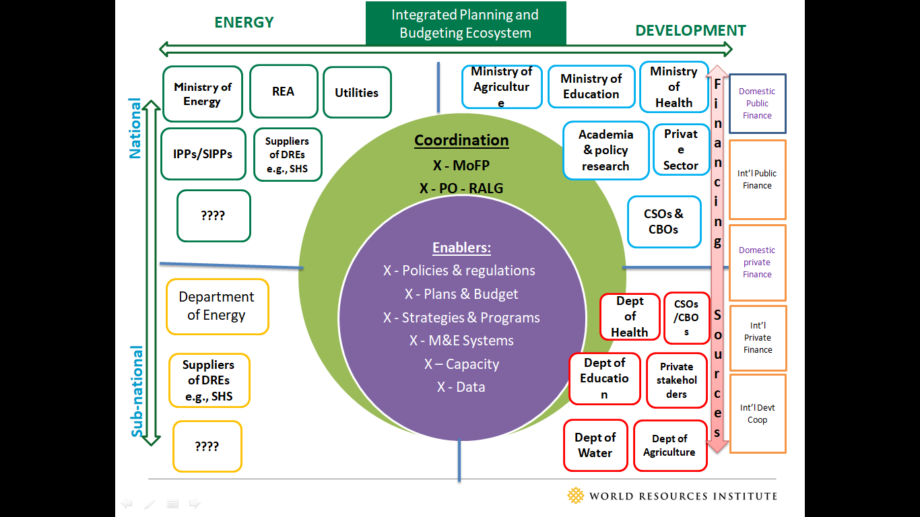

**v) Mechanisms Supporting Integrated Planning and Associated Challenges across the Planning Cycle**

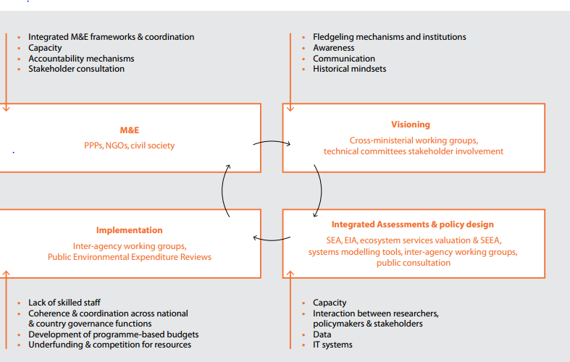

**vi) Budget Cycle in Tanzania**

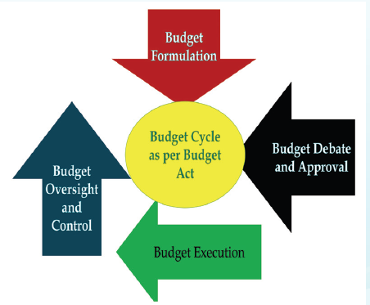

**vii) Annual Budget Formulation Process in Tanzania**

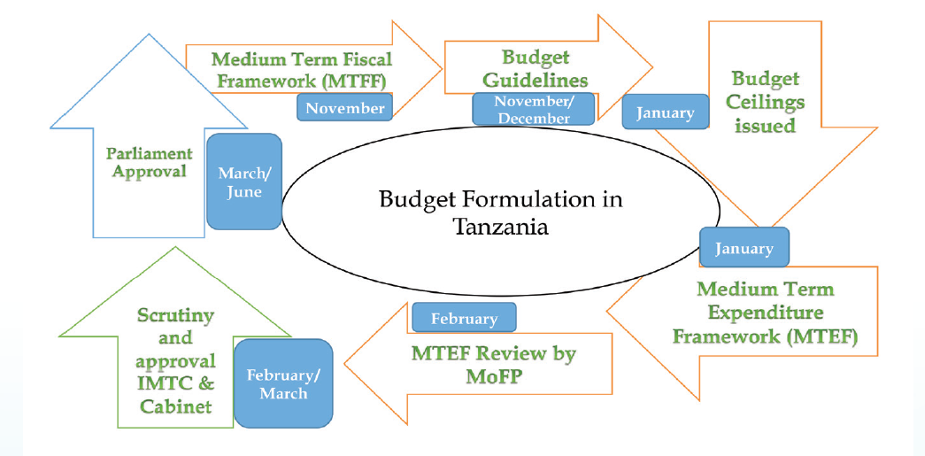

**viii) Formulation, Debate and Approval of LGAs Plans and Budgets**

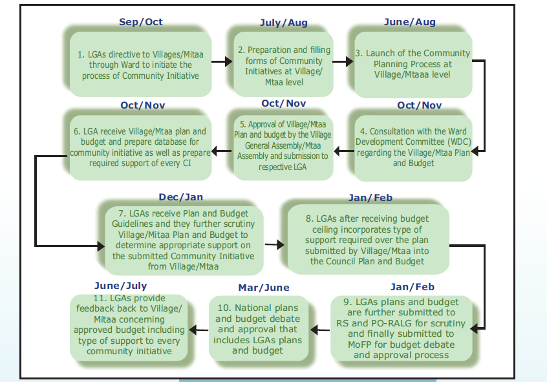

**ix) Existing Planning Practices and Experiences in SSA**

* Despite the interdependencies, electricity and development sector goals in Africa are largely pursued in isolation from one another
* Siloed approach to planning and budgeting at national and sub-national government levels has denied needed finance for energy access interventions from development budgets, as budgetary structures are not fully appropriated

**For example,**

* Agricultural departments prioritize agricultural inputs, even when lack of access to reliable power could be one of the largest constraints or risks faced by farmers.
* In the health context, funds designated for health sector initiatives are typically targeted toward the salaries of health care professionals and the purchase of medical equipment.

**x) Case stories on IDPB**

### The Global Agenda 2030 – stresses the importance of Integrated Approach to manage trade-offs and maximize synergies across targets.

### S. Africa: Municipal Systems Act [No. 32 of 2000] - Department Of Energy: All municipalities in S. Africa are required by law to implement integrated planning & budgeting

### Republic of Zambia: The Integrated National Planning & budgeting process comprises long term, medium term and short term Plan (National Planning and Budgeting Act, 2020) - has temporal and spatial dimensions.

**xi) Features of Integrated Planning Process**

### Transparency – Communication amongst stakeholders is key to effective integrated planning.

### Comprehensive – Participation from all relevant stakeholders is necessary to best integrate organizational goals.

### Structured – integrated planning should be completed using a framework that includes timelines and deadlines throughout the planning cycle.

### Results – Integrated planning should include real decision-making results, with resources attached to those decisions.

### Consultative – Stakeholders should be involved and there should be opportunities for leadership to offer advice and guidance for emerging initiatives

### Action-oriented – The budgeting and planning process should be robust and principled so that it results in decisions on the allocation and re-allocation of resources.

### Streamlined – Efficiencies should be built into the process to reduce duplication of effort. Effort should be focused on selected strategic initiatives, keeping bureaucracy to a minimum.

### Flexible – The process should provide a way to respond to changing conditions and emerging opportunities.

### Accountability – The process should link decisions to responsibilities and results. There should be a way to explain those decisions to a variety of communities and stakeholders. Budgeting should be delegated to operational decision-making. Information should be provided on what resources are needed, organizational data, budget projections and other documentation.

**xii) What are the Key Principles of Good Integrated Planning?**

* Planning that occurs at all levels – Integrated planning should take place at all levels : national & sub-national.
* Data-driven planning framework– Information needs to be up-to-date to inform planning processes and decisions based on current and future needs.
* Risk and challenge identification – Integrated planning helps to find challenges and key risks to deliver on priorities and find methods for mitigation of potential issues.
* Transparent, justifiable decision-making – Integrated planning should be values-based, transparent, and communicated regularly to employees and stakeholders.
* Regular reporting – The organization should establish regular intervals for reporting that shows planning efforts and results.
* Monitored, measured, and evaluated – Performance and progress towards objectives should be monitored.

“*The Third Plan has set ambitious goals that are the foundation of the nation’s long-term success. To achieve this, the contribution of every citizen and development partners is needed. In addition, Government institutions must work together to carry out their responsibilities efficiently and effectively. Similarly, the Government will provide cooperation to the Private Sector which has been given special importance in implementing this Plan”*

H.E Samia Suluhu Hassan, The President of The United Republic of Tanzania, June 2021

**xiii) Points for Reflections**

* Existing planning and budgeting practices and experiences in Tanzania at national and sub-national level
* Key stakeholders and their roles in planning and budgeting processes at national and sub-national levels
* Gaps/challenges and opportunities for integrated planning and budgeting
* Possible solutions to overcome the challenges and actions needed to use opportunities
* If changes have to be made, what should be the process of introducing and effecting such changes required in integrated planning and budgeting?
* Building Consensus on way forward (Action Points for Next Steps)

## **3.3 Key Steps in MTEF Planning and Budgeting Process** (Mr. *Timotheo Semuguruka, Deputy DPP, MoA)*

**3.3.1 Overview**

Agriculture in Tanzania represents almost 30 percent of the country’s GDP with three quarter of the country’s workforce involved in this sector.  Agriculture is undoubtedly the largest and most important sector of the Tanzanian economy, with the country benefitting from a diverse production base that includes livestock, staple food crops and a variety of cash crops.

Tanzania has an ambitious plan to prioritize agriculture for economic growth.  The private sector led Agricultural Sector Development Program Phase II (ASDPII) initiative and the establishment of the Southern Agricultural Growth Corridor of Tanzania (SAGCOT) have been endorsed by the Government of Tanzania.  The ministry has Policy and planning division which provides expertise and services in policy formulation, implementation, monitoring and evaluation.

**3.3.2 Purpose**

The Medium Term Expenditure Framework (MTEF) focuses on the results, improving decision making, fostering internal and external accountability and improving allocation of resources. The MTEF sets out three-year spending plans of the national and provincial governments. It aims to ensure that budgets reflect Government's social and economic priorities and give substance to Government's reconstruction and development commitments. The MTEF is one of the most important reforms of the budgetary process the Government has introduced.

**3.3.3 The Purpose of Planning, Budgeting, and Reporting**

Tanzania’s planning, budgeting, and reporting processes aim to improve Public Sector performance by:

* Focusing institutions on the delivery of results
* Improving internal decision making
* Fostering internal and external accountability
* Improving the allocation of resources and ensuring their prioritization.

The planning process in Tanzania contains seven key steps. These include:

* **Situation Analysis,** which is a process of critical thinking and understanding. During this stage, planners aim to identify the main issues and problems that need to be addressed in the future. They try to “put themselves in their client’s shoes” and to better understand the environment in which they operate.
* **Strategic Plans,** It focuses on the big picture from a longer-term perspective. Because it is prepared collectively, the strategic plan helps clarify priorities and unify staff in the pursuit of shared objectives. Strategic Planning provides an opportunity to address fundamental questions and to undertake bold initiatives and reforms. Ultimately, Strategic Plans serve as communication instruments for both staff and external stakeholders.
* **Budgeting** involves a projection of revenue, the costing of Strategic Plans, and a costing of personnel. The budget is made according to a clear set of priorities established both nationally and within the institution. During the preparation process, the budget is scrutinized to ensure costs are within existing resource envelopes. The budget is ultimately approved by Parliament.
* **Action Planning:** During this stage, institutions schedule their activities for the up-coming year and prepare subsidiary and detailed documents to translate their broad plans into reality. This may include disbursement schedules (or cash flows), detailed departmental plans, procurement and training plans, and individual performance agreements.
* **Implementation**. During this stage enforcement of the budget occurred.
* **Monitoring and Evaluation**: internally, institutions track their progress in implementing their plans. This may focus on activity completion or on the level and quality of the services they provide. Periodically, they may undertake more detailed evaluations, for example to assess whether their objectives are being fulfilled, and if not, why. Oftentimes this involves undertaking special studies or surveys.
* **Reporting**: within this cycle, results are communicated to management so that actions can be taken to adjust direction and improve performance. This may involve an alteration to the plan or a change in strategy. Ideally, progress and performance (assessed through M&E) is communicated or reported to clients, politicians, regulators, and other interested parties, including the general public.

**3.3.4 Guiding Instruments**

* **Long Term National Strategies:** the most prominent of these strategies is The Tanzania Development Vision 2025. The Vision articulates the aspirations the nation wants to achieve over a 25 year period. These are general, and include, for example, “Peaceand Stability” or “a well educated and learning society” Or Modernized Agricultural Sector.
* **Medium Term National Strategies and Plans**: consisting, most prominently of the Five Years Development Plan and MKUKUTA designed to cover 3 and 5 years respectively to operationalize the Vision.
* **Sector Policies, Plans and Strategies**: these usually cut across several institutions.
* **Overarching Policies:** these cut across sectors like D-by-D

**3.3.5 The Planning Entities**

1. **Objective**: a broad statement of what is to be achieved. An objective describes an intended outcome or impact and summarizes why a series of actions have been undertaken. Objectives should be considered institutional. Objectives should be lettered A to Z. This lettering does not imply prioritization as all carry equal importance,
2. **Target:** The final goods or services produced over a given period of time, by an institution, in order to achieve its objectives. A target corresponds to an output. In addition: Targets are of three major classifications: services (S), capital investment (D), and capacity building (C). Targets are ordered under their objectives as 01, 02, etc. This reflects a priority ordering where the lower numbered targets are deemed more important than the higher numbered targets.
3. **Activity:** The actions taken or work performed in order to produce a given target. Activities are what institutions do and describe processes which are largely internal to the institution. They describe how a target is to be produced. Activities are ordered under their targets as 01, 02, etc. This reflects a priority ordering as it did with targets. A single activity is assumed to be completed by a single sub-vote (i.e. multiple sub-votes cannot work together on a single activity)
4. **Input**: financial, human, and material RESOURCES USED in carrying out the activity.

**Note:** Objectives and targets are created during Strategic Planning while activities and inputs are developed during MTEF preparation.

**3.3.6 Budgeting and MTEF**

The Medium Term Expenditure Framework (MTEF) is a prioritised three-year integrated performance budget to implement the Strategic Plan. MTEF starts with the review of performance of the previous year and the current mid-year budget. It takes cognisance of available resources both local and foreign and establishes the cost of implementing activities which will produce targets and meet objectives.

MTEF is intended to carry forward earlier planning and budget reforms including the Rolling Plan and Forward Budget (RPFB) and Performance Budgeting (PB). RPFB was aimed at introducing some forward planning and predictability in resource allocation by moving away from budgeting on a one year basis to three years.

The PB framework was made up of vision, mission statements, objectives, policies and strategies, targets, activities and inputs.

**3.3.7 Steps in the MTEF Process**

All MDAs, Regions and LGAs will have developed strategic plans that contain among other things:

* Situation Analysis;
* Institutional vision and mission statements;
* Institutional objectives linked to national planning frameworks as necessary;
* Prioritised targets that cover revenue and expenditure aspects.

To develop the MTEF, institutions will use the targets from their strategic plans to:

* Identify the activities to be carried out under each target;
* Establish and cost the inputs required for implementing activities, which will ultimately result in three-year budget estimates;
* Prioritize the activities and identify those which could be scaled down, dropped or postponed in order to fit in the plan within the available resources;
* Prepare the institutional MTEF document for submission to the Ministry of Finance and other key stakeholders.

## **3.4 Planning and Reporting System (PLANREP)** *(Mr Joseph Mwacha, Deputy DPP, PO-RALG)*

PlanRep is a popular, user-friendly planning and reporting database used by Local Government Authorities (LGAs) and designed to incorporate the Strategic Plan (Medium-Term Expenditure Framework), revenue projection, budgets, funds received, and track expenditure and physical implementation.  The software is designed to import and export data from and to the Epicor accounting system (IFMS) as used in Local Government Authorities (LGAs).

PlanRep operates as aggregating software at regional level and PO-RALG, where it constitutes a key component of the Management Information System.  It uses indicators for objectives from the Local Government Monitoring Database.

**3.4.1 Why Planning and Reporting System (PlanRep)**

**Implementation and Financial Reporting eg LGA Development and Financial Reports,** etc

**Revenue Estimates**

**Budget Implementation (expenditure)**

**Financial Monitoring**

**Budget Planning**

**Why**

**PlanRep ?**

**Budget Reallocation**

**Budget Analysis**

The steps planning and budgeting for the PO-RALG has managed to undertake:

* Capacity Building Training for Staff at National and Local Levels,
* The PlanRep tool is used by Registrar of the Ministry of Finance and Planning and Local Governments (Regional and District Councils),

The following are benefits of PlanRep System

Business Tips Four

Engage All Sectors

**Business Tips Three**

Business Tips Four

Tool is used for services to the local levels

Business Tips Four

It increase openness and transparency in the budgeting planning process

A single System-which is simple and can be controlled and supported.

Business Tips Four

Tool has Self-Report Preparation System

Costs Reduction and High Efficiency

**Mafunzo kwa Maafisa**: Ngazi ya Taifa hadi Msingi

**Matumizi**: Unatumika kwa Msajili wa Hazina na Serikali za Mitaa

**3.4.2 Implementation Hierarchies**

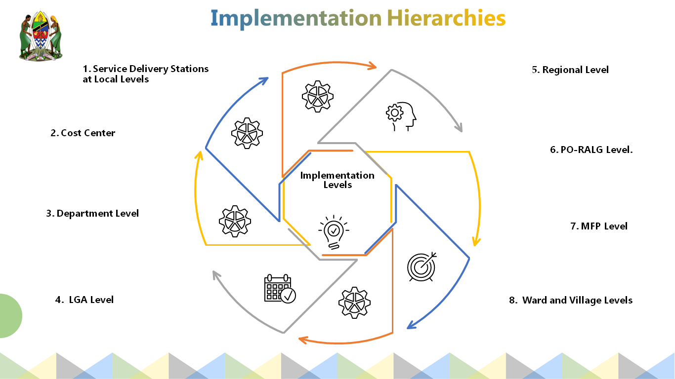

1. **Cost Centres**

Staff in cost centres are involved in the data inputting to the system

* Inputs plans and budgets for costs centres at the local levels
* Inputs plans and budgets for costs centres at the national level

1. **Service Delivery Stations at Local Levels**

* Receive plans and budgets from the costs centres
* Allocate budget and plans according to the expenditures
* Collate budget and plans from costs centres into a document at services delivery stations
* Submit the plans and budgets to the required specific departments

1. **Department Level**

The head of the department will

* Receive the budget and distribute them according to categories of expenditures.
* Receive the plans and budgets from service delivery levels
* Return to service delivery station for corrections in case of queries
* Submit Plans and Budget for Department to Planning Officer for further assessment
* Analyze plans and budgets from services delivery stations

1. **District Council Level**

The planning officer will:

* Receive budgets and distribute in district departments
* Input revenue estimates according to their sources and allocate according to type of expenditures and departments
* Receive the plans and budgets from department level
* Check plans and budgets on their conformity to the guidelines.
* Submit district council plans and budgets to the region for further assessment
* Analyze and return plans and budgets to departments for corrections

1. **Regional Level**

The budget and plans are tabled to the meeting of the regional secretariat for further assessment as indicated hereunder:

* Input plans and budgets for each district council to the regional plan,
* Receive plans and budgets from each district in the region
* Submit plans and budgets to the PO-RALG for further assessment
* Manage the implementation of recommendation from the PO-RALG and MoFP in local governments

1. **PO-RALG Level**

The national assessment team will perform the following:

* Receive budget guidelines and budgets ceilings from the Ministry of Finance and Planning
* Distribute budget guidelines and their ceilings to the regional level
* Receive Plans and Budget from the each region
* Return plans and budgets to the regions for corrections.
* Submit approved regional budgets and plans to the Ministry of Finance and Planning
* Assess Plans and Budgets from regional level
* Transform budgets into expenditure codes according to the system

1. **Level of Ministry of Finance and Planning (MoFP)**

The responsible departments and staff in the Ministry of Finance and Planning will:

* Prepare and send budget guidelines to responsible staff and regions
* Provide budget ceilings to PO-RALG
* Receive Plans and Budget from regions
* Submit budget to the parliament for discussion and approval
* Allocate approved funds to the PO-RALG
* Assess plans and budgets from each region on their conformity to the budget guidelines.

**3.4.3 Exchange of Information between PlanRep and other systems through Muungano Gateways**

Muungano Gateway is electronic system of exchanging information among systems. Different electronic systems exchange and share the information through this gateway.

## **3.5 Planning Budgeting and Reporting Systems of the MoE *(****Ms Alika Ilomo, Economist, MoE)*

**3.5.1 Introduction**

The government ministries, agencies, departments, parastatal, regional secretariat and local government authorities are expected to prepare their annual plans and budgets every year. The preparation of these plans and budgets are based on budget guidelines and timeframe which are prepared by the Ministry of Finance and planning every fiscal year. The ministry of energy has been preparing its annual budgets and plans based these procedures. The task of preparing and coordinating Annual Plans and Budgets is vested under the Policy and Planning Departments.

**3.5.2 Plans and Budget Preparation**

The process of preparation of plans and budgets starts in October of each year by preparing inputs for the National Budget Guidelines. The Policy and Planning Department of the ministry coordinates initial preparation of the draft budget by involving departments, agencies and institutions which are managed by the ministry. The draft budget is completed after receiving budget ceiling from the Ministry of Finance and Planning (MoFP). The budget is discussed by the Budget Technical Committee (BTC) and Budget Committee.

The Sector Development Committee (SDC) and the Budget Scruitinazation Committee which include staff from the Ministry of Finance and Planning and President Office – Finance and Planning Commission. The process further continues in the Energy and Minerals Parliamentary Committee and completed in the budget sessions of the National Parliament.

**3.3.3 Guidelines for Preparation of Annual Plans and Budgets**

* The National Annual Plans and Budgets Preparation Guidelines
* The Ruling Party Manifesto (2020-2025)
* The National Vision 2025,
* The National Five Year Development Plan (2021/22-2025/26)
* The Ministry of Energy Strategic Plan
* The Policy, Strategies and National and International Guidelines

**3.5.4 Important Aspects for Considering During Preparation of Plans and Budgets**

* The budget is prepared based on *Objectives* and *Targets* in the Ministry of Energy Strategic Plan. The ministry assesses implementation of plan and budget of previous year in order to identify the uncompleted activities for budget allocation.
* The ministry continue with assessing important activities required for achieving goals and objectives stipulated in the strategic plan and budgeting according to priorities set by the Government for planned activities by using the *Government Finance Statistics (GFS) codes* (eg: 22010105-per diem).
* The budget is prepared by assessing the real requirements and priorities and come up with realistic budget estimates which can be achieved during budget implementation.

**3.5.5 Conclusion**

* It is of prime importance to ensure the ministry priorities and issues promised by government leaders in relation to the Energy Sector are inserted in the plans and budgets.
* The flagship projects and other projects stipulated in the Ministry Strategic Plan should be given priorities during planning and budgeting.
* There is need to increase budget ceiling and timely fund disbursement in order to achieve ministry and national goals.

# **4.0 PANNEL DISCUSSION**

The panel discussion is a follow-up to points of reflections from the presentation done by Dr Adugna Nemera on Overview of Integrated Planning and Budgeting but also an opportunity of the further discussion from experiences of participants. The session was chaired by Mr. Benson Ireri. The panellists were Timotheo Semuguruka (MoA), Subira Msabaha (MoFP), Joseph Mwacha (PO-RALG) Godfrey Mnyamale (CDC) and Alika Ilomo (MoE). Composition of the panel brought together the important entities and staff involved in planning and budgeting. Each panellists responded to their respective questions.

Q1 What do you think needs to be done to facilitate an integrated approach for planning and budgeting in the country? And what needs to change in order to enhance the approach? (MoFP)

A1. There is a need to strengthen awareness on importance on integrating plans and budgeting, in implementation, make sure all actors from different government institutions implement projects in a way that every actor knows what the other is doing so that projects are integrated to solve a common problem for greater impact. All sectors are expected to provide budget for these projects in a timely manner to ensure no stalling.

Q2. How do you think institutions like WRI and TaTEDO, as well as other development partners can help in mainstreaming an integrated approach to planning and budgeting? (MoFP)

A2. Equip government employees with knowledge on energy planning through capacity buildings. The Government to support these organizations with all they need to implement their objectives.

Q3. Could you briefly speak about the challenges in the energy access for development space? You could focus on gaps in access to electricity for powering agriculture, SMEs, and health sector.(MoE)

A3. Access provided but connectivity not done due to affordability issues. Need to partner with MoFP and others to provide funding for this and enhance productivity e.g., PUE activities. Inability to recoup investment used to connect low energy users in rural areas. Can be expensive to connect small industries e.g., food processing ones since they need dedicated 3-phase supply.

Q4 Based on your experiences, what do you think needs to be done to facilitate an integrated approach to planning and budgeting at both national and sub-national level? How can the MoE support such a process? (MoE)

A4 MoE mostly on the spot to the most issues related to energy. Planning process takes time; therefore it needs to put all efforts in order to ensure the process of planning and budgeting integrates other sectors. There is a need for renewable energy to be given more priority in suggested energy projects and identify stakeholders to take part in the process. At the moment the political will of support in energy activities is high. It is important to use the political will available to push energy development activities.

Q5 How do you think institutions like WRI and TaTEDO, as well as other development partners can help in mainstreaming an integrated approach to planning and budgeting?(MoE)

A5 Need for more forums with representations for higher level stakeholders to own and steer the process. MoE and MoA linkages – REA provides access and connectivity for villages which are practicing agriculture. PUE dependent on Energy provided may add value to the products and service in agriculture.

Q6 Could you briefly speak about the challenges in the energy access for powering agriculture and value addition? i.e., what has been the missed opportunity in the agriculture sector in Tanzania due to lack of access to electricity.(MoA)

A6 Agriculture contributes to 22.9% of national GDP. The challenges within the agricultural sector are how to get power to support production, pump water for irrigation and reduce post-harvest losses. There is a need to plan projects with other ministries and parastatals e.g. MoFP, MoE, TANESCO so as to ensure all inputs including energy for Agriculture are provided before project starts.

Q7 Are there any examples where there have been successful experiences in taking an integrated approach in planning and budgeting for energy and agriculture project? If yes, please share a specific example of such a project or programme, as well as what you think contributed to the success. (MoA)

A7 Southern Economic Growth Project – collaborates with government, private sector to implement activities e.g., strategic value chain partnership to link value addition and markets. Provides or links different stakeholders with inputs, capital and markets to support agriculture societies in their value chain network comprising of different stakeholders doing one or more of these.

Q8 Based on your experiences, what do you think needs to be done to facilitate an integrated approach to planning and budgeting at both national and sub-national level? How can the MoE support such a process? (MoE)

A8 i) Organize such sessions as today to bring together diff ministries and institutions to discuss ways of collaboration.

1. Set priorities as MoA. Ministry of Finance and Planning and other relevant ministries to be identified brought into the process for implementation.
2. Streamline budgets for crosscutting activities between different ministries to ensure some activities don’t stall because budget has not been availed from the other ministry that’s supposed to implement.

Q9. PO-RALG plays a critical role in the planning and budgeting process, as well as implementation of programmes and projects at the sub-national level. As a key actor; (PO-RALG)

1. Q *Could you also share your overall reactions and observations from Adugna’s presentation, with a particular focus on local administration planning & budgeting process?*

A Appreciation for what WRI and TaTEDO have done to invest in Huzi Mango project

1. *Q Considering the significant opportunity that local administrations have in adopting an integrated approach to planning and budgeting, do you think, based on your knowledge and experience, these administrations have taken full advantage of the opportunity? If yes, please share some examples with us. If no, what do you think are the major challenges?*

A. Identifies projects that can benefit them and take them forward for implementation. Public participation key

1. *Q. Could you outline to us, what kind of support is needed to help local administrations develop integrated plans and budgets?*
2. Project coordination unit to be created.
3. *Q How do you think institutions like WRI and TaTEDO, as well as other development partners can help in mainstreaming an integrated approach to planning and budgeting?*
4. Keep supporting with data management and common storage from all different departments in one platform. Others are risk assessment support and M & E trainings

Q10 Local governments are at the centre of where development actions take place. WRI and Chamwino partnered with Chamwino local council to support the Huzi mango project where your council had identified an opportunity in the agriculture sector. (CDC)

1. Q *Could you share with us how the whole process of planning and budgeting for the Huzi Mango project took place up to its implementation? What do you think were some of the success factors?*

A. Chamwino – Project for mango planting and processing- 700 acres. Energy required to pump water by using diesel generator set. Diesel pumps would constantly run out of fuel resulting to plants dying or drying up. TaTEDO and WRI intervened to solve some of these challenges by replacing diesel pumps with 12kV solar connection which has now solved the problem of irrigation.

1. Q. *What are some of the challenges that you experienced during that process?*
2. Getting a development planner to integrate resources to capital investment. Most partners could only provide capacity building support not support to buy infrastructure like what WRI/TaTEDO did for solar connectivity.

# **5.0 PLENARY DISCUSSION AND FURTHER REFLECTIONS**

After panel discussion, the participants had opportunities for contributing to the on-going integrated planning and budgeting discussions. The following are some of the points revealed by the participants:

* Existing planning on-going efforts may take advantage of using the National Planning Day 5th of Dec, to be organized by Ministry of Finance and Planning for most planners in the whole country, to meet for a week. WRI could take advantage of this day and present integrated budgeting and planning.
* There is a need to plan programs together and ensure energy is part of the process.
* For most infrastructural project, the plans for implementation exist, what is required is to sensitize and activate them and integrate stakeholders from different sectors.
* There is a need to create awareness of existing plans and platforms in order to ensure element of integrated planning and budgeting is understood by stakeholders.
* There is lack of interconnectedness of projects. Most of them operate in silos which make the costs of projects too high.
* Complement efforts of planning with others across departments, ministries and countries e.g. TZ to learn from Kenya’s geothermal power projects before implementing theirs.
* Planners not to work in isolation by knowing challenges in their own institutions. There is a need to start discussing how to integrate their plans and jointly work together
* There is a need to plans which will combine both bottom up and top down to feed into each other from local to national level
* There is a need of having open door policy to improve information sharing across departments and ministries
* Need to introduce stakeholder scope statement during budgeting and planning by attaching all proposals where key stakeholders have to sign to confirm their participation
* Develop a system for availing statistics and data which are most critical for planning and M & E systems
* Introduce a system whereby all national development projects – stored and monitored in a digital platform.

# **6.0 PROPOSED ACTIONS FOR NEXT STEPS**

* Strengthen awareness on importance of integrating planning and budgeting for government institutions at all levels particularly on integrated energy planning.
* Identify and engage stakeholders from government ministries/departments and others to take part in the process
* Follow up and organize similar forums with representations for higher level stakeholders to own and steer the process,
* Take advantage of existing planning forums such as a National Planning Day beginning 5th of December 2022, organized by Ministry of Finance and Planning for planners, coming across the country, to meet for a week,
* Supports from WRI and TaTEDO need to continue to ensure institutionalization of the integrated planning and budgeting,
* Support on Monitoring and Evaluation system,
* Need for a unit to monitor national programs and project and identify synergies and areas of cooperation among sectors,
* Coordination and partnership with another ministry to be criteria for approval of the budget,
* Information sharing on what is planned in one ministry and shared with other ministries,
* Harmonization of budgets to involve transactions of activities required in the budget of another sector.

# **7.0 CLOSING SESSION**

## **7.1 Closing Remarks** *(Eng. E. N. Sawe, CEO TaTEDO-SESO)*

First of all I would like to take this opportunity to thank the Ministry of Finance and Planning especially Commissioner from the Ministry of Finance and Planning. We have experienced that most them they open and leave for other activities in their office. You have stayed with us till the end of the workshop. Thank you for your time and patience.

We have learned and understood that issue of integrated Planning and budgeting which is important for planning and budgeting in the country. We have discussed about collaboration between ministries and this should go hand in hand with harmonization of plans and budgets.

During planning with example of energy, planners always think about supply side of energy sector but it is time now to consider about the demand side of the energy sector. In this country, we have large projects and programmes which are very expensive but are planned and implemented by a single ministry. For instance, the funds used for energy are used for infrastructure projects which are expensive; therefore it is issue which requires planning together.

Thank you for all who came to this consultation and make it a success. It is my hope that this event has ignited sprit of ministries and other stakeholders to work together during planning and budgeting in the future projects and programmes to enhance energy access in the country.

##### 7.2 Closing Speech *(Dr. Muhajir Kachwamba, Assist. Comm. National Planning Dept – M&E, MoFP)*

*Ladies and Gentlemen*

Let me convey my gratitude to WRI and TaTEDO for the important training workshop. It is my hope that everyone has appreciate the approach of integrated Planning and Budgeting we have learnt through this training that it is very important for our planning and budgeting activities.

If you read the five year development plan 2020/21 to 2025/26, it expresses that its success will depend on private sectors and Civil Society Organisations (CSOs). There are several systems in this country which can be used for budgeting and planning at different levels of the community. All these systems are in place but what we need is capacity building for the government staff in order for to use them properly and deliver required outcomes.

*Ladies and Gentlemen*

It is my observation and there are some steps we should adopt from this training. Each development project should go the steps ahead of including Integrated Planning and Budgeting by also putting extra eye to find out there is element of integration with other ministries. The paper should be attached that has been signed by other ministry staff on integration.

Monitoring and evaluation requires data and system is in place. There is need of electronic platform of the national project and M&E policy is under development. It requires some kind of monitoring and evaluation system for the government.

I wish all participants to travel well back to your ministries and those who are travelling to Kenya and Ethiopia, have a safe journey.

I now declared that this training is officially closed

**Annex 1: Workshop Programme**

**Consultation on Integrated Planning and Budgeting, November 23rd, 2022**

**Organized by: Ministry of Finance & Planning, Tanzania; TaTEDO and World Resources Institute, Africa**

|  |  |  |  |
| --- | --- | --- | --- |
| **Time** | **Agenda** | **Responsible** | **Facilitator** |
| 8:30 – 9:00 am | Arrival and Registration | * All | TaTEDO |
| **Opening Session** |  |  |  |
| 9:00 – 9:10 am | Welcome Remarks | * Mr. Benson Ireri - Africa Lead - Energy Access Program, WRI Africa | Shukuru Meena – TaTEDO-SESO |
| 9:10 – 9:30 am | Participants Introduction | * All participants |
| 9:30 –10:00 am | Opening Speech | * Dr Muhajir Kachwamba, Comissioner Energy Planning from the Ministry of Finance & Planning |
| **Papers: Overview and Existing Planning and Budgeting Systems** | | |  |
| 10:00 - 10:45 am | Overview of Integrated Planning and Budgeting | * Mr. Adugna Nemera - Senior Finance Associate, WRI Africa | Shukuru Meena – TaTEDO-SESO |
| 10:45-10:55 | Key Steps in MTEF Planning and Budgeting Process | * Mr. Timotheo Semuguruka, Deputy Director Policy and Planning, Ministry of Agriculture |
| 10:55-11:05 | Planning and Reporting System (PLANREP) | * Mr. Joseph Mwacha, Deputy Director Policy and Planning, President Office-Regional Administration and Local Governments) |
| 11.05-11:15 | Planning Budgeting and Reporting Systems of the MoE | * Ms Alika Ilomo, Economist, Ministry of Energy |
| 11:15- 12:00 am | Break |  | All |
| **Panel Discussion** |  |  |  |
| 12:00 – 12.30 noon | Panel Discussion | * Representatives from the following Ministries and agencies: * PO-RALG * MoFP * MoE * MoA * Representative from Local Government | Benson Ireri - WRI |
| 12.30– 1:05 pm | Plenary Session | * Participants | Adugna Nemera |
| 1:05 -1:25 pm | Build consensus on next steps | * Participants |
| **Closing Session** |  |  |
| 1:25 -1:40 PM | Closing remarks  Closing Speech | * Mr. Estomih Sawe (CEO) TaTEDO-SESO * Dr Muhajir Kachwamba Commissioner – MoFP | Mr. Shukuru Meena |
| 1:40pm | Lunch & Departure | | All |

**Annex 2: Participants of the Consultative Integrated Planning and Budgeting**

|  |  |  |  |  |  |
| --- | --- | --- | --- | --- | --- |
| **S. No.** | **Name** | **Organization** | **Designation** | **Telephone** | **Email** |
| 1 | Adugna Nemera, | WRI-Africa | Senior Finance Associate | +251-91-148-5305 | adugna.nemera@wri.org |
| 2 | Akiba Kibona | Ministry of Water | Senior Statistician | 0754-552980 | [akiba.kibona@maji.go.tz](mailto:akiba.kibona@maji.go.tz) |
| 3 | Alika Ilomo | Ministry of Energy | Economist | 0686-565564 | alike.ilomo@nishati.go.tz |
| 4 | Andrew Mahende | Ministry of Water | Senior Economist | 0763-328022 | [andrew.fredrick@maji.go.tz](mailto:andrew.fredrick@maji.go.tz) |
| 5 | Benson Ireri | WRI-Africa | Africa Lead EAP | +254-738-784488 | benson.ireri@wri.org |
| 6 | Cecilia Meela | PO-RALG | PLO | 0713-031029 | cecilia.meela@tamisemi.go.tz |
| 7 | Christine Odeph | WRI Africa | Comm. Officer | +254-746-157136 | christine.odeph@wri.org |
| 8 | Daniella Tindamonyira | MLF -Livestock | Principal Economist | 0787-333597 | [daniella.tindamonyire@mifugo.go.tz](mailto:daniella.tindamonyire@mifugo.go.tz) |
| 9 | Douglas Ronoh | WRI -Africa | GIS Associate-EAE | +254-714-773494 | douglas.ronoh@wri.org |
| 10 | Estomih Sawe | TaTEDO-SESO | CEO | 0754-279868 | ceo@tatedo.or.tz |
| 11 | Gabriel Muhuwa | NGONENGO-Dodoma | PM | 0746-525337 | [gabriel.muhiwa01@gmail.com](mailto:gabriel.muhiwa01@gmail.com) |
| 12 | Godfrey Mnyamale | Chamwino DC | District Agriculture Office | 0713-765953 | gmnyamale@yahoo.com |
| 13 | Hebert Lyimo | Ministry of Investment, Industry and Trade | STO | 0762-359264 | herbert.lyimo@mit.go.tz |
| 14 | Jensen Shuma | TaTEDO-SESO | Senior Manager | 0713-420387 | [jcshuma@yahoo.com](mailto:jcshuma@yahoo.com) |
| 15 | Jeremia Ninda | SESCOM Dodoma | Centre Manager | 0752-893481 | [nindajeremia@gmail.com](mailto:nindajeremia@gmail.com) |
| 16 | Joseph Haule | RUWASA Kongwa | Engineer II | 0620-400439 | josephhaule2895@gmail.com |
| 17 | Joseph Mwacha | PO-RALG | Deputy DPP | 0685-214949 | joseph.mwacha@tamisemi.go.tz |
| 18 | Lwitiko Mwampaja | MLF-Livestock | Senior Economist | 0625-893667 | lwitiko.mwampaja@mifugo.go.tz |
| 19 | Mugeta Kurwijira | Kongwa DC | PLO | 0764-470063 | kurwijira@gmail.com |
| 20 | Neema Mgweno | VPO-Dodoma | EMO | 0756-338977 | neema.mgweno@vpo.go.tz |
| 21 | Neema Mirumbe | Chamwino DC | Deputy DPLO | 0786-125340 | mirumbeneem7@gmail.com |
| 22 | Patrick Mkai | MIIT _Dodoma | Economist | 0715-736524 | [patrick.mkai@mit.go.tz](mailto:patrick.mkai@mit.go.tz) |
| 23 | Sanford Kway | PO-RALG | PO-RALG | 0754-290074 | [kwaysanford@gmail.com](mailto:kwaysanford@gmail.com) |
| 24 | Shukuru Meena | TaTEDO-SESO | Sustainable Energy Manager | 0765-003094 | [shukurumeena@gmail.com](mailto:shukurumeena@gmail.com) |
| 25 | Stephen Mzoli | RUWASA | Principal Technician | 0784-414221 | stephenmzoli@gmail.com |
| 26 | Subilaga Mwakibete | Vice President Office | SECON | 0787-909905 | subilaga.mwalibete@vpo.go.tz |
| 27 | Subira Msabaha | Ministry of Finance and Planning | Economist | 0753-095109 | [subira.msabaha@hazina.go.tz](mailto:subira.msabaha@hazina.go.tz) |
| 28 | Theonest Katemana | DONET Dodoma | Executive Director | 0754-547560 | donetdodoma@yahoo.com |
| 29 | Timotheo Semuguruka | Ministry of Agriculture | Deputy DPP |  | timotheo..semuguruka@kilimo.go.tz |
| 30 | Valency Basso | Kongwa DC | Deputy DALFO | 0658-910864 | six.valancy@yahoo.com |