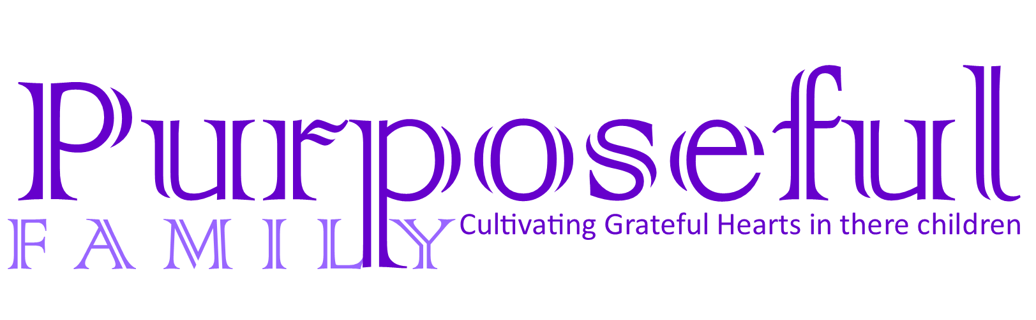
How do we raise grateful kids in an entitled world? Most parents want to have grateful kids. And there are a lot of ways that we can try to help our kids be transformed from feeling entitled to having a thankful heart.
One of the things we focus on as Christian parents is helping our kids memorize God’s Word. In our home, we find that when our children learn Bible verses that a change takes place in their hearts.
Teaching our kids Bible verses is an (almost) effortless way to nurture a thankful attitude in our homes.
Why? Because the Word of God does the work! Heart change is accomplished by the Holy Spirit! I like how the Contemporary English Version translates 2 Timothy 3:16-17: “Everything in the Scriptures is God’s Word. All of it is useful for teaching and helping people and for correcting them and showing them how to live. The Scriptures train God’s servants to do all kinds of good deeds.”
Scripture teaches and corrects wrong attitudes and turns our hearts toward doing what is right. Among other things, it shows us what God has done for us and the reasons we have to be thankful too!
So how can we have a part in cultivating thankfulness in our homes?

By teaching our kids (and ourselves) what God’s Word says about being thankful, of course :) With that in mind, here are 17 bible verses on thankfulness that every child should memorize! I dare say, we adults should memorize them too ;)

Bible Verses About Thanksgiving and Christmas that Every Child Should Know
You are my God and I will give you thanks: you are my God and I will exalt you. Psalm 118:28
Give thanks to the Lord for He is good. His love endures forever. 1 Chronicles 16:34
I will give thanks to you, O Lord, among the peoples; I will sing praises to you among the nations. Psalm 57:9
Let the peace of Christ rule in your hearts, since as members of one body you were called to peace. And be thankful. Colossians 3:15
Give thanks to the LORD, for he is good, for his steadfast love endures forever. Psalm 136:1
The Lord is my strength and my shield; my heart trusts in him and he helps me. My heart leaps for joy and with my song I praise him. Psalm 28:7
Therefore, since we are receiving a kingdom that cannot be shaken, let us be thankful, and so worship God acceptably with reverence and awe, for our “God is a consuming fire”. Hebrews 12:28-29
God is our refuge and strength, a very present help in trouble. Psalm 46:1
For everything God created is good, and nothing is to be rejected if it is received with thanksgiving, because it is consecrated by the Word of God and prayer. 1 Timothy 4:4-5
I will praise the name of God with a song; I will magnify him with thanksgiving. Psalm 69:30

You will be enriched in every way so that you can be generous on every occasion, and through us your generosity will result in thanksgiving to God. 2 Corinthians 9:11

Rejoice always, pray continually, give thanks in all circumstances; for this is God’s will for you in Christ Jesus. 1 Thessalonians 5:16-18
I will give thanks to you, Lord, with all my heart; I will tell of all your wonderful deeds. Psalm 9:1

Giving thanks always for all things unto God and the Father in the name of our Lord Jesus Christ; Submitting yourselves one to another in the fear of God. Ephesians 5:20-21
Thanks be to God for his indescribable gift! 2 Corinthians 9:15
I will praise the name of God with a song; I will magnify him with thanksgiving. Psalm 69:30
Enter his gates with thanksgiving, and his courts with praise! Give thanks to him; bless his name! Psalm 100:4 ESV

Cultivating Grateful Hearts in Our Children
If you’d like to go deeper than just taking a look at these verses, grab our Thanksgiving Bible lessons, best for families with kids ages 3-14!
The holiday season can be busy, but we don’t want to let it slip by without the chance to get into God’s Word with our kids so that we can apply Scripture to our lives and allow the Holy Spirit to work in our kids’ hearts.
When we our kids to practice gratefulness and have giving hearts, there are a lot of things we can do and ideas we can put into practice!
Studying what God’s Word says and memorizing Bible verses about gratefulness and praise helps connect actions with a heart attitude that is full of thanksgiving (not just doing “nice things” for people because we should!)

That’s why I created these Bible lessons–to give you a tool to teach your kids what God’s Word says about being grateful and also what it teaches us about who God is and what He has done for us, in a way that sticks.

Learn God’s Word with your Kids this Thanksgiving and Christmas Season with God make us Grateful: Lessons on Thanksgiving & Christmas for Families!

God Makes Us Grateful: Lessons on Thankfulness for Families – Thanksgiving & Christmas Bible Study
This Bible study contains seven biblically based lessons with discussion questions to help you connect as a family plus an activity (with instructions and printables) and with each daily lesson. There are also printable Scripture cards to use for place cards at your Thanksgiving and Christmas a variety of other activities that go with each lesson to keep young hands busy!
Great for families with kids ages 3-14, but the littlest ones can be a part of it too!

God Makes Us Grateful: Lessons on Thanksgiving and Christmas for Families is a Thanksgiving and Christmas Bible study written with the goal of helping you talk with your kids about what God’s Word teaches us about gratefulness so they can connect the Bible to their everyday lives!
So many times we can try to command thankfulness–but what really works is the Holy Spirit’s work in our kids hearts, through the Word of God, to give them an attitude of gratefulness.
With that in mind, I wrote this Bible study for your family and mine!

God Makes Us Grateful includes seven Bible lessons on thankfulness with:-

- Scripture memory verse for each day with activities for memorization
- Application of the Bible verse to life
- Daily discussion questions to get your family’s minds and hearts engaged in God’s Word
- Activity suggestion plus a song or video for each day
- November and December Scripture Reading and Writing Plan

