Gold Hill Radio Watch
Quick Guide: Wouxun KG-935G GMRS Radio

Key/Button Functions

Key | Keypad Functions
*SCAN | Short Press: Reverse Frequency (not something most of us will use)  Long Press: Channel/Frequency Scan
#LOCK | Press 2 seconds to lock/unlock keypad
MENU | Enter menu, select options, and save to the radio
EXIT | Exit the menu or cancel a function
BAND | Short Press: Switches primary and secondary (or upper and lower) areas of  the display (which represent the radio’s dual receiver capability)  Long Press: Weather Mode
MODE | Switches Channel and Frequency Modes (not something most of us will use)
TDR | TDR stands for “true dual receive.” Switches between single receiver and dual receiver displays.
UP | Goes to the next channel, frequency, or menu item
DOWN | Goes to the previous channel, frequency, or menu item
Button | Programmable Side Button Functions
PF1 | Short Press: FM Radio  Long Press: FRQ2-PTT (Secondary frequency PTT function). Gives you an alternative push-to-talk (PTT) button that transmits on the lower/secondary area. (See manual page 46.)
PF2 | Short Press: Flashlight  Long Press: MONI (Monitor function). Opens squelch so you can hear weak signal transmissions. (See manual page 47.)
Note: These are the default functions of these PF1 & PF2 keys. See manual, pages 59-61 & 41-42, for instructions on how to program different functions.
Button | Side Button Function
PTT | Push-to-talk. Remember to push and then pause for 1-2 seconds before speaking or the first part of your sentence will get cut off. Hold down to speak, release to listen.

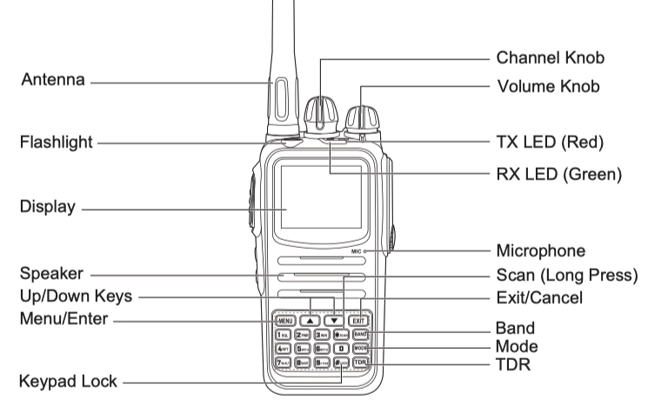

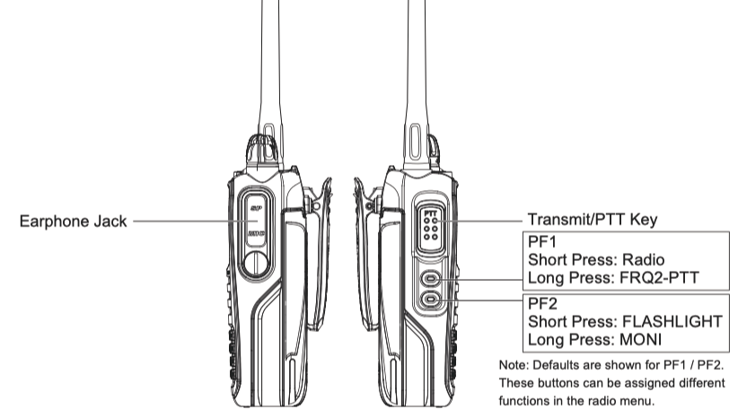

Programming Settings

How to program:
- Select Menu.
- Use the arrows, channel dial, or keypad to find/enter find the function you want. Each function is indicated by a name/abbreviation and a number.
- When you find the function you want, select Menu again to select that function.
- Find the value you want to program (e.g., 20 seconds), then select Menu to program in that value.

Examples:

Active Backlight. BRT-ACTV. Function 05. Sets the brightness of the backlight while the radio is transmitting, receiving, or otherwise active. There are 10 brightness levels from lowest (1) to highest (10). Recommendation: 10, the brightest, helps with seeing the screen outdoors.

Backlight Timeout. BACKLIGHT. Function 14. Sets the timeout of the LCD display backlight while the radio is in standby. The timer can be set from 1-20 seconds in one second increments. It can also be set to turn off immediately or always remain on. Options: ALWAYS OFF, ALWAYS ON, 1-20 seconds. Recommendation: 20 seconds. The default is 8 seconds, which isn’t long enough.

Transmit Overtime Timer. TOT. Function 25. When the transmission time exceeds the time set by the Transmit Overtime Timer, the unit will emit an error prompt and stop transmitting (cut you off). Options: 15-900 seconds (15 second increments). Recommendation: 150 seconds. The default is 60 seconds, which isn’t long enough, especially in the beginning when we are learning and conversing more.

PF1 Button, Long Press. PF1-LONG. Function 32. After you select Menu and get to PF1-LONG and select Menu again, use the channel dial to scroll through your options. When you find what you want, select Menu to program it in. Options are explained in manual page 42.

