Gold Hill Radio Watch
Dual Display Guide
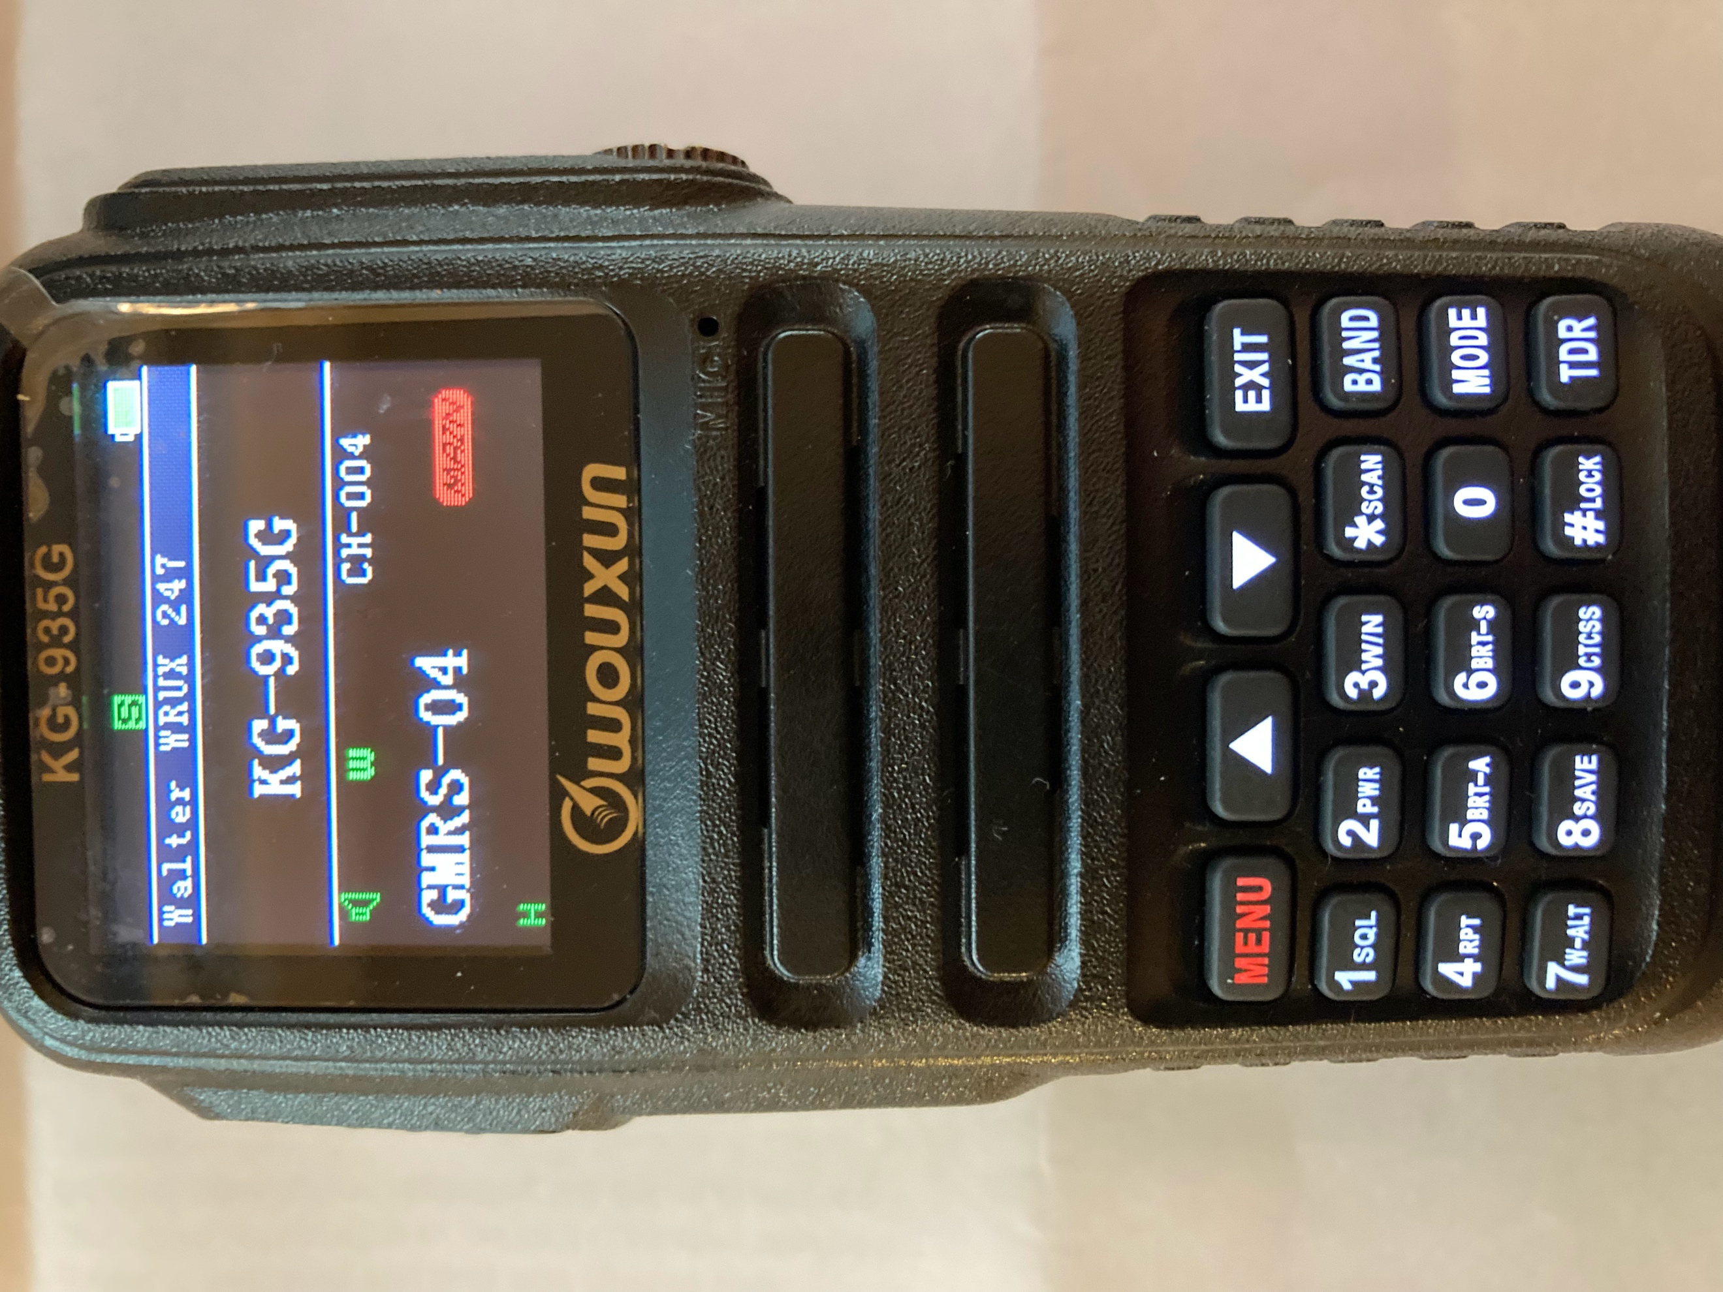
The Wouxun KG-935G radio has “dual display” functionality, which allows for monitoring two channels/frequencies at the same time.
Area A
Area B

The upper display is “Area A” and lower is “Area B.”

When the dual display is off, the inactive display will have the text “KG-935G.” The inactive display can be in either Area A or B.

To turn the dual display on or off use the [TDR] key (which stands for True Dual Receive) on the keypad.
[Band] – Switches which area is primary (with short press).
[TDR] – True Dual Receive. Turns Dual Display on and off.

The primary display area is larger, occupying about two-thirds of the screen and has a red “MAIN” icon to the right of the channel or frequency. The channel/frequency displayed in the primary area is the one that will be affected by operations you perform—like transmitting or changing the channel.
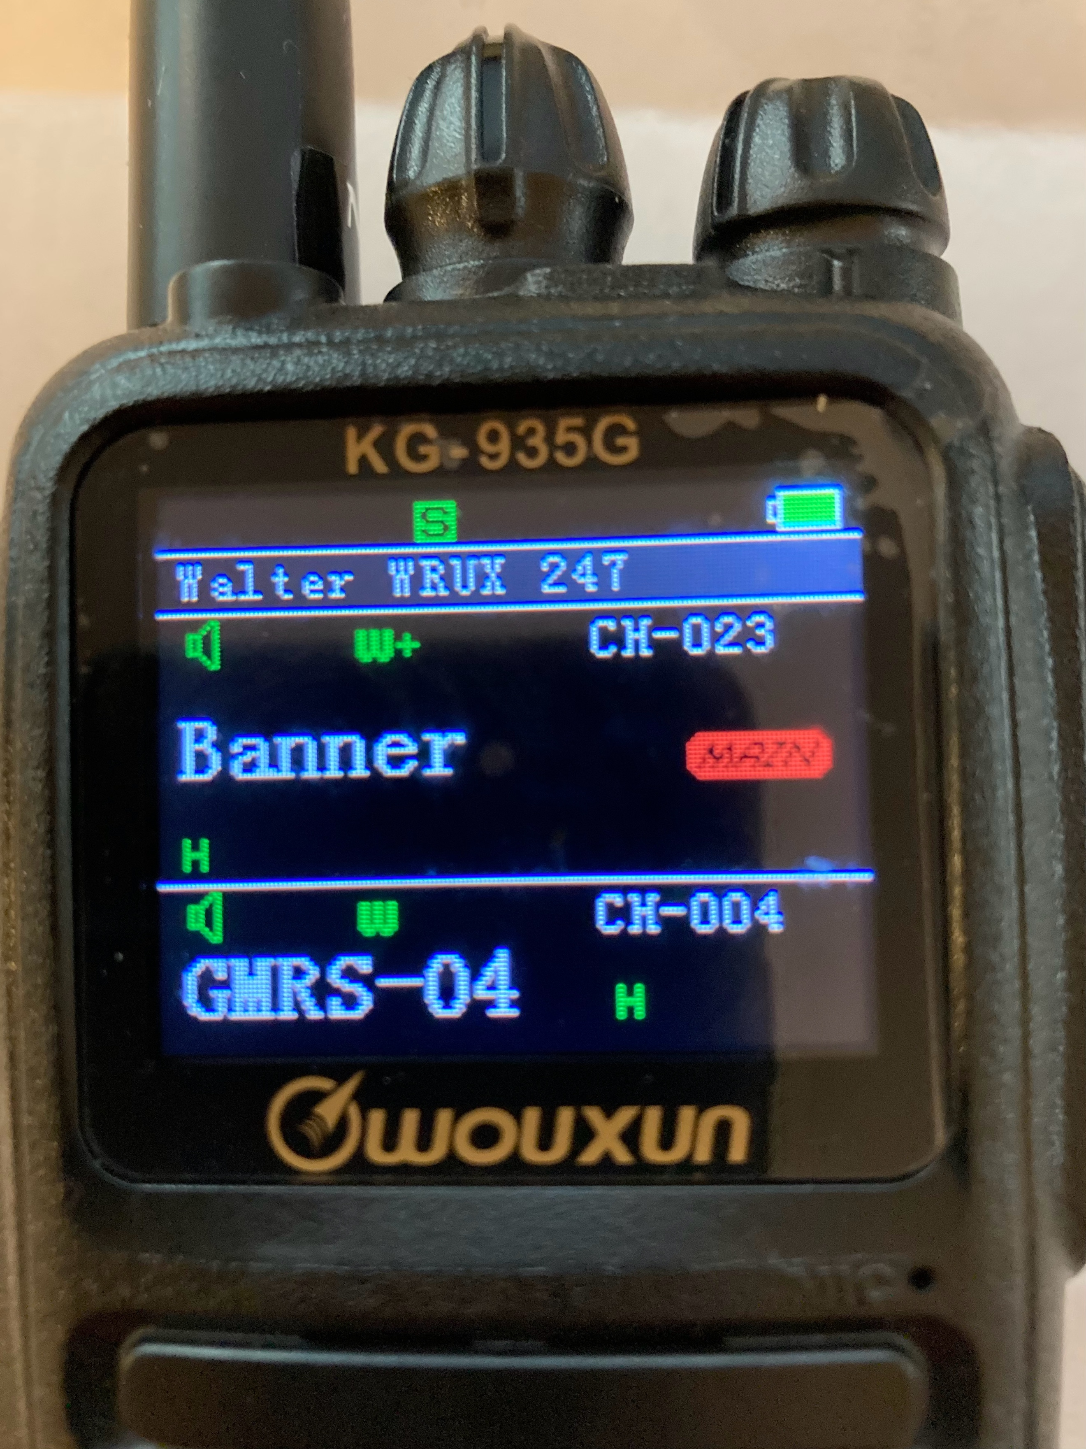

The secondary display area is the smaller area. Its channel/frequency is just being monitored.
Primary
- bigger,
- “Main” icon
To switch the primary area (with Dual Display on), press the [BAND] key on the keypad. Note, if you press it for too long (2 seconds), it will activate NOAA Weather instead.
Secondary

Exercises:
In this example, the Banner repeater is primary. If you wanted to talk on Channel 4, you’d need to push the [Band] button to make Channel 4 primary.
1. Switching between Banner and Channel 4 as primary.
a. Starting with Dual Display off, then set up the radio to
have Channel 4 as primary and Banner as secondary.
b. Then switch to Banner as primary (making it possible to transmit to the Banner repeater).
c. Then switch back to Channel 4 as primary.
2. Turning NOAA Weather on and off.
a. With Dual Display on, press the [Band] key for 2 seconds, activating the NOAA weather frequency in Area A.
b. Press the [Band] key for 2 seconds again to revert to the previous channel.

The Main icon displays only if the radio is in Channel Name mode, which is the mode we use.

