30-DAY CLEAN-UP COURTESY NOTICE
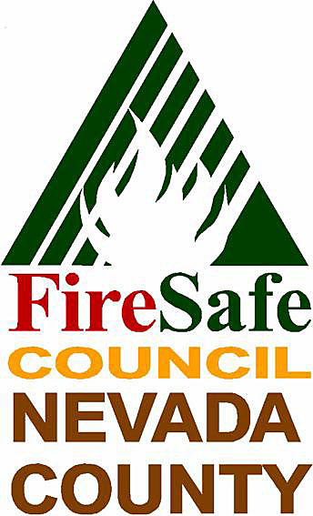
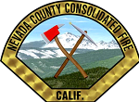
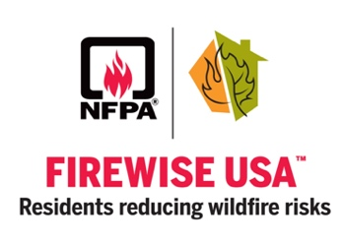
TYPE YOUR FIREWISE COMMUNITY NAME IN THIS TEXT BOX. ARIAL FONT SUGGESTED

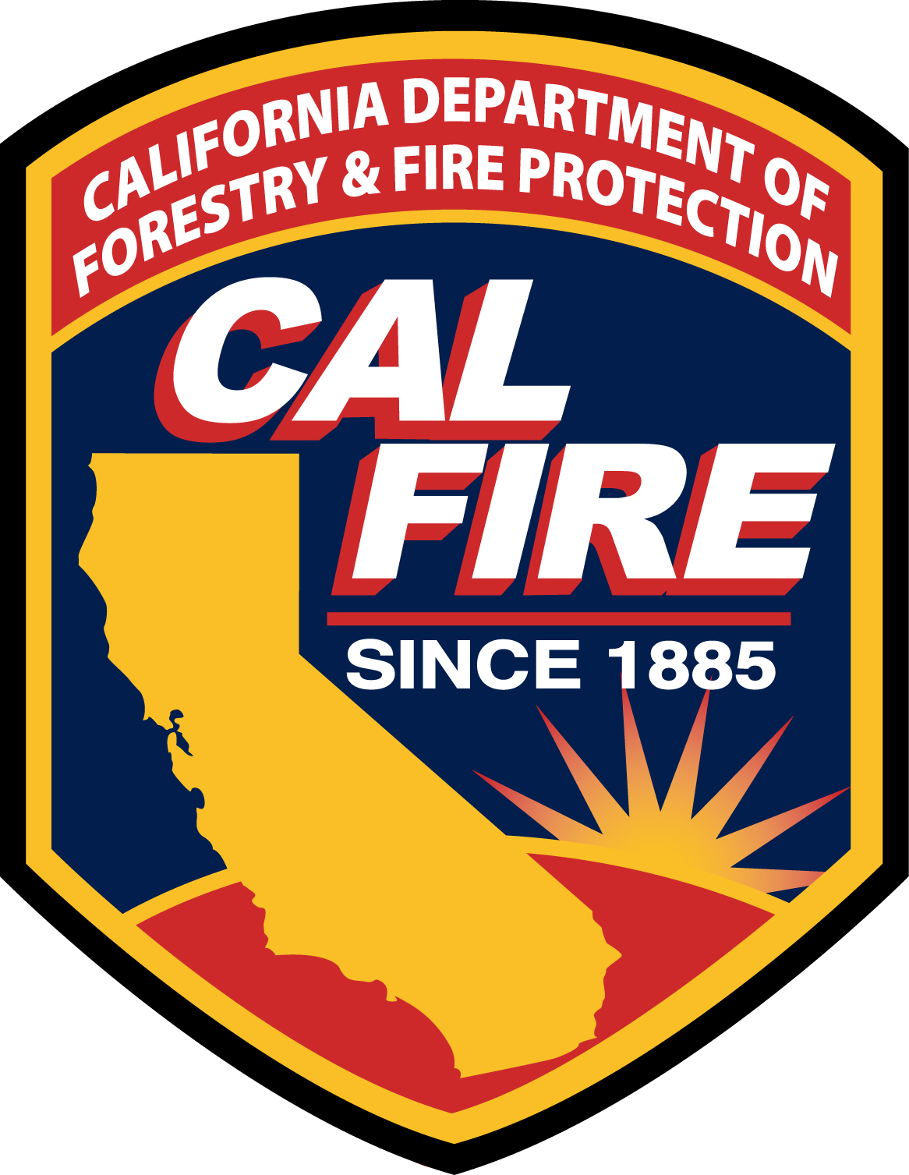

Date Mailed
To: Name
Street
City, State, ZIP

Dear Property Owner at ________________________________________ in Your Community Name:

As part of the fire safety program and “Firewise” in Your Community Name, we are working with fire officials to identify serious fire hazards. An alternative first step in the correction process, prescribed by fire authorities, is to provide this notice and to give you extra time to abate the safety problem(s) cited below.

Observed problems on a lot with structure(s):

_____ Heavy fuel load not cleared to 100 feet from structure(s).

_____ Excessive dry debris on roofs, gutters, and/or decks. (Marked as applicable.)

_____ Excessive “ladder” fuels likely to spread potential ground fire into trees above.

_____ Other: __________________________________________________________________

Good progress toward correcting the above must be made by this date: _____________________

After this date, fire authorities may intercede with their own enforcement procedures. Please go to www.areyoufiresafe.org At this site you will find information about the Firewise program, wildland fire issues, and requirements of property owners, contacts, and resources for making your property safer.

NOTE: This “Courtesy Notice” supplements but does not replace ultimate fire agency authority to inspect
and enforce.

Thank you for your cooperation in helping to make a safer community.

Community Name Here Firewise Community
Please call (530) contact number here with any questions

