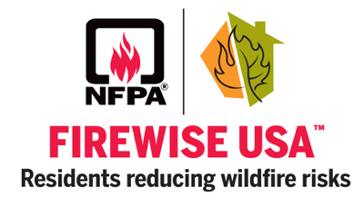
Foxwood – Slate Creek
Firewise Community

