Tanker Ladder Platform
With Adjustable Height

Assembly instructions

Content

1. General content. ... ... ... ... ... ... ... ... ... ... ... ... ... ... ... ... ... ... ... ... ... ... ... ... ... ... ... ... ...
1.1 Owner Responsibilities. ... ... ... ... ... ... ... ... ... ... ... ... ... ... ... ... ... ... ... ... ... ... ... ...
1.2 Manufacturer. ... ... ... ... ... ... ... ... ... ... ... ... ... ... ... ... ... ... ... ... ... ... ... ... ... ... ... ...
1.3 Applicable standards. ... ... ... ... ... ... ... ... ... ... ... ... ... ... ... ... ... ... ... ... ... ... ... ... ...
1.4 Warranty. ... ... ... ... ... ... ... ... ... ... ... ... ... ... ... ... ... ... ... ... ... ... ... ... ... ... ... ... ... ...
1.5 Copyright and Manufacturer's Rights. ... ... ... ... ... ... ... ... ... ... ... ... ... ... ... ... ... ...
1.6 Release date. ... ... ... ... ... ... ... ... ... ... ... ... ... ... ... ... ... ... ... ... ... ... ... ... ... ... ... ... ...

2. Product data. ... ... ... ... ... ... ... ... ... ... ... ... ... ... ... ... ... ... ... ... ... ... ... ... ... ... ... ... ... ...
2.1 Intended use. ... ... ... ... ... ... ... ... ... ... ... ... ... ... ... ... ... ... ... ... ... ... ... ... ... ... ... ...
2.2 Improper use. ... ... ... ... ... ... ... ... ... ... ... ... ... ... ... ... ... ... ... ... ... ... ... ... ... ... ... ...

3. Safety instructions. ... ... ... ... ... ... ... ... ... ... ... ... ... ... ... ... ... ... ... ... ... ... ... ... ... ... ... ...
3.1 Safety instructions for installation and use. ... ... ... ... ... ... ... ... ... ...
3.2 Pictograms. ... ... ... ... ... ... ... ... ... ... ... ... ... ... ... ... ... ... ... ... ... ... ... ... ... ... ... ... ...

4. Usage. ... ... ... ... ... ... ... ... ... ... ... ... ... ... ... ... ... ... ... ... ... ... ... ... ... ... ... ... ... ... ... ... ...
4.1 Before use. ... ... ... ... ... ... ... ... ... ... ... ... ... ... ... ... ... ... ... ... ... ... ... ... ... ... ... ... ... ...
4.2 Terms of use. ... ... ... ... ... ... ... ... ... ... ... ... ... ... ... ... ... ... ... ... ... ... ... ... ... ... ... ... ...
4.3 Extending the ladder. ... ... ... ... ... ... ... ... ... ... ... ... ... ... ... ... ... ... ... ... ... ... ... ... ...

5. Technical data. ... ... ... ... ... ... ... ... ... ... ... ... ... ... ... ... ... ... ... ... ... ... ... ... ... ... ... ... ... ...

6. Designations of parts. ... ... ... ... ... ... ... ... ... ... ... ... ... ... ... ... ... ... ... ... ... ... ... ... ... ... ...

7. Installation of the ladder. ... ... ... ... ... ... ... ... ... ... ... ... ... ... ... ... ... ... ... ... ... ... ... ... ...
7.1 Preparation. ... ... ... ... ... ... ... ... ... ... ... ... ... ... ... ... ... ... ... ... ... ... ... ... ... ... ... ... ...
7.2 Assembling the ladder. ... ... ... ... ... ... ... ... ... ... ... ... ... ... ... ... ... ... ... ... ... ... ... ...

8. Adjusting the height of the ladder. ... ... ... ... ... ... ... ... ... ... ... ... ... ... ... ... ... ... ... ... ... ...

9. Maintenance and inspection. ... ... ... ... ... ... ... ... ... ... ... ... ... ... ... ... ... ... ... ... ... ... ... ...

10. Disposal. ... ... ... ... ... ... ... ... ... ... ... ... ... ... ... ... ... ... ... ... ... ... ... ... ... ... ... ... ... ... ... ...

11. Manufacturer's declaration. ... ... ... ... ... ... ... ... ... ... ... ... ... ... ... ... ... ... ... ... ... ... ... ...

1. General content

This instruction is only valid for the aforementioned type of cistern drain. The ladder consists of various elements that can be purchased separately to complement the structure or be used as a replacement.

For safe installation, please note the individual steps shown in the illustrated assembly view.

If installation, modification or disassembly causes problems, please contact your supplier. The manufacturer / supplier does not accept any responsibility for damage caused by incorrect assembly, modification or disassembly. Damaged or defective components should not be used. We reserve the right to make technical changes to the product.

1.1 Obligations of the owner

The ladder owner is solely responsible for:

–– these instructions are available for every use, as well as for assembly and disassembly.

–– the operating personnel are familiar with the contents of the instructions and the safety requirements and strictly follow them.

–– The ladder is used only for its intended purpose

1.2 Manufacturer

The manufacturer of the ladder specified in the documentation is:
Cagsan Merdiven ve Erisim Ekipmanlari Sanayi Ticaret Limited Sirketi
Dilovasi O. S. B. 3. Kisim Meric Cad. No: 1 Muallim Koyu - Gebze / Kocaeli / TURKEY
VAT Office: Uluçınar - VN: 2160109067
Tel: 00 90 262 759 18 08
Fax: 00 90 262 759 18 78
http://www.cagsanmerdiven.com/

1.3 Applicable standards

The ladder was produced in accordance with DIN EN ISO 14122

1.4 Warranty

The exact wording of the guarantee is reflected in the sales documents and the supplier's terms of delivery. The manufacturer assumes a 2-year warranty for

material defects after purchase. The manufacturer reserves the right to replace the defective part at its discretion or to have it repaired.

For warranty claims, documentation valid on the date of sale is fundamental. Warranty claims are excluded if the damage was caused by one or more of the following reasons:

–– Ignoring or neglecting the requirements of the assembly and operating instructions, especially the requirements for safety, intended and inappropriate use, care and maintenance, assembly and disassembly.

–– If the staff is insufficiently qualified or insufficiently informed.

–– When using non-original spare parts and / or accessories.

–– When using a damaged or defective component.

1.5 Copyright and manufacturer's rights

All rights to the installation and use instructions belong to the manufacturer. All types of copying, even partially, are allowed only with the permission of the manufacturer. The manufacturer reserves all rights to the granted patent. Violators will be held liable and must pay damages.

1.6 Release date

The release date of this instruction is 05/01/2021.

2. Product data

2.1 Intended use

The ladder may only be used in accordance with the instructions for use. It is designed for lifting and accessing the upper part of the tank within the limits of its enclosure. The platform of the ladder should be at the same height as the level of the tank exit.

The maximum permissible load on the rungs and platform is 150 kg.

–– The ladder should only be placed on a sufficiently level and firm surface.

–– Before use, make sure that all necessary precautions have been taken and that the drain is installed in accordance with the instructions for installation and use. To do this, it is necessary to assess the potential hazard and the possible load in combination

with a serviceable vehicle to minimize or eliminate the hazard.

–– Any other use is considered as improper use. Any damage resulting from improper use releases the manufacturer from liability and all risks are borne solely by the user.

–– All components of the drain may only be used for their intended purpose and in a technically sound condition. Use, maintenance, repairs are carried out exclusively by trained and authorized personnel.

–– In case of improper use, there is a danger to life and health of people, as well as the possibility of damage or destruction of the gangway.

2.2 Improper use

The ladder can only be used for the purposes specified in 2.1 of this manual. Failure to do so is considered a violation of the terms of use. This also applies to:

–– ignoring the safety requirements listed in the instructions for installation and use.

–– carrying out repairs improperly or by unauthorized persons
–– use of non-original spare parts,
–– using a ladder with faulty components
–– insufficiently qualified installation and user personnel
–– unauthorized technical changes
–– force majeure circumstances

–– cases of improper use, resulting in danger to life and health of people.

3. Safety instructions

3.1 Safety instructions for installation and use

- The user is solely responsible that the safety and maintenance instructions are followed and the intended use is ensured.

- It is the responsibility of the person responsible for installation, modification and dismantling of the person to ensure that the work is carried out by persons with sufficient knowledge or under the supervision of specialists in order to ensure safety.

- Installation, disassembly and use must only be carried out by persons who are familiar with this manual.
- Minimum 3 people are required for installation and dismantling

- Installation and use must be carried out on flat and stable mounting surfaces that can support the weight of the drain.
- The manager must ensure that there are no electrical equipment / open power lines and moving objects in the immediate vicinity of the gangway.

- Only original spare parts may be used.

- Before using the ladder, the rollers must be locked by pressing the brake lever and all components must be checked for correct assembly and function.

3.2 Pictograms

Attention! Read the instructions before installation and use!

Dangerous place!

Fall risk!

4. Usage

4.1 Before use

Before use

–– Check if everything is installed and functioning correctly.
–– Lock all rollers by pressing the brake lever. Unlock the casters for ladder movement only.
–– Before use, after long interruptions, in particular from external influences (storm, snowfall, vibration, etc.), check the drain by visual inspection for defects. Do not use the ladder when icing!
–– Do not use the ladder in strong winds. Move it to a secure location. Protect it from overturning if possible. Do not attach any objects to the ladder that increase windage.
–– Extend the platform to the required height. The platform of the ladder should be installed approximately at the same level with the top of the tank.

Then lock the lifting gear.

4.2 Terms of use

–– Observe all safety precautions before using
–– Climb the ladder to the work platform only
–– Do not use the ladder to lift objects
–– Do not store tools or materials on the platform
–– Do not subject the platform to stress
–– Do not lean on the railing
–– Do not step over the platform railing

–– The ladder guard is intended only as a limitation of the movement space. Vertical loads are not intended. The fence absorbs horizontal loads only to a small extent.
–– When using outdoors or in open areas in strong winds, storms, and after working in open areas, move the ladder to a wind-protected place or secure from tipping over.
–– Do not install the ladder on other lifting devices.

4.3 Extending the ladder

–– It is forbidden for persons or objects to stand on the platform during the pull-out process.
–– Use only on a reasonably stable basis
–– Move the ladder only by hand on a flat surface in order to move (incline max. 3 °) at normal pedestrian speed
–– The use of the car for movement is prohibited
–– Apply the four parking brakes after driving.

5. Technical data

YP 250 MODEL

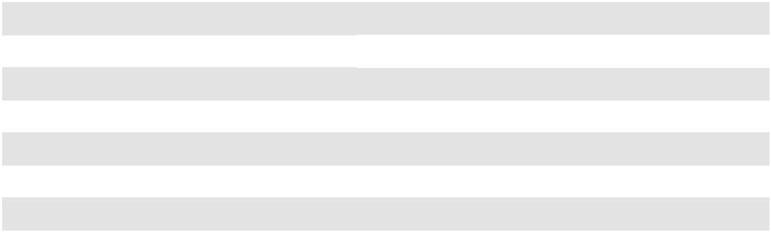

Platform height | min.: 2.480 мм | max.: 3.180 мм
Total height | min.: 3.580 мм | max.: 4.280 мм
Width of steps / rungs | 120 мм
Traverse width | 1.750 мм
Fence (cage) size | 1.300 x 1.300 мм; rounded corners
Base length | 2.100 мм
Platform protrusion | from. 450 мм to 790 мм

YP 300 MODEL

Platform height | min.: 3.050 мм | max.: 4.050 мм
Total height | min.: 4.150 мм | max.: 5.150 мм
Width of steps / rungs | 120 мм
Traverse width | 1.750 мм
Fence (cage) size | 1.300 x 1.300 мм; rounded corners
Base length | 2.330 мм
Platform protrusion | from. 490 мм to 960 мм

YP 400 MODEL

Platform height | min.: 4.000 мм | max.: 5.960 мм
Total height | min.: 5.100 мм | max.: 7.060 мм
Width of steps / rungs | 120 мм
Traverse width | 2.000 мм
Fence (cage) size | 1.500 x 1.500 мм; rounded corners
Base length | 3.035 мм
Platform protrusion | from. 530 мм to 1300 мм

6. Designation of parts

7. Installation of the ladder

7.1 Preparation

Remove the packaging material and dispose of it in accordance with current environmental protection regulations.
The assembly should be done by a team of two or three people.
Assembly requires the following aids and tools:

• The ladder should only be installed on stable ground.
• Stepladder with a height of about 2 - 3 m
• Socket wrench with socket width in different apartments 13, 19
• Width of the combination key on the walls 13, 19
• Rubber or wood hammer
• Minimum 2-3 people are required

7.2 Assembling the drain

Step 1.
Install a retractable platform ladder for two or three people. Make sure all parts of the product are present and check Figure 1
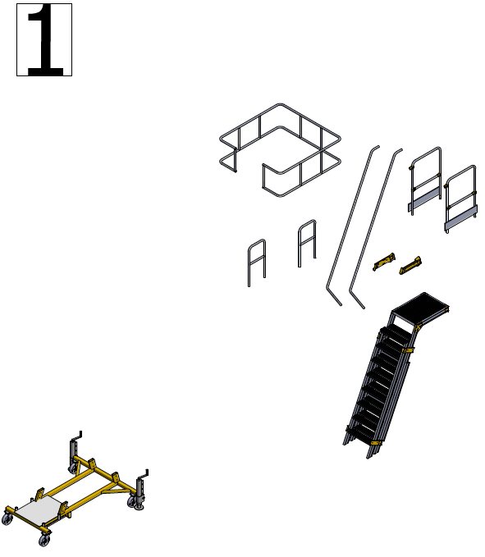

Step 2.
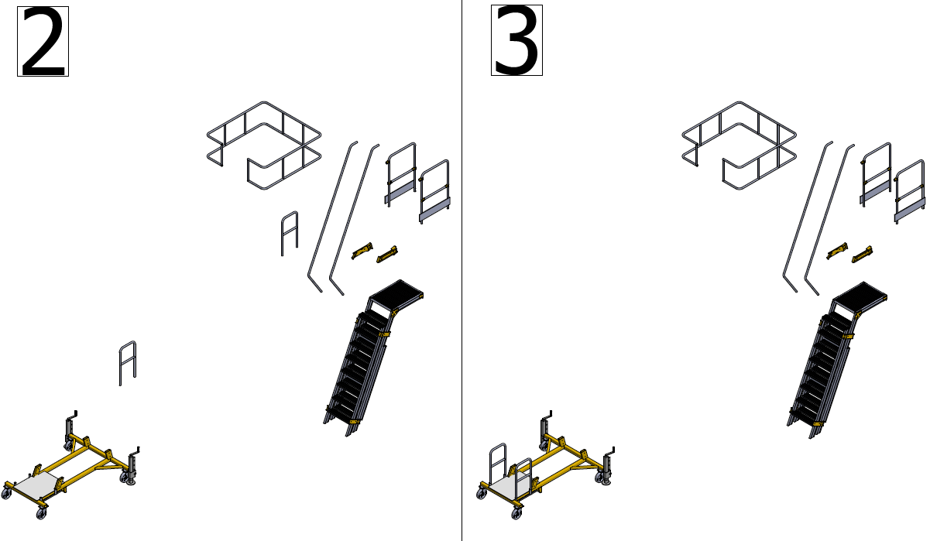
Connect the side rails to the metal frame. Figure 2-3

Step 3.
Insert the ladder into the channels indicated on the chassis and secure the M8x50 bolts with 13 wrenches. Figure 4-5
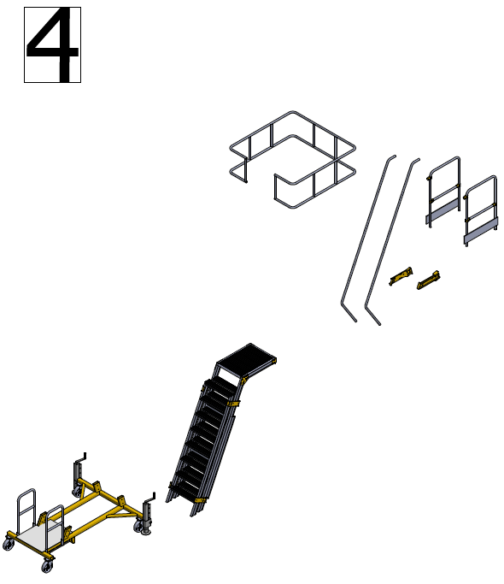
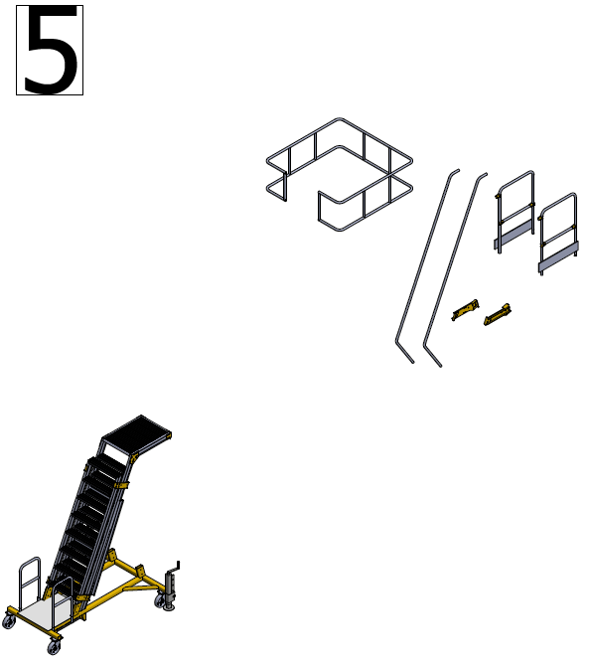

Step 4.
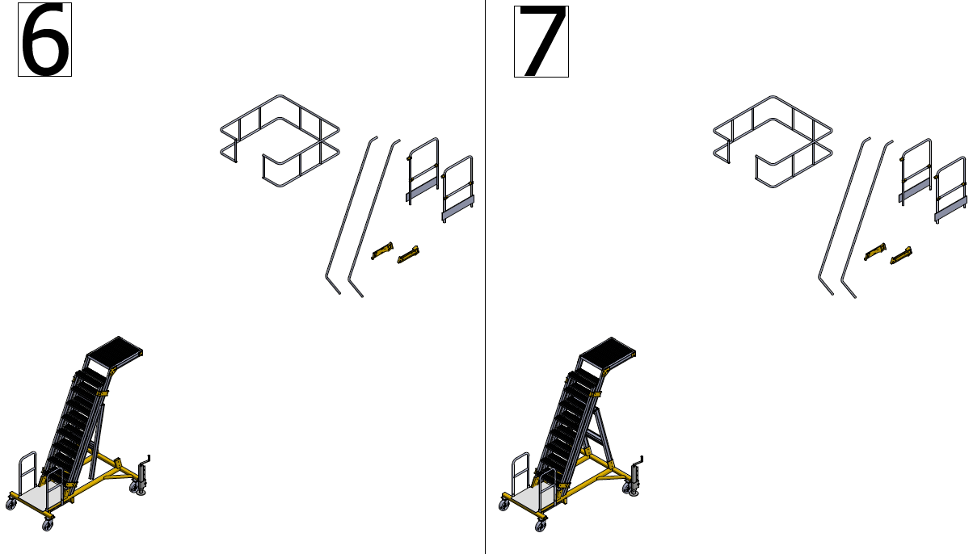
Connect the rear frame, which is combined with the steel wire on the ladder profile, to the channels on the lower metal frame, and connect the M8x50 bolts with 13 wrenches. Figure 6-7

Step 5.
Note: According to the platform height, it is recommended to use 3 or 4 step ladders for Figure 8-9.

To connect the ladder to the metal frame and back frame, connect the supplied metal parts using the special M8x15 screws with 13 keys from the available channels. Connect the M14 pin and wheels at the end, between the two attached side plates, using 19 wrenches between the ladder and the rear frame..

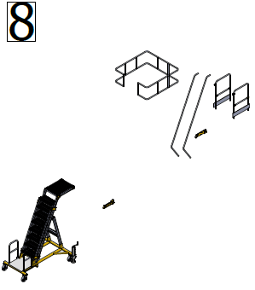
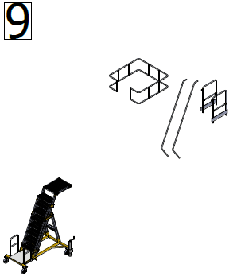

Step 6.
Note. After all the screws are tightened, you can step out onto the platform to apply Figure 10-11. Connect the platform side guard railings to the empty channels on the platform using the special M8x45 bolt with 13 wrenches.
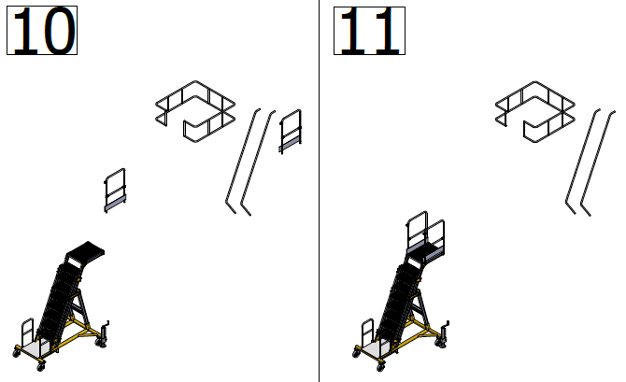

Step 7.
Note. After all screws are tightened, you can step onto the platform to apply the image
To connect the guard railings, attach the side brackets to the yellow clamps on the platform and tighten the screws on the clamp using a Torx wrench. Connect the bottom of the guard railings to the profile of the moving ladder using a special M8x45 bolt with 13 keys. Figure 12-13.
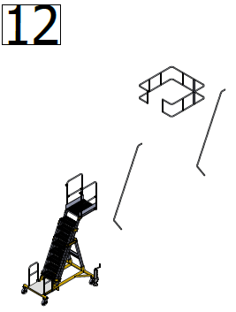
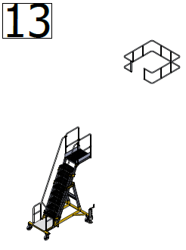

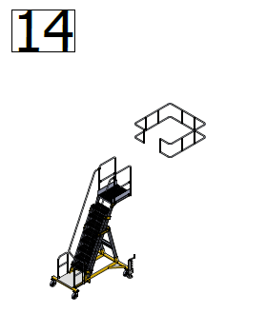
Step 8.

Attach the safety cage
to the side rails with M8 bolts.
Figure 14

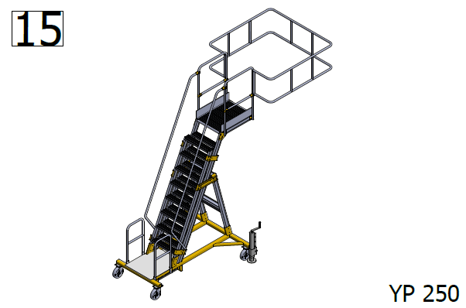

Dismantling

- Minimum 2-3 people are required for demontage.
- Dismantling is carried out in the reverse order.

8. Adjusting the height of the ladder

- Before turning the handle, unlock the lever.

- Set the desired height. Make sure the steps are same level.
Lock the lifting mechanism with the lever

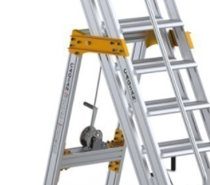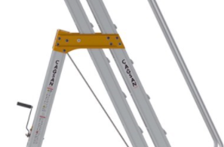

9. Maintenance and inspection

Gear rack lubrication

The rail should be checked once a week for a lubricating coating.

Lubricate with conventional lubricants if necessary.

Caution: Avoid getting grease on the steps, as this increases the risk of accidents due to slipping.

Cleaning the stairs

The drain parts can be cleaned with water and ordinary detergent.

Cleaning the stairs

Check the drain for functionality before each use.

–– All components should be checked for deformation and cracking.

–– In addition, the roller locks must be checked too.

–– Damaged components or components that do not guarantee their function cannot be used and must be removed by the user. They can only be used again after renovation.

10. Disposal

When decommissioning the drain, the relevant regulations regarding the disposal of technical equipment must be strictly observed!

11. Manufacturer's declaration

We hereby declare:

Cagsan Merdiven ve Erisim Ekipmanlari Sanayi Ticaret Limited Sirketi
Dilovasi O. S. B. 3. Kisim Meric Cad. No: 1 Muallim Koyu - Gebze / Kocaeli / TURKEY

that the products listed below, on the basis of their concept, design and type of production, have been planned and manufactured in accordance with DIN EN 14122.

This declaration is no longer valid if the product is changed. The product's name:

Ladder for service of tanks.

–– Intended use: use as access to the roof and other surface of vehicles.

–– Regulations: Applicable Safety Regulations.

