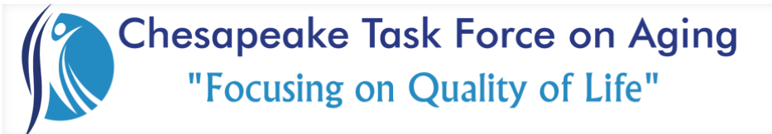

Membership Meeting March 1, 2024

Thank You….
Freedom Point Financial Group for providing breakfast.
Chesapeake Public Safety and the Emergency Operations Center for hosting us.
Guest Speaker:
Ingrid "Jo" Phillips & Lorraine Logan, Chesapeake Fire Department's Mobile Integrated Healthcare Program
They do case management and care navigation for those in need, especially in the underserved population.

Reports, Discussions & Announcements:

- The Website now has a google calendar of CTFOA and other senior related events that you can contribute to. All you need to do is invite Chesapeaketaskforce@gmail.com to your event.
- Community Committee Updates:
  - Our Q1 St. Patricks party is on 3/15 from 12-2 at Greenbrier Senior Apartments 1509 Ring Rd. 23320. We will have food, music & games so come join us!
  - Next month we will begin our stuffed animal drive, more details to come
  - We are also planning fake flower deliveries to residents of Kemet house. No date has been set yet but if you would like to be a part of the delivery, contact Morgan
- Safety Committee Updates:
  - We have the police on board to help us develop a “Coffee with a Cop” program that we plan to take to the various senior communities with clubhouses.
  - Elder Abuse taskforce and safety summit moved from 6/5 to 5/22 to coincide with the Chesapeake Human Services Annual Wellness Fair.
  - Chesapeake Sheriffs event is 9/9 & 9/10

NEXT MEETING
Friday, April 5, 2024
Chesapeake Lifestyle Health & Fitness Center
800 N Battlefield Blvd, Chesapeake, VA 23320

