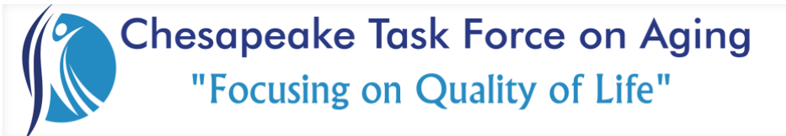

Membership Meeting November 3, 2023

Thank You….
1st Class Real Estate Integrity for providing an amazing breakfast.
Chesapeake Public Safety Operations for hosting us and for your last-minute speaking engagement.
Guest Speaker:
Chesapeake Public Safety Operations Center

Reports, Discussions & Announcements:

- Reverse Trick-or-treat event was a great time, and we plan to do it at Cambridge Square again next year.
- Teddy Bear Donations at Indian River Apartments will be on 11/16/23 at 3pm. Please let Morgan or Lisa know if you would like to attend.
- Thank you to those who took ornaments from the Silver Tree Seniors “Adopt-A-Senior” Tree. Please bring them unwrapped to the December event. If you can’t make the event, please get with Morgan or Lisa for collecting before the event.
- The December meeting is 12 /1 at Lighthouse Pointe 8:30-10am. There will be no speakers however there will some reminiscing and a member vote for Board Seats in which Jennifer and Zeib are running unopposed for their current roles.
- The January joint task force will not occur this year. Instead, we are asking our members to use that time doing something unusual (not your industry) but impactful (for Senior Advocacy). Examples are to volunteer somewhere new, or write a letter (we will share more ideas soon), but we ask that you tally the efforts & impacts for a greater recognition, not only for Chesapeake, but for our entire Hampton Roads Agencies on Aging. We need a new chair for the Membership committee. Please let Julie or Zeib know if you are interested.
- The Legislative Committee is asking if you have any Delegate relationships to please assist with connecting us to them. There is a need for sponsorship on relevant Bills. SSSEVA recently asked for a letter to John Little, the secretary of Health & Human Resources.
- The Chesapeake Thrives, “Aging in the Community” workgroup will be moving to CTFOA as a means to increase the opportunities for collaboration & partnerships to better serve older adults in Chesapeake. More to come but checkout these links and the current Resources Guide.
- This month’s community donation will be $250 going to Buffalo Family. They are also accepting food donations for Thanksgiving.

NEXT MEETING
Friday, February 2, 2024

