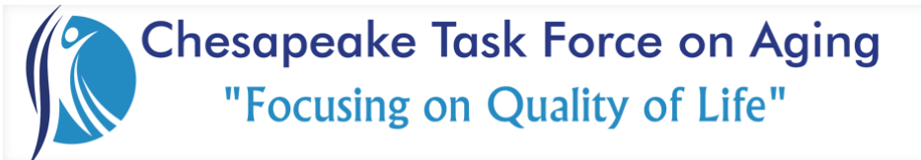

Membership Meeting September 1, 2023

Thank You….
Chesapeake Regional’s Lifestyle Center, for hosting and accommodating our growing numbers!
Security Allied Storage & Van for sponsoring a full breakfast!
Guest Speaker:
Elise Hasenstab, Resources 757
“Building Pathways out of Poverty.”

Reports, Discussions & Announcements:

- Thank you to everyone for bringing donations to the Essentials Drive today.
- Looking forward to the MOWC partnership on the United Way’s Day of Caring event on 9/15. We will begin here for a kickoff breakfast. Thank you to all who are making this possible!
- The December meeting will be Holiday get together at Lighthouse Point. It will include a White Elephant gift exchange, more info to come.
- Reverse-Trick-or-Treat Halloween event will be on 10/25. We will go to both Cambridge Square Apartments and Kemet House. More info to come.
- Legislative team is heading to Richmond in preparation of next year’s opportunities.
- Membership is up which is fantastic, thank you and welcome to all new members. For those whose dues may be due, please see Christy Hanson to ensure your payment is marked complete.
- If you would like to join a committee, please contact the appropriate lead:
  - Community: Morgan Aspinwall or Lisa Johnson
  - Membership: Cristy Hansen or Zeib Parvez
  - Legislative: Judy Ewell or Jimmy Jackson

NEXT MEETING
Friday, October 6, 2023
Guest Speaker: Tobey Allen, Fire & Life Safety Educator, Chesapeake Fire Department
Breakfast Sponsor: Chesapeake Place Senior Living
Location: Chesapeake Regional’s Lifestyle Center

