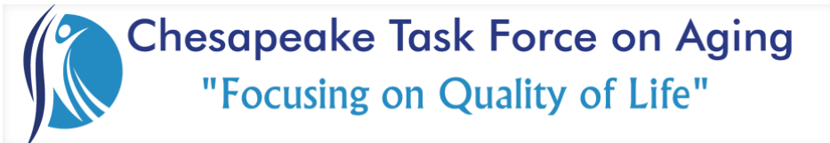

Membership Meeting June 2, 2023

Thank You….
Chesapeake Regional’s Lifestyle Center for our meeting space
Commonwealth Senior Living for sponsoring the tremendous breakfast!

Guest Speaker:
Kristen Martin, CIBH (Chesapeake Integrated Behavioral Healthcare)
Coping Skills presentation
The CIBH website has a lot of resources & information.

Reports & Announcements:
Treasurer: Over $3k after applying funds for teddy bear fund. Memberships help us do this!

Legislature Committee: iRide now has an “uber” like program for people over 60. It’s still in test phase but it’s out there.

Community Committee:
- See the joy getting out there can do by looking at pictures from our successful Teddy Bear Drive! Click here or visit the blog on our website.
- There will be a new program coming that we hope to run throughout the year. It partners CTFOA members with teddy bears to present to various seniors in need throughout Chesapeake. More details are coming.
- Next community party will be on July 19th from 11am – 12:30pm at The Commons. The next planning meeting is on 6/13. Reach out to Morgan or Lisa if you want to assist and be part of the community committee.

Reminders:
- Let Jennifer know if you would like to speak at, or sponsor a breakfast for, an upcoming meeting. There are only 2 months left in this calendar year to fill up. August still needs a breakfast sponsor.

- There is no member meeting in July.

NEXT MEETING
Friday, August 4, 2023
Guest Speaker: Lisa Johnson, ASIL Insurance Group (Medicare Basics)
Breakfast Sponsor: TBD
Location: Chesapeake Regional’s Lifestyle Center

