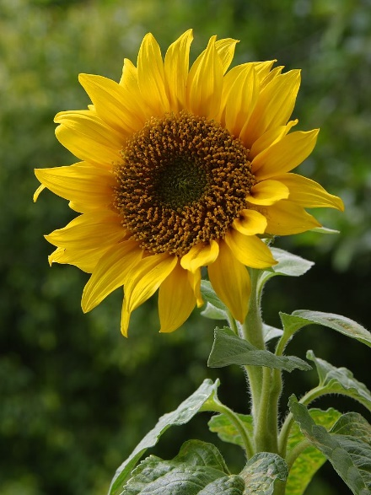

INSTRUCTIONS FOR
GROWING A SUNFLOWER SEED
YOUR SUNFLOWER PACK CONTAINS:
1 small flower pot
Compost/soil
2 sunflower seeds
STEPS:
1 Put some soil into the pot so that it almost reaches the top of the pot
2 Using your finger or a pen, poke a hole in the soil (roughly 2cm deep)
3 Drop a sunflower seed into the hole
4 Cover the seed with a little soil and pat gently
5 Sprinkle with a little water so the soil is moist
6 Place the sunflower pot on a sunny windowsill
7 Give a little water each day just enough to keep the soil moist
8 It should take about 1-2 weeks before your sunflower seedling appears

Enjoy growing your sunflower!

