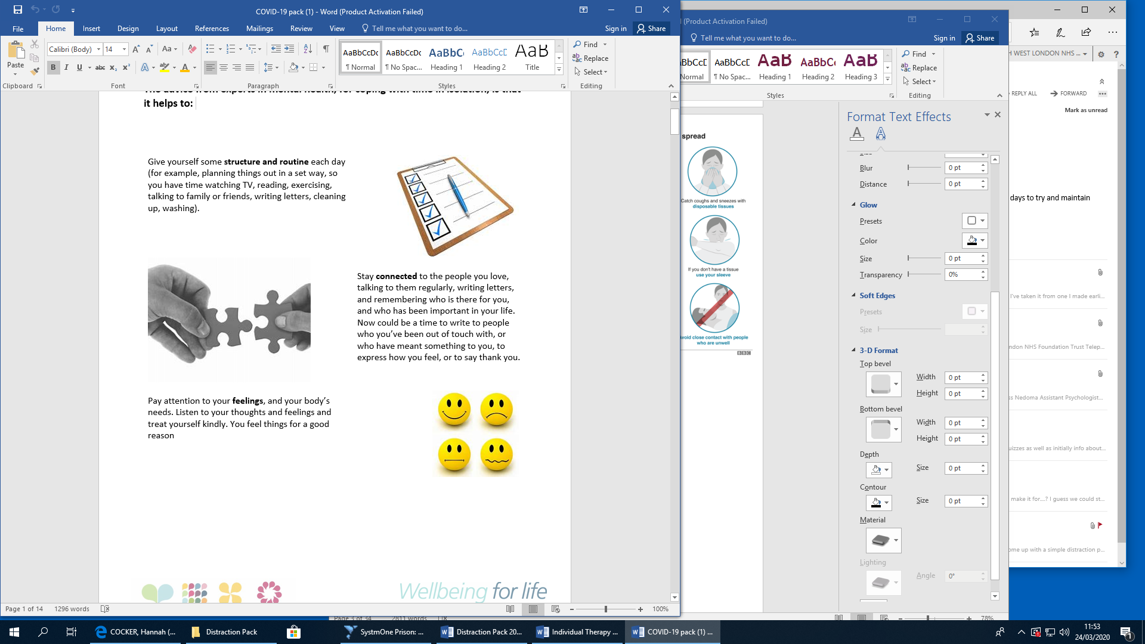**The advice from experts in mental health, for coping with time in isolation, is that it helps to:**

