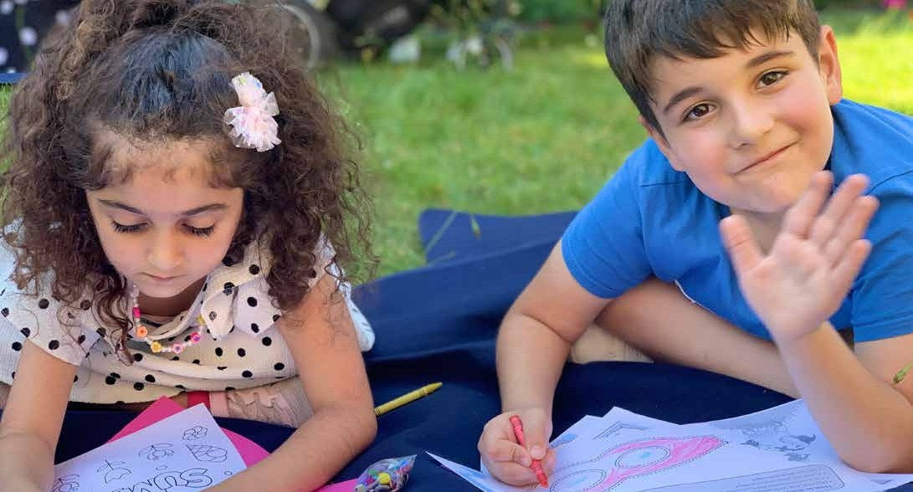

St. Vincent’s Newcastle Activity Timetable

All programmes are free and open to everyone

Mondays
11am - 1pm: Proggy Mat Making
A friendly drop-in session to try out a traditional craft technique.
Drop in, all welcome

2pm - 3pm: Knit and Natter with a Twist A friendly drop-in session led by Aisha. Unravel the art of knitting and share in friendship.
Drop in, all welcome
2pm - 4pm: Crafting For All
A relaxed crafting workshop to try something new, have a coffee or tea and a chat.

2pm - 4pm: Art of Watercolour
Learn the skill of this soft and light medium, which dates as far back as the stone age and is used today in illustrations, paintings and animation media!
Drop in, all welcome

Tuesdays
11am - 1pm: Vinnies Café
A free, home cooked 3 course meal, with table service for all.
Drop in, all welcome
11am - 1pm: Chat to Matt
A listening service with Mental Health Concern. Share your worries with Matt. Drop in, all welcome

1.30pm – Tuesday Film Club
If you like watching and discussing movies – this group is for you! Join us every week for a friendly get together with the like- minded film enthusiasts! (Launching October 18).

Wednesdays
12pm - 2pm: Chit Chat ladies Café Meet other ladies for coffee and a chat. Drop in, all welcome

Thursdays
12 - 2pm: Art Programme
Art as a key to good mental health.
Drop in, all welcome

Fridays
10am - Patchwork, Patter Cutting, and Design
If you are thinking of learning something different, or, you’d like to turn your textile
hobby into a money spinner - this class is for you!
(Launching October 14)

2pm - 4pm: Pie and Poetry Men’s Club
Come together with other men to explore
poetry and self-expression.
Drop in, all welcome

2pm – 4pm: Knit and Natter
A friendly drop-in session led by Aisha. Unravel the art of knitting and share in friendship.
Drop in, all welcome

Monthly
Group walk
Keep your mind and body healthy with our monthly group walk.
Enquire at: stvincentsnewcastle@svp.org.uk

Employability one to ones
Find out if we can support you in learning new skills to help you into work.
Enquire at:megann@svp.org.uk

Scan the code to see the timetable on your phone:

Register your interest and find out more:
stvincentsnewcastle@svp.org.uk Or call 0191 2616027

St. Vincent’s Newcastle Activity Timetable

All programmes are free and open to everyone

Mondays
11am - 1pm: Proggy Mat Making
A friendly drop-in session to try out a traditional craft technique.
Drop in, all welcome

2pm - 3pm: Knit and Natter with a Twist A friendly drop-in session led by Aisha. Unravel the art of knitting and share in friendship.
Drop in, all welcome
2pm - 4pm: Crafting For All
A relaxed crafting workshop to try something new, have a coffee or tea and a chat.

2pm - 4pm: Art of Watercolour
Learn the skill of this soft and light medium, which dates as far back as the stone age and is used today in illustrations, paintings and animation media!
Drop in, all welcome

Tuesdays
11am - 1pm: Vinnies Café
A free, home cooked 3 course meal, with table service for all.
Drop in, all welcome
11am - 1pm: Chat to Matt
A listening service with Mental Health Concern. Share your worries with Matt. Drop in, all welcome

1.30pm – Tuesday Film Club
If you like watching and discussing movies – this group is for you! Join us every week for a friendly get together with the like- minded film enthusiasts! (Launching October 18).

Wednesdays
12pm - 2pm: Chit Chat ladies Café Meet other ladies for coffee and a chat. Drop in, all welcome

Thursdays
12 - 2pm: Art Programme
Art as a key to good mental health.
Drop in, all welcome

Fridays
10am - Patchwork, Patter Cutting, and Design
If you are thinking of learning something different, or, you’d like to turn your textile
hobby into a money spinner - this class is for you!
(Launching October 14)

2pm - 4pm: Pie and Poetry Men’s Club
Come together with other men to explore
poetry and self-expression.
Drop in, all welcome

2pm – 4pm: Knit and Natter
A friendly drop-in session led by Aisha. Unravel the art of knitting and share in friendship.
Drop in, all welcome

Monthly
Group walk
Keep your mind and body healthy with our monthly group walk.
Enquire at: stvincentsnewcastle@svp.org.uk

Employability one to ones
Find out if we can support you in learning new skills to help you into work.
Enquire at:megann@svp.org.uk

Scan the code to see the timetable on your phone:

Register your interest and find out more:
stvincentsnewcastle@svp.org.uk Or call 0191 2616027
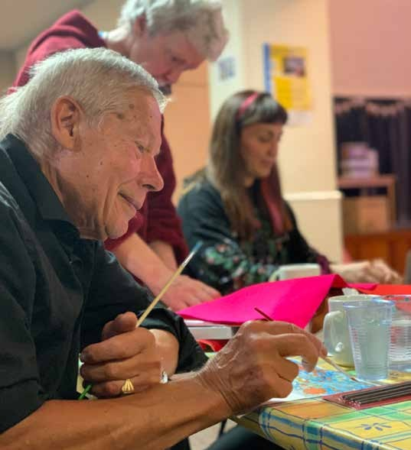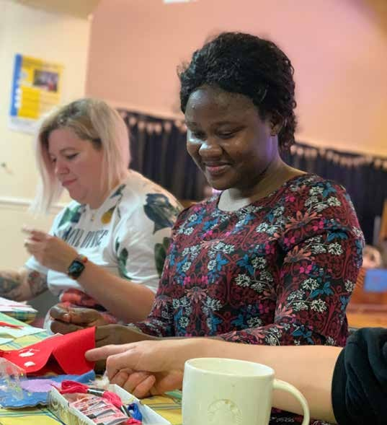

St. Vincent’s Newcastle Activity Timetable

All programmes are free and open to everyone

Mondays
11am - 1pm: Proggy Mat Making
A friendly drop-in session to try out a traditional craft technique.
Drop in, all welcome

2pm - 3pm: Knit and Natter with a Twist A friendly drop-in session led by Aisha. Unravel the art of knitting and share in friendship.
Drop in, all welcome
2pm - 4pm: Crafting For All
A relaxed crafting workshop to try something new, have a coffee or tea and a chat.

2pm - 4pm: Art of Watercolour
Learn the skill of this soft and light medium, which dates as far back as the stone age and is used today in illustrations, paintings and animation media!
Drop in, all welcome

Tuesdays
11am - 1pm: Vinnies Café
A free, home cooked 3 course meal, with table service for all.
Drop in, all welcome
11am - 1pm: Chat to Matt
A listening service with Mental Health Concern. Share your worries with Matt. Drop in, all welcome

1.30pm – Tuesday Film Club
If you like watching and discussing movies – this group is for you! Join us every week for a friendly get together with the like- minded film enthusiasts! (Launching October 18).

Wednesdays
12pm - 2pm: Chit Chat ladies Café Meet other ladies for coffee and a chat. Drop in, all welcome

Thursdays
12 - 2pm: Art Programme
Art as a key to good mental health.
Drop in, all welcome

Fridays
10am - Patchwork, Patter Cutting, and Design
If you are thinking of learning something different, or, you’d like to turn your textile
hobby into a money spinner - this class is for you!
(Launching October 14)

2pm - 4pm: Pie and Poetry Men’s Club
Come together with other men to explore
poetry and self-expression.
Drop in, all welcome

2pm – 4pm: Knit and Natter
A friendly drop-in session led by Aisha. Unravel the art of knitting and share in friendship.
Drop in, all welcome

Monthly
Group walk
Keep your mind and body healthy with our monthly group walk.
Enquire at: stvincentsnewcastle@svp.org.uk

Employability one to ones

Find out if we can support you in learning new skills to help you into work.
Enquire at:megann@svp.org.uk

Scan the code to see the timetable on your phone:

Register your interest and find out more:
stvincentsnewcastle@svp.org.uk Or call 0191 2616027

