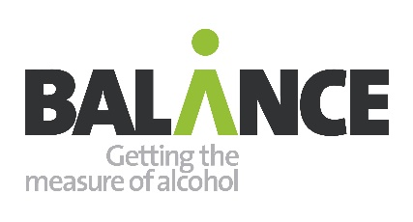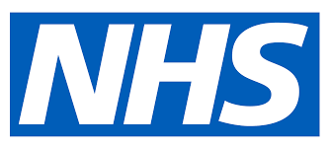
Alcohol Causes Cancer media campaign October – Nov 2022
Campaign PR and communications toolkit
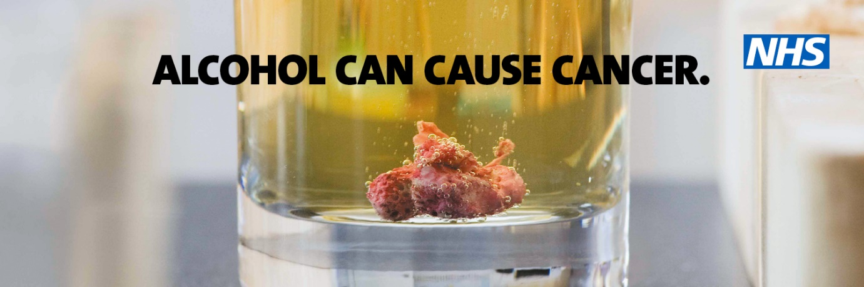
- Introduction
- Supporting the campaign
- Health risks
- Statistics – death, illness, consumption
- Alcohol Causes Cancer – the Campaign
- Reduce my Risk website
- Resources for partners
- Template article
- Social posts
- Ways to support
- Evaluation
- Q&A

1/ Introduction
On Monday, October 17, Balance will be launching the next phase of our “Alcohol Causes Cancer” campaign.

We know most people think of alcohol problems as only affecting a small minority of people. But the fact is that any regular drinking increases the risk of cancer – including breast, bowel, mouth and throat cancer.

“Alcohol Causes Cancer” is part of a long term strategy to raise awareness of the risks from alcohol as a product and a substance, to make people think about their drinking patterns and take steps to cut down.

This phase of the campaign will be running in the LA7 area of Northumberland, Tyne and Wear and County Durham and is branded with the Balance, NHS and “Supported by Cancer Research UK” logos.

Despite the risks, public awareness about the health risks associated with alcohol is still low. In 2020, only 1 in 3 (33%) North East adults were aware alcohol can cause cancer. Partners have called for Balance campaigns in the North East to be rolled out nationwide. See http://www.balancenortheast.co.uk/latest-news/calls-for-hard-hitting-alcohol-campaigns-to-be-rolled-out-nationally-

2/ SUPPORTING THE CAMPAIGN
We’re encouraging partners to share the campaign around your locality within the LA7 area of Northumberland, Tyne and Wear and County Durham. To support you, we’ve prepared this toolkit which contains:
- Aims and an overview of the campaign.
- Key messages and facts.
- Campaign copy for channels such as newsletters, intranet and websites.
- Suggested Tweets and Facebook posts to share on social media.
- A guide to additional printed and digital support materials.

3/ HEALTH RISKS
Alcohol raises the risk of more than 60 medical conditions:

Alcohol and cancer
- Regular drinking increases the risk of at least seven types of cancer - cancers of the bowel, breast, mouth and throat, voice box, oesophagus and liver. UK Chief Medical Officers’ Low Risk Alcohol Guidelines state that the risk of cancer starts from any level of regular drinking and rises with the amount of alcohol being drunk.
- 1 in 25 newly diagnosed cancer cases in the last year may be associated with drinking alcohol (see The Lancet Oncology.)
- Alcohol damages DNA by increasing the production of harmful chemicals in the body. It can also affect hormone production, which can contribute to cancer development and worsen the cancer-causing effects of smoking .
- Breast cancer is the most common cancer in the UK and drinking alcohol at even low and moderate levels is a risk factor. Breast Cancer Now warns that just one alcoholic drink a day increases the risk. Around 4,400 breast cancer cases each year are caused by drinking alcohol.
- Drinking alcohol increases the cancer risk even more if you smoke. This is because tobacco and alcohol work together to cause much more damage to cells.

Other health:
- Alcohol is the leading risk factor for death, ill-health and disability among people aged 15 to 49 in England and the fifth leading risk factor for ill health across all ages.
- Liver disease: Liver disease is the 3rd leading cause of premature death in the UK and is on the rise. Since 1970, deaths due to liver disease have increased by 400%. Alcohol-related liver disease accounts for 60% of all liver disease, causing around 7,700 deaths a year.
- High blood pressure and stroke: Alcohol can increase your risk of high blood pressure and stroke, even if you don’t drink very large amounts. And if you’ve had a stroke, alcohol could increase your risk of another stroke.
- Immune system: The World Health Organisation warns that alcohol use, especially heavy use, can weaken the immune system and leave us more vulnerable to infectious diseases like Covid .
- Mental health: increasingly alcohol is linked to mental health problems. Regularly drinking affects the chemistry of the brain and can increase the risk of depression, low mood and anxiety. Drinking can make you feel more tired and lower in mood. (Royal College of Psychiatrists)
- Dementia and brain: Alcohol can cause damage to the brain. According to the Alzheimer’s Society, those with Alcohol Related Brain Damage (ARBD) suffer from problems such as memory loss and difficulty concentrating, similar to Alzheimer’s disease.
- Weight: Alcohol contains hidden calories and contributes to weight gain. Reducing how much alcohol we drink is a good way to keep our weight in check.

4/ STATISTICS – ILLNESS, ConSUMPTION AND INEQUALITIES
NHS
In 2019/20 there were almost 980,000 hospital admissions where the primary reason or a secondary diagnosis was linked to alcohol – a 4% rise on 2018/19 (broad measure). This represents 5.7% of all hospital admissions and includes:
- 435,000 admissions for cardiovascular disease
- 227,000 admissions for mental and behavioural disorders due to alcohol
- 93,000 admissions due to cancer
- 74,000 admissions for liver disease.

Consumption
Alcohol use has soared since 2020 especially among those already drinking heavily and more at risk, and shows no sign of slowing:
- Alcohol specific deaths in England hit a record high during 2020 amid the pandemic. The worst rates in the country were in the North East.
- A survey by Balance – thought to be the largest in-depth study of alcohol use in any English region during the pandemic – found that in the North East:
  - 4/10 adults, or an estimated 855,000 people in the region, were drinking above Chief Medical Officers’ low-risk guidelines.
  - Heavier drinkers were more likely to have increased how often they drank.
  - Heavier drinking is highest amongst 45 to 54 year olds: almost one in two 45 to 54 year-olds were drinking at levels which increase their risks.
  - Even in retirement (65+), one in three adults are drinking above the low risk drinking guidelines.

Alcohol worsens health inequalities:
- People living in deprived areas are more likely to experience an alcohol-related hospital admission or die of an alcohol-related cause.
- The rise in drinking has been greater among people in the North and from less affluent backgrounds.
- Alcohol consumption increased most among heavy drinkers, those in deprived communities and people in the north of England during Covid, research has shown. A study by Newcastle University found the heaviest drinkers bought about 17 times more than those who had been drinking the least.

5/ Alcohol Causes Cancer - the campaign
Overview: The campaign is due to launch on October 17 for four weeks in the run up to the 2022 FIFA men’s World Cup*. Balance has also produced digital assets to help partners amplify the campaign at a local level.

Key audience: Our target audience is all adults, especially those aged 35 plus, who are most likely to be drinking at higher levels. Targeting is weighted especially towards C2DE households with a view to tackling health inequalities.

Channels across Northumberland, Tyne and Wear and Co Durham:
- Video on Demand: ITV Hub, C4 Hub and Sky Adsmart (around 718,000 impacts)
- Radio advertising:
  - Hits/ Metro, Capital and Smooth radio stations with a potential reach of around 868,000 people
- Digital
  - Facebook and Instagram: est 1.2m impressions
  - Google display advertising: est 788,000 impressions

*During the World Cup we can expect a huge increase in alcohol advertising. During the Euros alcohol companies were criticised for positioning star players in front of alcohol brands at post match press conferences and there has already been coverage about the relaxation of alcohol rules in Qatar. However the fact is that consumers in the UK will be bombarded by messages encouraging alcohol consumption.

6/ REDUCE MY RISK.TV
“If you reduce your drinking you can reduce the risk – visit ReduceMyRisk.tv.”

This is our main call to action on all advertising and materials to promote our updated campaign website where people can find out more about the risks of alcohol and find tips, tools and support to cut down.

This site – which has had over half a million visits since launch - has been updated and improved since the last campaign. This includes a new mobile friendly interface, a refreshed quiz about drinking consumption and units, real stories, and information about health risks and the links between alcohol and cancer.

The website also signposts to Drinkline, the free, confidential alcohol helpline and we are asking local colleagues to send us details of local alcohol recovery services.
We do not support or promote the alcohol industry funded website Drinkaware.

Campaign messages:
- Like tobacco, alcohol is a carcinogen which raises the risk of at least seven types of cancer, including bowel, breast, throat and mouth cancer.
- The risk of cancer starts from any level of regular drinking and increases the more you drink.
- Even low levels of drinking increases the risk of some cancers. The risk of breast cancer increases from the first drink.
- Around 17,000 cases of cancer in the UK a year are linked to alcohol consumption.
- There is no “safe” level but the best way to reduce your risk is to stay within the Chief Medical Officer’s low risk guidelines of no more than 14 units a week.
- Drinking alcohol has been shown to cause damage to DNA and accelerates the ageing process, leading to diseases such as cancer.

The advert

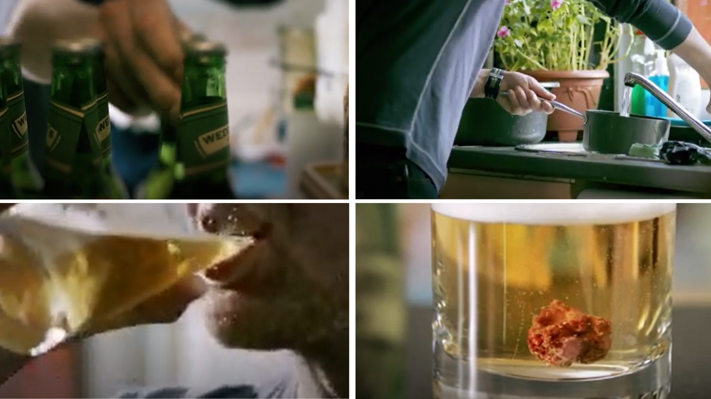

“Just like smoking, drinking alcohol can give you cancer.
“And any level of regular drinking increases your risk.
“Alcohol can cause at least seven different types of cancer.
“So the more you drink…and the more often you drink….the greater your risk of developing cancer …including bowel, breast, throat and mouth cancer.”
“Reduce your drinking. Reduce your risk. Find out how at reducemyrisk.tv”
WATCH AT https://www.youtube.com/watch?v=ramUXv-QJAg

7/ Resources for partners
Partners can help us ensure the campaign is seen and heard locally in October and November – especially in the run up to the World Cup when we can expect to see an increase in alcohol advertising.
- Printed posters and A5 flyers – please contact us if you require these (limited supply.
- Digital screens for waiting areas, housing offices, GP surgeries and hospitals
- Short video animations for social media
- Social media images
- PR and social media content
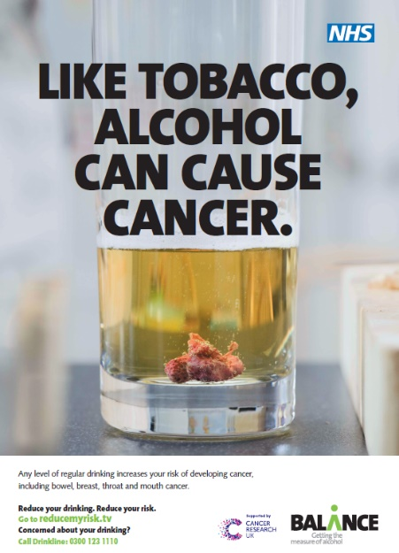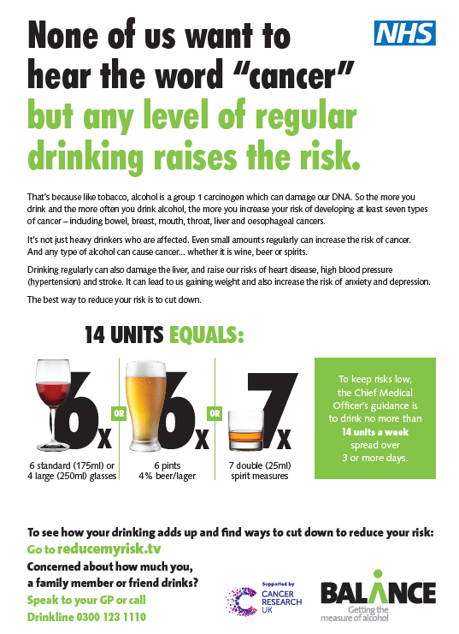
Poster Flyer (back)

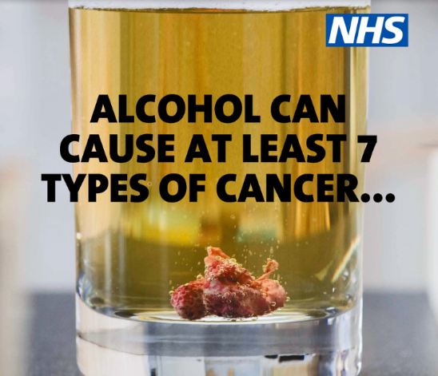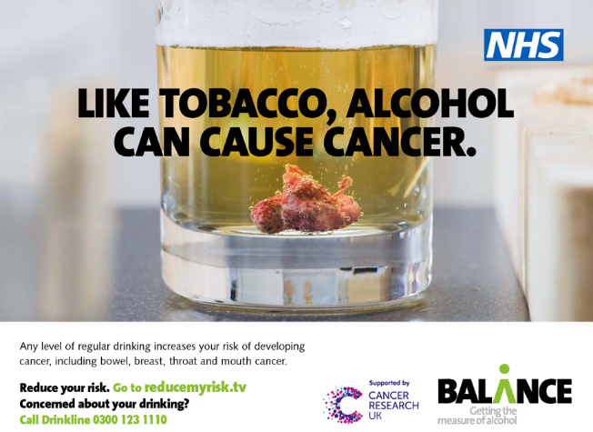
Facebook animation / video Screen for waiting areas

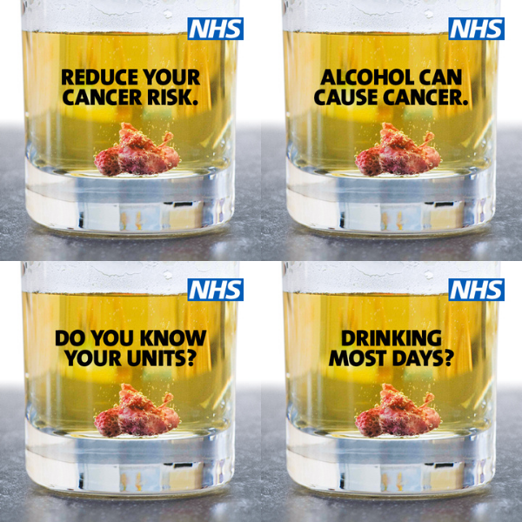 Facebook and Twitter images

8/ Template article
If you drink alcohol, how do your drinks add up? And are they putting your health at risk?

Most of us know that smoking causes cancer. But it is now proven that alcohol is a direct cause of at least seven types of cancer including bowel, breast, mouth and throat cancer.

It’s not just heavy drinkers at risk. The risks start from one or two drinks a day and rise the more you drink. Any type of alcohol can cause cancer... whether it is wine, beer or spirits.

Regular drinking can also damage the liver and raise the risk of heart disease, high blood pressure (hypertension) and stroke. It can worsen weight problems and increase the risk of anxiety and depression.

INSERT SPOKESPERSON: “If you drink most days or binge at the weekend the fact is you’re probably drinking above the recommended limits and putting health at risk.

“Alcohol can make us feel more tired and increase our risks of serious illness like cancer, high blood pressure and liver disease over time.

“Cutting down can reduce those risks.”

The best way to reduce your risk is to cut down and limit your drinking:
- Drink no more than 14 units a week (about six glasses of wine, six double spirits or six pints of lager) spread out over several days
- Take more drink free days to give your body a break.

VisitReducemyRisk.tv for tips and free tools such as the free Try Dry app to track your units, calories and money saved when you cut down or cut out alcohol.

UK Chief Medical Officers’ Low Risk Drinking Guidelines
The UK Chief Medical Officers’ guidance is that men and women are safest not to drink more than 14 units per week. This does not mean no risk but low risk.

The guidance states that a good way to cut down on alcohol consumption is to have several drink-free days each week. 14 units of alcohol is equivalent to six pints of average-strength beer or six medium glasses of wine. However - just one pint of premium lager or a large glass of wine can contain more than three units of alcohol.

9/ SOCIAL POSTS
(sample images below – full range can be downloaded)
None of us want to hear the word cancer, but alcohol can cause at least 7 types of cancer – including breast, bowel, mouth and throat cancer. Reducing your drinking reduces the risks. Find free tips and tools to cut down at www.reducemyrisk.tv | 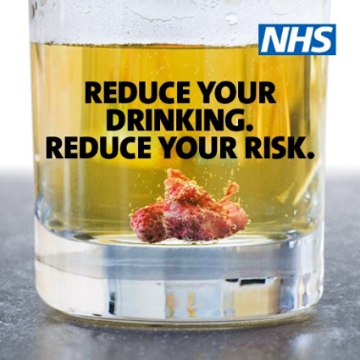
If you drink most days, cutting down can help you feel more alive and lose weight. It also reduces the risk of bowel, breast, throat and mouth cancer. Find free tips and tools to cut down at www.reducemyrisk.tv
Just like smoking, alcohol can give you cancer. Even one or two drinks a day can increase the risk – whether wine, beer or spirits. Find free tips and tools to cut down at www.reducemyrisk.tv
Do you know your alcohol units? None of us like to think we’re drinking too much. However it’s too easy to under-estimate how much we’re putting away. How does yours add up? Try this quiz at www.reducemyrisk.tv | 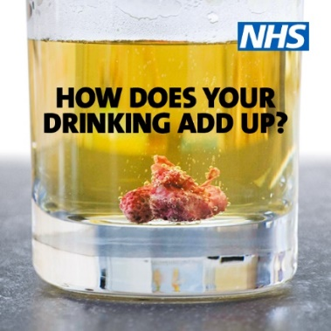
Did you know? The Chief Medical Officer’s advice is that BOTH men and women are safest not to drink regularly more than 14 units a week. How do your drinks add up? Try the quiz at www.reducemyrisk.tv | 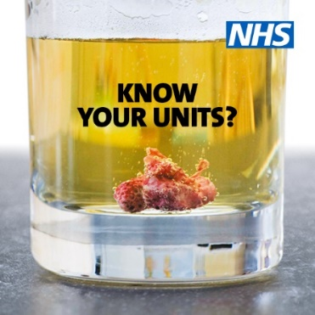
None of us want to hear the word cancer, but alcohol can cause at least 7 types of cancer – including breast, bowel, mouth and throat. Cutting down how much you drink can help lower your risk. Find out more at www.reducemyrisk.tv #AlcoholCausesCancer | 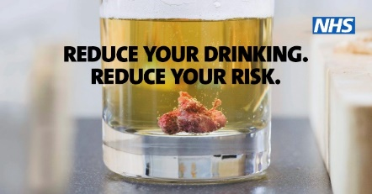
Time to cut down on alcohol? We’re backing @BalanceNE #AlcoholCausesCancer campaign to help people reduce their drinking and reduce the risk of bowel, breast, throat and mouth cancers. Find free tips and tools at www.reducemyrisk.tv | 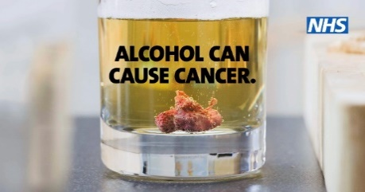
Drinking above the low risk limits of 14 units a week increases the risks of cancer, heart disease, liver disease, high blood pressure and stroke. How do your drinks add up? Try the quiz at www.reducemyrisk.tv
Alcohol causes cancer but as deaths from alcohol rise, awareness of this is too low. We are supporting the #AlcoholCausesCancer campaign from @BalanceNE to raise awareness and encourage people to cut down. Visit www.reducemyrisk.tv
Alcohol causes cancer but unlike tobacco you’d never find that information on the bottle or can. We’re supporting the #AlcoholCausesCancer campaign from @BalanceNE to raise awareness. There are so many reason to cut down – for tips and free tools visit www.reducemyrisk.tv

10/ ways to support
As ever, partners can help us ensure the campaign is seen and heard locally in October and beyond:
- Plan distribution of any printed posters and flyers you may have ordered
- Plan a template article for websites and in-house publications for residents
- Use our digital screens for public areas – waiting rooms, reception areas, housing offices etc.
- Plan dissemination of digital resources to GP surgeries, within hospitals, partner organisations, treatment services.

11/ EVALUATION
A survey of 701 people across the North East the North Cumbria were surveyed in December 2021 on their recall of the campaign, the impact on their attitudes and their drinking behaviour:
- 61% recalled the campaign and 67% thought it was good or excellent
- 84% thought it is important to have campaigns like this.
- Those who recall the campaign are almost twice as likely to link alcohol with cancer
- Almost half (46%) and 43% of increasing and higher risk drinkers took action as a result of seeing or hearing the campaign, including:
  - 17% cut down how often they drink
  - 13% cut down how much they drink
  - 13% began monitoring alcohol units
  - 29% also felt like they should take part in Dry January as a result of seeing or hearing
In addition phase 1 resulted in over 45,000 visits to the campaign website.

12/ Q&A
Aren’t people aware of the risks?
Compared to tobacco, alcohol is still catching up when it comes to public awareness around the links with cancer. This is not surprising since some of the most compelling evidence around alcohol and cancer was only published in 2016 by the Committee on Carcinogenicity.

The Chief Medical Officer’s low risk drinking guidelines in 2016 states:
“Drinking alcohol increases the risk of developing a range of cancers. The Committee on Carcinogenicity recently concluded that ‘drinking alcohol increased the risk of getting cancers of the mouth and throat, voice box, gullet, large bowel, liver, of breast cancer in women and probably also cancer of the pancreas’. These risks start from any level of regular drinking and then rise with the amounts of alcohol being drunk. This was not fully understood when the last guidelines were drawn up in 1995.”

We have all seen and read claims about alcohol and especially red wine being supposedly good for health, but the Chief Medical Officer’s guidance is very clear that the net benefits from small amounts of alcohol are less than previously thought. A good explanation from NE Cardiologist Dr Michael Norton can be found here https://www.youtube.com/watch?v=-8H259K_Ziw

Meanwhile a 2018 Lancet study established that any level of alcohol consumption, regardless of the amount, leads to loss of healthy life.

Why are you running a campaign?
Previous alcohol campaigns in the North East have taken a hard hitting approach since we know there is such low awareness among the public about the impact of alcohol on health and especially cancer. This also includes the low understanding of alcohol units or Chief Medical Officer’s guidelines to stay within 14 units per week to keep risks low.

We believe just like tobacco, people have a right to know the facts about alcohol and weigh up the risks, but we also know people drinking at risky levels would like to hear more about ways to cut down, which we will be signposting on the campaign website. We also know that an informed population is more likely to take part in periods off abstinence and support the kind of policy measures which independent evidence indicates will make a real difference in reducing harm.

Campaigns like Dry January are positive and encouraging. Why is this harder hitting?
A BMJ paper compared the effectiveness of alcohol campaigns and this found that the most attention grabbing and informative alcohol ads focus on the negative health consequences. We also tested the concept with people who drink regularly and the concept was felt to be effective and the family setting made this more relevant to people's lives.

Are there any messages to avoid?
Alcohol industry funded advertising uses the term “drink responsibly” which is a vague term we should avoid. The problem is that many people who are putting their health at risk from alcohol and drinking well above the recommended low risk guidelines are in their minds, drinking responsibly.

Our communications need to be sensitive to the fact that people may be struggling with an alcohol addiction, may be in alcohol recovery, or may have come through recovery but have liver damage and cannot drink. 2020 was a record year for alcohol-specific deaths and well-publicised rates of addiction. The phrase “Drink Responsibly” assumes someone does drink and taken literally is an instruction to drink. A concern is that this could be taken as an endorsement for drinking.

Are you promoting zero or low alcohol drinks?
We are not promoting zero/ low alcohol drinks.

This is an issue which does cause some debate. On the one hand some advocates believe low/ zero alcohol drinks are helpful for those cutting down or taking time off. However others – including some people in recovery - have stated that zero alcohol drinks are a reminder of what they cannot have and have blamed these on relapses. Advertising of zero alcohol drinks was criticised during the Euro 2020 tournament as a backdoor way of advertising alcohol brands.

Research in this field will continue – however one study by Newcastle University has found that people are more likely to buy zero or low alcohol alternatives if they are younger, fall into a higher earning bracket and are well-educated. This is probably unsurprising, given that non-alcoholic alternatives aren’t cheap - and can sometimes be more expensive than their ‘normal’ equivalents. Newcastle University has conclude that zero and low alcohol alternatives are not enough to address the harm done by alcohol, and are not effective at reducing alcohol-related health inequalities. Additional evidence-based policy measures - such as a Minimum Unit Price and improved funding for alcohol treatment and intervention and prevention services - are needed to lessen harms of alcohol which are experienced by the most disadvantaged people in our society.
http://fuseopenscienceblog.blogspot.com/2021/10/are-zero-and-low-alcohol-alternative.html

https://www.cancerresearchuk.org/about-cancer/causes-of-cancer/alcohol-and-cancer
https://assets.publishing.service.gov.uk/government/uploads/system/uploads/attachment_data/file/545937/UK_CMOs__report.pdf
https://www.cancerresearchuk.org/about-cancer/causes-of-cancer/alcohol-and-cancer/does-alcohol-cause-cancer
https://www.cancerresearchuk.org/about-cancer/causes-of-cancer/alcohol-and-cancer/does-alcohol-cause-cancer
https://assets.publishing.service.gov.uk/government/uploads/system/uploads/attachment_data/file/733108/alcohol_public_health_burden_evidence_review_update_2018.pdf
https://britishlivertrust.org.uk/about-us/media-centre/statistics/
https://www.euro.who.int/__data/assets/pdf_file/0007/442690/FAQ-COVID-19-alcohol.pdf
http://www.balancenortheast.co.uk/latest-news/record-year-for-alcohol-deaths-highlights-crisis-of-harm
http://www.balancenortheast.co.uk/latest-news/alcohol-and-covid-19-a-perfect-storm
https://alcoholchange.org.uk/policy/policy-insights/alcohol-and-inequalities
https://www.euro.who.int/en/health-topics/noncommunicable-diseases/pages/news/news/2018/09/there-is-no-safe-level-of-alcohol,-new-study-confirms

