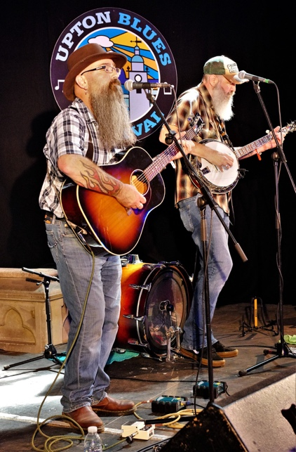

Hillbilly - roots - bluegrass
⭑ ⭑ ⭑ ⭑ ⭑ ⭑ ⭑ ⭑ ⭑ ⭑ ⭑ ⭑ ⭑ ⭑ ⭑ ⭑ ⭑ ⭑ ⭑ ⭑ ⭑ ⭑ ⭑ ⭑
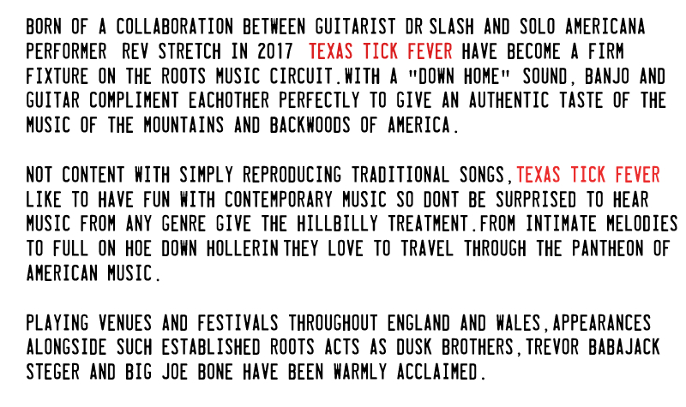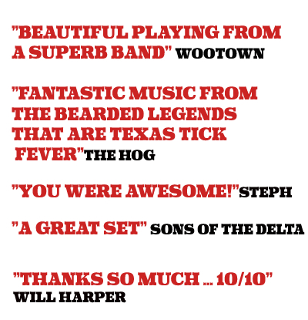
⭑ ⭑ ⭑ ⭑ ⭑ ⭑ ⭑ ⭑ ⭑ ⭑ ⭑ ⭑ ⭑ ⭑ ⭑ ⭑ ⭑ ⭑ ⭑ ⭑ ⭑ ⭑ ⭑ ⭑

Media Links: Facebook ⭑ youtube ⭑ Soundcloud ⭑ GIG GUIDE

www.texastickfever.com ⭑⭑ texastickfever@gmail.com ⭑⭑ TEL: 07504217390

