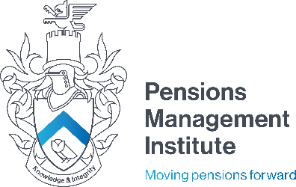
Registered office:
6th Floor
9 Appold Street
London
EC2A 2AP
T: +44 (0) 20 7247 1452
W: www.pensions-pmi.org.uk

Core Unit 4 -Financing and Investing for Retirement Provision

Assignment 2
(Part 2 – Risk Management)
Recommended Time: 2 hours

- In the context of equity markets, list the ways in which a company can issue shares in order to raise capital, and give a short statement regarding how each method operates.
15 marks

- Managing currency risk is important in order to mitigate the impact of adverse currency movements. Outline the following:

- The two main methods of managing currency risk
- The techniques active managers may use to manage currency risk
15 marks
- Pension schemes typically hold the majority of their assets in equities and bonds.
Briefly describe:
- how bonds compare to equities in terms of risk and return
- the factors that affect bond values
10 marks
- Describe the characteristics of infrastructure investment.
9 marks

- Why might a company choose to list its shares in a different country to the one in which it is headquartered and what factors would it take account of?
5 marks

- Briefly describe four common types of derivatives and explain why derivatives are different in nature to the main asset classes.
16 marks

- Write a Report to a new trustee detailing Property Investment used in the Pension Scheme.

Your Report should discuss

- Ways to invest in Property.
- Types of Commercial Property
- Attractions of Commercial Property
- Risks and other factors
- Property Management
30 marks

