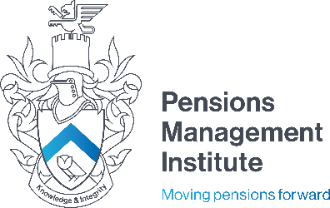
Devonshire House
60 Goswell Road
London
EC1M 7AD
T: +44 (0) 20 7247 1452
W: www.pensions-pmi.org.uk

Managing International Employee Benefits Assignment 4
Recommended Time: 3 hours

- Explain how a company might place a value on a transferring defined benefit pension scheme.

10 marks

- Identify the key stages of the merger and acquisition process.

10 marks

- Explain what is meant by due diligence.

5 marks

- Explain the difference between a representation, a warranty and an indemnity.

10 marks

- Explain how an employee benefits professional can contribute to a due diligence process.

15 marks

- Describe some of the actions that a purchaser must take after a merger and acquisition deal to acquire a target company has been signed.

20 marks

- List some of the current “hot topics” that are influencing the employee benefit arena and explain how the economic shift to Asia might impact on a multinational companies approach towards managing employee benefits in the region.

- Describe what best practice towards defined contribution schemes might include.

20 marks

10 marks

Managing International Employee Benefits – Assignment 4 2023 Edition
@Pensions Management Institute 2023

