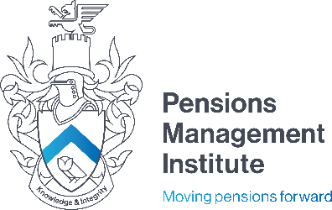
Devonshire House
60 Goswell Road
London
EC1M 7AD
T: +44 (0) 20 7247 1452
W: www.pensions-pmi.org.uk

Retail Advice and Regulation

Mock Examination

Recommended Time: 3 hours

- Write brief notes on the following:

  - MiFID.
  - The Financial Conduct Authority’s consumer and practitioner panels. (c) The Pensions Regulator.
    - marks

- Outline the nature and features of a Will. 5 marks

- Briefly describe the main tax wrappers. 10 marks

- Your client aged 55 is due to emigrate to Australia with his family. He has no intention of returning to the UK and would therefore like his DC retirement benefits to be transferred. Having obtained the relevant research your recommendation is to transfer the benefits into an Australian ROPS. Reproduce your suitability report focusing on:

  - Relevant information that you collated as part of the fact finding process (10 marks)
  - Suitability of a ROPS – you do not need to focus on the provider (5 marks)
  - Alternative solutions available (5 marks)
  - Advantage and disadvantages and other considerations to be aware (15 marks)

Candidates should be aware that marks are available for the format and clarity of the suitability report, therefore consideration should be given to the client’s taxation status, attitude to risk, the
costs and consequences of implementing the advice and the service levels to be expected from
you as their financial adviser. (10 marks)

45 marks

- Describe a financial services firm’s obligations in relation to the following financial crimes:

  - Fraud
  - Data Security (c) Bribery and Corruption.
    - marks

- Explain the difference between the Financial Conduct Authority’s Skilled Persons Review and a Thematic Review.
10 marks
Retail Advice and Regulation Mock Examination 2018/19 Edition
© The Pensions Management Institute 2019

