Reward & Retirement Provision
Assignment 2 Questions
(Part 2 – Health and Risk Benefits)

- Outline how Statutory Sick Pay (SSP) works.
10 Marks

- As the company's Benefit Consultant, prepare a paper for the HR Director explaining how a group income protection policy operates.

Your paper should also cover:

  - The design features of a group income protection policy
  - The cost to the employer
  - The taxation of benefits and contributions
35 marks

- Explain how the rules of a defined benefit occupational pension scheme may allow for payment of benefits based on ill health or incapacity.
5 marks

- A new employee has asked for information in relation to what is covered by the company’s private medical insurance (PMI) policy. As Total Rewards Manager, write an email to the employee outlining the main areas of treatment typically covered by PMI, including examples, and the treatments that are generally excluded, again providing examples.
10 marks

- Explain the different methods for calculating the cost of private medical insurance (PMI) and what steps companies can take to reduce the cost.
25 marks

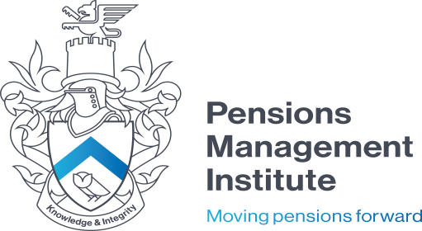
- Outline what personal accident schemes are and how they work, providing examples of the benefits payable.
5 marks

- Provide an overview of critical illness schemes, including how they work and the taxation of both premiums and payment of benefits.
10 marks

