i

“Check First” (Good Ending)

PSA by Edwin Cole

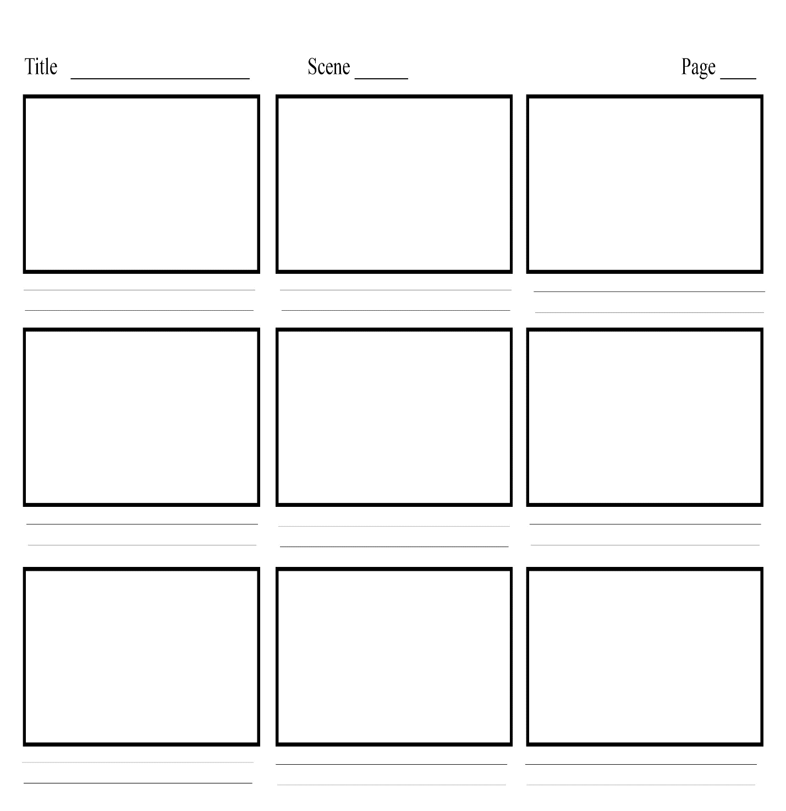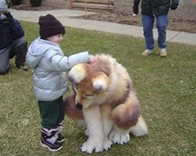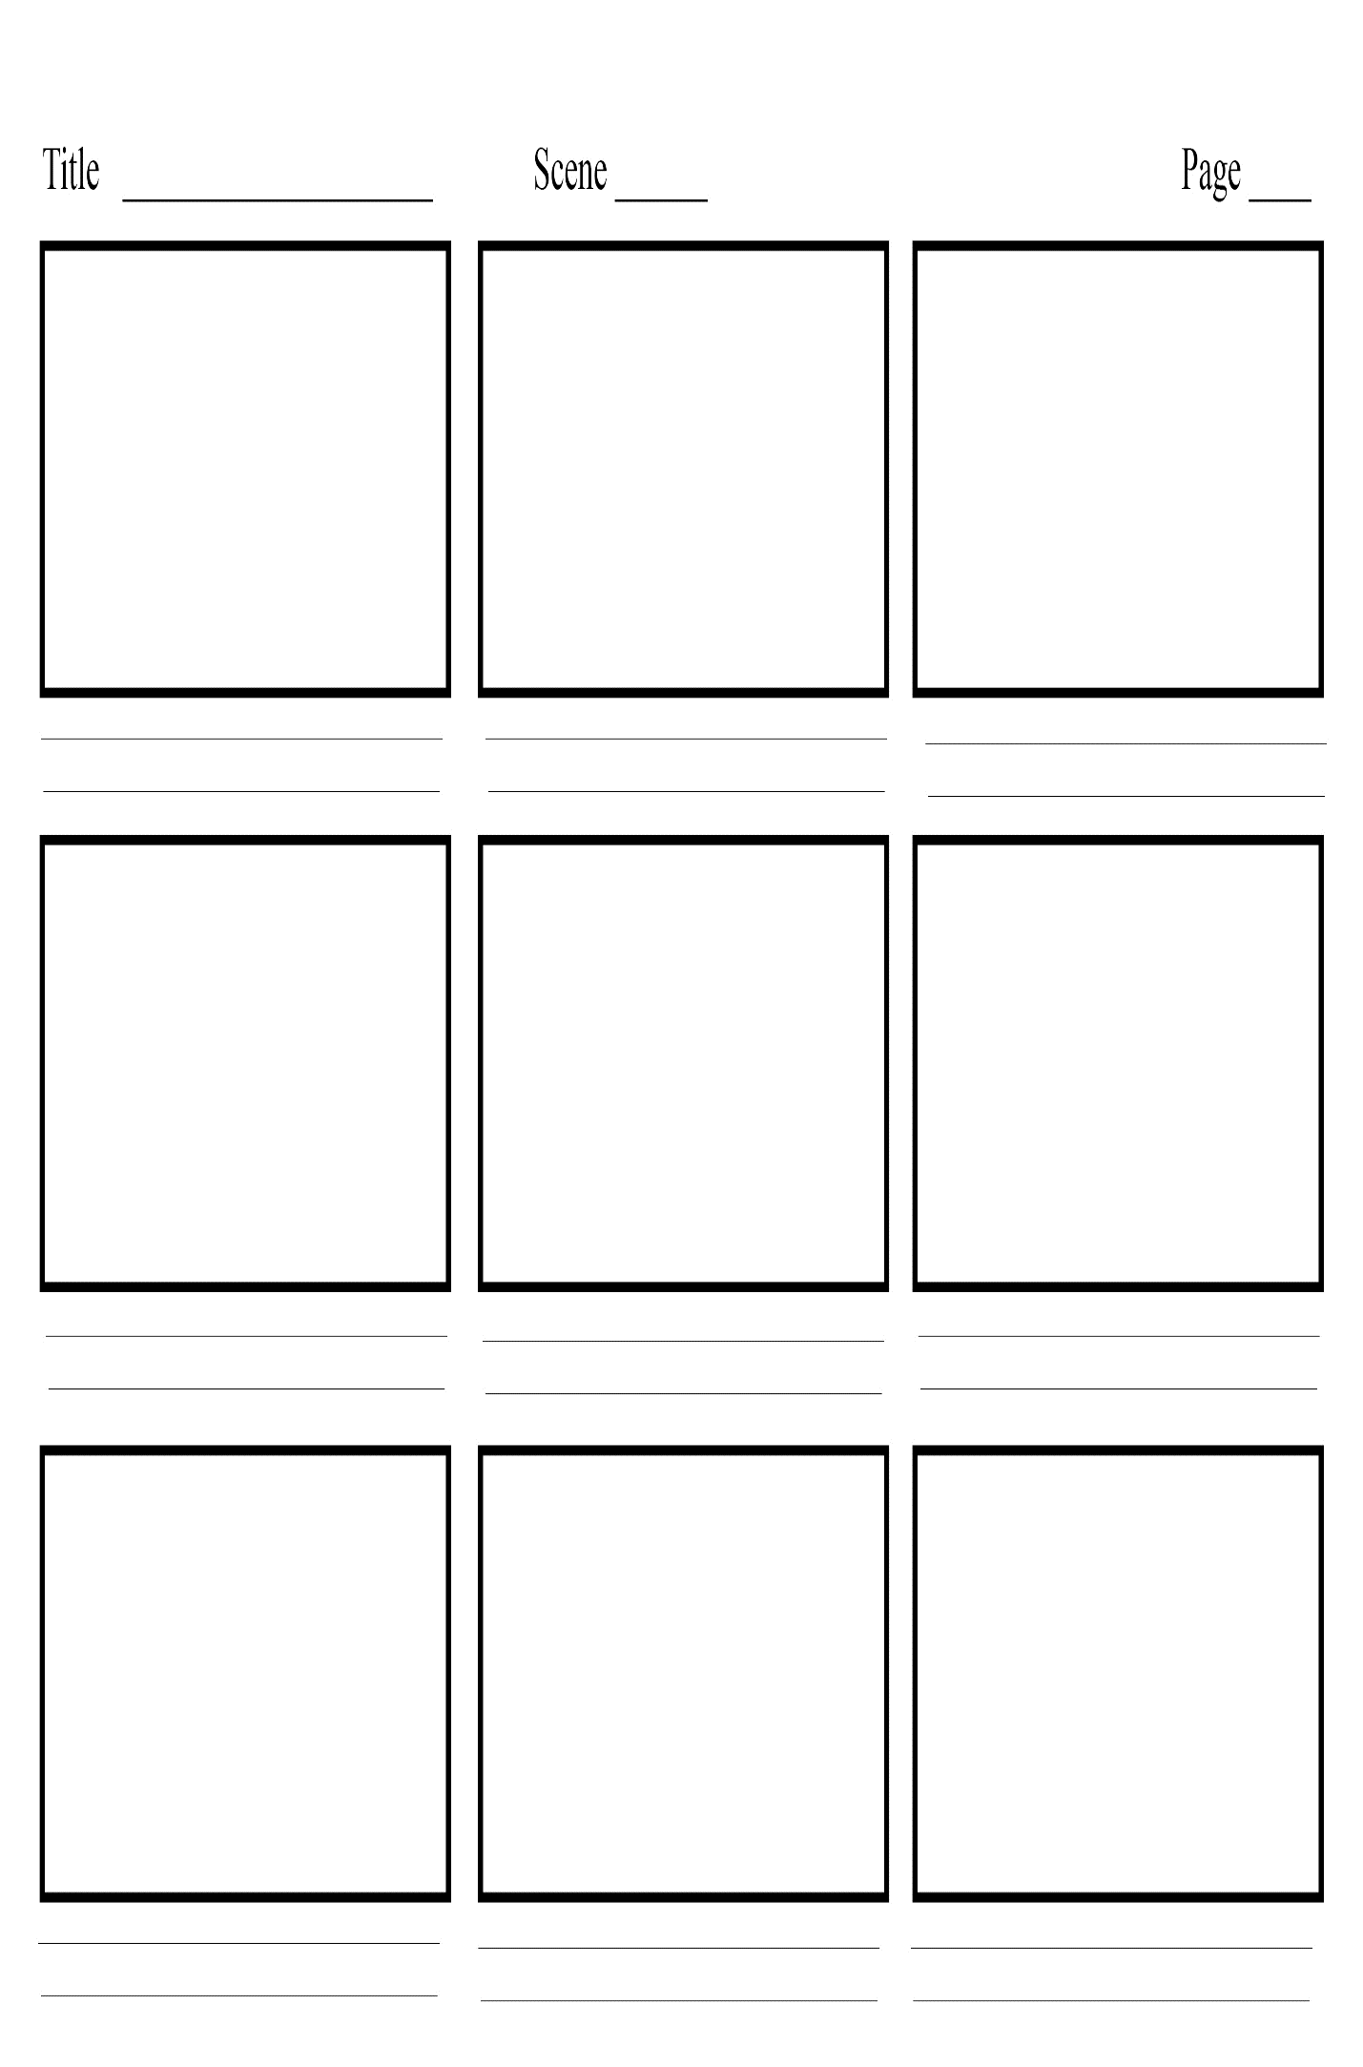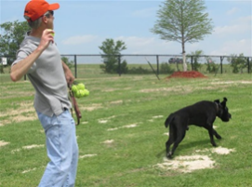

Man walks up to kid with dog and starts talking to the kid.

Kid thinks about it but remembers to go ask his mother.

The man runs away and is never seen at the park again.

The dog walks up to the kid and the kid pets the dog.

Man asks kids if we want to play with the dog and pulls out a ball and throws it.

Man comes to the park with his dog and sees kid.

Mom sees friend and starts to leave her son and goes to talk to her.

Mom and son playing at the park.

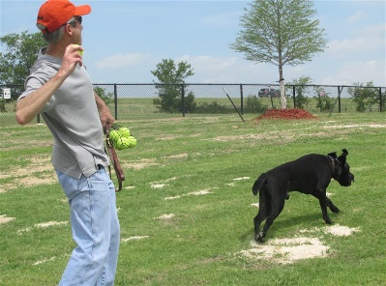  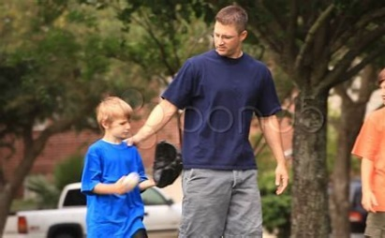

Mom sees friend and starts to leave her son and goes to talk to her friend.

The dog walks up to the kid and the kid pets the dog.

Rewind it back to before all this happens.

Man picks up kid and places him in the back of his car and drives away.

Kid runs after the dog and the man going towards the car.

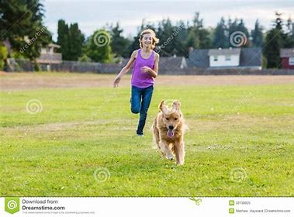

Man asks kids if we want to play with the dog and pulls out a ball and throws it.

“Check First” (Bad Ending)

PSA by Edwin Cole

Man walks up to kid with dog and starts talking to the kid.

Man comes to the park with his dog and sees the kid.

Mom and son playing at the park.