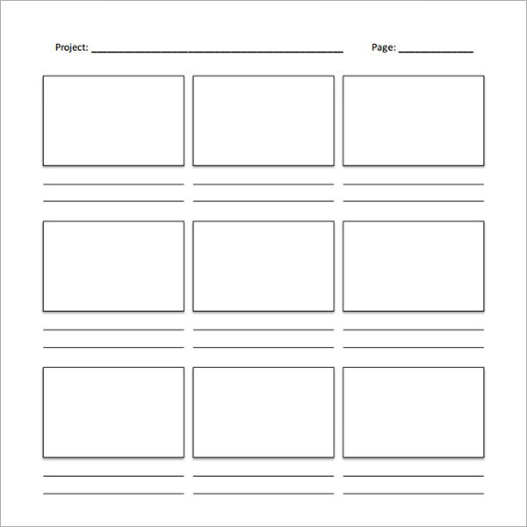

Sarah and the man go get food and make small talk to finds out Sarah ran away.

Sarah and Amy talk out problem

Sarah went to her room and called her friend and her friend convince her to call her mama.

Rewind to when Sarah and Amy were arguing

The man brought her to the house and sold her to the sex trafficking

Not long until a man that Sarah did not know pulled up and offered Sarah a ride Sarah agreed, and the man asks did she want any food

When Sarah got to the room, she starts packing her clothes, and ran away at midnight with no food or money and no place to go

Sarah did not want to keep arguing so Sarah yelled “I DON’T CARE” AND STOMPED AWAY

Sarah was having a big fight with her mother Amy about a boy she date