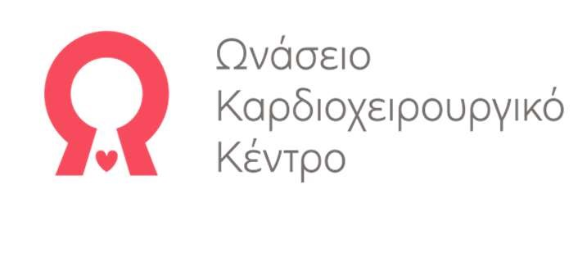Μονάδα Κληρονομικών και Σπανίων Καρδιαγγειακών Παθήσεων

Επιστημονικός Υπεύθυνος: Α. Αναστασάκης, MD, PhD Αναπληρωτής Διευθυντής Καρδιολογικού Τομέα anastasakis@ocsc.gr | www.icardiacnet.gr

Αθήνα, 14/04/2022

Cardiomyopathies
 | ORPHAcode | ICD-10
Hypertrophic cardiomyopathy | 217569 | I42.1/I42.2
Dilated cardiomyopathy | 217604 | I42.0
Arrhythmogenic right ventricular cardiomyopathy | 247 | I42.8
Left ventricular non-compaction | 54260 | I42.8
Restrictive cardiomyopathy | 217635 | I42.5
Peripartum cardiomyopathy | 563 | O90.3
Unclassified cardiomyopathy | 217678 | -
Myocarditis | - | I41.2
Noonan syndrome | 638/648 | Q87.1
Costello syndrome | 3071 | Q87.8
Leopard syndrome | 500 | Q87.1
Neurofibromatosis | 636 | Q85.0
Cardiofaciocutaneous syndrome | 1340 | Q87.8
Danon disease | 34587 | E74.0
Pompe disease |  | E74.0
MPS/PRKAG2 without orpha codes | --
Fabry disease | 324 | E75.2
Hereditary familial Amyloidosis | 271861 | --
Barth syndrome | 111 | E71.1
MELAS syndrome | 550 | E71.3
Friedriech | 95 | G11.1
Becker syndrome | 262 | G71.0
Duchenne | 262 | G71.0
Myotonic dystrophy | 206647 | G71.1
Emery Dreifuss | 261 | G71.0
Down | 870 | Q90.0 /Q90.1  Q90.2 / Q90.9
Channelopathies
Familial long QT syndrome | 768 | I45.8
Brugada syndrome | 130 | I49.8
Catecholaminergic polymorphic ventricular tachycardia | 3286 | I47.2
Familial short QT syndrome | 51083 | I49.8
Idiopathic ventricular fibrillation - not Brugada type | 228140 | I49.0
Aortopathies
Marfan syndrome | 558 | Q87.4
Loeys-Dietz syndrome | 60030 | Q87.4
Ehlers-Danlos syndrome | 98249 | Q79.6
Rare disease with thoracic aortic aneurysm and aortic dissection | 285014 | I71

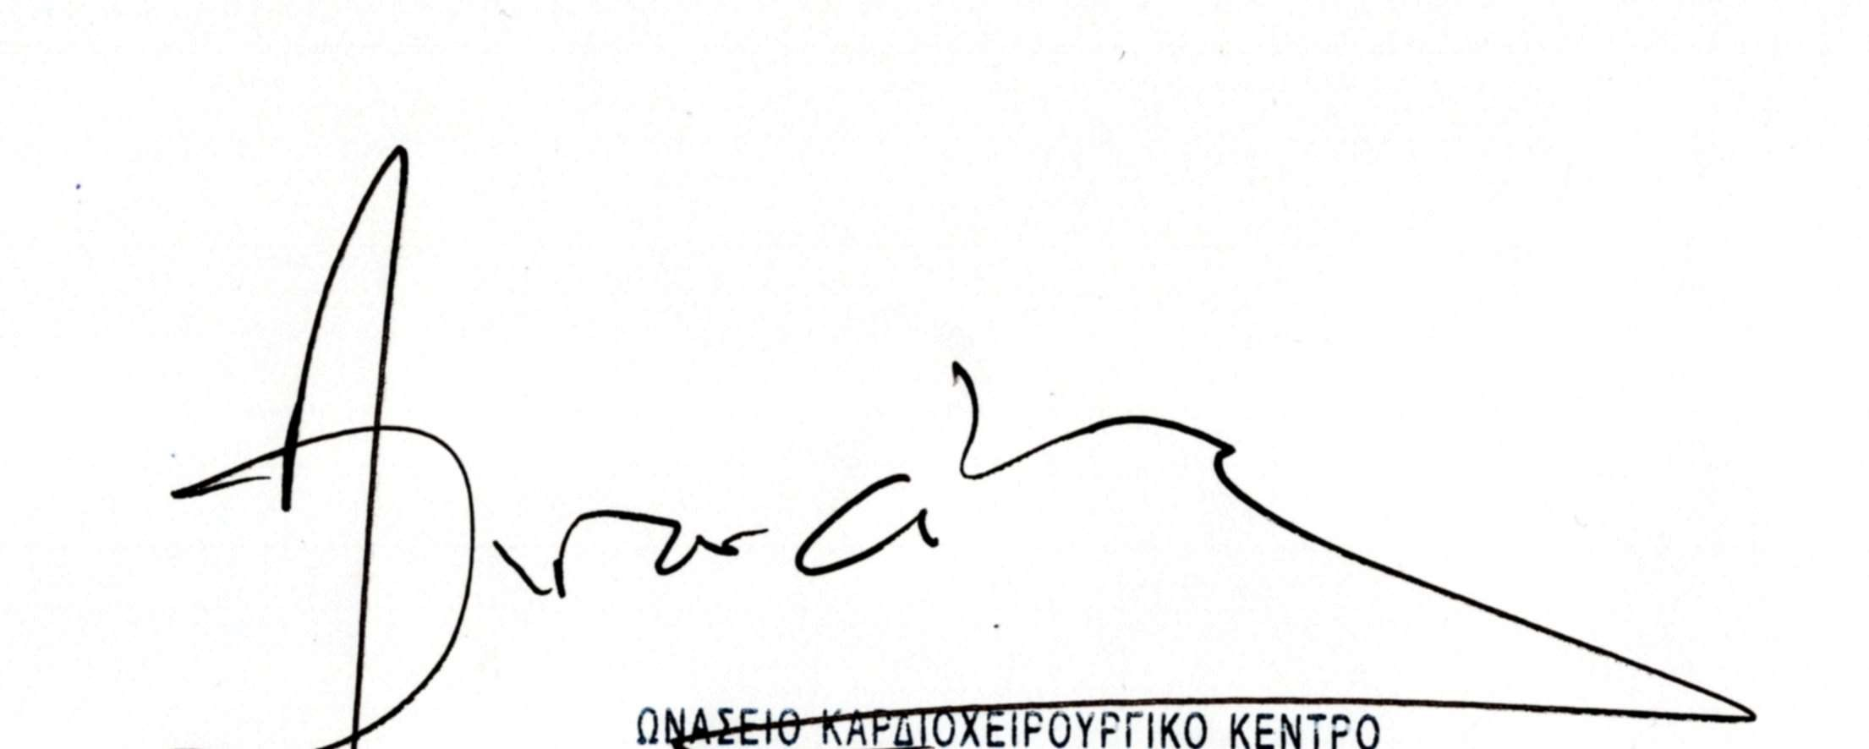
Καρδιολόγος
Άρης Αναστασάκης, MD, PhD
Επιστημονικός Υπεύθυνος
Μονάδας Κληρονομικών και Σπανίων Καρδιαγγειακών Παθήσεων
Αναπληρωτής Διευθυντής Καρδιολογικού Τομέα
Ωνάσειο Καρδιοχειρουργικό Κέντρο

