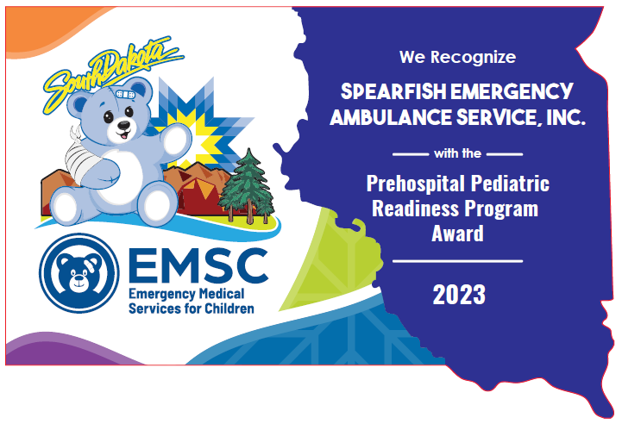

“This resource is supported by the Health Resources and Services Administration (HRSA), Maternal and Child Health Bureau (MCHB), and the Emergency Medical Services for Children (EMSC) Program through the following grant(s): H33MC06693. This information or content or conclusions are those of the author and should not be construed as the official position or policy of, nor should any endorsements be inferred by HRSA, HHS, or the U.S. Government.”

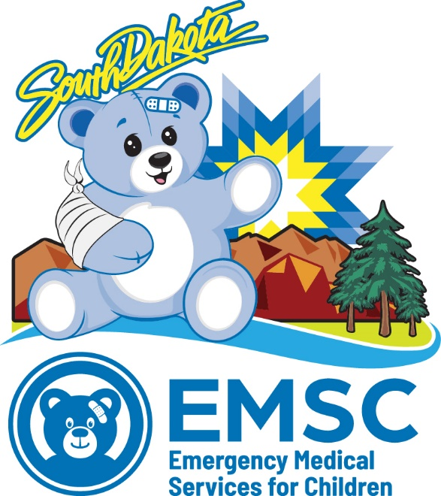
October 1, 2023

Dear EMS Agency Administrator:

We are pleased to introduce the newly revised voluntary statewide initiative sponsored by the South Dakota EMS for Children (SD EMSC) program, the Prehospital Pediatric Readiness Program Award (PPRP): a recognition project for South Dakota EMS agencies who are dedicated to the emergency care for pediatric patients in the event of a severe illness or injury.

Participating in this program is an excellent opportunity for your agency to receive community recognition for pediatric emergency medical care.

Participation in this project will not impact your licensure by the South Dakota Department of Health Division of Emergency Medical Systems. We encourage your organization to participate in the PPRP. Please review this guide and complete the application and scan a copy to: sdemsc@usd.edu

The SD EMS for Children Advisory Board will review this program annually. The Advisory Committee will collaborate to address these pediatric gaps while creating and sharing guidelines and resources essential to the provision of safe and effective prehospital care to children. Changes to the recognition criteria will be shared with participating organizations to allow them the opportunity to maintain their pediatric readiness status.

If you have questions, please contact SD EMS for Children at 605-328-6668 or sdemsc@usd.edu

Caring for children doesn’t get better by chance…It gets better by choice!

Corolla J. Lauck, NRP
Program Director
SD EMS for Children
1400 West 22nd Street
Sioux Falls, SD 57104
corolla.lauck@usd.edu

Mission Statement

The mission of the SD EMS for Children Program is to ensure that every child in South Dakota receives the best pediatric care in the event of severe injury or illness. SD EMS for Children aims to advocate for the unique needs of children of all ages, ensure all children in our state have timely access to optimal medical care, and provide safety, injury, and prevention initiatives.

The primary purpose of the PPRP is the improvement of pediatric emergency care outcomes and patient safety within the prehospital environment (local, regional, and state levels) through recognizing pediatric readiness gaps in emergency systems across SD.
This document was prepared by the SD EMS for Children Program to assist the leadership of licensed EMS agencies within the State of South Dakota who desire to apply for recognition through the SD EMSC PPRP. This handbook will describe the steps necessary to apply for and maintain recognition status. This program is based on the National EMS for Children PPRP.

The most recent version of this document will be posted on the SD EMS for Children website.

Criteria for Recognition

The SD EMS for Children PPRP is a single-level system designed to recognize agencies that have demonstrated a commitment to excellence in pediatric emergency care. Agencies must meet all requirements stated below to be eligible for participation in the program. Renewal recognition will occur every two years to coincide with the state ambulance inspections.

The PPRP features six (6) required areas of participation to achieve recognition:

- Compliance with SD EMS Statutes and Regulations
  - To include data submission requirements
  - NEMSIS Compliant

- Participate in SD EMS for Children assessments/surveys
  - EMS for Children Survey
  - Prehospital Pediatric Readiness Project (PPRP)

- Designate a Pediatric Emergency Care Coordinator
  - Pediatric Education
  - Pediatric Skills & Competencies

- Community Outreach

- Pediatric equipment: have equipment per national and state recommendations
  - Safe transport: have a pediatric restraint device – recommended

- Disaster Preparedness

1. Compliance with SD EMS Statutes and Regulations

All interested agencies must be compliant with all SD EMS statutes and regulations.

Quality data and effective data management play an important role in improving the performance of an agency’s system of care. Uniform data collection is needed to evaluate systems and develop quality improvement (QI) in pediatric emergency medical and trauma care. NEMSIS enables state and national EMS agencies to evaluate current pre-hospital care and patient outcomes.

Compliance with the SD CL 34-11-7 data collection regulation is important, and agencies must submit data to NEMSIS. An agency with a deficiency or disciplinary action related to data submission is eligible to apply, provided they have a corrective action plan and are not delinquent on planned benchmarks. Compliance will be verified through consultation with the SD EMS Data Administrator.

Deficiencies or disciplinary action related to other regulatory requirements or complaints may preclude or delay program participation depending on the circumstances and will be evaluated on a case-by-case basis.

2. EMS Agency Assessments/Surveys

Federal performance measures obligate SD EMS for Children to provide information to Congress on the effectiveness of our program through data collection. EMS agencies participating in the EMS for Children Survey and the PPRP are required to participate in all state and national EMS for Children surveys/assessments. These surveys generally take 30 minutes or less to complete. A review of previous assessment data and a signed statement by the Agency Director will be utilized to verify this requirement.

3. Pediatric Champion/ Pediatric Emergency Care Coordinator

Participating agencies are required to have a designated Pediatric Champion/Pediatric Emergency Care Coordinator (PECC). The Institute of Medicine recommends that EMS agencies have a PECC to champion and provide pediatric leadership for the organization to ensure the agency and its providers are prepared to care for sick and injured children.

A PECC should be an EMS Agency member familiar with day-to-day operations.
- Roles for a PECC:
  - Ensure pediatric perspectives are included in the EMS protocols and guidelines.
  - Promote pediatric continuing education
  - Facilitate pediatric QI/PI
  - Ensure availability of pediatric: medications, supplies and equipment
  - Promote pediatric safety, injury and prevention programs
  - Promote participation in pediatric research
  - Liaison with the Emergency Department PECC
  - Promote family-centered care

1 Institute of Medicine Committee on the Future of Emergency Care in the U. S. Health System (2007). Emergency care for children: growing pains. 2 Gausche-Hill, M., Ely, M., Schmuhl, P., Telford, R., Remick, K. E., Edgerton, E. A., & Olson, L. M. (2015). A national assessment of pediatric readiness of emergency departments. JAMA Pediatrics, 169(6), 527–534. 3 Department of Health and Human Services, Health Resources and Services Administration, Emergency Medical Services for Children Program Performance Measures Manual, 2023, 5600 Fishers Lane, Rockville, MD 20857.

Pediatric Continuing Education

Continuing education improves provider readiness, confidence, and competency skills to care for sick and injured children in high acuity low occurrence (HALO) events

Pediatric Skills Competency Evaluation Plan

An EMS agency must meet SD EMS regulations for pediatric-specific competencies to achieve program recognition.

4. Community Outreach Programs

Beyond providing high-quality and safe clinical care to children, EMS agencies also share a responsibility to provide education, safety, injury and prevention initiatives within their community. Outreach can be accomplished in multiple ways and may target various audiences, including children, parents, teachers, daycare providers, etc.

Outreach shall include at least two (2) offerings annually; there is no specific way this must be accomplished as long as a benefit to children can be demonstrated.
Examples include, but are not limited to:
- Host a community safety day
- Host a community CPR class, including child/infant curriculum
- Provide a presentation to local elementary school students about EMS
- Conducting injury prevention presentations or campaigns
  - SD EMS for Children has outreach programs available
- Community Health Fairs
- Host or participate in Pediatric Disaster Trainings or drills
- Collaborate with daycares and schools to educate and improve awareness of EMS topics, including, but not limited to: compression-only CPR, first aid, and 9-1-1 use.

5. Pediatric Equipment Standards

Pre-hospital providers must have the appropriate pediatric equipment and supplies to care for ill and injured children to achieve optimal pediatric outcomes. The Joint Policy Statement “Equipment for Ground Ambulances”⁴ is the metric used to determine a state’s compliance with the Federal EMS for Children performance objectives.

To obtain recognition through this program, agencies must demonstrate compliance with the state recommendations. Agencies must attest that they carry 100 percent of the state recommended equipment. National recommended equipment compliance is subject to review and discretion of the board.

Verification of any equipment items not included in SD regulations may occur either through an in-person or virtual site visit by SD EMS for Children representative(s).

4 American Academy of Pediatrics, American College of Emergency Physicians, American College of Surgeons Committee on Trauma, Emergency Medical Services for Children, Emergency Nurses Association, National Association of EMS Physicians, National Association of State EMS Officials. (2014) Equipment for Ground Ambulances. Pediatrics, 134(3), e919: DOI: 10.1542/peds.2014-1698.

Safe Transport of Pediatric Patients

The safe transport of pediatric patients remains an area of significant challenge for EMS providers. It is strongly recommended that EMS agencies have policies that include prohibiting the transport of unrestrained pediatric patients and provisions for securing all equipment during transport.

Furthermore, agencies should seek compliance with both the Safe Transport of Children by EMS: Interim Guidance (2017 NASEMSO) and the Working Group Best-Practice Recommendations for the Safe Transport of Children in Ground Ambulances (2012 NHTSA).

Future program revisions will likely include specific requirements regarding the safe transport of pediatric patients.

NOTICE: EMS agencies applying for recognition will be required to have pediatric transport devices designed to transport children between 5 and 99 lbs. on every ambulance in service. A single device or a combination of devices may be used to meet this requirement. Written policies/guidelines, as recommended in the 2017 NASEMSO guidance, may also be required.

6. Disaster Preparedness

EMS agencies must have a prehospital disaster plan considering the needs of children before a disaster. Plans should include responding to disasters and everyday readiness for children. Establishing lines of communication with community partners and identifying additional staff to support the EMS agencies is a critical step in preparing for a disaster.

Disaster plans should include the following:
    - Disaster triage systems with considerations for the unique needs of children
    - Participation in regional and local exercises that include considerations for children
    - Integration with regional and hospital disaster planning
    - Considerations for field decontamination of children
    - Patient tracking processes inclusive of considerations for children

Application Process

Application Process

1. Application forms can be completed using this document.
2. If you do not have internet access, applications can be requested by contacting SD EMS for Children at 605-328-6668, sdemsc@usd.edu, or mailed to:
SD EMS for Children
1400 West 22nd Street
Route #5679
Sioux Falls, SD 57105

3. Submitted applications will be reviewed, and the agency will be notified.

Award of Recognition

Upon successful submission of completed verification documentation, the EMS for Children Program will send a recognition certificate to the applicant.

Successful applicants, by virtue of applying for recognition, authorize their organization name and general information to be posted in program documents and digital media, including video, photos, and printed material.

EMS agencies are also encouraged to promote their recognition under this program through a public relations event, press release, etc. SD EMS for Children has a generic press release available for use. EMS Agencies seeking assistance with public relations events should contact us at sdemsc@usd.edu.

Renewal of Recognition

Recognition certificates will be marked with the year recognition is awarded. Renewal submissions will be due no later than April 1st each year of renewal. SD EMS for Children will release an updated list of recognized agencies to the press/public each year during EMS Week on EMS for Children Day.

In order to “renew” program recognition, the agency must update their application between January 1 and April 1 of every even year thereby synchronizing with the SD Office of EMS ambulance re-licensing process on even years.
This includes:
- Community outreach events for the previous year and a summary of plans for the coming year.

Appeal Process for Denied Applications

EMS Agencies may appeal a decision to deny recognition by submitting a written request to re-evaluate their application or status. Appeal letters should be submitted to the EMS for Children Program Director for further review by the EMS for Children Advisory Board. A written response to the appeal will be returned to the EMS agency within 90 days of its receipt.

Enrollment Form

To be completed by the EMS Agency Administrator
(E.g., Chief, Director, President, or Human Resources Administrator)

By signing this verification form, I attest to the fact that my EMS Agency is:

- Current and compliant with all applicable SD EMS statutes and regulations.

- Will participate in all national EMS for Children surveys/assessments administered by SD EMS for Children State Partnership Program.

- Designate an individual to serve as the Pediatric Champion/Pediatric Emergency Care Coordinator (PECC).

Named Pediatric Champion (s):
____________________________________________________Phone____________________

____________________________________________________Phone____________________

- Complete two community outreach programs every year.

1.____________________________________________________________________________

2. ____________________________________________________________________________

- Utilize safe transport devices in all emergency transport vehicles.
- Have a prehospital disaster plan and consider the needs of children.
- I certify that our records, specific to these requirements are true to the best of my knowledge and may be subject to an audit and inspection without notice.

I, __________________________________, attest that we are voluntarily enrolling in the SD EMS for Children Prehospital Pediatric Readiness Program Recognition and will follow all rules and regulations.

Print Name: __________________________________________ Title: ____________________

Agency Name: __________________________________________________________________

Ambulance Service State License #: _________________________________________________

Signature: _____________________________________________________________________

