Camp Edgewood, N.S.A.C.
  - Volume 1 / Issue 1
A Recent Success
Welcome back to Camp Edgewood, N.S.A.C.
We hope this year so far has kept you all safe, healthy, and happy. We would like to thank you all for your patience in this time of change, and to ease any doubts the Camp Board of Directors have continued to work forward for the betterment of Camp Edgewood, N.S.A.C.
President Robin Still
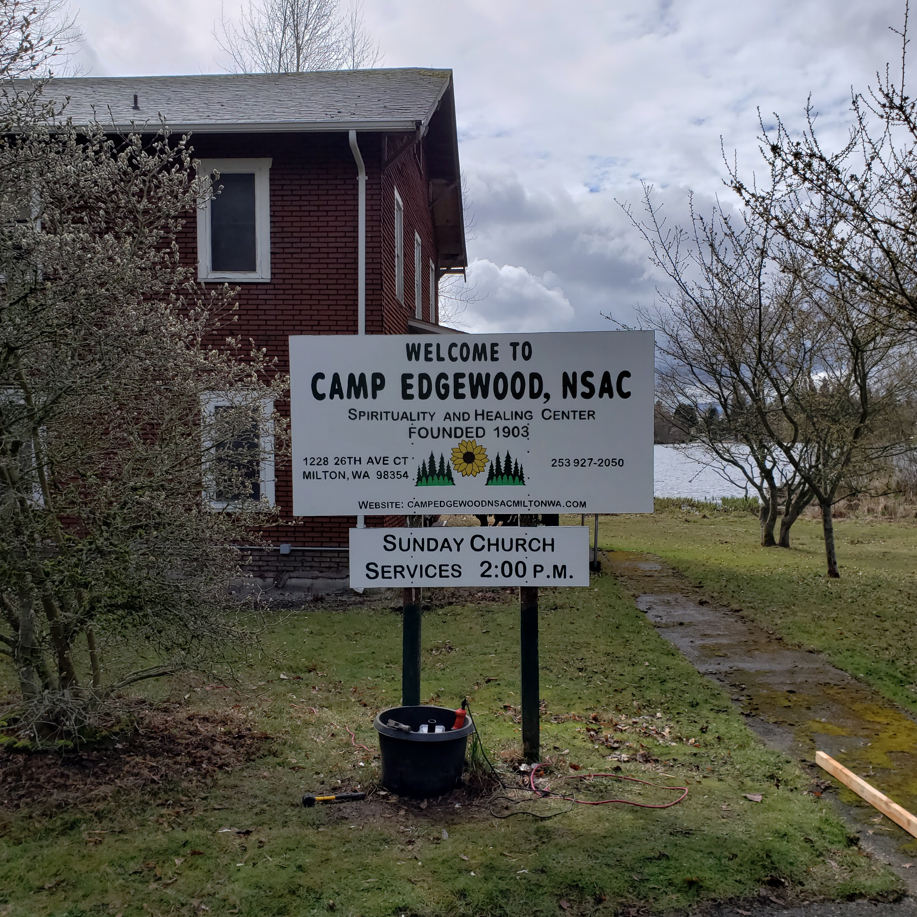
Camp Edgewood, N.S.A.C.

Hello Members,
Camp Edgewood Board of Directors have continued to move forward with completed and ongoing projects; however, the biggest one is welcoming you all back to the re-opening weekend starting Saturday, May 27, 2023 at the 1st Annual Camp Edgewood Yard Sale. To continue celebrating, we invite you to the Camp Church Service on Sunday, May 28th 2023, @ 2:00 pm with Reverend Donald McFarland as the guest speaker.
We hope to see you all there.
Behold here is the Magic Staff.
Under all Circumstances Keep an Even Mind: Take it. Try it. Walk with it. Lean on it,
Believe on it forever
With change, comes challenges, so remembering to keep an even mind continues to be a reminder that Camp will prevail. We received a new sign for the 175th Anniversary of Modern Spiritualism, from the hardworking, Secretary Brendan McDonald, and with the assistance of Marianne Mathews, they got the new sign up in front of the Healing Center. The Camp Board of Directors continues to meet every month via Zoom. In April, a vote passed to upgrade the WIFI to include accessibility to the guests in the Healing Center, and work continues toward incorporating hybrid Camp Services for the summer season. We are excited to have two out-of-state speakers, MPI Student, Mark Schoen, July 9th, 2023 from WI, and Stacy Schuerman, Spiritualist Teacher and Medium from WI, August 6, 2023 to join us. We are proud to say the Camp website and the domain will continue be a source of updated information for speakers, and classes for the next two years! We will also keep everyone updates on the Camp Facebook to reflect with the website. We are happy to say we will have several teachers for online classes starting in June, so please keep a look out for the events.

What is there to say?
Camp Edgewood Yard Sale
Contact Us
Camp Edgewood, N.S.A.C.
1228 26th Ave Ct Milton, WA
253-927-2050
info@campedgewoodnsacmiltonwa.com
Taking Spiritualism to new heights - (campedgewoodnsacmiltonwa.com)
Camp Edgewood, N.S.A.C.
1228 26th Ave Ct Milton, WA
Recipient Name
Street Address
City, ST ZIP Code

Sure this newletter is not a novel, but a short summary of the progress the Camp Edgewood Board of Directors continue to do. We still have a lot more to accomplish with buildings and maintance, but we continue to make small changes everyday. As a reminder, Camp opening will start off with a bang on Saturday, May 27th for the 1st Annual Camp Edgewood Yard sale from 9-4 pm, and Sunday May 28th 2023, for opening church services will be speaker Reverand Don McFarland @ 2 pm. Remember, June 30 is the last day to have your Camp Memberships paid, and August 12, 2023 will be the Annual Membership Meeting. Continue to watch the website and Facebook for online classes and guest speakers.

