It occurred to me recently that I should put pen to paper and document the early days of our Grand Prix’s and how Jaguars were a part of it, including some of the events that caused me to be swept up into those glamour days. After all, it is a bit of history and should be recorded as best as my memory allows, so here goes!!!
The Ecurie Ecosse C Type
Back in the early days of the Adelaide Grand Prix, I was President of the JDCSA and at about the same time JRA (Jaguar Rover Australia) appointed a new State Manager, a man called Ron Tunnell Jones (to be known as RTJ).
I decided to introduce myself to ensure that our club continued to receive support from JRA as it had in the past. I found him to be a great person, but he had the belief that “old cars don’t sell new cars”, so I knew that things may be difficult. Luckily, he and his wife Heather, had two young children about the same age as our two, and being from interstate, our two families became friends.
One day Ron and I were having a chat about the coming Grand Prix and the
fact that JRA very much wanted to be involved in the “off track events”. That year Ron had organised for Sir Stirling Moss to drive the Ecurie Ecosse C Type that belonged to John Blandon. However, John was very involved in the Grand Prix Rally and was concerned that the C Type needed some work.
A few days later, I received a call from John Blandon asking if I would be interested in preparing the C Type for Stirling Moss. After about half-a-second to respond, the car was duly delivered and parked outside my house, on the road with a set of trade plates and a request not to “bend it” or leave it out of my sight. I only had one option, and that was to use it as a daily drive to and from work where I could park it outside my office. It drew quite some attention as it had the original racing exhaust system, which was rather loud.
On one occasion, I drove past the then Darlington Police Station and was further up the road when a police car pulled me over on the main South Road. They took quite some time to go over the car and eventually, becoming impatient,
I asked them to please “just book me if you’re going to”. They replied, “no mate we’re not going to book you, our Sergeant saw you go past and told us to stop you so that he could look at the car”. Well a quick drive with the Sergeant in the passenger seat resolved that issue.
One last humorous event with this car occurred on the weekend before the Grand Prix. The car was ready to go mechanically, it was painted in Ecurie Ecosse blue with a light grey interior and it was looking in need of some interior detailing.
It was then that a long-standing member of the club, Ron Ozlanski, asked if he could come up to help with the C Type. He had the job of applying some grey leather shoe polish to the seats and dashboard and after a while he said, “I’ve run out, where’s the next tin of polish”. There was none, so a quick phone call to the local supermarket revealed that they had some in stock, so I said to Ron, let’s take the C Type.
Now I live at the top of a hill in a suburb called Marino and I have a rather steep driveway, and it’s the week before the
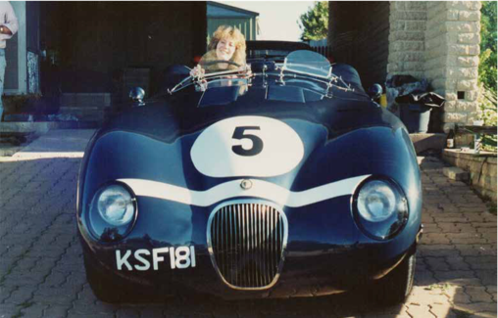
(Val Weeks in the Ecurie Ecosse C-Type. The team had 3 race-cars, identified from each other by the number of stripes across the bonnet. This C-Type has one stripe and was known as lance-corporal. The other two were known as corporal and sergeant.)

Grand Prix.
As we were driving down my driveway a car went past very slowly. Unbeknownst to us, driving it was the President of the Canadian Jaguar Club with his wife and some friends. They were over for the Grand Prix and just exploring Adelaide that day. The conversation in their car apparently went something like”, (wife to husband) “there’s two guys in a C Type leaving a house back there”. The husbands reply was “don’t be stupid, there’s only two in Australia (the other was owned by Lindsay Fox and was in Queensland at that time), and you’re not going to see one in the outer regions of Adelaide”. The wife insisted that he reverse back (otherwise, as she later told us it would be one of those mysteries in life), so this hire car reversed back and cut us off as we were coming down the driveway. Now Ron and I were not trying to set him up, we just tried to answer his questions, but the conversation (innocently) went something like this.
The Canadian “Hi guys where are you going?”
Us “we are going to the supermarket to get some shoe polish before they close”
The Canadian “Say that again”
The Canadian “you’re going in this; do you know what this is?”
Us “yes it’s an old Jaguar”
By now Ron and I knew that he was a Jag person, so we hammed it up
Us “yes it’s an old car, bit rattly and hasn’t even got a roof, so luckily it’s not raining”
The Canadian “but it’s an Ecurie Ecosse C Type”
Our reply was “what’s that”?
To which we burst out laughing and told him the story. They joined us on the front porch for coffee and after many photos went their way. He sent me a copy of his clubs’ magazine, where he told the story to his members.
Two D-Types
The following year I wasn’t involved much with the Grand Prix as JRA used two D Types for the off-track events. If I remember correctly, they belonged to Keith Berryman and Ian Cummins, so the cars were in great shape, had their owners with them, and not needing any work.
However, the following year was very different.
XJ13 Arrives
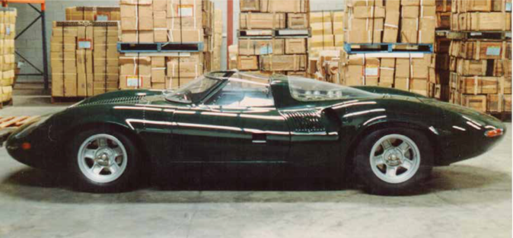
Another meeting with RTJ after the Grand Prix and the conversation went something like, so what can we do for next year after the C and D Types. Ron mentioned a car called an XJ13 that Jaguar had built to race at Le Mans and that JRA were going to try and get the car over here. As I left, my thoughts were “good luck”.
It was apparently contemplated to build a second XJ13 for Ecurie Ecosse who had a great deal of success racing Jaguar C-Types & D-Type’s. Ecurie Ecosse are now building their own replica’s

About a week later RTJ phoned me to say that JRA had secured the XJ13 to come to Adelaide, but with many conditions, including:
• a huge insurance policy
• it had to come with its own driver (an engineer called George Mason who built the car)
• it could only fly on British Airways, and
• it had to be on the same plane as George as personal baggage.
Also, because it had been in a Museum for some time, it would require some repairs, especially if it was to do the Climb to the Eagle (and take the Premier at the time, John Bannon). The question was asked “interested?” My reply was, “if Imust”.
This started a few rather whirlwind weeks of living with the XJ13. It was to be garaged in a Customs shed at the Adelaide Airport, and my first job when it arrived, was to meet the car as it was lowered from a jumbo jet and get water and petrol into the car. However, it was decided to trailer the car to its new home (due to the rules imposed, not by Jaguar but by the British Heritage Trust).
It was here that I first met George and his wife Celia (who also came with the car). His first words were “do you have a hammer?” My reply was “what for”? It was then that George told me that a customs officer had tried to open the doors but had turned the door handles up (they pull out horizontally) causing the handles to break and bend the aluminium doors. My reply was “I hope you don’t want me to hit the XJ13 with a hammer”? To which he said “yep”.
It was then that I found out that the XJ13 was only to be referred to as “The Car”.
George then told me that there were many people coming to Grand Prix who may be wanting to see the car, and “do you have a suitable garage”? My answer was no, especially seeing the ground clearance of the car. So, it was decided that the car should stay at the airport in the Customs shed. I then arranged to take a swag to the shed and sleep there to get it ready. However, the area went onto alarm overnight, so I simply got there early and left late.
It took a few days to replace old fuel, brake and water lines. Also, a bit of panel-beating and spray painting. I was lucky enough to find someone who could colour match the paint and put it into a spray can which made it a lot easier.
One problem was the broken door handles. In the end I found someone with
a pantograph machine. This basically can cut a profile from an original, and so I got some 1/8” 316 stainless steel and made a few sets of handles. However, vanity got the better of me, so I couldn’t resist engraving my initials under each handle. I often wonder if it still has those handles on it today. (I still have the original handles at home to this day and must bring them to a club meeting as they may be of interest to members).
We then began some rather interesting events and it’s amazing how the best laid plans can go astray. Apparently one of the conditions of the car coming over here was that it had to be trailered to all events, other than performing laps around the circuit and doing “The Climb to The Eagle”.

XJ13 to Rundle Mall
The Adelaide Lord Mayor of the day, Steve Condous had heard of the car and wanted to present the keys to the City of Adelaide to the XJ13. This was to happen in Rundle Mall at lunch time on a Friday.
So, we started the car at the Airport (the first time I had heard it), when a magnificent fully enclosed trailer arrived complete with a carpeted floor. This was
the first hitch. The XJ13 had at least 500 bhp (claimed) and was only about 50mm off the ground, so it immediately spun its wheels and threw the carpet under its boot which in turn lifted the car’s rear wheels off the bottom of the trailer.
When we got to Rundle Mall, with the rear wheels in the air with no traction, there was no way that the XJ13 would move, so we took it to Ezio’s (the local Ferrari garage) where the trailer was demolished and we used a forklift to get the car out.
George declared that the car would be driven from here on in. This caused quite some concern as it was as loud as the formula one cars of the day. Also, it couldn’t legally drive on the streets of Adelaide.
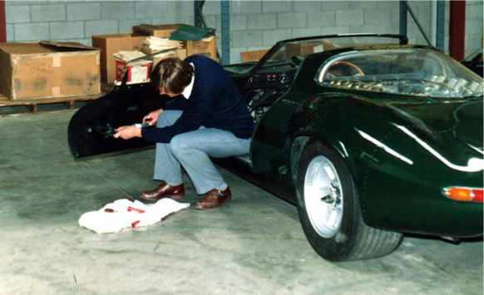
However, a quick phone call to Police Commissioner Hunt (who drove a black series 3 at the time), resulted in 4 police motorcycles, 2 squad cars and a set of number plates. George insisted that he was not going to allow the plates to be fixed to the Car, so someone had to sit in the passenger seat holding the plate above the windscreen. Once again, I found myself saying “well if I must”. It was a great experience and event. The garage got the keys, JRA treated us all to lunch, and George drove it back to Adelaide Airport with a police motorcycle escort
Steve in the Custom’s shed carrying out repairs to the damaged door on the XJ13
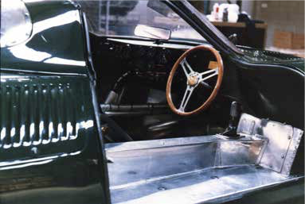
Our route was down Rundle Mall left onto King William St, right into Currie St (past the old Bryson Industries) and then to the Airport. There was one moment driving back along Currie St when some traffic lights went red. George was expecting the Police to drive straight through, but they stopped. George dropped the car back a few gears and dropped the clutch, this was as we were going past an STA bus. The combination of the noise and flames from the exhaust caused quite some alarm and I always wondered what the result was inside the bus. Who knows, maybe it had to make an unscheduled stop at a nearby public convenience?
The inside of the XJ13 was pure racing car with bare aluminium, no insulation and aluminium radiator pipes running above the passenger floor.

XJ13 - Historic Garage Cocktail Party
Another notable event was the Historic Garage Cocktail Party in Wakefield Street. It was always held on a Thursday evening with a 1,000 people, and it was a black-tie affair.
All was going well until someone asked if the XJ13 could be started and George was only too happy to oblige. Now this was an old building, normally used as an undercover car park, so if you can imagine hundreds of people including the elite of Adelaide (and from around Australia and the world) dressed as if they were at the opera. When the car started, the noise and vibration in the building caused it to “rain” dead pigeons (and their nests) along with debris that must have been there since WW2. Many a champagne glass had to be cleaned, refilled and hairstyle redone!!
While on that night, I had wrangled an invite for my mother. When she disappeared for a while, I went to find her and she said that she had gone to get a cup of tea for a rather shy man standing at the back. When we went over to introduce ourselves the conversation went like - “hi I’m Steve and this is my mother”, his reply was “Sir John Surtees”. I found this wonderfully talented man to be a very humble and one who was happy to be out of the limelight.
XJ13 - Climb to the Eagle
After that, things happened very quickly. The car was frequently doing demo laps on the race track, and then on Friday of the Grand Prix it did the “Climb to the
Eagle” taking our then Premier John Bannon up to the Eagle on the Hill Hotel. I was a bit miffed when the police told the Premier that there was no need for him to hold the number plate.
I remember that George stopped at the service station before the Toll Gate to fill up and Les Hughes was there to photograph this. Can you imagine the XJ13, with a D Type behind and numerous JRA Jaguars all lined up.
I was to come down to the track in the car that day (complete with rego plate) when a very concerned George came up to me and asked if I would mind changing seats with someone else who wanted the ride. I was only too happy for this (for those interested, the passenger seat was not that comfortable and the aluminium radiator pipes ran above the passenger floor). So, I watched as a man in a naval uniform got into the car, it was an Admiral of the RAN and his ride back was a Sea King Helicopter straight to the track - so it was a good swap.
XJ13 Goes Back Home
The day came when it was all over. RTJ from JRA organised a farewell dinner for George and Celia at the Lord Melbourne Hotel, and the last task for George and I was to drive the car out onto the runway at Adelaide Airport and onto a platform.
There I removed the battery and drained the fluids out of the car in preparation for its return to the UK. If I remember correctly, Ray Smithers followed us in his car so that we could drain the petrol into his Jag.
It was sad saying farewell to the XJ13, but it had been an incredible privilege to have been involved while it was here.

One More Thing of Interest:
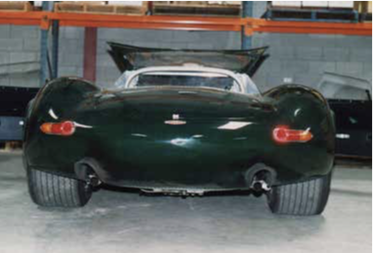
George told me that the XJ13 would never have raced as we know it because in his words “it created dirty air at the rear and wanted to get airborne above 170mph”. So, if development had continued, it would have had a number of aerodynamic changes including a rear wing.
I hope that this has been of some interest to members, they were great days (most probably never to be repeated). I don’t know if the car had ever been road registered before, but it happened right here in sleepy little Adelaide.
Steve Weeks (Member No.22)

