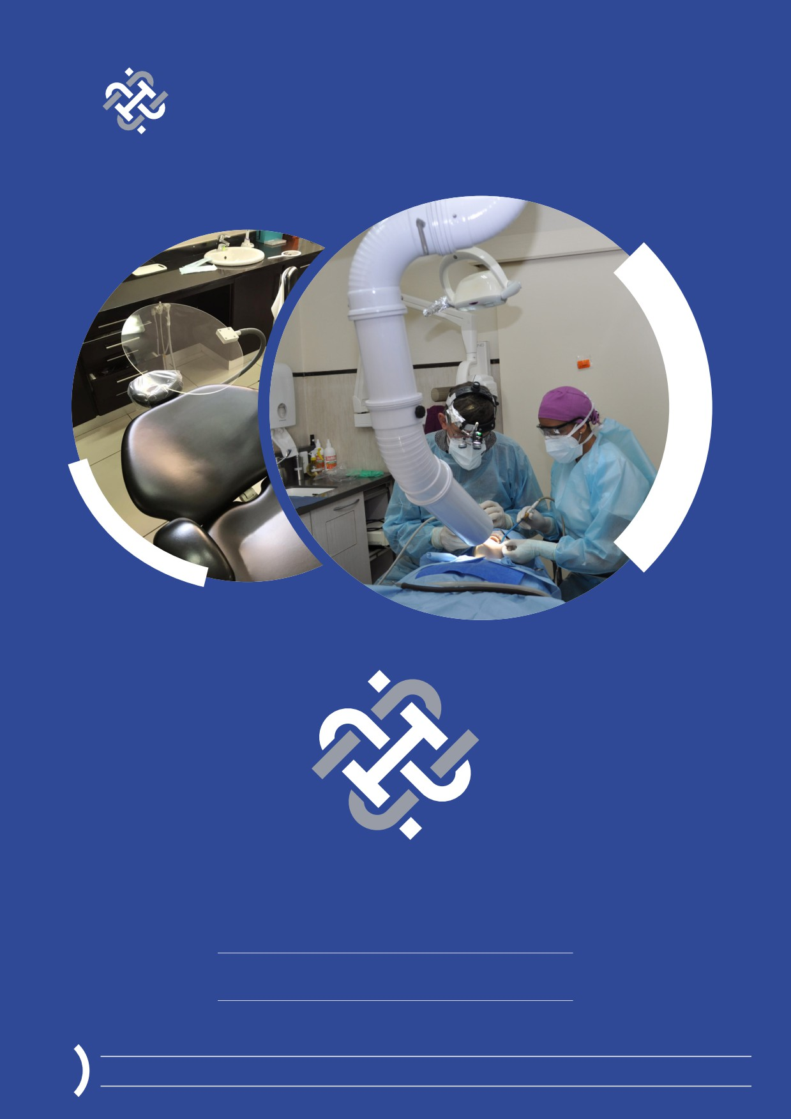PDC PRODUCTS AND SERVICES BROCHURE

PDC
Prosurg Dental Components

We can help you put a smile on their face...

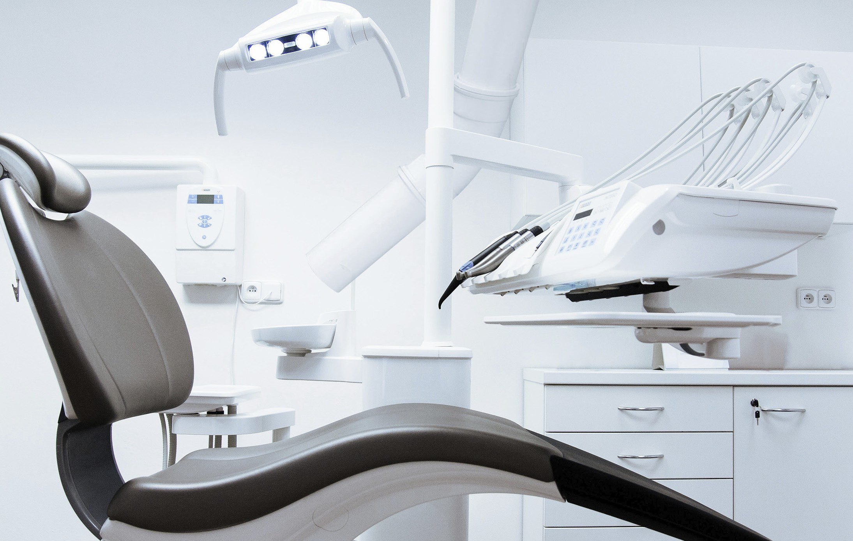

THE RIGHT
CHOICE FOR
YOUR PRACTICE

For over 20 years, Prosurg Dental Components (PDC), has been committed to
providing dental professionals products of the highest quality. Combined with
our commitment to excellence, we have established a continuous high level of
customer satisfaction. At PDC, we go out of our way to meet the expectations of
our clients.
We work with you to come up with innovative solutions to ensure your practice is equipped with distinctive products that is always up to date with the
technology that the dental industry has to offer.

Is your practice equipped for COVID-19?
Our products

Aerosol Extraction System

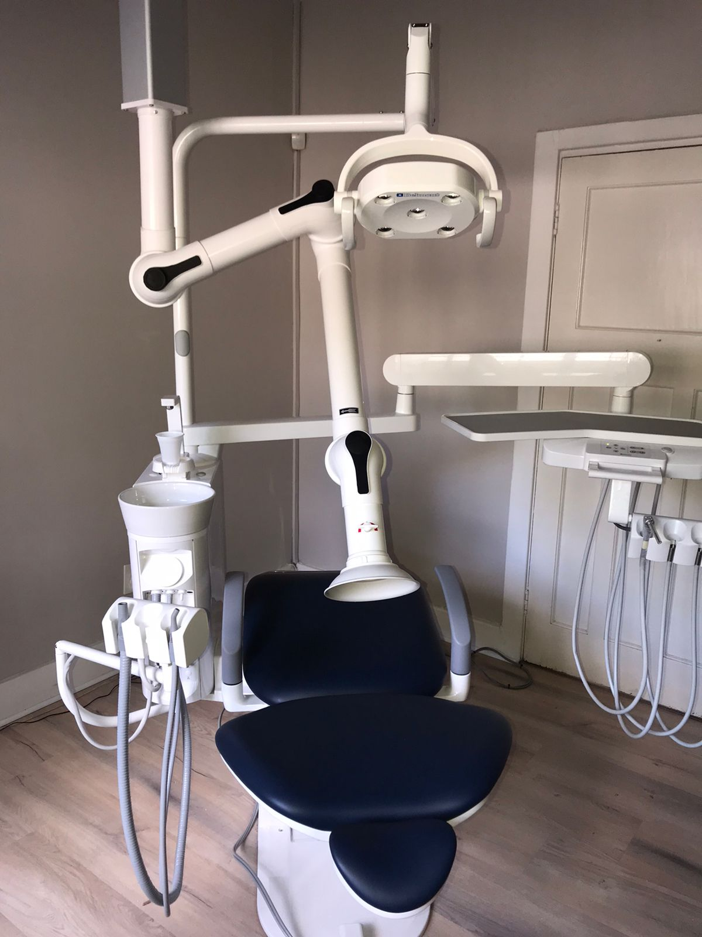Prosurg Dental Components developed an Aerosol Extraction System in conjunction with dental clinicians to assist with the fight against Covid-19 and other viruses/bacteria. It consists of a specialized super-silent pump, so that the noise does not interfere with communications or during clinical working. The down-pipes over each chair are connected to ducting in the roof. These downpipes do not take up any space and they are adjusted to a position close to the mouth. The volume of extraction is about 300 cubic meters of air per hour, enough to replenish the air in the surgery at least four times per hour. The aerosol is extracted out of the room into the atmosphere and it is not recirculated back into the room.
Most viral load in aerosol is created when the patients either talk or cough. At that stage it is important to have the air extracted. Coughing does happen, especially when fluid enters the trachea during dental procedures and the patient has the confidence of being able to cough safely into the pipe. This system gives the patients a lot of confidence to come to you during these trying times and Covid related cancellations are minimized (as per the doctors who have installed it already).
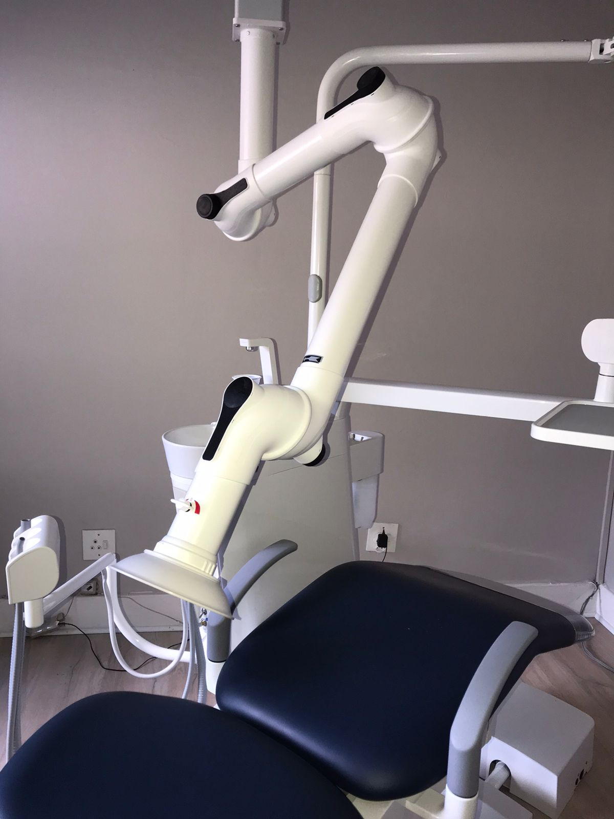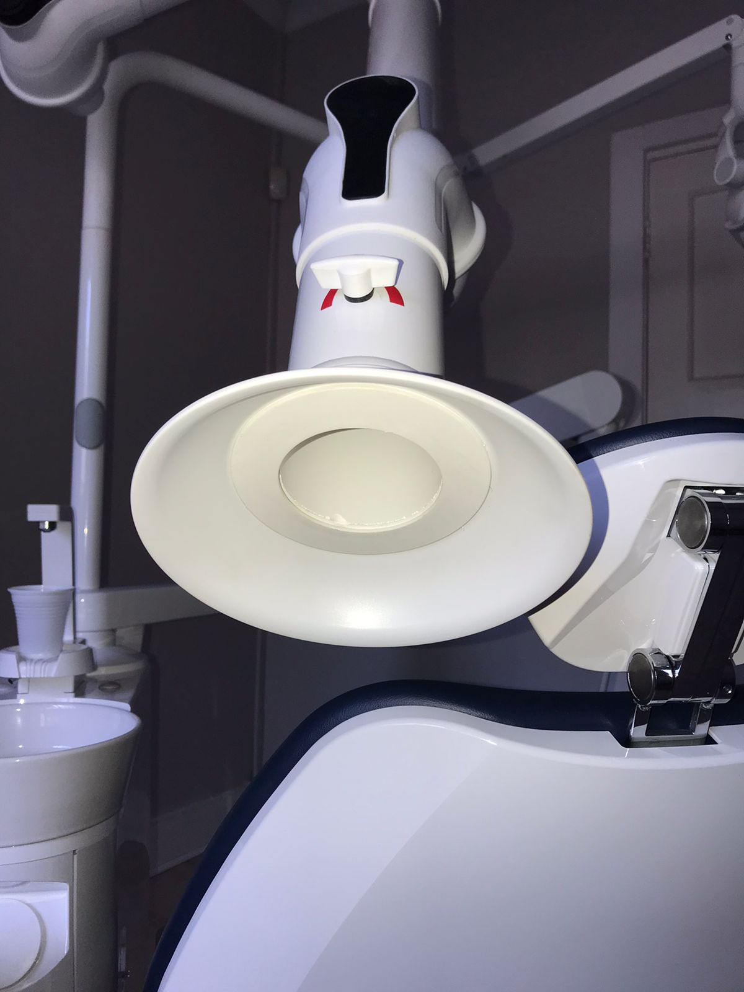This system is also perfect for institutions with a high number of chairs, as it is very cost efficient per chair and no additional infrastructure is necessary.

