Delivery Units
Manufactured on order

Units are designed and manufactured to preference and quoted accordingly

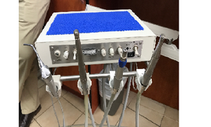
Side delivery unit
- 3 Handpiece plus syringe

Price: Quote on request

Add-ons

- Built in scaler
- Clean water system

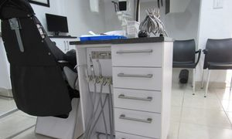
Mobile unit
- 3 Handpiece plus syringe

Price: Quote on request

Add-ons

- Built in scaler
- Clean water system
- Waterproof cupboard available

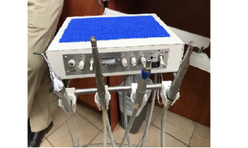

Over the patient Unit
- 3 Handpiece plus syringe

Price: Quote on request

Add-ons

- Built in scaler
- Clean water system

