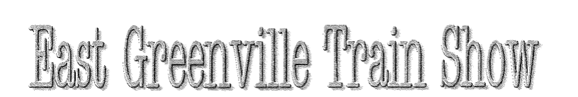
Fall Show Saturday November 19, 2022
9:00 AM to 3:00 PM
East Greenville Fire Company
4th & Washington St
East Greenville, Pa. 18041
- Hosted By North Penn S Gaugers
- Layout # 1 North Penn S Gaugers Layout
- Layout # 2 Trains in Motion 6 X 9 for Kids 11 yrs. and Under
*Layout #3 TCA 6X12 Layout for Kids 11 and Under
*Layout #4 Chuck the Train Man 2X4 HO
- Buy and Sell All Gauge G - Z
- Test Track Available
- Trains, Toys, Collectables, Railroadiana and Train Parts
- Refreshments * Free Parking
- Questions or Table Information Call Rich: 610-570-2021
- Admission: $3.00 per person* $5.00 per Family
Under 12 is Free with Adult
www.npsgauge.org

