FREE ARCHITECTS DESIGN GUIDANCE

ADDING PROPERTY VALUE

Adding property value is not usually your first intention when you’re thinking of renovating your home. But understanding how to increase market valuation is intelligent investment when planning your building extension. Keeping your focus on value can give clear direction on some of the many decisions and choices you will be making.
If you are considering renovating your home, it is likely your plans will reflect aspects that are of value to you. With some design creative thinking, these concepts, listed below can be developed for maximum value.
A good place to start is to assess some of the hard-to-change value drivers for your property. This will help identify negative features that could possibly be improved for added value as you make your plans.

As you assess your house for added value, ask yourself these questions:

1. Has my house ever been designed with a concept or style in mind or is it a miss matched combination of bad ideas with no design flair for proportions of all shapes therefore resulting in a feeling of awkward disharmony. Does it have real “x factor” a wow element that flows easily from its carefully resolved style?
Many houses were built with NO thought for style or uniqueness of expression.
Unfortunately many builders believe they are also designers and so offer “design build” packages that includes all design done by a person who never trained.
It requires 6 years of full time training at university to get the skills required for a professional degree in Architecture, so how can a builder whom has never trained compare? Most people don’t know this and accept it as normal. If your house has suffered this outcome it cannot possibly be a well resolved and refined design solution can it?
Like music it takes years to learn design skills properly to higher levels of perfection.

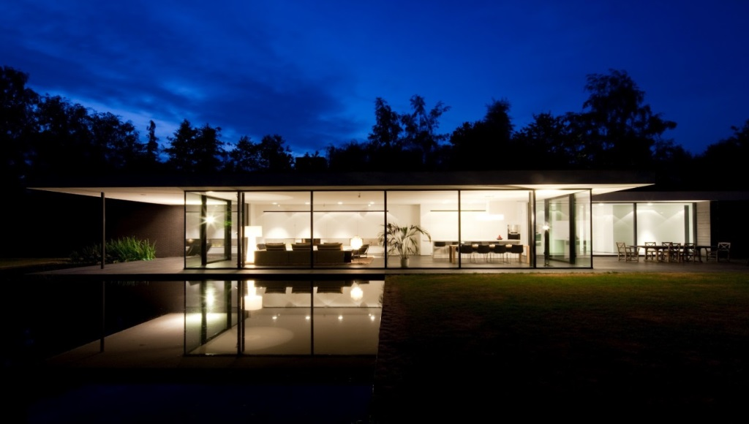

2. Is there a feeling of overcrowded, cluttered spaces caused by trying to utilize every single square meter of floor area ?
Remember good art is also about what you leave out as opposed to where I can add more all the time. Simplicity is an art. There is beauty in simplicity.

3. Could I possibly create a small rentable self-contained flat in any underutilized spaces? This provides passive income and adds property value. Due to home + income. This is developer’s strategies. If you are prepared to share your section it can add a lot of wealth eventually.

4. Could I possibly add a bedroom easily that links to access ways like hall spaces that exist or do I need to re-arrange the access ways to add more rooms.

5. Have the colours been carefully considered? The colours of your house can make a huge difference – you might need guidance here, remember the presentation is found in the details.
So material surfaces and colours are of critical importance to your “x factor”.
Are you even aware of what “x factor” is? It is timeless , architecture that will always be cool no matter what is in fashion. We are the experts, you need to trust our guidance.

CAPTURE THE SUN WHERE EVER POSSIBLE

Having the sun filter into the living areas of your home is a huge improvement to health, psychologically and lifestyle.
Many homes built in Auckland pre-1980 were designed with no consideration for orientation to the sun or use of outdoor spaces as an extension to the living areas.
This “lack of vision” needs to be reconsidered. Sun light filtering through to internal spaces will add a huge ambiance to the interior. Often highlighting features in the room.

LOOK AROUND YOUR NEIGHBOURHOOD

Houses in your area which have been upgraded set the standard for housing quality. Special features of your suburb – such as being costal or proximity to CBD – may mean that you can push beyond this standard, housing price inflation in Auckland makes overcapitalizing not so much of a problem. You will know what you paid for it and what it is worth now.
Adding bedrooms or a second bathroom is one of the biggest value-add strategies you can apply.

Building houses to be healthier is also now a minimum standard – this includes higher grades of insulation, double glazing and efficient heating. While these items will not add the same value as additional floor space, for quality of life it is well worth considering.

CREATE OUTDOOR ROOMS - SPACES

Giving careful thought to how the rest of your section is used can add an extra boost to the value of your property. You want to make every part of your property earn it’s keep by using all the features available to you. Don’t let any part of your section be doing nothing.
A little bit of landscaping can give a lot of definition to your yard. An entertainment area just outside the living room can be paved or decked, a pergola added for summer shade. Is there a space for a kitchen garden – if you’re not into vegies, you can always fill them up with flowers.
Think about how to make lawns useful. Maybe a small amount of retaining would help flatten them. Perhaps add a path that takes you somewhere. The key is to give the outdoor spaces a defined use or purpose so that they become an extension to the lifestyle features you are building into your home.
Large decks as outdoor rooms are very trendy at the moment, and it is clever design borrowed from resorts. Think Bali style with pools and beautiful gardens. You can add so much “spirit of place” to a bland, lonely area of your section.

HIGHER DENSITY LIVING IS NOW AN ACCEPTED NORMAL

Property price inflation over the last few years and a more general acceptance of higher density housing has an exciting “change in ideas” for units. The average two bedroom unit can quite easily be converted to four bedrooms and two bathrooms by building up. This will require careful planning to gain neighbours permission, and is likely to involve resource consent. The result will be large added value as well as a modern and accommodating home. The Auckland council has made this very possible by changing the District Plan Rules to allow for higher maximum height and more buildings on underutilised sections. Especially in some specific “zoned sites” This also helps to bring the people back into the city central areas so as to make the loading on the infrastructure more economical. EG: Less travelling distance to work and less need to build roads and elctricity lines – service pipe lines by the council.
This higher density living was a driving objective by the new PUAP distric plan in Auckland areas. So allowing more freedom for property owners to develop their land to its full potential.

THINKING BIG PICTURE FIRST –THEN SMALL

Considering Value when planning your renovation means you need to work from big too small. What is the value of the property now? What will be the value be after these changes. This can help set your budget. You may need a conceptual design to do this finished value accurately.

1. Consider the standard of housing in your neighbourhood and modern building trends when you are setting the level of your renovation. What is the new zoning on your section for development.
2. Look at how you can improve the use of the unchangeable features of your property—land contour and house orientation.
3. Develop the internal layout and extensions to give you the lifestyle you want and to achieve the highest and best use for the spaces you have.

4. Would you be open to sharing your property with rental tenants? Adding an income from your property. Visonary thinkers always ask this question. Could there even be potential to build another house/ unit on your section to sell and pay for your improved house. We are also experts in modular container house design which can be utilised to make smaller rentable flats without to much cost.

INVESTMENT IN LYFESTYLE
Renovating your property is an investment in your lifestyle first of all. But it’s also an investment in the value of the biggest asset you own. Think about value as you make your decisions and make every change count.
Fortunately the huge increase in the Auckland house values will allow you to do this and not lose any money on re-sale value most of the time. Infact you are probably well aware of the price you paid for your house and what it is worth now, so that alone will show you what you can spend and get all your money back risk free if you sold. The value added by your renovation then becomes profit for you.
Please don’t hesitate to call us as we are trained professionals and can often see potentials that will add to your ideas to increase the value.
Email : builtart1965@gmail.com
MOB: 021 1443479 Darren ( proprietor BuiltArt)

