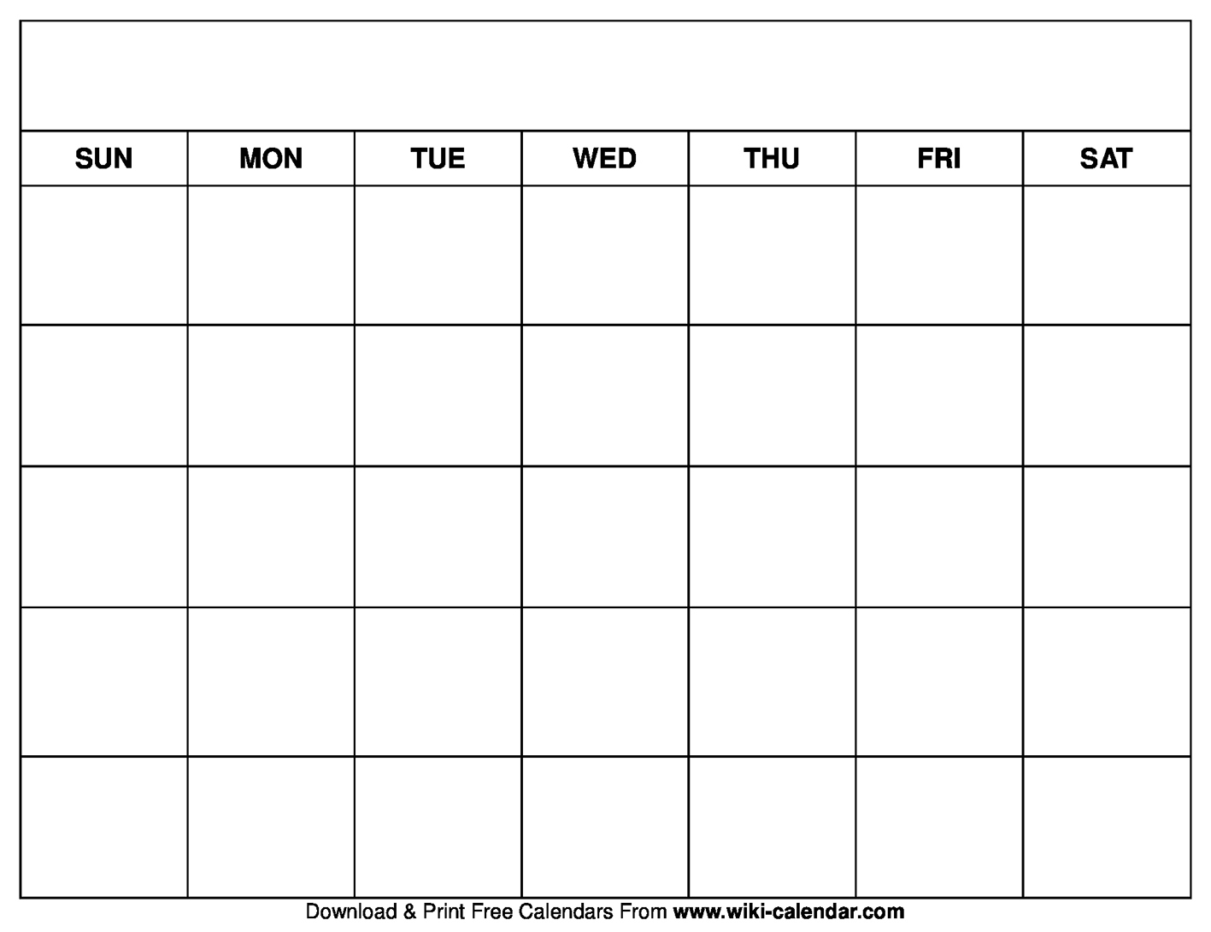 

11am Nogi Adult Comp Prep

5:30pm Kids Striking

Wrestling

2:00 pm

**www.Themmacollective.com**

**The MMA Collective**  **Weekly schedule 2021**

6:30PM Adults Striking

5pm Kids Brazilian Jiu Jitsu

6:30pm Adults BJJ Fundamentals

6:30pm Adults BJJ Fundamentals

7:30pm Adult BJJ Blue belt & higher

7:30pm Adult BJJ Blue belt & higher

7pm Adult Nogi

6pm Kids comp Nogi

5pm Womens Fitness

4pm Comp Wrestling

5pm Kids Brazilian Jiu Jitsu

7:30pm Nogi sub grappling

Boxing 11:30

;

;30

Mini warriors 11am