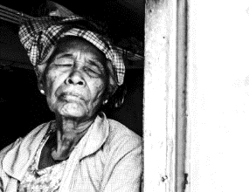
Windows For Widows
A Mission for Christ Jesus to
The People on Culebra Island, Puerto Rico
June 5th – 12th, 2020
Please Pray for Your Mission Team:
Bryttany Ditmar
Carl Towns
Sandra Hubbard
Lorretta Floyd
Emmy Hubbard
Kayla Hubbard
Blake Russell
Pastor Zack Ditmar

